Research & Sponsored Programs, The University of Toledo
How to create a SPIN account and get it activated

- Be sure you don't already have one! If you’re not sure, you may contact Marcie Ferguson or Rick Francis, and either can check, and can re-set your password if necessary.
- To create your account, be sure you are on campus (it checks for a match between the institution you claim affiliation with and the IP domain indicated by your browser). Go to https://spin.infoedglobal.com/, click Sign In, and click Need to create a new profile?

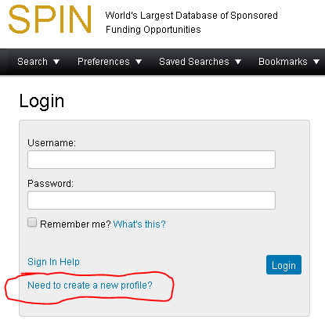

Please use your UT email address to create the profile, as that indicates to the UT staff that your account should be approved for activation. After your profile is approved, you may use it from any location and you may change the preferred email address. If you have a SPIN profile with another institution, you will still want to create a UToledo account.
Most of the search functions are intuitive, and the rest are easily learned with the short (about one minute) training videos.
