Instructions for the Crestron Media in

Stranahan Hall Building

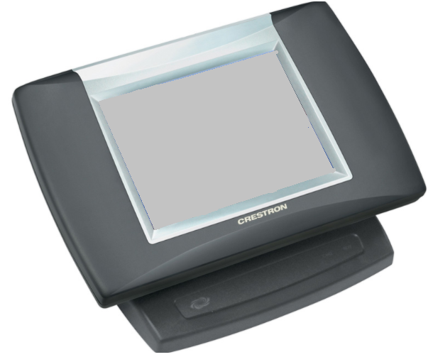

THIS IS FOR ROOM USE ONLY! ANY QUESTIONS, PROBLEMS, OR FOR ADDITIONAL COPIES CALL 419-530-4607.

Starting Up
- If the Crestron screen is black then touch the Crestron screen to turn it on
- If the Crestron is turned on but the projectors are off/ showing a black screen please restart the Crestron system to fix this.
.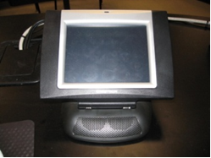
- When the UT picture is displayed, then touch the screen to begin.
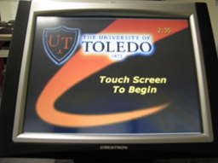
- Projector will warm up for about 60 seconds - Please Be Patient, a light should illuminate in the projector. (The projector will automatically shut off after 5 minutes if nothing is being displayed on the screen)
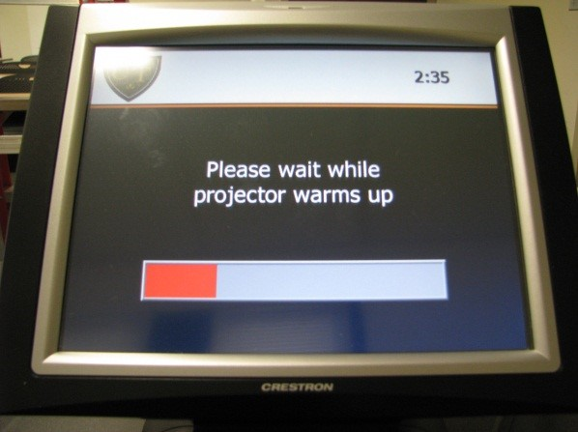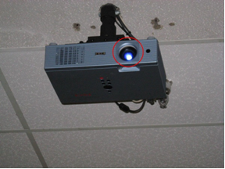

- A menu screen of devices will appear on the Crestron screen.
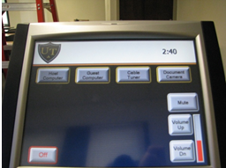

IF THE MONITOR IS OFF…
- Make sure the power button is green. This is located on the lower right hand side of the monitor.
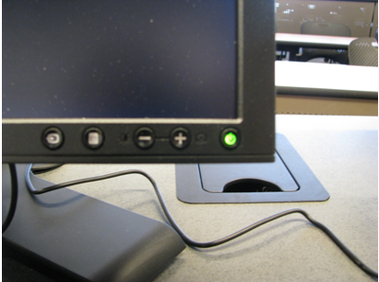
- Also check to make sure that the computer is on by checking to see if the power button is blue.
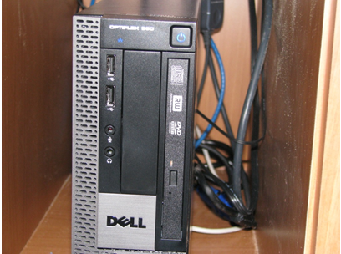

HOST COMPUTER
- To display the host computer on the projector, touch the Host Computer button.
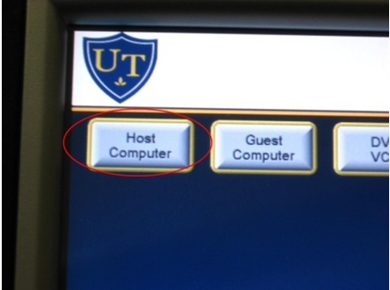
- To login to the Host Computer press “Ctrl Alt Delete” simultaneously.
- Your login screen will appear. Type in your username and password and make sure the “Log on to” is set to UTAD.
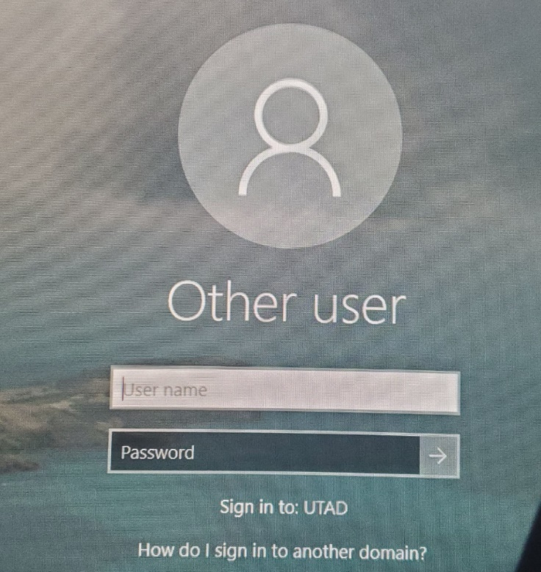
- Do not forget to logoff when you are finished.

GUEST COMPUTER
- Located on the desktop is the caddy.
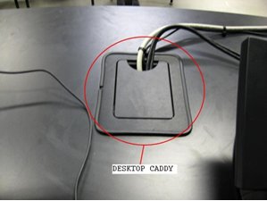
- Inside the caddy are 2 electrical outlets, an audio cable, VGA cable, and an Ethernet cable for the guest computer.
- WIFI is also available when using a guest computer. Either UT guest network or EDUROAM can be used.
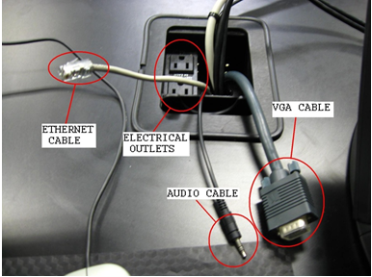
- Make sure that the VGA cable is plugged into your laptop.
- To view your laptop through the projector, push the Guest Computer button.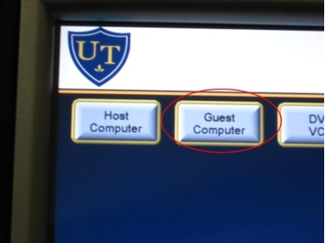

DOCUMENT CAMERA
- The Elmo Document Camera is now used in place of the overhead projector. It can read 8x11 sheets of paper, transparencies, and any printed material you want to project.
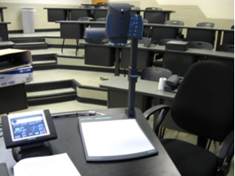
- Located near the base of the ELMO is the power button. To turn on press the power button and it should be illuminated blue.
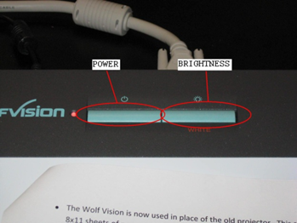
- Place your document under neither of the ELMO camera head.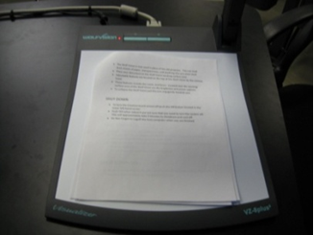
- To zoom or focus in on your documents, use the knob located on the opposite end of the head from the camera.
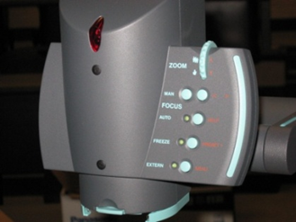

SHUT DOWN
- At the end of your class, please turn off the projector. To do this, touch the Off button located in the bottom left side of the Crestron touch screen.
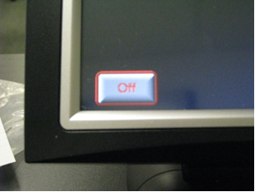
- Touch YES when asked if you are sure that you want to turn the system off. This will approximately take 2 minutes to shut down and cool off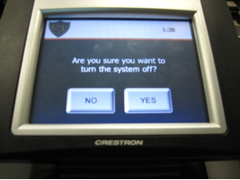 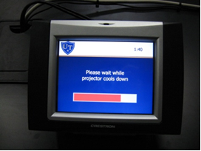

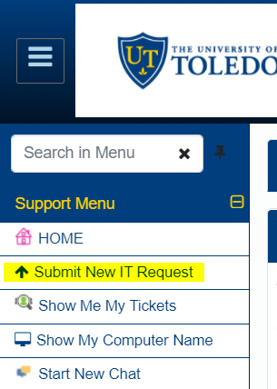
Sending a Help Desk Request
- Go to: https://ithelp.utoledo.edu/
- Use your credentials to login
- Click “Submit a New IT Request”

- Fill out the Form, and click

