General Hospital System Campus
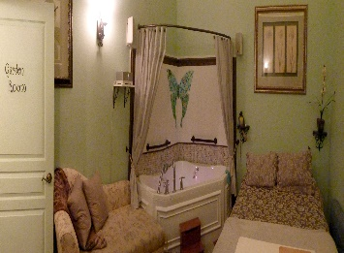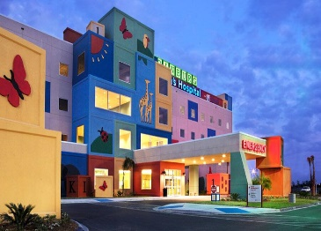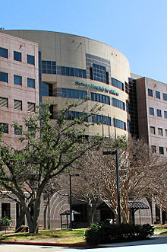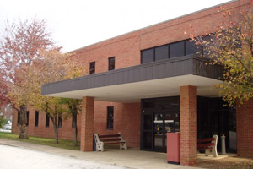
Birthing Center Pediatrics (Full Service) Burn Center Worship / Meditation Services
Neonatal Disaster Services Translation/ Interpreters
Women’s Health Counseling/ Psychiatrics
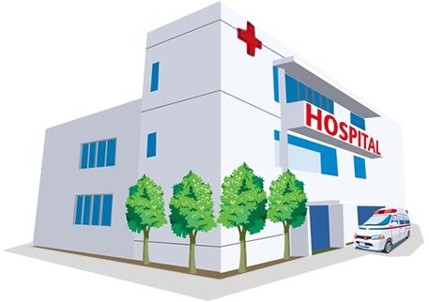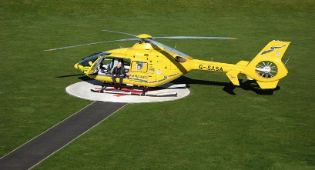
Transportation Ambulatory Service Main Hospital Helicopter Air Transport
Shuttle service at every building
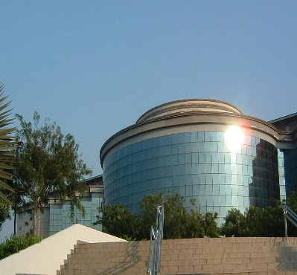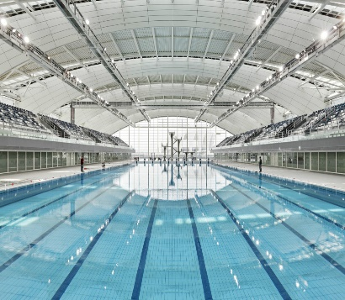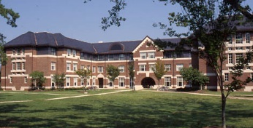
Administration Orthopedics Residence Services
Research Sports Medicine Hospice
Human Resources Physical Therapy
Information Technology (IT) Concussion Clinic
Charitable Giving Foundation Recreation Center
Doctors without Borders

