Zoom User Guide

Sections
Creating and Using a Zoom Profile
To Schedule a Meeting
To Launch Your Scheduled Meeting
To Record Your Meeting
To Launch Breakout Rooms
For Participants to Self-Select Breakout Rooms

Creating and Using a Zoom Profile
- Go to: https://zoom.us/
- Enter your email address where it says sign up for free
  - Students are strongly encouraged to use their UToledo Rockets email address
  - Others are encouraged to use their email address on file with ESSPS
- After doing this, Zoom will send an email to you that says activate account. Follow that link to activate your account.
- Fill in your information to complete registration.
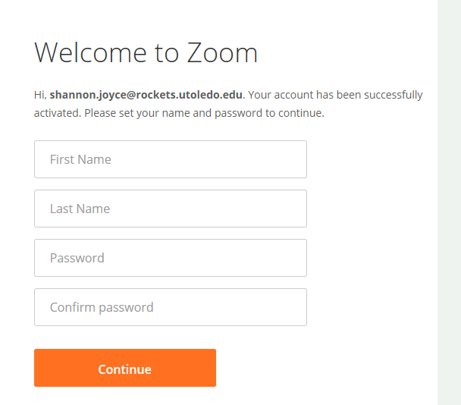

- Skip step saying Don’t Zoom Alone.
- Click Go to My Account.

To Schedule a Meeting
- Log in to your Zoom account: https://zoom.us/signin
- At the top right of your screen, click Schedule a Meeting.
- Fill in the necessary information: Topic, Date, Time, Enable Video for you and your participant, click Both for audio options, and Enable join before host. Click Use Personal Meeting Room if you want to consistently use the same URL and Personal Meeting ID for your virtual meetings (instead of a new URL and Meeting ID for each meeting). You can make that choice each time you schedule a meeting. Click Save when you are done entering the meeting details.

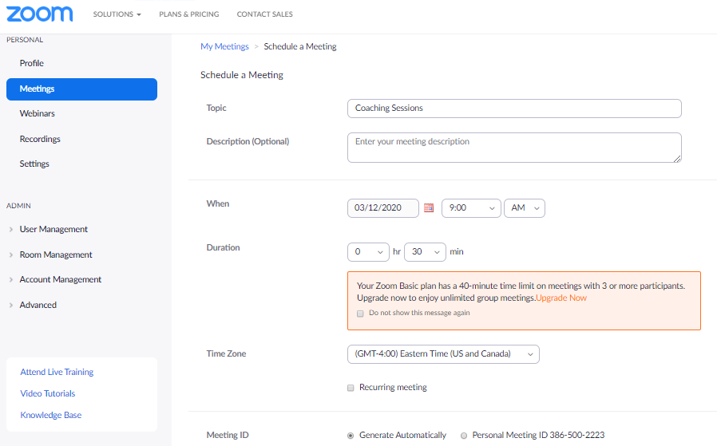
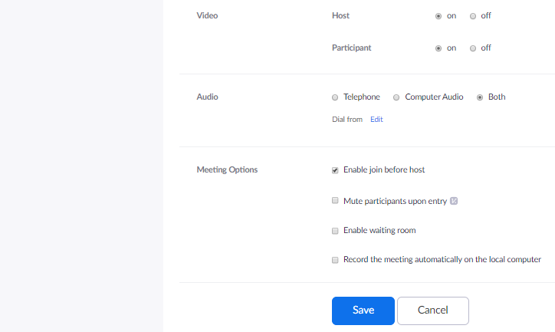
- You will then be taken to a page that says “Manage.” Click Copy the invitation on the right side of the screen.

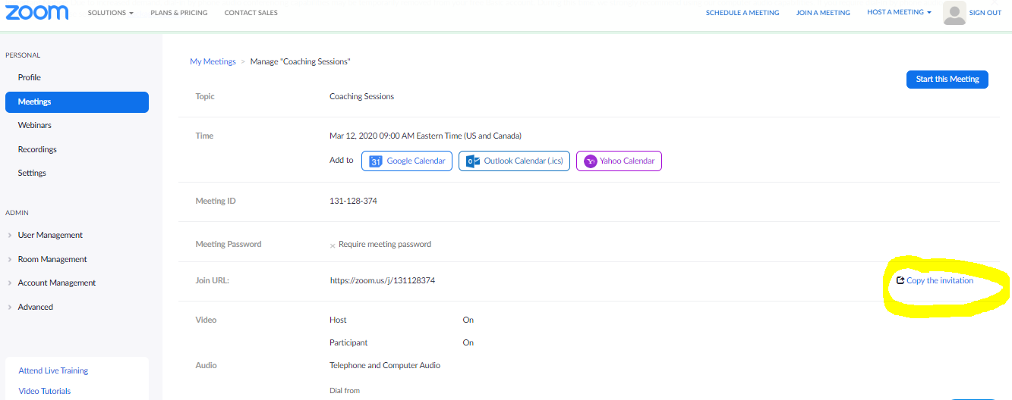

- Copy the message on the screen, paste it into a new email message in your UToledo Rockets email, and send the message to your virtual meeting participants
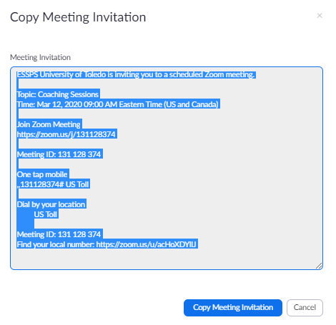

- NOTE: You can also use your Personal Meeting Room at any time for any or all of your virtual meetings. The URL and Meeting ID are always the same when using the Personal Meeting Room.
  - Go to My Meetings along the left hand side of the screen
  - Select the Personal Meeting Room tab
  - Locate the Meeting ID and/or Join URL and send them to your attendees
  - Click the Start Meeting button when you are ready to start your virtual meeting

To Launch your Scheduled Meeting:
- Log in to your zoom account: https://zoom.us/signin
- Go to My Meetings along the left hand side of the screen
- Locate your meeting on the Upcoming Meetings tab or Personal Meeting Room tab
- To launch, click the Start button
- NOTE: If your virtual meeting guest(s) are new to Zoom, they will be asked to download Zoom, enter their name, and select their audio. The whole process takes around one minute. The download prompt should come up automatically, and your guest should choose the Run button in the window that pops up next. There is a link on the screen to click to manually start the download if needed. The download only takes a minute, and the user does not need to create a Zoom account. After the download, the guest will need to enter their name how they want it to show on the screen (then click Enter/Okay button) and then select Computer Audio as their audio option (then click Enter/Okay button).
To Record your Meeting:
- Note: you can go to account settings or meeting settings and have your meetings automatically record (see above screen shot on scheduling)
- Once you have launched your meeting, hover cursor over the bottom of your screen to make the menu appear
- Click the circle button that says Record on the bottom right of your screen

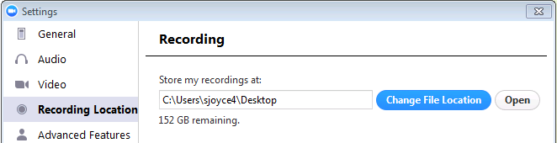
- Once you hit Record, a dialogue box will appear asking you where you want to store your recording. Select where you would like the recording to be saved.

- Once you have selected where you want to store your recording, exit this dialog box, and hit the Record button again.
- You will then see a red light in the upper left hand corner of your screen that says Recording.

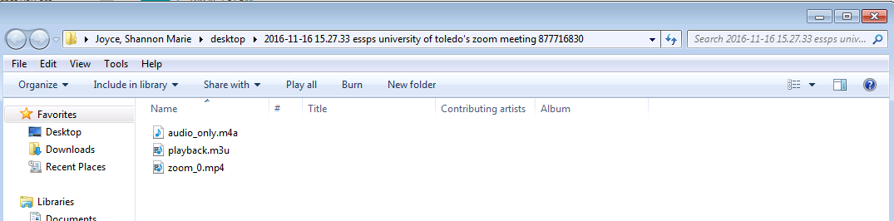
- The recording will automatically save to its assigned location when you click the End Meeting button (look for button in bottom right of screen).

To Launch Breakout Rooms
- Once the meeting is started, at the bottom of your tool bar, click “More” in the bottom right corner, then “breakout rooms”
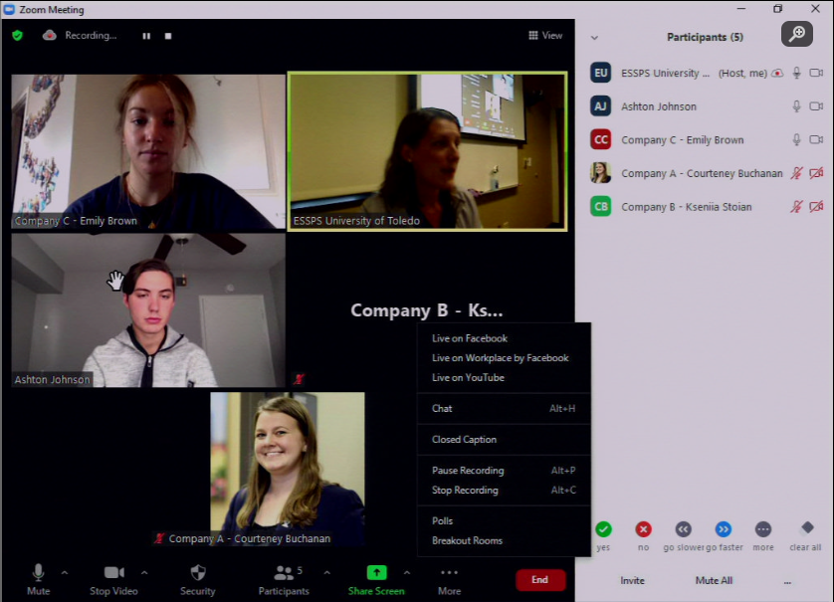

- When the breakout room window pops up, select “options” in the lower right hand corner to create settings for your breakout rooms
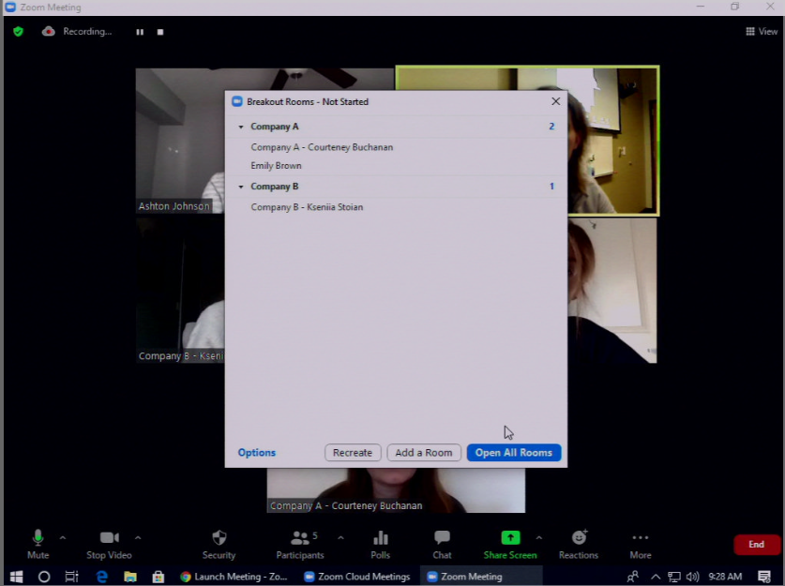

- Select the following settings:
  - Select “Allow participants to choose rooms”
    - This will enable breakout room “self-select” covered in the next portion of this guide
  - Select “Allow Participants to return to the main session at any time”
  - Select “Breakout rooms close automatically after ____ minutes”
    - Input how long you would like breakout rooms to be open
  - Select “Notify me when time is up”
  - Select “Countdown after closing breakout room”
    - Input how long you would like the countdown timer to last before rooms close
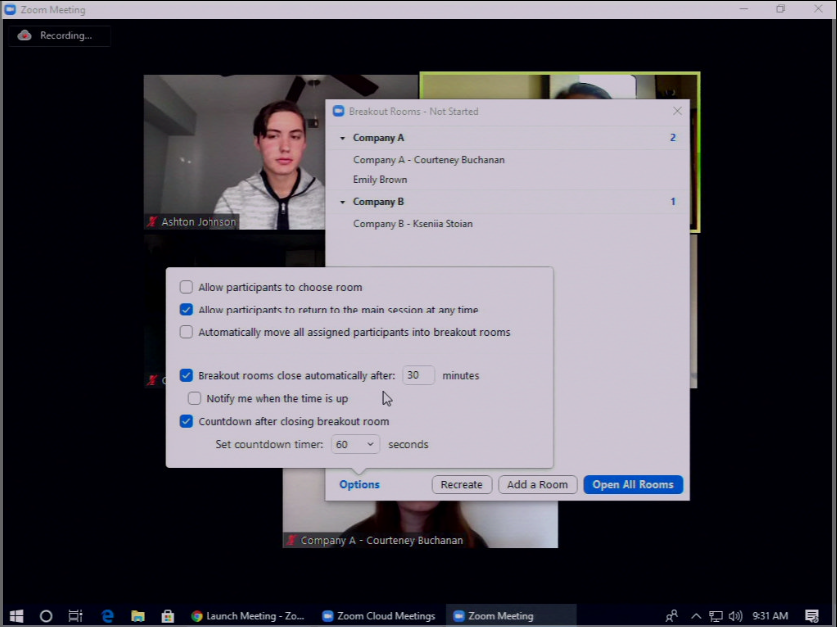

- Once options are completed, select “open all rooms” in the bottom right corner
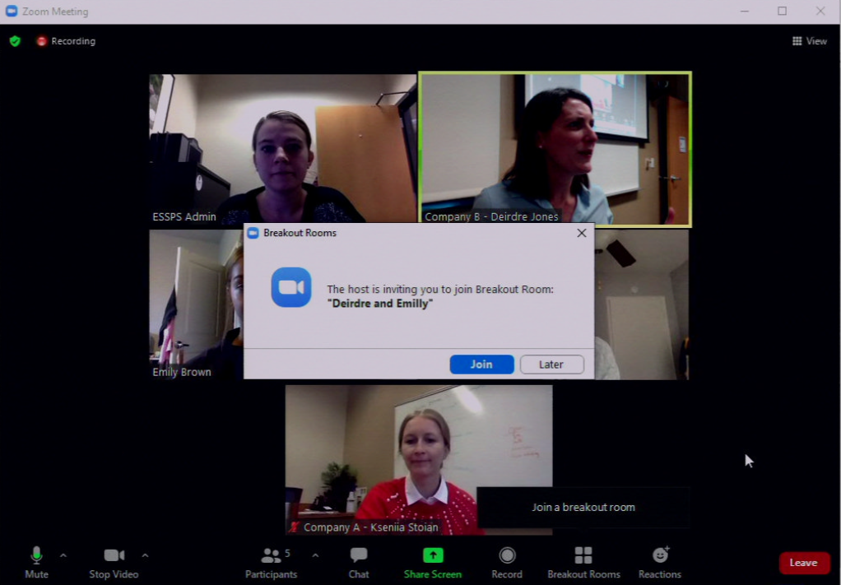
  - Participants will receive a notification to “Join Breakout Room” on their screen – they must select “Join”

- If you need to manually move someone to a different breakout room, you can do so by opening the “breakout room” button on your tool bar
  - It will show everyone in the meeting and their room assignments
  - To move them, click to the right of their name, click the “assign to” button, and select the room you would like to move them to
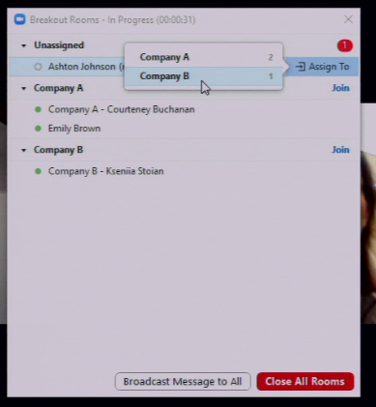

- You can broadcast a message to everyone in their rooms by selecting “Broadcast message to all” in the bottom of the breakout room window
  - The broadcasted message, along with time remaining in the breakout room, will show at the top of the participant’s screen
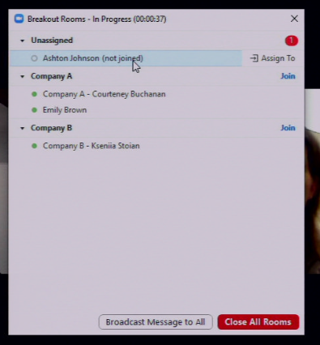
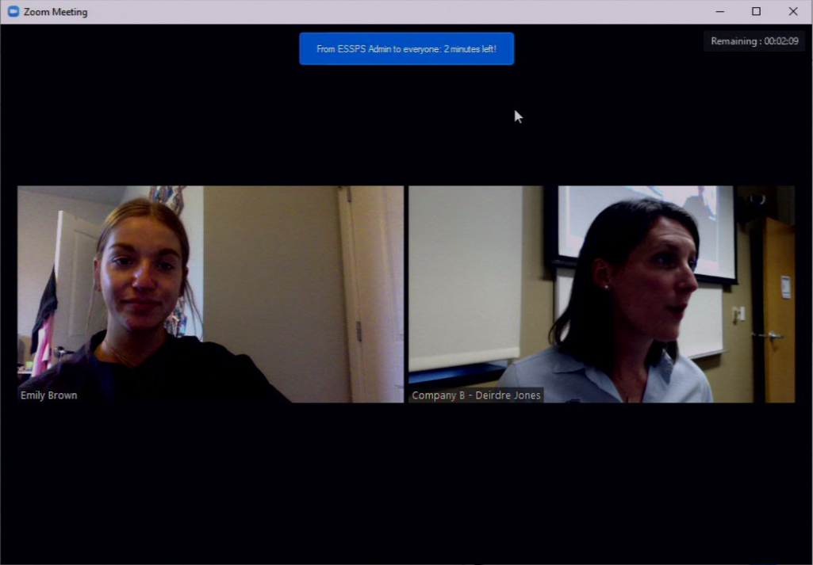

For Participants to Self-Select Breakout Rooms
After the Zoom host has launched breakout rooms, participants with Zoom version 5.3.0 or later can self-select which breakout rooms they’d like to join
- On the bottom tool bar, participants should select the “breakout rooms” button
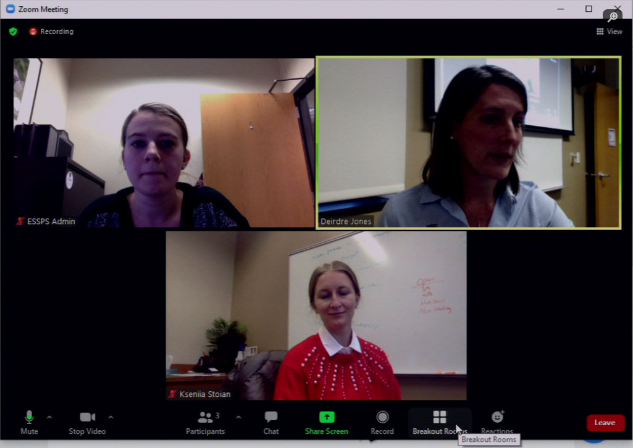

- This will prompt a listing of all available rooms, along with who is currently in them. Rooms can be joined by selecting the blue “join” to the right of the room’s name
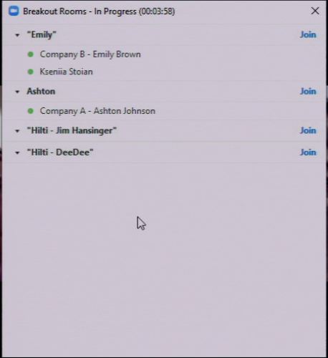

- If participants would like to move to another room, they can self-select another room to visit
  - Select “breakout room” on the bottom tool bar
  - Select “choose breakout room” to bring back the listing of available rooms
  - They can also “ask for help” to request the admin visits the room
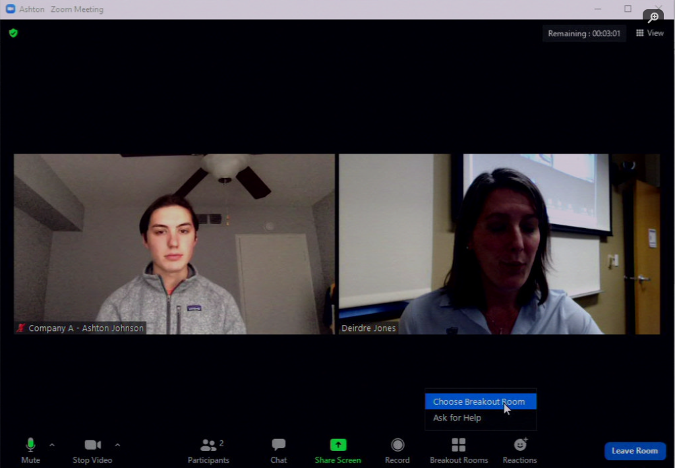

- Selecting “Leave Room” will prompt the options to:
  - “Leave Breakout Room” (return to the main room with the meeting admin)
  - “Leave Meeting” (leave the entire Zoom meeting)
