AP 90 – Invoice Search by Vendor-Invoice

In the white box in the right hand corner type AP90 and hit enter.
Type in Company 1000, tab to Vendor section, type in vendor number if known, if you do not know the vendor number click on the drop down box to the right of the vendor box.

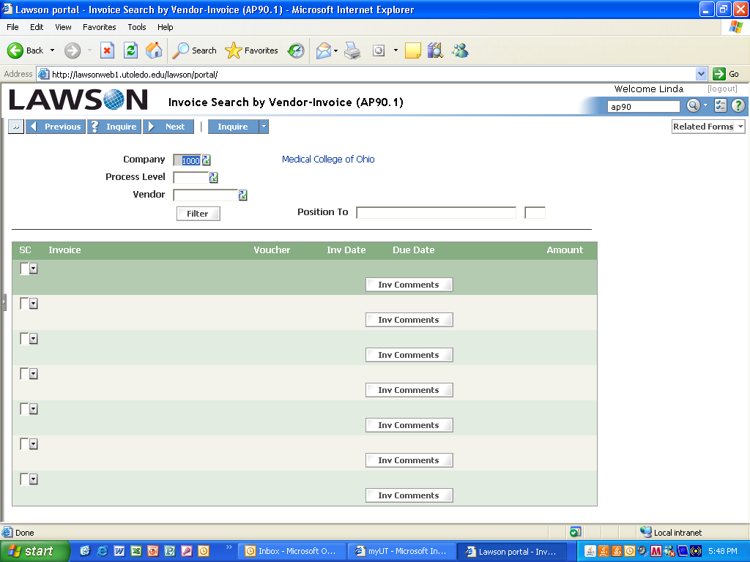

The drop down displays this screen.

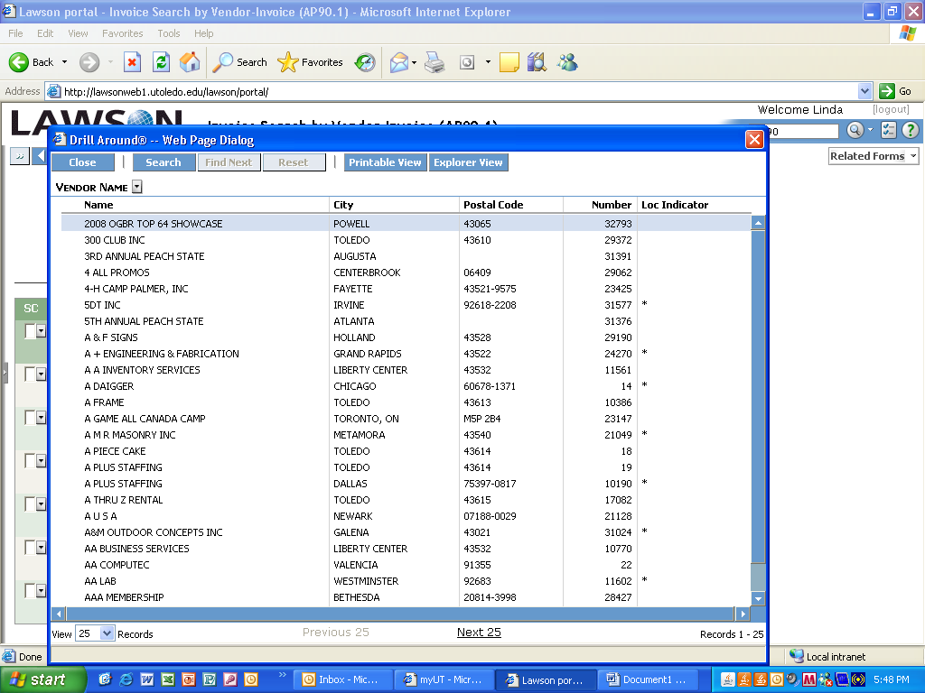

Click on the search button

You can search by name – enter the name or the beginning of the name in the last box.

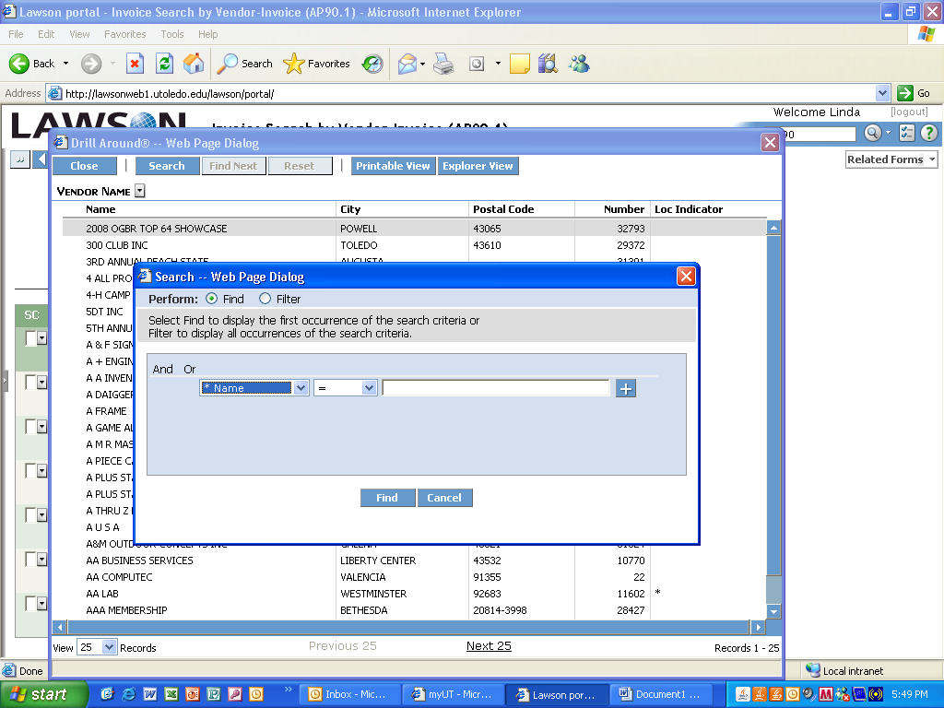

Put an asterisk after the letters entered (this will take you to names beginning with these letters, otherwise it will take you through all names that include those letters even within the name). This will also change the middle criteria from equal to like.

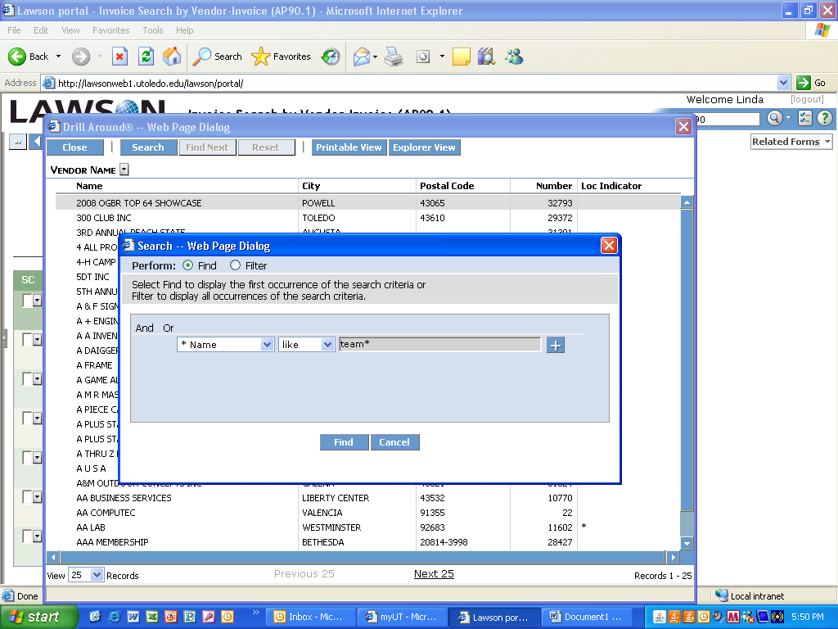

The screen will display names that begin with the letters you entered. Once you find your vendor select the vendor by clicking on the name. If you do not find the name it could be it is not setup as a vendor yet or name is setup different than what you entered.

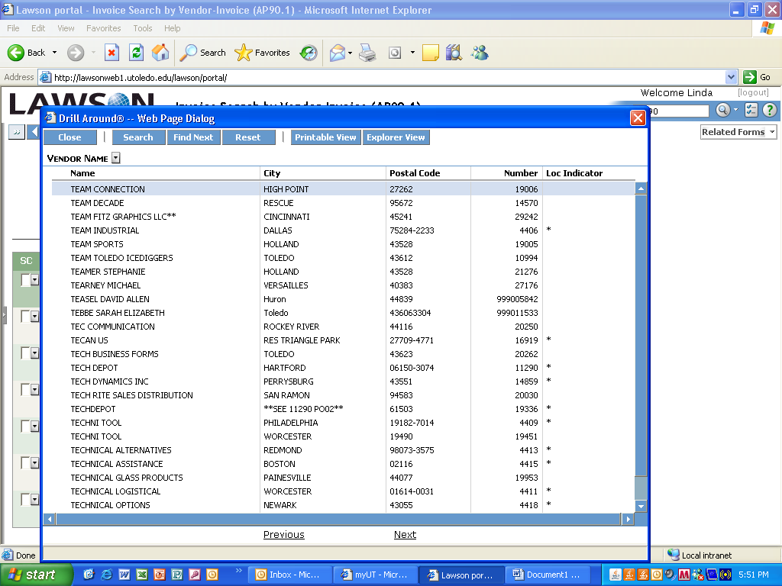

In this example Team Sports was clicked as the vendor and once you click on the vendor it will take you back to the AP90.1 screen and display the vendor number in the box and the vendor name to the right of the box. To display vendor history you will need to click the Inquire button.

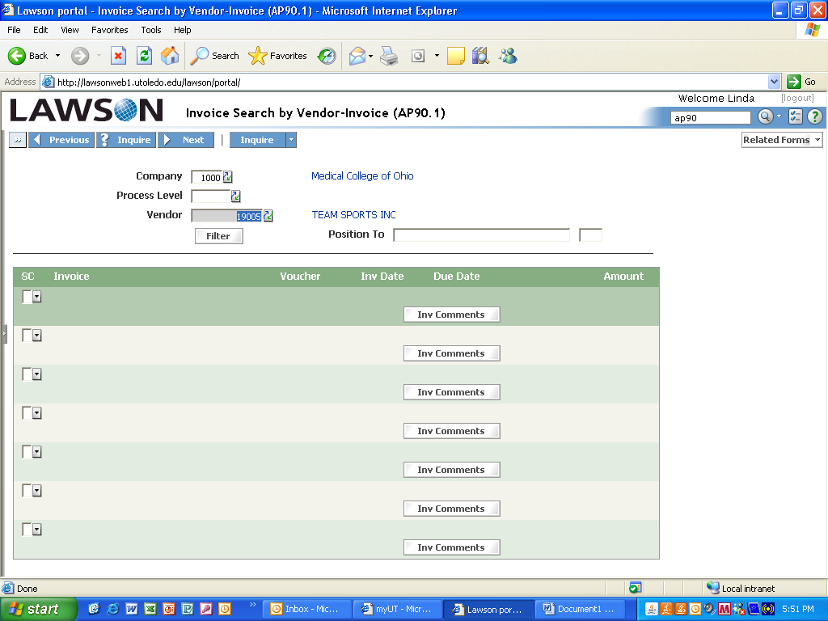

After clicking Inquire the vendor history appears. You can search by invoice number if you know the number by entering the invoice number in the Position To box and clicking Inquire. This will bring your invoice to the top if the invoice has been entered into the system. If you do not know the number and do not see a matching $ amt you can view more pages by clicking on the page dn button on the keyboard. Do not click on the Next button at the top of the screen as this displays the next vendor.

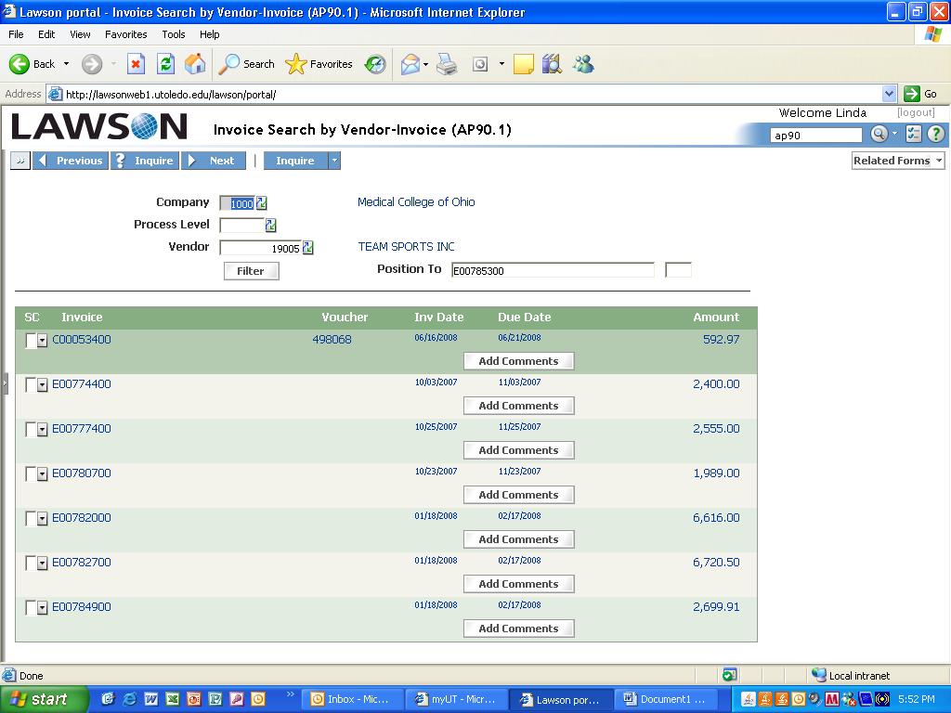

Find your invoice number and you can view other information (Paid? Check, Credit Card, ACH – Payment number/date, etc). Place the cursor in the small box under the SC column on the line of your invoice, right click on the mouse and Drill Around will display – click on the words Drill Around.

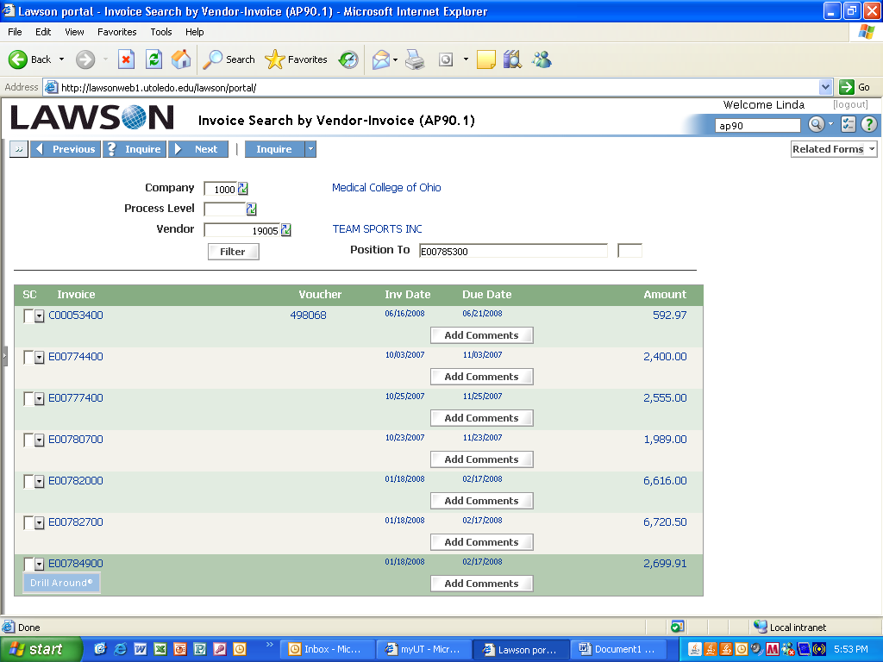

After clicking on Drill Around this screen will appear. This displays payment information. The Payment Number will show either a check number, CCP number (credit card payment) or ACH number. A check number will be six digits and will have the letters SYS ( system) to the right, CCP and ACH will be a 4 digit number and will have CCP or ACH to the right of the number. If the screen states SYS and there is no payment number then the check has not been issued. You can view a Payment Due or if the check has been issued a Payment Date on this screen. If the screen states CCP and there is no payment number this does not mean that the invoice has not been paid since the report to issue numbers is run on Fridays and the vendor may have been contacted and paid before this report has been run.

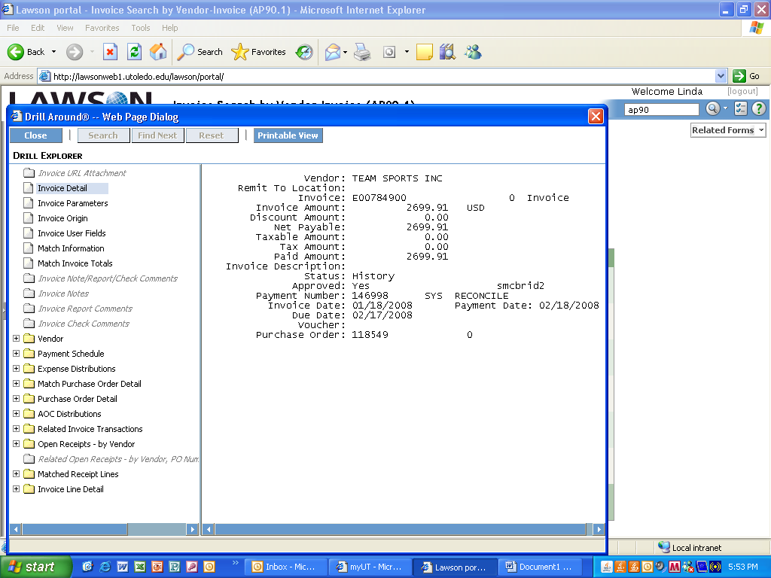

You can view the Index and Account that was entered to charge by clicking on the title Expense Distributions on the list on the left. The Index is listed under the title Account and the Account (expense) is listed under the title Dis Account.

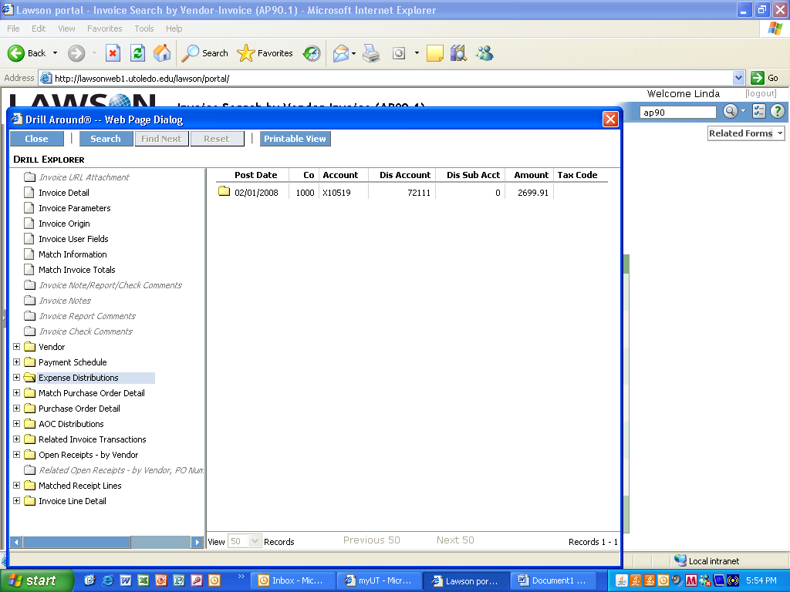

You can search by other methods by typing in the box under the Welcome or by clicking on the Related forms drop down button. Clicking on the title from the drop down will place the screen number in the white box above the related forms. If you know the screen you want to view you can type it in the box. Company must be entered or selected from the drop down box.

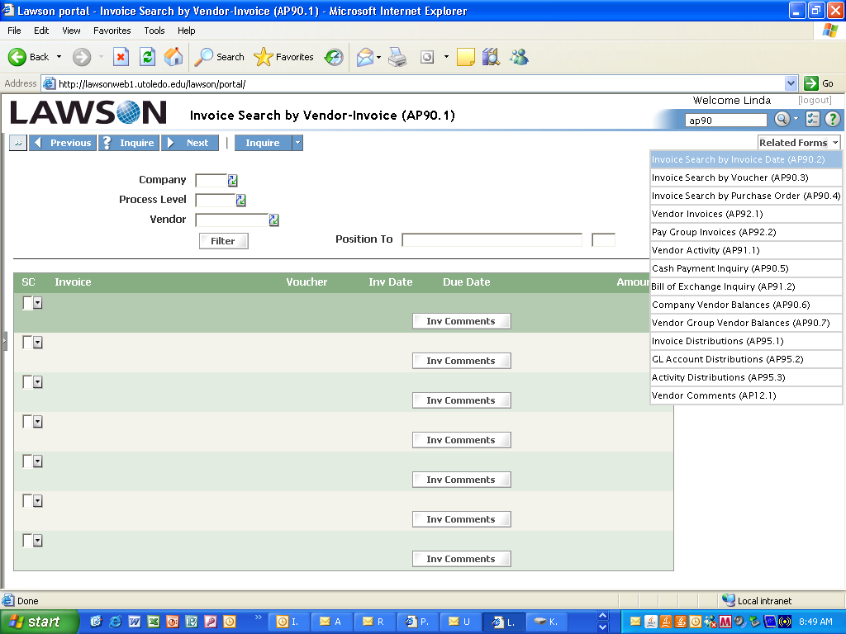

AP90. 3 - Invoice Search by Voucher if you submitted a requisition. Enter the requisition number in the box titled Voucher and Inquire.

To view more information follow the instructions for the drill around under AP90.

Place the cursor in the small box under the SC column on the line of your invoice, right click on the mouse and Drill Around will display – click on the words Drill Around.

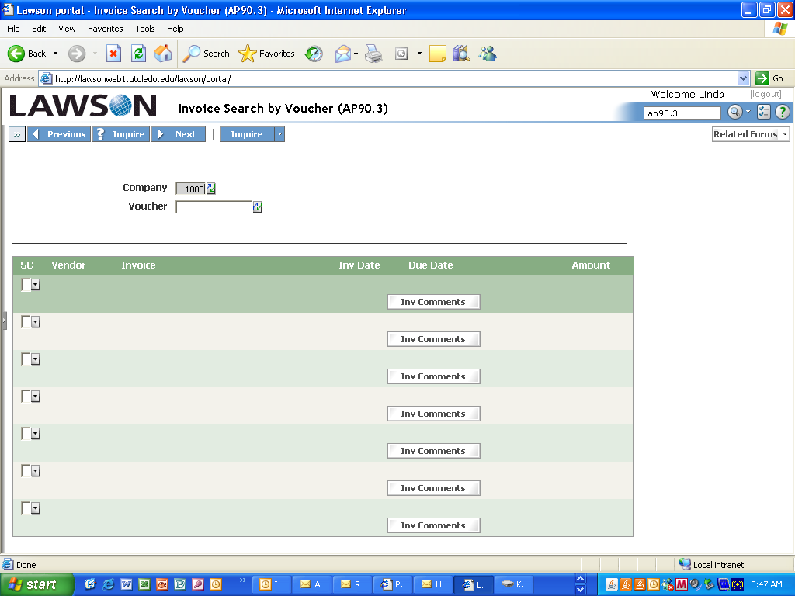

AP90.4 – Invoice Search by Purchase Order to view information for a Purchase Order number. Enter the PO number in the Purchase Order box and click Inquire. You do not need to enter the Vendor number, it will appear once the PO number is entered and Inquire is clicked.

Place the cursor in the small box under the SC column on the line of your invoice, right click on the mouse and Drill Around will display – click on the words Drill Around.



