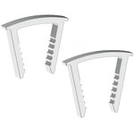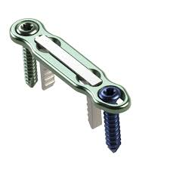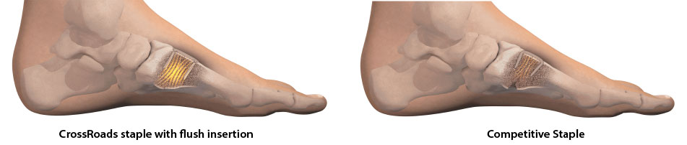

#### [**CrossRoads Extremity Systems**](https://app.lumere.com/research/brands/9553/products/)

##### Product overview by Lumere Research Team

DynaFORCE MotoClip Max & HiMAX Clips are shape-memory nitinol staples used for osteotomy fixation and joint arthrodesis in the hand and foot. The MotoClip Max is specifically intended for low profile forefoot applications, while the HiMax is used in midfoot and rearfoot applications. The top-loading compressions clips can be inserted flush without tamping and can be reloaded or repositioned intraoperatively.

DynaFORCE MotoClip Max & HiMAX Clips are offered sterile in several staple bridge widths and lengths. The clips are designed to be used simultaneously with the DynaFORCE High-Compression Plates. Reusable stainless steel instrumentation is available through the EcoSmart instrument rebate program.

##### Indications

The CrossCLIP Implant System is indicated for hand and foot bone fragment osteotomy fixation and joint arthrodesis

Follow up: 10% rebate offered on ECO-Smart… pre sterilized instruments and implants delivered before case and return to crossroads minus used implants. Pricing is slightly lower than Stryker and there is not impact on our Stryker pricing agreement. Reaching out to Michelle Mallett (OR director) to determine the feasibility of implementing the ECO-Smart system

#### [**LAPIPLASTY System Anatomic Biplanar Implants**](https://app.lumere.com/research/products/18034/)

  Treace Medical Concepts

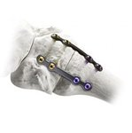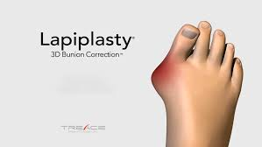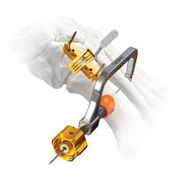

##### Product overview by Lumere Research Team

The LAPIPLASTY System Anatomic Biplanar Implants are a fixation system used in the foot for first metatarsophalangeal (MTP) joint, tarsometatarsal (TMT) joint, and other midfoot fusions. The system contains low-profile plates and unicortical locking screws manufactured from titanium alloy. Two plates are used at the site of fusion to achieve multiplanar fixation, which distributes forces to promote healing.

The LAPIPLASTY System instrument set, which includes a fulcrum, positioner, joint seeker, and cut guide, is used to facilitate correction of metatarsal rotation prior to fixation with the plates and screws. The positioner is used to position and lock the first metatarsal in the anatomically correct angle while it is cut using the cut guide and a sagittal saw.

##### Indications

The TMC Plating System is intended for use in stabilization of fresh fractures, revision procedures, joint fusion and reconstruction of small bones of the feet.

Follow up: Met with Shana from the reimbursement specialist for Treace Medical… there are several additional CPT codes that can increase the reimbursement… I communicated that to Dr. Elattar… See communication and response below.

Dr. Elattar,

            In looking at the paper… the suggestion made was when we have a J1 procedure code in pairs that a complexity adjustment is made and the reimbursement goes from, in our case, $5,629.49 to $11,258.98. As an example below:

CPT      Description               APC         UTMC Payment Rate 
28740 Arthrodesis, midtarsal or tarsometatarsal, single joint    5115    $5,629.49 

28298 Correction, hallux valgus, with sesamoidectomy, when performed ; 
with proximal phalanx osteotomy… any method      $5,629.49 Complexity adjustment
                               Total reimbursement : $11,258.98


**Questions:**

**Will the complexity adjustment be occasional?**

**Will it add cost in addition to the SK12 or SK14? (See Price list below)**

**Best guess, how many patients do we expect to perform the lapiplasty on and what percentage will be complex.**

On Mar 4, 2021, at 8:29 AM, Elattar, Sam M <[Osama.Elattar@utoledo.edu](mailto:Osama.Elattar@utoledo.edu)> wrote:

﻿ Hi,

So the main Lapiplasty code as you know is the 28740.

Here are three other codes that I am pretty sure at least one will be included with every case:

- 28292

- 28298

- 28730

This is a very common procedure, and I will plan to use this system in pretty much every Bunion given its reproducibility, and the frequency varies but for example this month I did one and have like 3 more coming.

I am available to talk on the phone on the next couple of hours if you have any time.

Best,

Sam Elattar, MD

Assistant Professor of Orthopedic Surgery

University of Toledo

**As this is a new procedure… When conversing with Dr Elattar he agreed that we should proceed with cases and review the financials 90 days out to determine the viability of continuing.**

### [***Zephyr Endobronchial Valve***](https://app.lumere.com/research/products/3259/)

### [Pulmonx](https://app.lumere.com/research/brands/2920/products/)

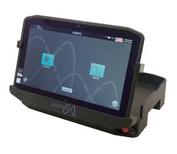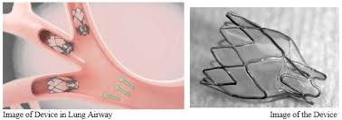

##### Product overview by Lumere Research Team

The Zephyr Endobronchial Valve is a one-way valve designed to restrict air inspiration in portions of a patient's airway and reduce the symptoms of emphysema, such as hyperinflation. Quantity and placement of the valves is determined by an assessment with the Pulmonx Chartis System. The valves are delivered using a flexible delivery catheter that is inserted through standard bronchoscopes. Once the valve is properly positioned, an actuator button on the catheter retracts the sheath, and the Zephyr valve is allowed to expand against the bronchial wall.

##### Indications

The Pulmonx Zephyr Endobronchial Valves are implantable bronchial valves indicated for the bronchoscopic treatment of adult patients with hyperinflation associated with severe emphysema in regions of the lung that have little to no collateral ventilation.

Follow up: Average size program 6 per month… we will do about 2-4 a month in the beginning… referrals from Promedica. Procedural work up and follow up generates revenue. 3-4 day hospital stay if the patient receives the valve… Outpatient Diagnostics reimbursement $4,095 cost for rental and catheter is $1,450… DRG id procedure need is validate by diagnostics… 50% DRG 164 and others will be around 25%... DRG 163 and DRG 165… Data to support efficacy… approved in November 2020… Good outcomes for patients … freed up to walk etc.. for example, a patient was able to take a shower by themself after the procedure.

#### [**Vashe Wound Solution**](https://app.lumere.com/research/products/6388/)

 Urgo Medical



##### Product overview by Lumere Research Team

Vashe Wound Solution is a solution used for cleansing, irrigating, moistening, debriding, and removing foreign material from the wound and peri-wound area. Microorganisms can be removed from acute and chronic dermal lesions, stage I-IV pressure ulcers, stasis ulcers, diabetic ulcers, post-surgical wounds, first- and second-degree burns, abrasions or minor irritations of the skin, graft and donor sites, and exit sites. Vashe Wound Solution is also used to moisten or lubricate absorbent wound dressings such as the Drawtex Hydroconductive Wound Dressing. This product is a hypochlorous acid (HOCl) solution that mimics the normal pH of human skin and is non-cytotoxic, non-irritating, non-sensitizing, and has no oral toxicity.

Vashe Wound Solution comes in a variety of bottle volumes and case quantities. Urgo Medical North America was formerly known as Steadmed.

##### Indications

Under the supervision of healthcare professionals, Vashe Wound Solution is intended for cleansing, irrigating, moistening, debridement and removal of foreign material including microorganisms and debris from exudating and / or dirty wounds, acute and chronic dermal lesions, such as Stage I-IV pressure ulcers, stasis ulcers, diabetic ulcers, post-surgical wounds, first and second degree burns, abrasions, minor irritations of the skin, diabetic foot ulcers, ingrown toe nails, grafted and donor sites, and exit sites. It is also intended for moistening and lubricating absorbent wound dressings.

Follow up: Vashe Spend on Dakin minimal… reduction in length of stay expected…. Dakin kills good tissue Vashe does not… Dr. Osman felt it makes sense to use Vashe in place of Dakin

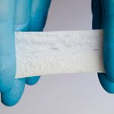 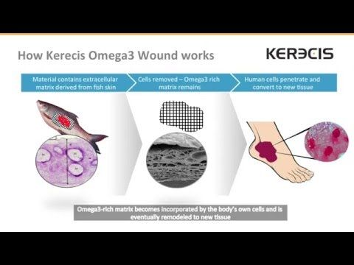

[Omega3 Burn](https://app.lumere.com/research/products/44519/) [Kerecis](https://app.lumere.com/research/brands/10252/products/)

##### Product overview by Lumere Research Team

Omega3 Burn is a biologic wound dressing used as a scaffold to regenerate skin tissue in burn wounds. The product is an acellular xenograft from Icelandic fish skin, which has antimicrobial properties and is homologous to human skin. It is specifically designed to facilitate healing in burn wounds through faster revascularization and control of moisture and temperature. Each size offered is full thickness fish skin, which is full of Omega3.

**Indications**

MariGen Wound Dressing is indicated for the management of wounds including:

* Partial and full-thickness wounds
* Pressure ulcers
* Venous ulcers
* Chronic vascular ulcers
* Diabetic ulcers
* Trauma wounds (abrasions, lacerations, second-degree bums, skin tears)
* Surgical wounds (donor sites/grafts, post-Mohs surgery, post-laser surgery, podiatric, wound dehiscence).
* Draining wounds

Follow up: Used on Skin Ulcers added to tool box and is covered by some insurances… important to have… The product is fully reimbursed when covered as it is billed out by the square CM. Karen, “coding and billing is important to us… created a macro for medical necessity and it helped in coding and reimbursement”.

Dr Osman, outside of our VA authority…. Work with Michelle Mallett to develop a strategy to educate Physicians on a determination as to whether or not a wound care product can or should be used…

Kerecis:

Omega3 comparison to current wound care overlays…. Integra primatix is $68 a CM and the Kerecis is $58 a CM… savings of $10 a CM

**After meeting consensus:**

Crossroads:

Jen ok with … contractual and ECO Smart. Follow up with Michelle. No inventory

Dr. Osman, favorable

Lapiplasty:

Dr. Osman… CPT codes follow up and work with Treace… Meet with Reimbursement specialist for added reimbursement… Follow up with Dr Elattar… and communicate to the committee. If there is not additional reimbursement it does not make sense to bring it in…

Zephyr valve:

Dr. Osman makes sense to move forward….

Jen makes sense to move forward…

Troy no comment… had to leave meeting.

Vashe:

Jen: Dakin not even $5,000 in spend not significant cost increase when compared to patient outcome benefits.

Dr. Osman: Agrees to move forward.

Kerecis:

Omega3 comparison to current wound care overlays…. Primatrix

Old Business follow up trials and approvals.

Cortrak: In process Spoke with Vendor 5 to 8 weeks before they can ship and schedule training… Eric Bernard is working the contract through the system.

Ambu aScope: Up and in use

Shockwave: CardioVascular wants to trial it… Dr. Osman to talk with Dr. Eltahaway

Si Bone: Have not done any case as of 3/12/2021

Inari: Financials are good… vote needed to move forward.