Slide | Notes to Trainers
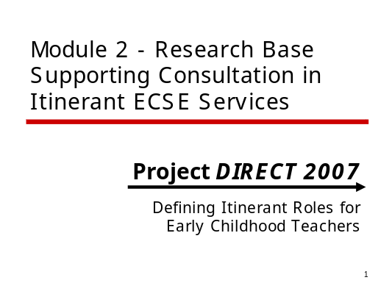 | M2 #1  All references to ‘partners’ or ‘consultees’ include early childhood teachers, preschool teachers, Head Start personnel, parents, or other caregivers.
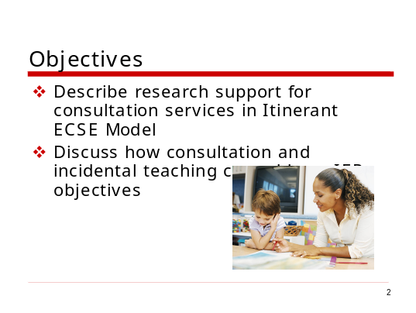 | M2 #2  - It’s important for Itinerant ECSE teachers to understand the principles underlying a consultative approach to service delivery. The information presented in this module will provide a rationale for a consultative approach.
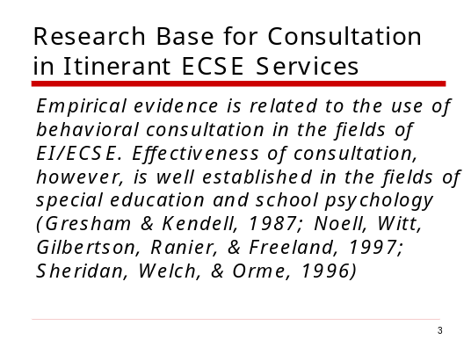 | M2 #3  - The term “empirical” refers to scientific evidence derived from experimental research. The use of a consultative model is emerging in the field of early childhood special education and can be viewed as a “promising practice”. Within in the field of behavioral consultation, it is viewed as “evidence-based practice”.
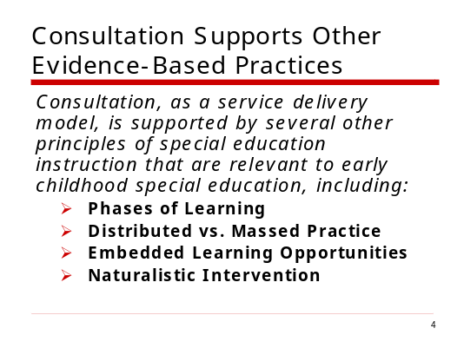 | M2 #4  - Consultation is a model of delivering services—it’s a broad-based approach to support for inclusion.  - Ask participants if they’ve heard of the four terms listed here and ask volunteers to explain.
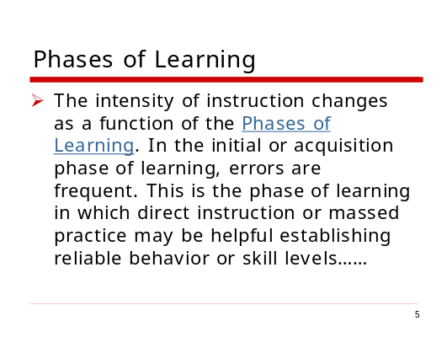 | M2 #5  - Ask participants to describe how they’ve learned different skills. For example, how they learned to use the computer or learned to cook. The ways in which we learn different skills or information follows predictable patterns.
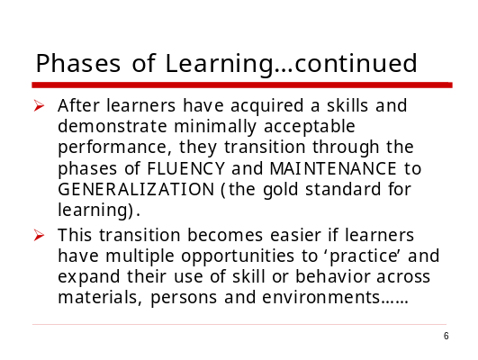 | M2 #6  - Ask for examples of how a learner (either themselves or children with whom they work) improves their use of a skill or behavior through practice.
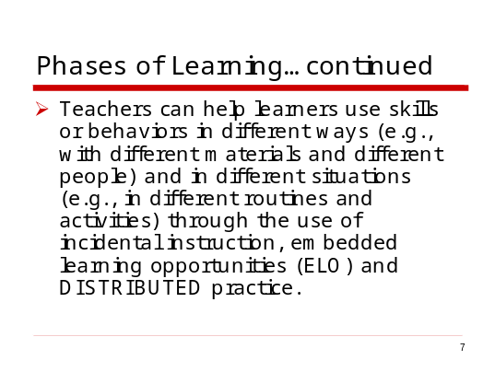 | M2 #7  - Ask participants to describe how one skill can be used in different ways and in different situations. For example, initiating a conversation with someone is an important skill that children need to learn to use in different situations (e.g., at snack and during center-based learning) and with different people (e.g., their teacher and their peers).  - The terms “incidental instruction”, “ELO Strategies”, and “distributed practice” will be explained later in this module.
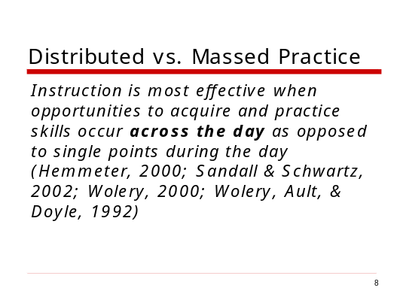 | M2 #8  - The reference citations included here provide empirical evidence of the effectiveness of distributed practice.
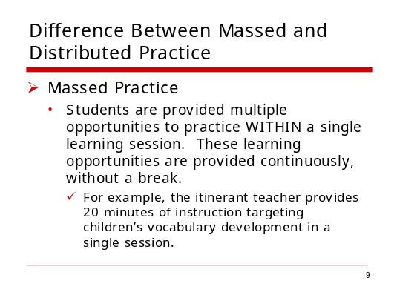 | M2 #9
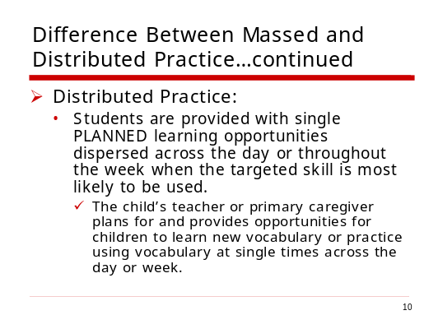 | M2 #10
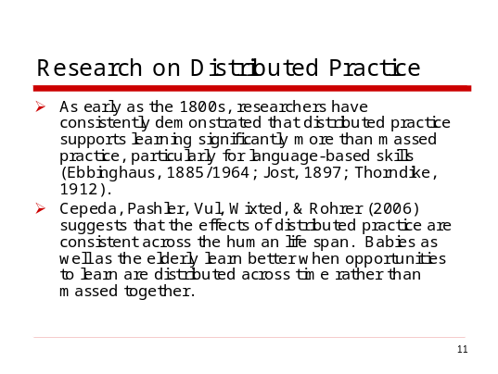 | M3 #11
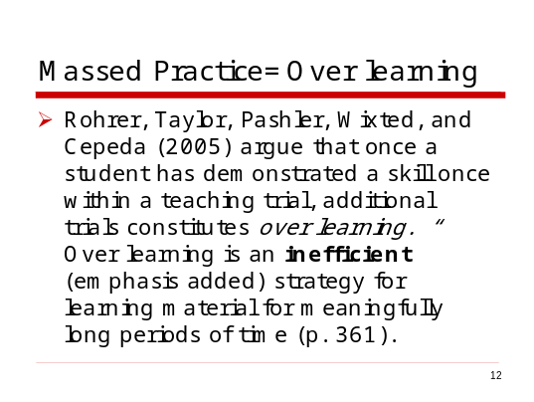 | M3 #12
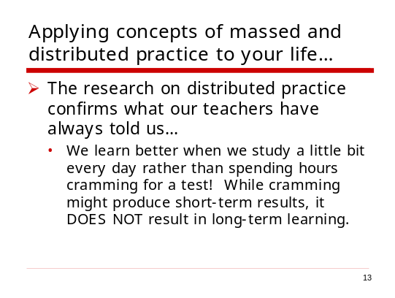 | M2 #13
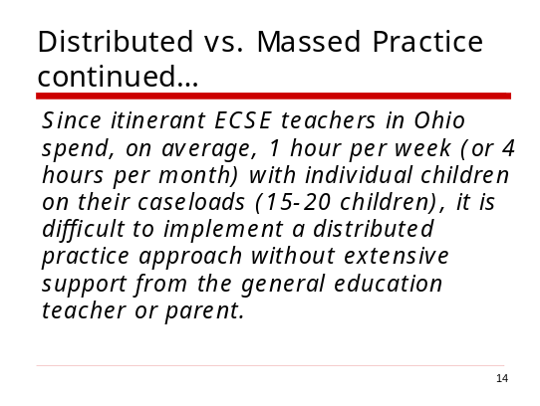 | M2 #14  - Ask participants for their views about this statement—does it make sense? Are there ways of implementing a distributed practice model of supporting learning if just the itinerant ECSE teacher is working with the child to achieve IEP goals?
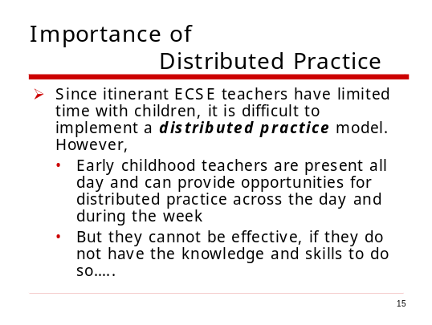 | M2 #15
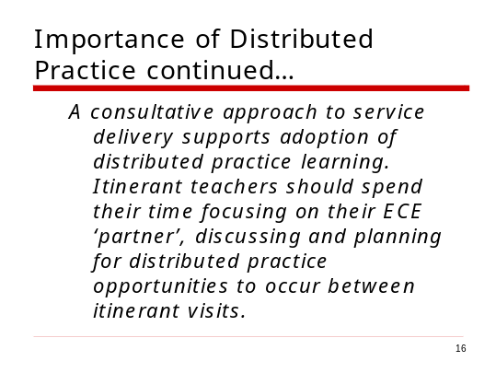 | M2 #16
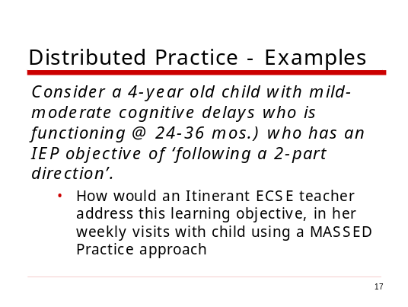 | M2 #17  - Make sure participants understand the nature of the IEP objective. Ask participants to discuss this question with each other and share examples.
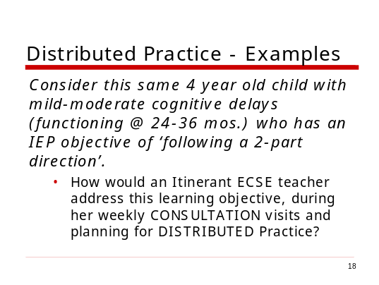 | M2 #18  - Ask participants to discuss this question with each other and share examples.  - Discuss the fact that from the itinerant teacher’s point of view, providing massed and direct practice may be EASIER, but it will not be as effective in supporting children’s learning as a distributed practice approach.
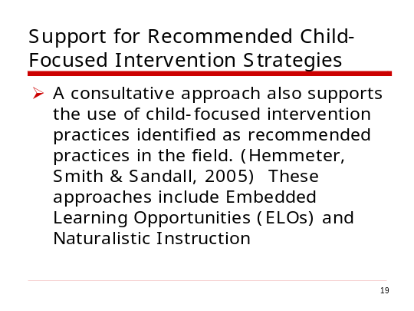 | M2 #19  - Recommended child-focused intervention strategies include the use of embedded learning opportunities and naturalistic instruction. The purpose of this training is to focus on consultation within itinerant ECSE service delivery. Participants can learn more about child-focused intervention strategies in DEC’s Recommended Practices for EI/ECSE (Hemmeter, Smith, & Sandall, 2005).  - DEC’s Recommended Practices in Child-Focused Strategies discuss the use of naturalistic interventions as a preferred method of instruction (although teachers must be aware that a range of instructional strategies can be used to support children’s developmental outcomes).
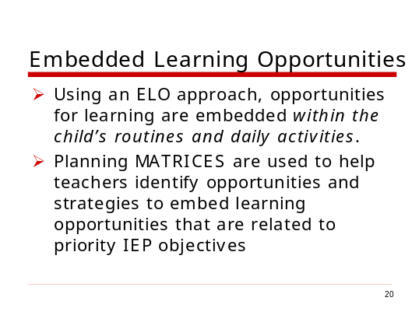 | M2 #20  Participants will learn more about embedding learning opportunities within naturally-occurring routines and activities in Module 4. These strategies can help ECE teachers and parents understand how to plan and structure interactions and activities for children in order to promote learning. Examples of planning matrices are also included in Module 4.
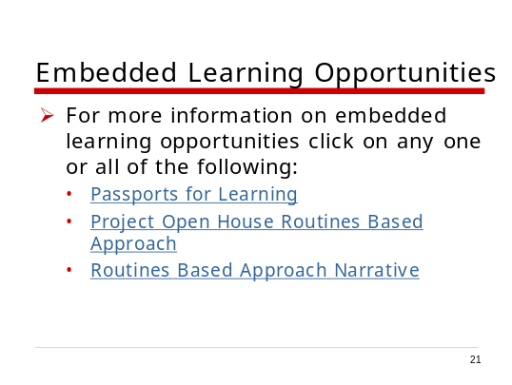 | M2 #21
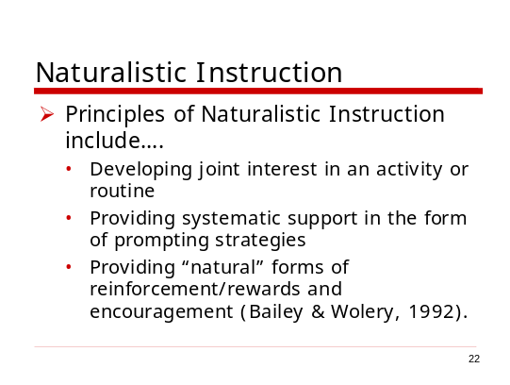 | M2 #22  - Naturalistic instruction is also referred to as incidental or coincidental instruction since instruction occurs at the same time as children are engaged in other activities. It’s important for teachers to understand that naturalistic instruction is a PLANNED approach to supporting learning. Teachers plan opportunities for learning and take advantage of children’s engagement in an activity to provide opportunities to practice skills or behaviors.
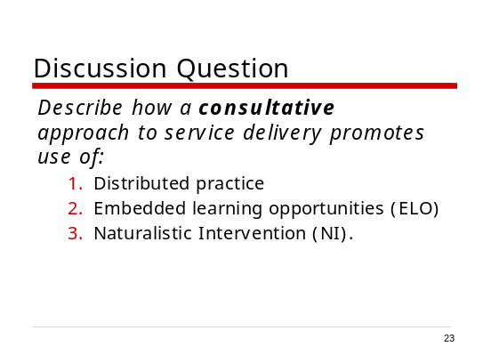 | M2 #23  - It is critical for itinerant ECSE teachers to be able to explain to others (e.g., partner teachers, parents) the importance of these principles and why it’s easier to implement these strategies using a consultative approach to service delivery. If there is time, ask participants to role play a situation in which an itinerant ECSE teacher explains to a parent why it’s probably MORE important to work in consultation with partner teachers to support children’s learning than it is for the itinerant ECSE to ONLY work with children during itinerant visits.  - Make sure participants understand the terms “distributed practice”, “embedded learning opportunities (ELOs)” and “naturalistic intervention”.  - For Slide #20, discuss vignette as a large group. Divide the group into small discussion groups for vignettes in slides 21 and 22.
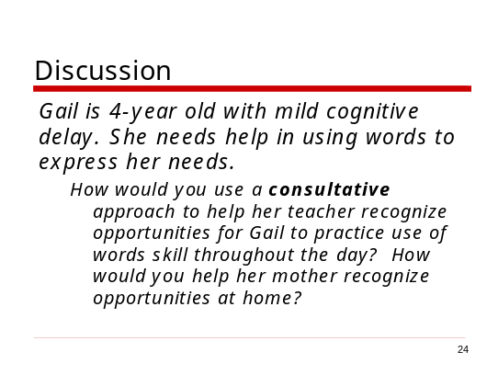 | M2 #24
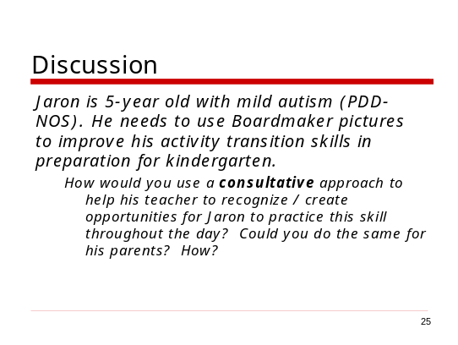 | M2 #25
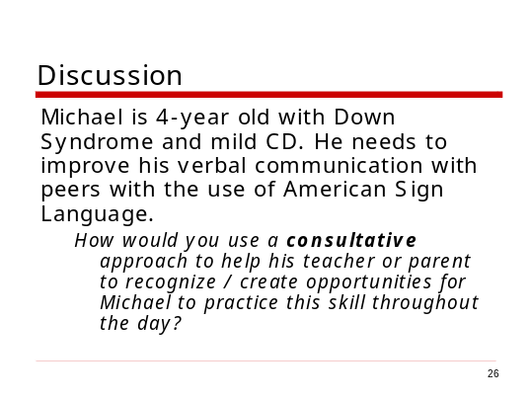 | M2 #26
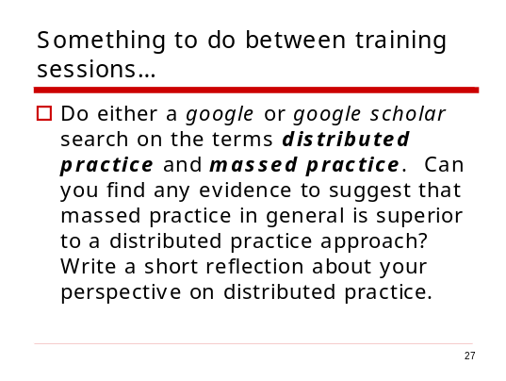 | M2 #27  This is a follow up activity that will help participants see the vast literature base that supports the use of distributed practice.

