BECOMING A TEACHER AT THE UNIVERSITY OF TOLEDO
Section I

Information for Pre-Education Majors

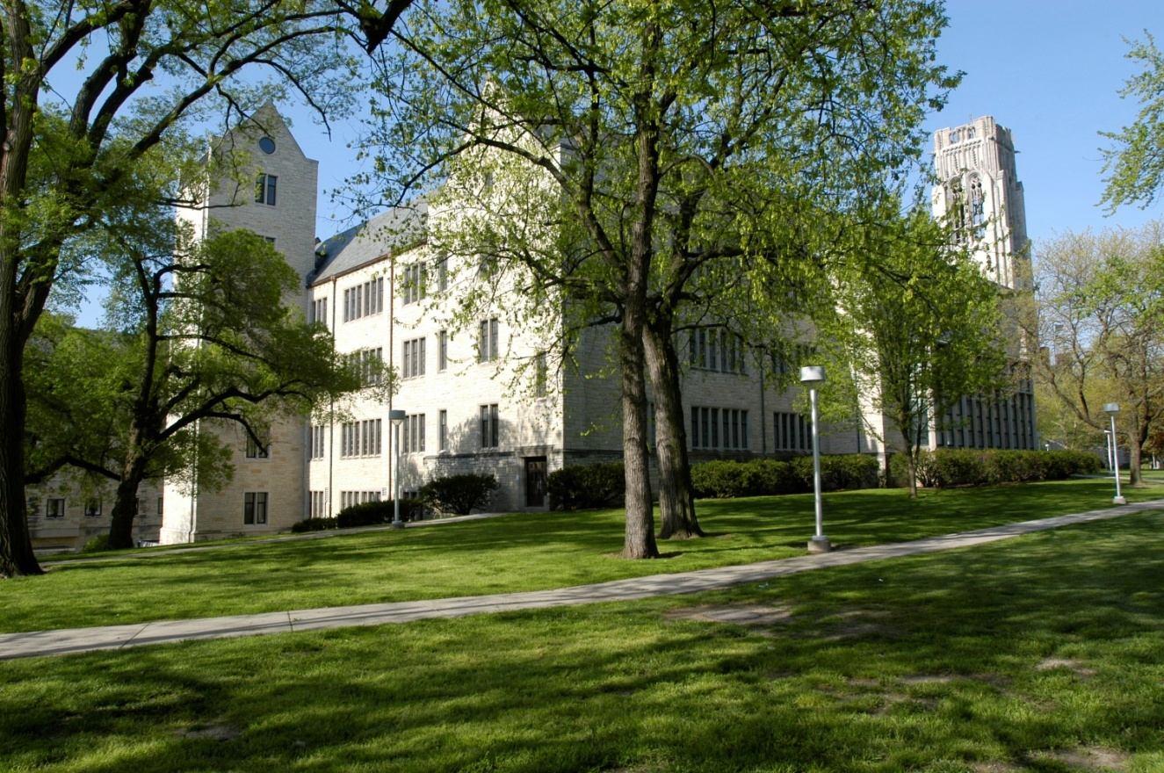

Copyright © 2007, 2010, 2011, 2013, 2014, 2018 by Judith Herb College of Education, at The University of Toledo

Section I: Information for Pre-Education Major

Your first semester at UT will undoubtedly be exciting and interesting as you meet new friends and take classes in many different areas as you prepare for your career in Education.

History of the JHCOE

The Judith Herb College of Education was founded in 1916 as the Teachers College and later became the College of Education. The first doctoral programs at The University of Toledo were introduced in 1959 in Education. The College of Education was renamed the Judith Herb College of Education on May 6, 2006. Judith and Marvin Herb, two UT graduates, contributed $15 million to fund numerous scholarships as well as educational assessment support and research initiatives.

The Education programs are located in Gillham Hall on the Main Campus.

Conceptual Framework of JHCOE

The Conceptual Framework of JHCOE is further defined by four distinctive but interrelated elements: (a) standards based curricula; (b) inquiry, reflection, assessment and accountability; (c) metropolitan focus; and (d) engagement with professional practice. These elements are discussed below.

Standards-based Curricula

Professional education programs are aligned with professional and state standards that are grounded in research and are relevant to contemporary practice. The alignment with standards establishes consistency and coherence across all programs within the College. Clinical and field experiences are built on prior coursework and reflect exemplary practice. The alignment of professional standards with practical experiences enables the College to prepare knowledgeable, reflective, innovative educators who are committed to improving educational practice and learning in a diverse metropolitan community.

Inquiry, Reflection, Assessment, and Accountability

Professional education programs engage candidates in educational theory and practice through a process of inquiry, reflection, assessment, and accountability. Candidates are guided individually and in groups, through sets of developmentally appropriate learning experiences. Candidates are required to demonstrate that they have a positive impact on the development and the learning of their students. The elements of inquiry, reflection, assessment, and professional accountability are reflected throughout programs.

Metropolitan Community Focus

The mission of The University of Toledo is “to improve the human condition in the region and the world.” The University is dedicated to meet student needs, and to become fully engaged in the community and its schools. The mission of the Judith Herb College of Education reflects the institutional mission in this regard.

Engagement with Professional Practice

Candidates in the JHCOE participate in programs that are fully integrated in the world of professional practice in collaboration with school partners. School partners are licensed practitioners from pre-kindergarten through 12th grade who provide instruction, supervision, and direction for candidates in field-based assignments.

Accreditation

The teacher education programs are accredited by the Council for the Accreditation of Educator Preparation (CAEP) and approved by the Ohio Department of Higher Education (ODHE). They meet state of Ohio standards for licensure, standards of the respective national Specialized Professional Associations (SPAs), and CAEP standards for programs accreditation.

JHCOE Professional Dispositions

Professional dispositions describe the professional and interpersonal qualities, attitude and behavior of education professionals. Professional dispositions speak to the character of the educator and guides how s/he engages as a professional and with the multiple stakeholders including, students, families, and professional colleagues. The professional dispositions valued by the JHCOE are:
- responsibility for meeting professional and institutional standards;
- commitment to continuous improvement and lifelong learning by remaining current in knowledge and professional practice;
- commitment to ongoing assessment, reflection and inquiry in professional practice;
- sensitivity and responsiveness to individual and cultural differences in a diverse community;
- commitment to connecting with school and community; and
- commitment to accountability for student learning and development.

The JHCOE expects pre-service educators to:
- be punctual and regular in terms of attendance;
- be dependable and responsible (e.g., initiate timely communication with cooperating teacher and supervisor regarding absences, scheduling, documentation, etc.);
- demonstrate positive communication style with students, colleagues, and supervisor;
- not use school technology for non-classroom activities (e.g., using social media, texting, personal emails, etc.);
- be an appropriate role model (e.g., passion for teaching, positive attitude, no inappropriate content on social media sites such as Facebook or Twitter, not “friending” students, etc.);
- have an appropriate professional appearance (e.g., proper attire, personal hygiene, etc.);
- have high ethical standards (e.g., proper citation of resources, not representing others’ work as your own, adhering to the Student Academic Code of Conduct, etc.);
- use appropriate grammar and vocabulary (avoiding use of slang, inappropriate humor, etc.);
- be responsive to constructive feedback; and,
- respect the privacy of students and confidentiality of information.

Teacher Education Programs

Office of Student Services

The Office of Student Services, located in Gillham Hall 3100, will assist you through orientation and academic advising. The field coordinator will assist you with all field placements. Our professional staff is committed to serving all Education students.

Initial Licensure Transition Points and Assessments

The following tables detail the transition points from entry to The University of Toledo’s teacher education program through professional licensure for the undergraduate and graduate preparation routes.

Traditional Undergraduate Preparation Route
Entry to UT (Education) | Entry to Professional Ed. | Student Teaching Eligibility | Graduation | Recommendation for Licensure | Professional Licensure
high school diploma / general education development (GED) diploma | Core Courses | Completion of 90% credits or minimum 100, including pre-professional courses | Completion of all course work | Pass Student Teaching | Entry year program (OH)
ACT test scores >= 21  or  SAT test scores  (Math >= 900 and Reading >= 900) | Comp II  (& Comp I if required) | TSOC requirement | Student Teaching Portfolio  Task 1: Planning for Instruction and Assessment  Task 2: Instructing and Engaging Students in Learning  Task 3: Assessing Student Learning | Ohio Assessments for Educators Pedagogy Test  (& other SPA requirements) | Ohio Residency Requirements
 | Math Requirement | EDP Requirement |  | Ohio Assessments for Educators Content Test
DHS students  High school grade point average (HSGPA) >= 2.7 | Technology Requirement | GPA >= 2.7 |  | GPA >= 2.7
 | GPA >= 2.7 | Planning for Instruction and Assessment(CP1) | Student Teaching Seminar Requirement  Initial Educator Module (Ohio Requirement) | Reading Content (Ohio Requirement)
Transfer students GPA requirements  < 30 credits, >=2.3  30–59 credits, >=2.5  > 59 credits, >= 2.7 overall and in student’s major | Mastery of reading, writing, and mathematics  (50th percentile on approved assessment) |  |  | Posted Baccalaureate
Instructing and Engaging Students in Learning
(CP2)
 |  | Assessing Student Learning (CP3) | Supervisor & Cooperating Teacher Student Teaching Field Evaluations
 |  | Methods Field Evaluations
 |  | Pass Methods Field

Type of Assessment | Content Knowledge | Professional Skills | Impact on Student Learning

Alternate Graduate Preparation Route

Entry to Professional Ed. | Student Teaching Eligibility | Licensure | Recommendation for Licensure | Degree Requirements | Professional Licensure
Core Courses as determined by Transcript Audit | Completion of 90% of licensure coursework, including all methods courses | Completion of all course work | Pass Student Teaching | Research & Measurement Requirement | Entry year program (OH)
Completion of Licensure Core Requirements | TSOC requirement | Student Teaching Portfolio Task1: Planning for Instruction and Assessment  Task 2: Instructing and Engaging Students in Learning  Task 3: Assessing Student Learning | Ohio Assessments for Educators Pedagogy Test  (& other SPA requirements) | Capstone Experience | Ohio Residency Requirements
CUM GPA >= 2.7 in Undergrad Content | EDP Requirement |  | Ohio Assessment for Educators Content Test
Technology Self-Assessment | GPA >= 2.7 (Undergraduate)  GPA >= 3.0 (Graduate) |  | GPA >= 2.7 (Undergraduate)  GPA >= 3.0 (Graduate)
CUM Grad GPA >= 3.0 | Planning for Instruction and Assessment (CP1) | Student Teaching Seminar Requirement  Initial Educator Module (Ohio Requirement) | Reading Content (Ohio Requirement)
Mastery of reading, writing, and mathematics  (50th percentile on approved assessment) |  |  | Completion of licensure requirements
Instructing and Engaging Students in Learning
(CP2)
 | Assessing Student Learning (CP3) | Supervisor & Cooperating Teacher Student Teaching Field Evaluations
 | Methods Field Evaluations
 | Pass Methods Field

Type of Assessment | Content Knowledge | Professional Skills | Impact on Student Learning

Admission to the Judith Herb College of Education

All direct from high school students who are accepted to UT can declare an Education major within the Judith Herb College of Education. Candidates in good standing may transfer with the following minimum requirements from another college at UT or from another accredited college or university. However, all candidates must apply for admission to Professional Education later in their program.

Transfer Requirements

Number of credit hours | Minimum required GPA
Less than 30 | 2.3 overall
30-59 | 2.5 overall
60 or more | 2.7 overall and 2.7 in student’s major

Mastery of Reading, Writing, and Mathematics

All candidates in the Judith Herb College of Education are required to demonstrate mastery of reading, writing, and mathematics. Students must present test scores at or above the 50th percentile from ONE of these standardized assessments: ACT, SAT, GRE, or Praxis Core Academic Skills for Educators.

Below are acceptable minimum scores (current scoring scale) on these nationally normed assessments:

ACT
Math - 21
Reading - 21
Writing - 6

SAT
Math - 532
Reading ("Evidence-Based Reading and Writing") - 543
Writing ("Essay - Writing Dimension") - 5

Praxis Core Academic Skills for Educators (Core)
Mathematics (test code 5732) - 150
Reading (test code 5712) - 156
Writing (test code 5722) - 162

GRE
Reading (“Verbal Reasoning”) - 151
Math (“Quantitative Reasoning”) - 153
Writing - 4
Candidates, who score below the required score on any of the content tests, must retake the failed content. Candidates must have successfully passed ALL content areas to be admitted to Professional Education.

Field Experiences

Initial field placements depend on the candidate’s major. As a part of the coursework introducing candidates to the teaching profession, many programs require short placements, usually in the second year. Methods field experiences, which are longer, usually begin in the third year. Student teaching is normally done in the final semester; however, some programs have a year-long experience during the final two semesters. Candidates are responsible for their own transportation; however, the field coordinator will work to locate placements where shared rides or bus transportation is necessary. Candidates must obtain an Ohio Bureau of Criminal Identification and Investigation (BCI&I) and FBI background check prior to going into area classrooms.

Applying to Professional Education
Students should apply for Admission to Professional Education no later than the fifth semester of full-time enrollment. Students in the respective licensure programs should apply while enrolled in the following respective courses:
Licensure Program | Course
Early Childhood Education | CIEC-3200 Philosophy and Practices
Middle Childhood Education | Check with your adviser
Adolescent & Young Adult Education | Check with your adviser
Special Education | Check with your adviser
Visual Art Education, Music Education | Check with your adviser
Foreign Languages Education | Check with your adviser
Career and Technical Education | Check with your adviser

Acceptance to Professional Education

To be eligible for admission to Professional Education, candidates must:
- Be currently enrolled in the Judith Herb College of Education
- Complete 48-64 semester hours of approved course work, including required pre-professional courses and 12 hours in residence
- Have a cumulative and higher education GPA of 2.7
- Demonstrated mastery of reading, writing, and mathematics (50th percentile from ONE of these standardized assessments: ACT, SAT, GRE, or Praxis Core Academic Skills for Educators)
- Demonstrate acceptable progress in arts & science content licensure courses or other published criteria
- Complete prior experience with appropriate populations in schools and agencies based on satisfactory completion of introductory courses/seminars, letters of support, and/or portfolios
- Demonstrate effective communication and interpersonal skills based on early experiences, introductory course/seminar(s), ratings from professionals in the field, and/or interview ratings
- Complete verification of good moral character (i.e., Background Check Policy) as stipulated by the State of Ohio.

Applying for Student Teaching

Candidates will apply to student teach through the online link available here. To student teach during a fall semester, the application must be submitted during the preceding September and to student teach in the spring semester it must be submitted during the preceding January. There are no exceptions to these deadlines. A thorough review of credentials is completed to determine if candidates are eligible to student teach. Final approval is not granted until all grades and activities are reviewed.

Criteria for Student Teaching Approval

In order to be eligible for student teaching, candidates must have fulfilled the following requirements:

- Full admission to professional education

- Completion of at least 100 semester hours

- Completion of 90 percent of the course work in the major area.

- Completion of professional courses, including methods, with a grade of “C” or better.

- A 2.7 GPA in the major(s), Professional Education courses, and overall.

Ohio Assessments for Educators

The Ohio Assessments for Educators (OAE) tests assess the content-area and professional (pedagogical) knowledge of candidates who are seeking initial Ohio educator licensure or adding a new licensure area. The assessments are aligned with Ohio Academic Content Standards. Ohio licensure candidates are required to successfully complete only ONE assessment of professional (pedagogical) knowledge for their first license. The addition of other licensure areas or endorsements will require only successful completion of the associated content-area assessment. The Ohio Department of Education requires successful completion of the OAE as one of the requirements for licensure.

The Ohio Assessments for Educators tests are given several times each year and established deadlines for registration are strictly enforced. A delay in taking the required test(s) will delay a job search and employment opportunities. It is recommended that candidates complete the OAE test(s) before graduation. Click here for registration materials for the OAE.

Application for Graduation

Before a candidate can graduate, he or she must apply for graduation by the posted deadlines. An application must be completed even if a student does not intend to participate in commencement. Graduation Applications are available from this web page (click here).

Ohio Teacher Licensure

In order to teach in an Ohio public, state-supported elementary, middle or high school, candidates need to be licensed by the State of Ohio. Candidates will apply for licensure online through the Ohio Department of Education’s website. To complete this application process, candidates must:
- Pass all required OAE tests, and
- Have a valid Ohio BCI&I and FBI background check on file with the state of Ohio.

Other JHCOE Information

Many resources are available to assist students.

The General Catalog is designed to familiarize candidates with University academic policies, course offerings, academic programs, and college degree requirements.
http://catalog.utoledo.edu/

The Student Handbook describes policies, procedures, and support services that will assist candidates at the University.
http://studentactivities.utoledo.edu/studentconduct/studenthandbook.pdf

Other resource links are available throughout this document.

Student Checklist of Requirements for Undergraduate Educator Candidates

- Apply to the Judith Herb College of Education at The University of Toledo
  - Submit application along with fee
  - Submit SAT or ACT scores

- Apply to Professional Education
  - Complete core curriculum requirements
  - Demonstrate mastery of reading, writing, and mathematics (50th percentile from ONE of these standardized assessments: ACT, SAT, GRE, or Praxis Core Academic Skills for Educators)
  - Maintain a minimum 2.7 grade point average (Higher Education, UT, and content area)
  - Meet additional program requirements

- Apply to Student Teaching
  - Complete 90% or minimum 100 credit hours of course work
  - Maintain minimum 2.7 grade point average (overall, content area(s) and professional education courses)
  - Pass critical performance assessments
  - Pass methods class, successful field experiences

- Apply for graduation
  - Complete all required course work

- Apply for Ohio teacher licensure
  - Pass student teaching
  - Bachelor’s degree post to transcript
  - Pass all required Ohio Assessments for Educators licensure exams
  - Pass state mandated reading requirement
  - Successfully pass a state and federal criminal background check

Student Checklist of Requirements for Licensure Alternative Master’s Program (LAMP) Candidates (Graduate-level Educator Candidates)

- Apply to the Judith Herb College of Education at The University of Toledo
  - Completed bachelor’s degree with a minimum 2.7 grade point average from an accredited college or university
  - Submit application along with fee
  - Submit undergraduate transcript
  - Some programs require candidates to pass appropriate content exams as specified by the Ohio Department of Education prior to starting the program. Consult the department chair to determine if passage is required by the program in which you are seeking admission.
  - Demonstrate mastery of reading, writing, and mathematics (50th percentile from ONE of these standardized assessments: ACT, SAT, GRE, or Praxis Core Academic Skills for Educators)

- Apply to Professional Education
  - Complete licensure course requirements
  - Maintain a minimum 3.0 grade point average (UT graduate course work) and 2.7 content area grade point average (undergraduate licensure course work)
  - Meet additional program requirements

- Apply to Student Teaching
  - Complete licensure of course work requirements
  - Maintain minimum 3.0 grade point average
  - Pass critical performance assessments
  - Pass methods class, successful field experiences

- Apply for Ohio teacher licensure
  - Pass student teaching
  - Pass all required Ohio Assessments for Educators (OAE) licensure exams
  - Pass state mandated reading requirement
  - Successfully pass a state and federal criminal background check

