BECOMING A TEACHER AT THE UNIVERSITY OF TOLEDO

Section II

Information for Professional Education Majors

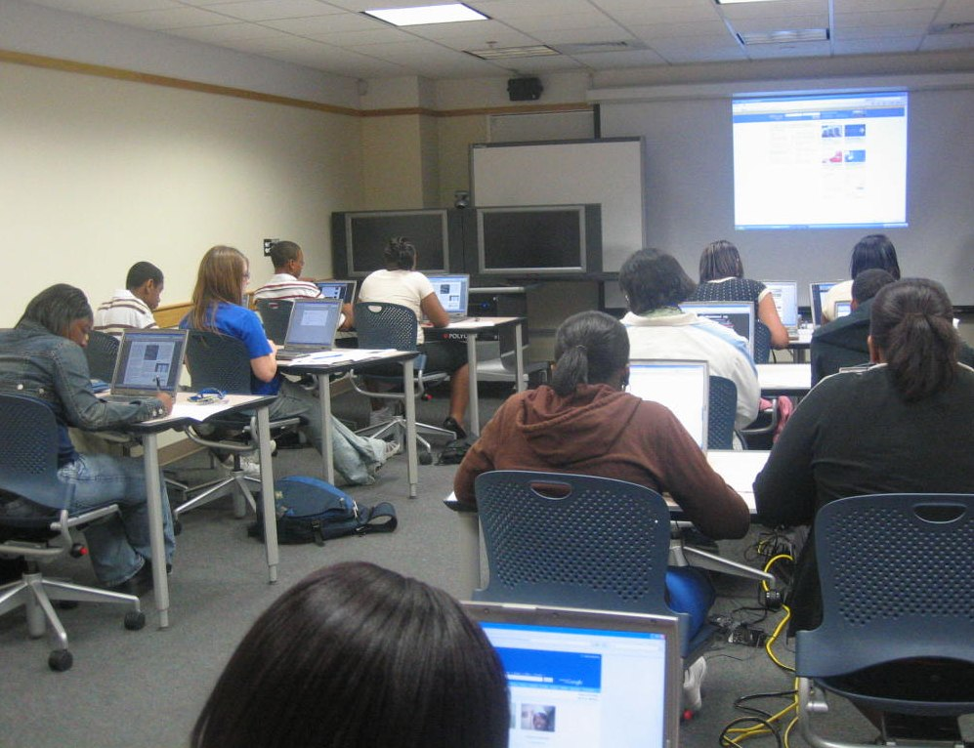

Copyright © 2007, 2010, 2011, 2013, 2014, 2018 by Judith Herb College of Education, The University of Toledo
Section II: Information for Professional Education

Professional Education Assessment Manual

In 2004, Gov. Bob Taft signed Senate Bill 2, which mandated the creation of the Educator Standards Board (ESB) to bring standards-based reform to the educator level by defining standards for teachers and principals at all stages of their careers. The ESB and standards writing teams met throughout the 2004-2005 academic year to draft the Ohio standards. The revised standards were adopted by the State Board of Education in fall 2005. The Standards for Ohio Educators articulate what a beginning teacher should know and be able to do to teach effectively. These requirements define the kinds of performances that should be used to assess the knowledge, understandings, and skills of a beginning teacher. They also guide the selection of tasks that could be used to elicit these performances and enable teachers to demonstrate their knowledge, understandings, and skill. Each required task is carefully crafted to yield the kind of evidence required to evaluate the critical aspects of teaching performance that are defined by the Ohio standards.

The Judith Herb College of Education uses the Ohio Standards for the Teaching Profession as a framework for the evaluation of the classroom performance of methods candidates and student teachers. The framework was built on the essential teaching skills as defined by professional educators. In the Ohio Standards for the Teaching Profession, seven standards are delineated. The standards fall under three larger organizers:

- The Focus of Teaching and Learning
Standard 1: Students
Standard 2: Content
Standard 3: Assessment
Standard 4: Instruction

- The Conditions for Teaching and Learning
Standard 5: Learning Environment

- Teaching as a Profession
Standard 6: Collaboration and Communication
Standard 7: Professional Responsibility and Growth

Within this framework, rubrics describe the actual levels of performance one might see when observing a student teacher. The rubric descriptors provide consistency and standardization in expectations for all student teachers regardless of their content area, their placement, or other circumstances. Therefore, each of the seven standards and their respective rubrics are used within the JHCOE evaluation framework. The next section will provide an overview of the seven Ohio Standards for the Teaching Profession. All content in this section can be found at this link.

Ohio Standards for the Teaching Profession

The Focus of Teaching and Learning

Standard 1: Students - Teachers understand student learning and development and respect the diversity of the students they teach.

A thorough understanding of how students learn is essential to quality teaching. Effective teachers must understand the processes and strategies students use to construct knowledge, and use this understanding to create learning activities appropriate for students’ ages, abilities and learning styles. Effective teachers understand the impact of students’ backgrounds and experiences on their learning. They connect instruction to students’ needs, interests and prior knowledge. They understand the abilities and talents of their students, and use that knowledge to determine appropriate learning activities and identify resources for students that foster rich learning opportunities. Teachers’ sense of efficacy results in their persistence to help all students learn and achieve at high levels.

Standard 1: Students
Teachers understand student learning and development and respect the diversity of the students they teach. A beginning teacher should:

1.1 Display knowledge of how students learn and of the developmental characteristics of age groups.
1.2 Understand what students know and are able to do and use this knowledge to meet the needs of all students.
1.5 Recognize characteristics of gifted students, students with disabilities and at-risk students in order to assist in appropriate identification, instruction and intervention.

Standard 2: Content - Teachers know and understand the content area for which they have instructional responsibility.

A deep understanding of content is essential for teachers to have the power to positively impact student learning and achievement. Teachers must understand the structures and the history of the content they teach and recognize that the content is not static, but complex and evolving. Effective teachers demonstrate a deep and reflective understanding of content specific practices, processes and vocabulary. They connect the content and skills of their disciplines to the Ohio academic content standards and are committed to staying abreast of current research and development within their disciplines. These teachers make content meaningful, relevant and applicable to students by making connections between the content that they teach and other content areas, real life experiences and career opportunities.

Standard 2: Content
Teachers know and understand the content area for which they have instructional responsibility. A beginning teacher should:

2.1 Know the content they teach and use their knowledge of content-specific concepts, assumptions and skills to plan instruction.
2.2 Understand and use content-specific instructional strategies to effectively teach the central concepts and skills of the discipline.
2.3 Understand school and district curriculum priorities and the Ohio academic content standards.
2.5 Connect content to relevant life experiences and career opportunities.

Standard 3: Assessment - Teachers understand and use varied assessments to inform instruction, evaluate and ensure student learning.

The professional imperative of teachers is to maximize student learning and eliminate gaps between students’ potential and their performance. Toward that end, the relationship between instruction and assessment is purposeful, interdependent and recursive. Effective teachers are assessment-literate. They use multiple assessments to learn about their students, to plan and adjust instruction and to evaluate student learning. Teachers have sufficient knowledge and skills in probability and statistics to use a variety of assessment data to plan effectively for all students. Teachers use formal and informal assessment data to determine the incremental development of students based on the Ohio academic content standards. Teachers encourage students to critically examine their own work and foster their students’ ability to become knowledgeable of how they learn. Teachers provide students and parents with formative assessment results and provide them with strategies to improve student learning.

Standard 3: Assessment
Teachers understand and use varied assessments to inform instruction, evaluate and ensure student learning. A beginning teacher should:

3.1 Are knowledgeable about assessment types, their purposes and the data they generate.
3.2 Select, develop and use a variety of diagnostic, formative and summative assessments.

Standard 4: Instruction - Teachers plan and deliver effective instruction that advances the learning of each individual student.

Effective teachers have high expectations for all students and implement strategies designed to enable all students to achieve. They continually reflect on student outcomes to make appropriate decisions resulting in increased student success. Effective teachers have a deep knowledge of the content they teach. This content knowledge allows them to effectively sequence content for learning and structure differentiated opportunities for student remediation, reinforcement or acceleration. Effective teachers use a variety of research-based instructional strategies that provide challenging and positive learning experiences for all students. These teachers build ideas and concepts logically to lead students to comprehend more complex concepts and encourage higher order creative and critical thinking skills. They use effective questioning strategies to stimulate thinking. Effective teachers explore, evaluate and integrate learning tools, including technology, to make content comprehensible to students.

Standard 4: Instruction
Teachers plan and deliver effective instruction that advances the learning of each individual student. A beginning teacher should:

4.1 Align their instructional goals and activities with school and district priorities and Ohio’s academic content standards.
4.3 Communicate clear learning goals and explicitly link learning activities to those defined goals.
4.4 Apply knowledge of how students think and learn to instructional design and delivery.
4.7 Use resources effectively, including technology, to enhance student learning.

The Conditions for Teaching and Learning

Standard 5: Learning Environment - Teachers create learning environments that promote high levels of learning and achievement for all students.

Teachers create a learning environment that promotes high levels of achievement for all students and in which all students feel a responsibility for their own learning. Teachers orchestrate the learning environment to maximize each student’s opportunities to learn. They create a content-rich and reflective learning environment for students. Teachers recognize that students learn in a variety of formal and informal settings. They motivate students by demonstrating enthusiasm for the subject(s) they teach. Teachers create a learning environment where all students feel safe, valued and enjoy a sense of belonging.

Standard 5: Learning Environment
Teachers create learning environments that promote high levels of learning and achievement for all students. A beginning teacher should:

5.1 Treat all students fairly and establish an environment that is respectful, supportive and caring.
5.2 Create an environment that is physically and emotionally safe.
5.4 Create learning situations in which students work independently, collaboratively and/or as a whole class.
5.5 Maintain an environment that is conducive to learning for all students.
5.5B Maintain effective classroom management of student behavior, including inappropriate use of technology by students.

Critical Performances

Teaching as a Profession

Teaching as a Profession

Standard 6: Collaboration and Communication – Teachers collaborate and communicate with students, parents, other educators, administrators and the community to support student learning.

Teachers understand the role of communication in their profession and use it to foster active inquiry, and collaborative and supportive interaction in and out of the classroom. They value families as an integral component of teaching and learning. Teachers acknowledge what families have to offer and provide opportunities for them to contribute to the learning community. Teachers demonstrate respect for confidentiality with students and their families and create relationships built on trust. Teachers collaborate with their colleagues within the school learning community and in the larger community to share responsibility for the development and learning of all students. Recognizing that they can learn from each other, teachers form learning communities and engage in coaching, mentoring, modeling and work in teams to develop curriculum and assessments.
Standard 6: Collaboration and Communication
Teachers collaborate and communicate with students, parents, other educators, administrators and the community to support student learning. A beginning teacher should:

6.1 Communicate clearly and effectively.

Standard 7: Professional Responsibility and Growth – Teachers assume responsibility for professional growth, performance and involvement as an individual and as a member of a learning community.

Teachers are professionals who must recognize that they are in a unique and powerful position to influence the future of their students. It is imperative that teachers practice the highest standards of integrity, honesty and fairness. Effective teachers grow and learn, contribute to the profession and engage in continuous professional development. Effective teachers are leaders within the school community and engage in a variety of leadership roles. They ensure student achievement and well-being by participating in decision- making, initiating innovations for school change and fostering ongoing collaboration with colleagues. Teachers serve as change agents in the learning community by thinking and acting critically and addressing concerns related to inequities among students.
Standard 7: Professional Responsibility and Growth
Teachers assume responsibility for professional growth, performance and involvement as an individual and as a member of a learning community. A beginning teacher should:

7.1 Teachers understand, uphold and follow professional ethics, policies and legal codes of professional conduct.
7.2 Teachers take responsibility for engaging in continuous, purposeful professional development.
7.3 Teachers are agents of change who seek opportunities to positively impact teaching quality, school improvements and student achievement.

The Ohio Standards for the Teaching Profession are the foundation for the teacher education program in the Judith Herb College of Education. The remaining portion of Section II describes performance assessments that are used with methods, which are called Critical Performances.

Chalk and Wire

The Chalk and Wire electronic assessment system in the Judith Herb College of Education tracks candidates’ progress throughout their teacher preparation coursework. Both formative and summative data are collected from teacher candidates at pre-determined transition points including professional education courses and student teaching. Additional information related to Chalk and Wire can be found in the tutorial.

Critical Performances

Faculty within the teacher preparation programs identified three Critical Performances, aligned with the Ohio Standards for the Teaching Profession and the Teacher Performance Assessment (edTPA) from Stanford Center for Assessment, Learning and Equity, which serve as benchmark assessments to document the performance of all teacher candidates. These performance-based assessments provide evidence of critical knowledge, skills, and dispositions that all beginning teachers must have in order to be effective in their context. These critical knowledge, skills, and dispositions are aligned with the College’s conceptual framework, which outlines its vision in accordance with institutional and national standards. The Critical Performances are:
- CP #1 – Planning: Planning for Instruction and Assessment
- CP #2 – Instruction: Instructing and Engaging Students in Learning
- CP #3 – Assessment: Assessing Student Learning

Upon completion of these critical performances, candidates will be eligible to proceed into the student teaching experience. The critical performances also provide formative feedback to the candidates and the College regarding student teaching readiness as described in the edTPA Student Teaching Portfolio. The assessment of critical performances is managed through Chalk and Wire, the electronic assessment system.

edTPA is a trademark of Stanford University and specific requirements for the Critical Performances may be accessed within the JHCOE Chalk and Wire system.

Critical Performance 1: Planning for Instruction and Assessment

Preparing for good teaching begins with lesson plans. The plans in this assessment represent a set of learning experiences that are appropriate for curriculum goals, relevant to learners, and based upon principles of effective instruction. In this section, you will present a cohesive set of lessons organized around an important topic or idea, which is relevant to the curriculum. You will provide the plans for your series of lessons in the format that you learned in your methods class. Your plans, like any draft, are always subject to change. Therefore, the lesson plans you submit may include annotations you made as your instruction evolved. After each lesson is taught, you must reflect on the effectiveness of your instruction and identify modifications you made during the lesson, for the next day, or that you might make to the plan in the future.

Effective teaching is based upon knowledge of: curriculum goals, subject matter, students, the community, learner differences, and student development. For this entry, you will describe your plans for the learning segment and explain how the learning experiences you have planned are appropriate for the students you are teaching.

In CP1: Planning for Instruction and Assessment, you will write a (a) description of your Context for Learning, (b) plans for learning experiences, and (c) a commentary explaining your plans for the learning experiences. This evidence will be assessed using a rubric.

Copyright © 2016 Board of Trustees of the Leland Stanford Junior University. All rights reserved.

edTPA is a trademark of Stanford University and specific requirements for the Critical Performances may be accessed within the JHCOE Chalk and Wire system.

Critical Performance 2: Instructing and Engaging Students in Learning

For this entry you will provide a videotape of learning segments to demonstrate how you support and engage children in learning. The following is required for this critical performance:
- Obtain required permissions for video-recording from parents/guardians of your students and other adults appearing in the video.
- Identify lessons from the learning segment you planned in Critical Performance 1 to video-record. You should choose lessons that show you interacting with students to prepare them to read a complex text and participate in a discussion to construct meaning from and interpret the text.
- Video-record your teaching and select 2 video clips (no more than 10 minutes each in total running time).
- Analyze your teaching and your students’ learning in the video clips by responding to commentary prompts.

Copyright © 2016 Board of Trustees of the Leland Stanford Junior University. All rights reserved.

edTPA is a trademark of Stanford University and specific requirements for the Critical Performances may be accessed within the JHCOE Chalk and Wire system.

Critical Performance 3: Assessing Student Learning

In CP3, you will provide a detailed analysis of student learning. Samples of student work, which illustrate what you have learned from your use of the assessment must be included. The following is required for this critical performance:
- Select one assessment from the learning segment that you will use to evaluate your students’ developing knowledge and skills. Attach the assessment used to evaluate student performance at the end of the Assessment Commentary.
- Define and submit the evaluation criteria you will use to analyze student learning.
- Collect and analyze student work from the selected assessment to identify quantitative and qualitative patterns of learning within and across learners in the class.
- Select student work samples to illustrate your analysis of patterns of learning within and across learners in the class. At least 1 of the samples must be from a student with specific learning needs. These students will be your focus students.
- Summarize the learning of the whole class, referring to work samples from the focus students to illustrate patterns in student understanding across the class.
- Submit feedback for the work samples for the focus students in written, audio, or video form.
- Analyze evidence of students’ language use from (1) the video clips from the Instruction task, (2) an additional video clip of one or more students using language within the learning segment, AND/OR (3) the student work samples from the Assessment task.
- Analyze evidence of student learning and plan for next steps by responding to commentary prompts.

Copyright © 2016 Board of Trustees of the Leland Stanford Junior University. All rights reserved.

edTPA is a trademark of Stanford University and specific requirements for the Critical Performances may be accessed within the JHCOE Chalk and Wire system.

