SECTION 271100 - COMMUNICATIONS EQUIPMENT ROOM FITTINGS

PART 1 - GENERAL:

1.01 SECTION INCLUDES:

A. Requirements and standards for installation for Telecommunication spaces.

1.02 RELATED SECTIONS:

A. Section 27 0502 – Required Submittals for Communications

B. Section 27 0504 – Communications Contractor Qualifications

C. Section 27 0526 – Grounding and Bonding for Communications Systems

D. Section 27 0528 – Pathways for Communication Systems

E. Section 27 0553 - Communication Identification and Labeling

1.03 REFERENCES:

A. BICSI – Building Industry Consulting Services International – TDMM latest Edition.

B. NFPA -70 National Electric Code Latest Adopted Edition.

C. TIA-569-d Telecommunications pathways and spaces.

D. TIA-607-C Commercial Building Grounding and Bonding Requirements for Telecommunications.

1.04 SUBMITTALS:

A. Submit under provisions of Section 01 3300 and 27 0502.

B. Product Data: Provide catalog cut sheets for all materials, equipment, components, and software.

PART 2 – GENERAL:

2.01 MANUFACTURES:

A. The Contractor is directed to Appendix “A” for list of acceptable manufacturers and material list.

2.02 ROOM CONDITIONING:

A. Technology rooms shall be cooled 24/7 to humidity and temperature parameters specified elsewhere in this section. The University prefers portable “Movin Cool” portable spot cooling units with rigid ductwork or a permanently installed “split” system. “Kwikool” portable spot cooling units shall only be used as approved. Units shall be on emergency power. Manufacturer models shall be as determined by owner during the design phase of the project.

PART 3 – EXECUTION

3.01 DEFINITIONS AND SCOPE OF SPACES:

A. DATA/TELECOMMUNICATION SPACES SHALL GENERALLY BE DEFINED AS FOLLOWS:

1. The data/telecommunications entrance facility shall consist of the entrance point (room or space within the building) where telecommunication services enter, where joining of inter- and intra-building backbone facilities takes place, and where the proper grounding and bonding of these facilities is accomplished. The data/telecommunications entrance facility may also contain antenna entrances, and electronic equipment serving telecommunication functions.
2. The Data/Telecommunication Equipment Room shall be a centralized space for the data/telecommunication equipment (e.g., PBX, computer mainframe, printers, disk drives, video switch, A/V control, etc.) that serves the building facility and occupants.
3. The Data/Telecommunication Distribution Room shall be a space dedicated to the transition between the backbone and horizontal distribution pathways. The Telecommunications Room shall be able to contain telecommunications equipment, cable terminations and associated cross- connecting wiring.
4. Depending upon the specifics of the individual facility, the data/telecommunication entrance facility, Equipment Room and Telecommunication Rooms may be separate dedicated spaces or combined together in one or more spaces (e.g. entrance facility and Main Distribution Room or Equipment Room and Main Distribution Room.
5. New data/telecommunication spaces shall be dedicated to the data/telecommunication functions and related support facilities. The data/telecommunication spaces shall not be shared with electrical distribution, electrical control systems, HVAC, mechanical systems, plumbing, storage or janitorial facilities.
6. The data/telecommunication spaces shall be laid out for the efficient utilization of the assigned space for the equipment to be installed with a minimum crossing of the interconnecting wiring.

7. There shall be a minimum of one (1) data/telecommunication space per building. Horizontal distribution distance to the furthest data/telecommunication outlet shall not exceed 90 meters (295 ft.) total cabling length.
8. The data/telecommunication space shall be located as close as practical to the center of the area served and preferably near the core area. There should be a minimum of one (1) Distribution Telecommunications Room per floor, however, where approved by the Owner, and workstation density allows, one (1) Distribution Telecommunications Room may serve three (3) floors (e.g., one (1) floor maximum above and one (1) floor maximum below).

3.02 SPECIAL CONDITIONS:

A. The computer systems associated with this work shall not be taken off-line or removed from service during normal working hours.

B. These systems are critical to the provisioning of services to the Owner's clients and shall not be interrupted by the Associate's activities.

C. Arrangements must be made by the Contractor to coordinate any such activities.

D. The Contractor shall be required to work around all of the conditions listed above as well as working with the Owner's staff to minimize disruptions to normal Owner activities.

3.03 GENERAL:

- Wherever possible, cable and raceway routings shall follow the logical structure of the building (i.e. follow hallways, aisles and corridors). All data/telecommunication spaces and pathways shall run parallel and perpendicular to the structure, diagonal runs shall not be permitted.

B. An open ceiling distribution system is the preferred cable distribution system. An open ceiling distribution system shall not be installed above inaccessible ceiling areas such as "lock-in" type ceiling tiles, drywall or plaster. Suspended ceiling tiles shall be of the removable "lay-in" type and located at a maximum height of 11'-0" above the floor. The "open" wiring shall be accessible from an 8'-0" stepladder.

C. Adequate and suitable space shall be available in the ceiling area for the distribution system. Mechanical systems (i.e. HVAC, sprinkler, etc.) shall be located as high as possible above the ceiling to provide space for the data/telecommunication spaces and pathways.

D. Generally, a minimum 24"W x 18"H continuous corridor or space is required immediately above the ceiling and light fixtures for major routes of 12” wide cable tray (dimensions may vary with specific cable tray requirements).
E. A minimum of 3" of clearance space all around the cabling spaces and pathways shall be clear accessible space not required for the removal of tile, light fixtures or for service and access to other systems.

F. Data/telecommunication spaces shall be protected from contaminants and pollutants that could affect operation and material integrity of the equipment installed. When contaminants may be present, vapor barriers, positive room pressure, or absolute filters shall be provided.

G. Conduits, sleeves and slots through the space floor shall be located adjacent to and/or behind the door. Sleeves or slots shall not be left open except during cable installation and shall be properly fire stopped per applicable codes.

H. The data/telecommunication space and pathways shall be located away from sources of Electromagnetic Interference (EMI) and Radio Frequency Interference (RFI) at a distance which will reduce the interference to less than 3.0 V/m throughout the frequency spectrum. Special attention shall be given to electrical power supply transformers, motors, generators, x-ray equipment, D.C. drives, variable frequency drives, welders, radio/radar transmitters, induction devices, elevators, etc.

I. Minimum lighting levels in data/telecommunication spaces shall be 50-foot candles, measured 3 feet above the finished floor. Nominal fixture mounting height shall be 8'-6" above the finished floor. Fixtures shall be located in front of racks and in back of racks and parallel to racks not perpendicular and not located above the racks.

J. If an emergency power source is available in the building, the Equipment Room power panel shall be sourced from the emergency power supply.

K. Lighting fixtures and general use convenience outlets for data/telecommunication spaces shall not be powered from the same electrical distribution panel as the data/telecommunication equipment. Emergency lighting fixtures and exit signs shall be provided as required by code or directed.

L. It shall be desirable to provide a dedicated power distribution panel with a dedicated ground conductor and surge suppression for the Data/Telecommunication Equipment Room.

M. Dedicated electrical circuits with dedicated ground conductors and surge suppression shall be provided for data/telecommunication equipment as required.

N. The floors, walls and ceilings of data/telecommunication spaces shall be sealed to prevent dusting. Finishes shall be light in color, to enhance lighting. Flooring materials shall have anti-static properties. A positive pressure differential, with respect to surrounding areas, shall be provided utilizing a filtered air source.
O. Data/telecommunication spaces shall have access provided to the main building grounding electrode per EIA/TIA 607 grounding standards.

P. All four (4) walls of data/telecommunication spaces shall be covered with rigidly fixed 3/4" thick A-C plywood panels, fire retardant treated and painted to match the wall finish to a height of 8'-0" and capable of supporting the attached equipment for telephone backboard use.

Q. A minimum of two (2) dedicated 20 Amp, 120 VAC duplex electrical outlets on separate circuits shall be provided for equipment power in each data/tele-communication space; to be located as directed.

R. Duplex convenience outlets shall be located at 6'-0" intervals around the perimeter, and 18" above the floor on the walls of data/telecommunication spaces. One or more emergency power receptacles shall be provided if an emergency power distribution system is available.

S. HVAC facilities shall be included in the design of data/telecommunication spaces. Passive spaces shall be maintained at a temperature and humidity the same as adjacent occupied office spaces. A positive pressure shall be maintained with a minimum of one (1) air change per hour, or as required by applicable code. Where active devices (heat producing equipment) are present, a sufficient number of air changes shall be provided to dissipate the heat and maintain the specified temperature.

T. HVAC facilities shall be provided to Data/Telecommunication Rooms on a 24-hour per day, 365 days per year basis. If the building system cannot assure continuous operation or for large equipment applications, a stand-alone system shall be provided.

U. The HVAC system for data/telecommunication spaces should be powered from the same emergency power source as the equipment where applicable.

V. The temperature and humidity of the Equipment Room shall be controlled to provide continuous operation at 64°F. to 75°F at 35% to 55% relative humidity, measured at a distance of 5'-0" above the floor, at any point along an equipment aisle center line. Humidification and/or dehumidification equipment may be required, depending upon local conditions.

W. HVAC equipment may either be floor mounted, wall mounted, or suspended from joists, or building structure above. If the HVAC equipment is suspended from above, the minimum clearance below shall be 10'-0". HVAC equipment including lines shall not be located over or above data/telecommunications equipment. Type of HVAC unit quick cools or move & cools or split systems shall be determined in discussion with the university during the design phase.

X. Battery enclosures for UPS and back-up systems shall be positively ventilated to the outside as per applicable codes.
Y. Data/telecommunication spaces shall be sized to meet the known requirements of specific equipment to be installed, allowing for a minimum of 100% future expansion.

Z. Where the specific equipment and building utilization is not known, the following guidelines shall be utilized:

1. Allow for one (1) data/telecommunication outlet, consisting of one (1) "voice" and two (2) "data" modular jack receptacles per one hundred square feet (100 ft.2) of usable workspace. See the UT Engineering Standard Specification 271500 for specific workstation outlet requirements.
2. "Voice" distribution fields shall be wall mounted on telephone backboards as per Specification 271500.
3. Allow for a minimum of 12" of depth for equipment mounted on telephone backboards.
4. "Data" distribution fields shall be mounted on free standing 19" equipment racks, with cable management accessories as per Specification 271500.
5. Allow for a minimum floor space requirement of 27" width x 36" depth for each equipment rack. Multiple equipment racks should be lined up side by side in a row.
6. Allow for 36" clearance in front and back of the equipment racks and at least one end of the row. Rows of five (5) or more equipment racks shall have 36" clearance at each end.
7. Telephone backboards may be utilized for CATV distribution, fire alarm, building automation, access control systems, etc.

3.04 EQUIPMENT, MATERIAL, INSTALLATION:

A. Distribution Rack Frames:

1. The distribution relay rack frames shall be 19" wide by 84" high, heavy duty aluminum construction per E.I.A. Specification RS310C as per specifications or Owner approved equivalent.
2. The distribution relay racks shall be equipped with lower front and rear guard rails and a mounting base dust cover assembly.
3. The quantity of relay racks shall be indicated on the detailed Engineering Drawings.

B. Wall Mounted Data Cabinets:

1. Wall mounted data cabinets shall be used in IC/TR locations that do not have sufficient space for freestanding relay racks for equipment mounting.
2. Wall mounted data cabinets shall be utilized in retrofit applications only, freestanding racks shall be used in all new applications.

C. Patch Cord Organizers:

1. The data termination racks shall be provided with 1- and 2-R.M.U. patch cord organizers.
2. One organizer shall be provided directly above and below each 48- position patch panel.
3. The detailed Engineering Drawings to indicate the quantities and types or organizers to be furnished and installed.
4. The two (2) rack space patch cord organizer providing horizontal paths front side only for patch cords shall be the as per Appendix "A" or Owner approved equal.
5. The two (2) rack space patch cord organizer providing horizontal and vertical paths front side only for patch cords shall be as per Appendix "A" or Owner approved equal.
6. The one (1) rack space patch cord organizer providing horizontal paths front side only for patch cords shall be as per Appendix "A" or Owner approved equal.
7. The one (1) rack space patch cord organizer providing horizontal and vertical paths front side only for patch cords shall be per Appendix "A" or Owner approved equal.
8. Patch cord organizers providing horizontal paths front side only for patch cords shall be utilized on open equipment racks when vertical organizers are utilized between racks or in wall mounted cabinet enclosures with built-in vertical cable management.
9. Vertical cable organizers for use between and/or at the end of 84" relay racks (to be mounted with the loops to the front side only, open channel to the rear) shall be 3" wide; on each end and 6" wide; between racks or Owner approved equal.

3.05 GROUNDING:

A. Provide grounding and grounding testing in accordance with Section 270526.

3.06 GENERAL INSTALLATION PRACTICES:

A. The data/telecommunications cabling installation shall be fully compliant with the UT Standard Specifications 270526, 270528, 270553, 271343, and 271500.

1. Whenever possible, primary cable routing paths shall follow the logical structure of the building. All cable servicing an area should follow hallways and corridors where possible. When a wall must be breached, the cable shall pass through pre- established metal conduit sleeved openings.
2. Cabling should enter and exit these areas at 90°angles, keeping in mind the minimum bend radius requirements for data cabling. This minimizes potentially harmful field effects on the data signal from other powered devices in the area (such as lighting, air handlers, etc.).
3. Corridor crossovers should be kept to a minimum. Route all cables and cable raceways parallel or perpendicular to building structure. No diagonal runs will be permitted, unless noted otherwise or pre-approved by the Owner.
4. All above ceiling space is to be considered "return air plenum" space, unless noted otherwise or determined by the Architect. All non-plenum rated cables must be routed in conduits in plenum spaces. It is the responsibility of the Data/Telecommunication contractor to verify "plenum" rating requirements.
5. All cables shall be installed as single continuous "home run" pulls from connector block to connector block, or workstation data/telecommunication outlet to patch panel. No "in-line" connectors or splices, etc. will be permitted.
6. Cable that is run above a suspended ceiling should be supported by either a cable tray or "J Hook" hangers. Bridle rings are not acceptable. Do not support cables from ductwork, plumbing lines, fire suppression or mechanical systems. Do not lay data/communication cables on ductwork, piping and plumbing systems or on top of the lay-in ceiling tile.
7. In cases where a cable must bear some stress (vertical risers, etc.), "Kellem" grips shall be used to spread the strain over a longer length of the cable, or cables shall be supported by means of vertical cable ladder.
8. Cabling Contractor to observe all minimum bend radius and tension limitations, etc. as specified by the cable manufacturer when installing the cables.
9. Vertical riser cables shall be neatly bundled and supported on vertical cable ladder by means of cable ties on 48" centers maximum.
10. Where required to meet maximum cable loads, a vertical messenger wire shall be installed in vertical risers:
11. Install modular jack dust covers and 110 module "stuffer" caps as per manufacturer's recommendations and the specifications.
12. Insure that all faceplate assemblies, labels and associated raceway is properly aligned, centered and installed either perpendicular or parallel to the floor as required.
13. All items of voice and data equipment, including wires, cables, fibers and their respective terminations shall be identified according to TIA 606-B standards and specification section 270553
14. The Data Wiring Room will contain data patch panels for the cross connection of the system. The Wiring Room shall provide facilities for the passive and active devices used to interconnect two or more portions of the backbone wiring system.
15. The data wiring closet will also contain the network electronics. These devices will be provided and cross connected by others.
16. The Voice Communication Wiring Room shall contain the sub, intermediate or main distribution frames. Rooms shall be laid out in logical sections, grouping cross connections or similar classifications together.
17. Sections may be as small as a single mounting frame or as large as multiple mounting frames. Sections are to be combined such that cross connect wire "flows" between areas and the length of cross connections is minimized.
18. In the Data Wiring Rooms, open bay, 19" wide, equipment racks should be installed such that rear access is available for installation and maintenance.
19. Racks and cabinets shall be bolted to the floor using anchors in concrete floors and toggle bolts through raised flooring.
20. The tops of the racks should be securely braced from the wall from behind or from structural steel from above.
21. Freestanding data cabinets shall be bolted to the floor using anchors in concrete floors and toggle bolts through raised flooring.
22. Wall mounted relay racks or data cabinets shall be mounted to the wall using concrete anchors or through bolts depending on the surface and structure.
23. All racks and cabinets shall be bonded to the communications system ground riser.
24. All cable trays shall be securely bolted and installed in accordance with manufacturer's recommendations.
25. Provide a minimum of 12" clearance from the corner to the wall mounted 66M-block distribution frame, locate the top of the frame a maximum of 74" off the floor and the bottom of the frame a minimum of 34" off the floor.
26. All "voice" station cables, telephone riser and tie cables shall enter the wall mounted 66M-block distribution frame at the bottom left.
27. Cross connections to the 66M1-50 blocks shall be made following the standard AT&T procedure of routing the conductors between the posts and across the top of each group of pins, not down between pins.
28. All data racks for new installations shall be freestanding racks with a minimum of 36" working clearance on both sides (front and back).

3.07 ROOM CONSTRUCTION CLEANING AND FINAL ROOM COMMISSIONING

A. The contractor is responsible during construction and at the conclusion of construction to maintain and leave a completely dust free environment. Vacuums with HEPA filters shall be utilized to clean rooms during and at conclusion of the project. Entire room shall be completely cleaned to the satisfaction of the UT IT department and the Engineer.

B. When all work is complete the room shall have all construction debris, boxes, packaging materials, etc. removed and disposed of at the conclusion of the project. All attic stock shall be neatly stored and placed in the room at location as designated by UT IT services Department.

3.08 ROOM LAYOUT PROTOTYPE:

 |  | Rack #1 |  |  |  |  | Rack #2
 | 4U cable MGT |  |  |  |  |  | 4U cable MG | T | Vertical Cable Manage- ment
 | Horizontal | Transition M | GT |  |  | Horizontal Transition MGT
Vertical Cable Manage- ment | Fiber Rack |  |  | Vertical Cable Manage- ment |  | 48 Port Patch Data  2U
 |  |  |  |  |  | 48 Port Switch 1U
 |  |  |  |  |  | 48 Port Patch Data
 | 48 Port Patch Data-WAP  2U |  |  |  |  | 2U
 |  |  |  |  |  | 48 Port Switch 1U
 | 48 Port Switch 1U |  |  |  |  | 48 Port Patch Data  2U
48 Port Patch Data-CAM
2U
 |  |  |  |  |  | 48 Port Switch 1U
 | 48 Port Switch 1U |  |  |  |  | 48 Port Patch Data  2U
 | UPS
 |  |  |  | Front View

University of Toledo Data Rack Layout Prototype

All Telecommunications Rooms (TRs) should have a minimum of two 84” by 19-inch racks as shown above. It will become standard for all new TRs to follow the layout above. The number of racks will be determined by the size of the area being serviced and projected future growth. Retrofits or adding to existing TRs presents challenges and it will depend on how many cables are to be added to existing frames/racks and what is going to be removed. However, the end result is to move to the model layout above whether through attrition, transition or complete makeover. Each retrofit will need to be discussed with the IT Network Management group to get optimal builds under these circumstances. All racks must have vertical cable management installed as well as back frame ladder rack perpendicular to the vertical cable management between and on the ends of all 19-inch racks. 12-inch overhead ladder rack will be incorporated into the build to facilitate cable and fiber being fed into the racks/frames.

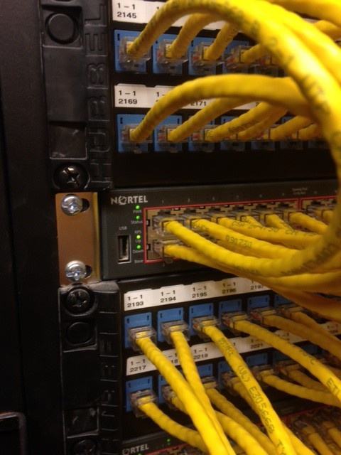

Note: The picture above shows a 2U 48 Port Data Patch Panel and a 1U Switch alternating this patter from top down with upper floors starting at the top.

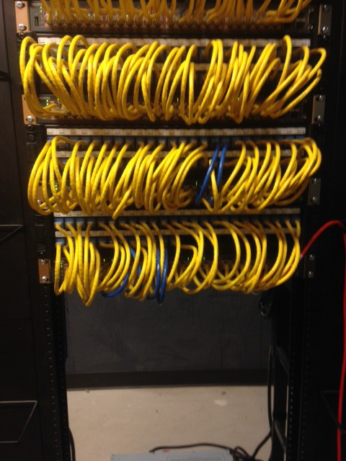
Frontal view of the 48 port patch panel alternating with a 48 port switch.

4U Horizontal Cable Management –Transition very top of each rack. A pathway between racks will be necessary.
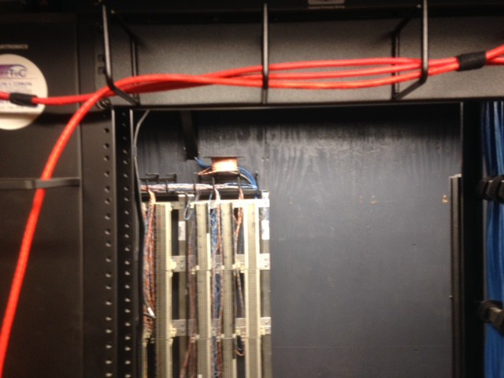
University of Toledo IT Closet Characteristics

Card Swipe
Light-50 foot Candles
36 inch min
DOOR
The minimum
data/telecomm unication space shall be an area of 12'-0" x 12'-
0"
No Drop Ceiling is
preferred. Floor to Deck above should be sealed. Pathways in and out of the room shall be fire stopped per industry standards.
Clearance shall be 36 inches on
either side of data racks.
FRONT
Floors shall be sealed: if concrete
or tiled and sealed: No carpet
Complete floor
plans and layouts of all spaces, equipment layouts of all
telephone backboards and equipment racks, service entrance facility details, cable routing, pathways and cable management details, data/ telecommunicatio n grounding
details and power
distribution
BACK
12Foot
36 inch min
Light-50 foot Candles
Cable Trays and
Ladder Rack designed to optimize pathways in/out of closet and provide growth for Fiber, Copper cable and coax transistions to Data Racks, voice and coax backboards.
12 foot
Coax Terminations
Voice Frame B-Line Frame sized for job
TGBB
Plywood all four walls: Paint with fire retardent paint
19 inch Racks by 84 inches high, Hubbell or Ortronics, number of racks determined by scope of work and growth potential. Cable management and patch cord managment as requested by UT Standards.
Each Data Rack shall have at least one 20AMP Power Strip and one L630P for two racks. No power will be run from wall to racks, all power to be hard wiried within the racks.

The ideal IT closet would take into consideration the "location first". You will reduce costs with the best location by limiting costs of materials, closet builds, and catastrophic events due to poor locations. It is best to have one closet service one floor however, for economic reasons we can service the floor above and below the IT closet as long as proper pathway distribution standards and distances are adhered to. Access to the closet should be off a common hallway to reduce interruptions to daily activities in the areas being served. If a Data cable or voice cable cannot be run properly within the IT standards of 295 feet from the service location jack to the patch panel a new IT closet or another closet location should be considered for the area to be serviced.
The size of the closet meets immediate requirements as well growth potential. Knowledge of the serviced areas and potential for new services will help with this determination. The layout of the closet is critical to allow for optimal service. Every service must have a logical useable space to operate efficiently. Those could include any or all of the following: Voice, Data, Security Cameras and doors, Wireless Services, Coax-Cable TV, Fire and Alarm, etc. (Follow 2 rack minimum for all New IT closets). It is this reason that all closets have plywood backboards (painted with fire retardant paint) on all 4 walls to allow for easy installations of other services that will end up in these IT closets.
Pathway allocation for all cables from the closet to workstation/service location is critical when defining the location of the closet in relation to the pathways and amount of materials required to service the area. Try to minimize the distance without compromising UT Standards. Make sure pathway growth is scalable to the location being served. All voice and data jacks shall not exceed 295 feet from workstation jack to IT closet jack at patch panel. Level III testers will not test any of these cables beyond this distance.

Proper labeling Identification (Annex A) is critical to our record keeping and must be followed per our standards.

IT Rooms with active equipment must have climate control to include humidity and AC controls for the area.
Preferred that these systems be on battery backup or backup generator in case of power loss. IT rooms should be clean with low levels on dust and contaminates. (See sealed floors and painted walls)
Security and sealed IT closets will provide higher security and save money on utilities. Drop ceilings are not recommended and floors should be sealed and walls should run from floor to the floor deck above the room. Security shall require a minimum of a Keyed lock for IT closets only, however we prefer all IT closets have a card swipe to allow for IT access logs for those using the closets.

Power is major component to any IT closet and should always be on emergency backup power, Generator Preferred. All active equipment should be on UPS of some sort. The power layout in IT closets builds should include power to the data racks, outlets in the room and lighting which all must meet optimal design standards.
The Contractor to provide two (2) 20A-120V-2P-3W NEMA 5-20 connector body receptacle (Hubbell #5369C) on a 2#12, 1#12G “SO” drop cord, elev. 42” A.F.F., each on a dedicated circuit, for Owner use. Receptacles to be located between the racks as directed by the Owner. Each Data Rack shall have at least one 20AMP Power Strip No power will be run from wall to racks, all power to be hard wired within the racks. We do not want trip hazards or the potential for equipment to be unplugged by accident by installing these outlets on walls instead of the racks.
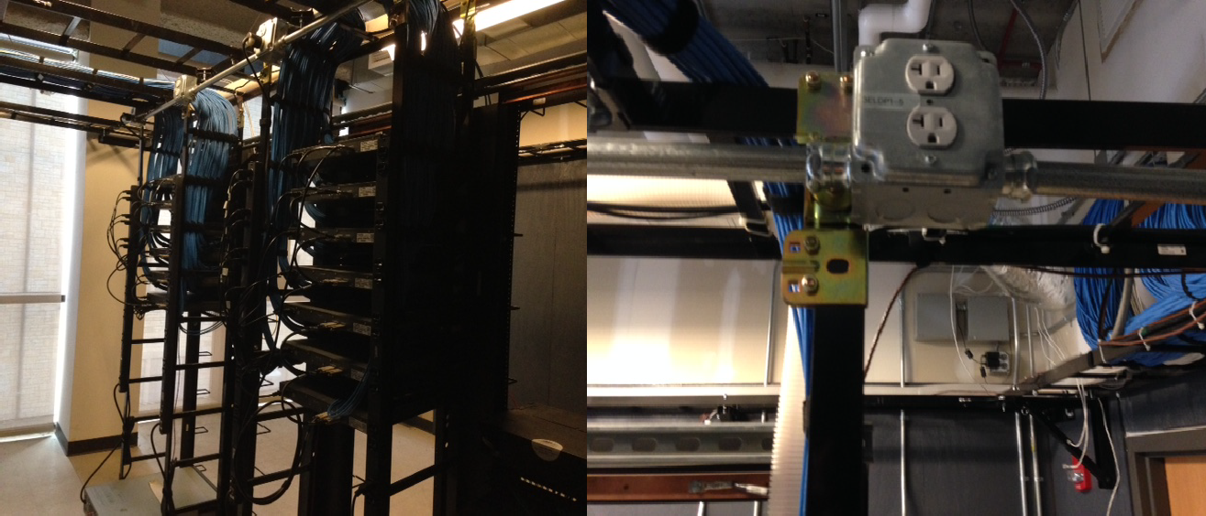

All IT Closets require proper Grounding which must be adhered to per UT standards. Improper grounding can create many problems. Proper grounding protects life and property.

Telecom Grounding Bus Bar: See Section 270526
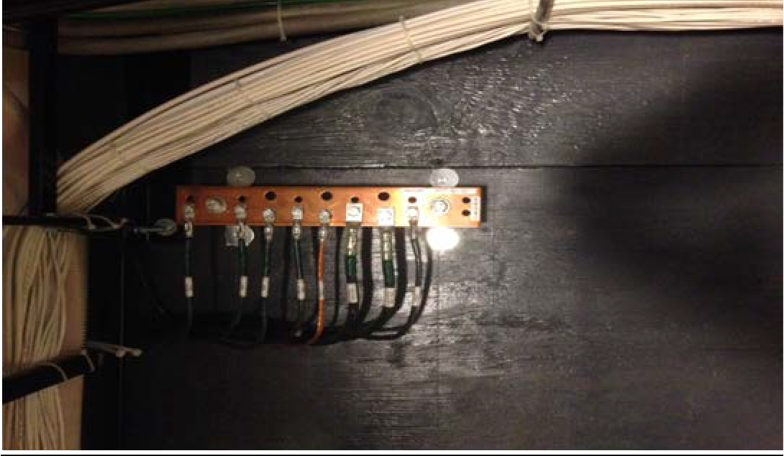

UT Telecom Backboard layout with B-Line Frame:

Feeder cables will always be to the far left followed by workstation category 3 voice cables. Note that the new

Labeling scheme uses the same identification as Data however a typed (Excel) cross reference sheet must be supplied to UT IT Network/Telecom for room identification. Example circuit 2-1 1002 is in room 1220.

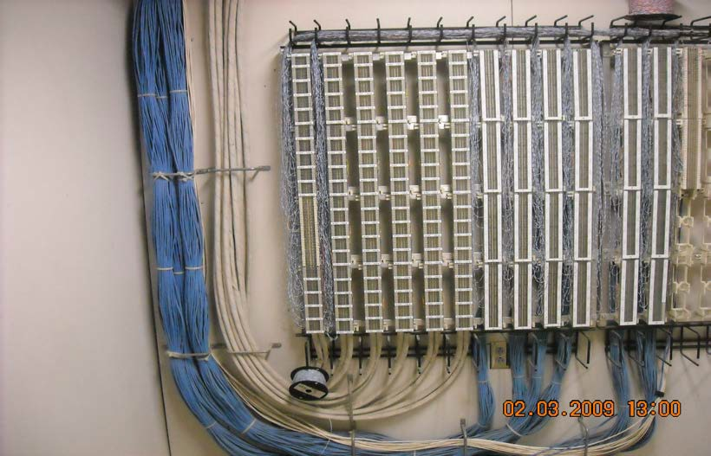

The IT Network Department, Contractors and Facilities collaboration is critical from the beginning stages of all projects to make sure we start on a solid foundation when it comes to the IT Infrastructures. With many retro fit situations, it becomes even more important to be involved in early planning stages. (Planning, Layout (Blueprints), Job monitoring and job punch lists upon completion with a follow-up to correct problems)

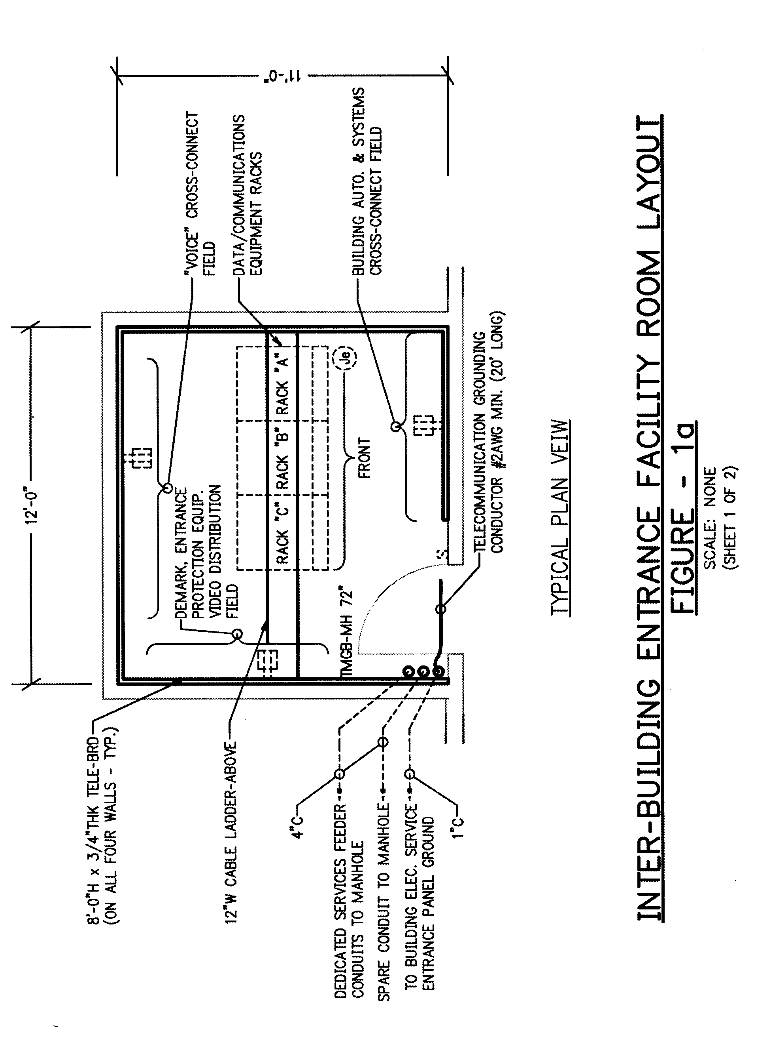

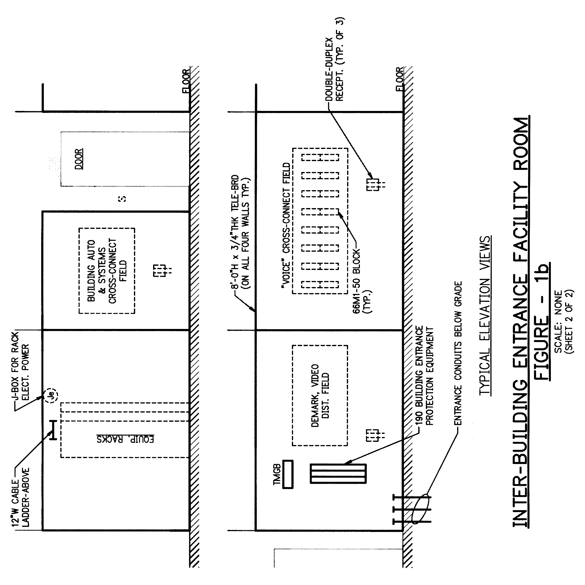

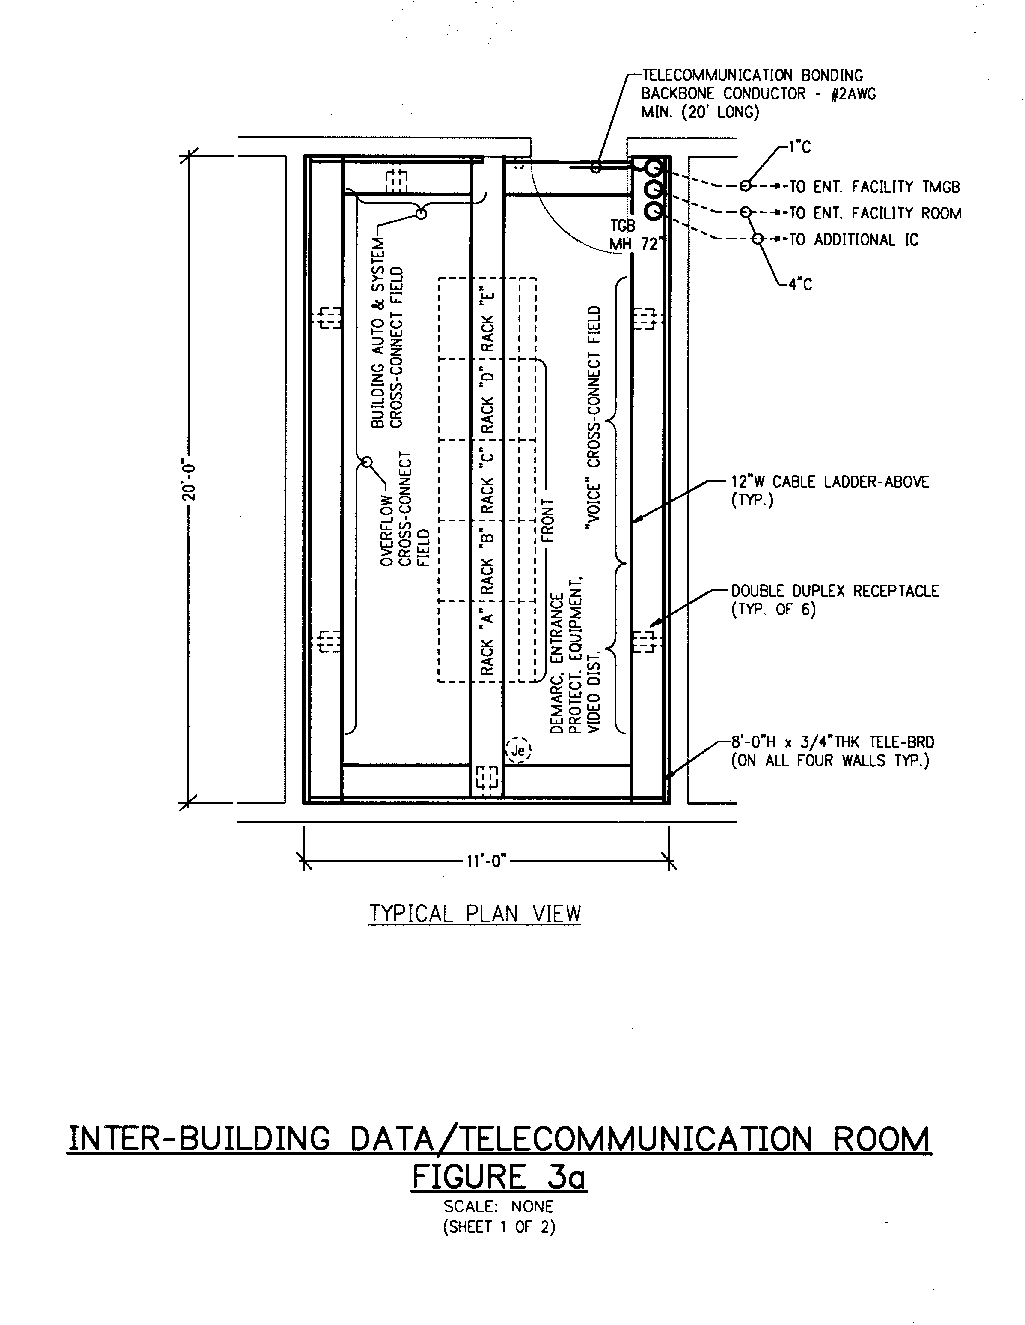

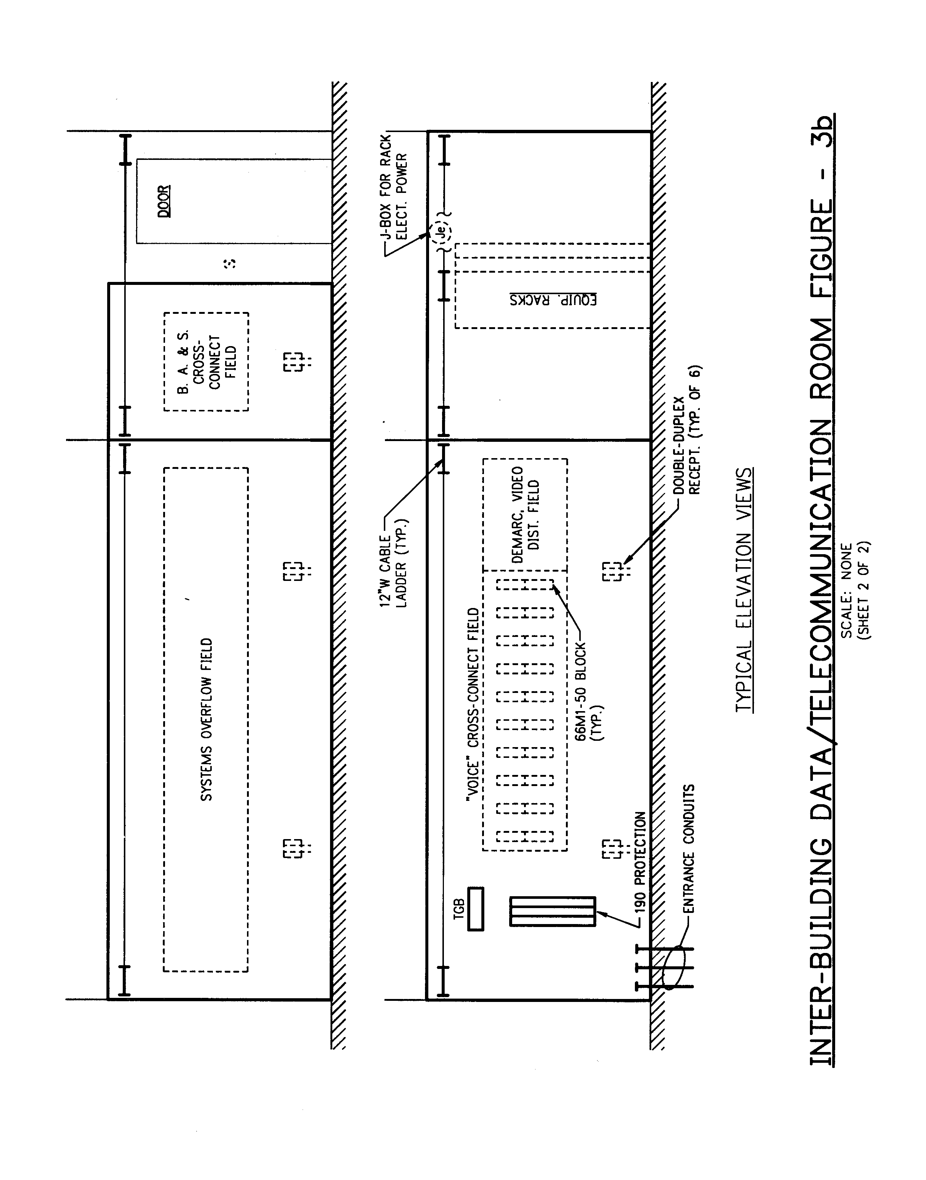
END OF 271100

