Faculty Senate

Academic Programs Committee

Review for February 27, 2024 Senate Meeting

The following 14 proposals need to be reviewed by the Academic Programs Committee.

CLICK (or ENTER) this URL.

https://nextcatalog.utoledo.edu/programadmin/

COPY & PASTE this comma-delimited list into CIM programs search box.

BU-OLM-BB, BU-PSLS-BB, BU-ACCT-BB, BU-FINA-BB, BU-HRM-BB, BU-MGMT-BB, BU-MKTG-BB, EN-CVLE-BSV, EN-ENVE-BSE, SM-ACHM-CFT, Consultative Sales*, BU-OSCM-BB, MGMT, BU-INF-BB, *Aerospace Engineering Concentration*, SM-MATH-BS-PURE, *Materials Chemistry*

Disregard anything that does not have FACULTY SENATE PROGRAMS in the workflow.
There should be 12 proposals to review.

The full instruction sheet, with images, is still included at the end of this document.

Program Modifications

Organizational Leadership and Management, BBA

Professional Sales, BBA

Accounting, BBA

Finance, BBA

Human Resource Management, BBA

Management, BBA

Marketing, BBA

Information Systems, BBA

Operations and Supply Chain Management, BBA

Management, Minor

Civil Engineering, BS

Environmental Engineering, BS

Analytical Chemistry Certificate

New Programs

Consultative Sales, Post Baccalaureate Certificate

Instructions to View Original Proposal Files on CIM

# NPP New Program Proposal
# PCR Program Change Request

CIM changes summarized: Green is NEW, Red (strikeout) is OLD

ENTER this URL to see the actual proposal documents of programs

https://nextcatalog.utoledo.edu/programadmin/

COPY & PASTE the comma-delimited list into CIM programs search box.

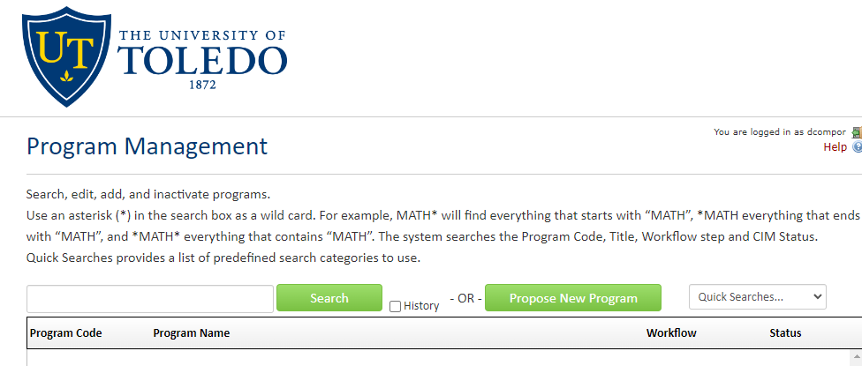

CLICK the Green Search Button, which pulls up all listed proposals in alphabetical order.

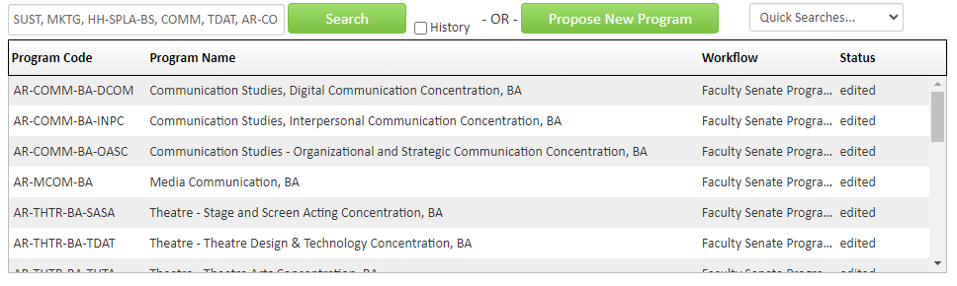
Only items that have Faculty Senate Programs under the Workflow tab have been endorsed by the committee.

SELECT A proposal to view. The list of proposals will remain at the top of the browser page.

