Faculty Senate

Academic Programs Committee

Review for January 16, 2024 Senate Meeting

The following four proposals need to be reviewed by the Academic Programs Committee.

CLICK (or ENTER) this URL.

https://nextcatalog.utoledo.edu/programadmin/

COPY & PASTE this comma-delimited list into CIM programs search box.

AR-ENGL-BA-CRWG, AR-ENGL-BA-LITR, AR-ANTH-BA, BU-INF-BB

The full instruction sheet, with images, is still included at the end of this document.

Proposals Sorted by College

Arts & Letters: FS Representative: Dan Compora

English - Creative Writing Concentration, BA

We are making a minor change to one of the requirements for the degree: Literature Excluded from the Traditional Canon. Under the current guidelines, students can take either a 3000-level or 4000-level course for this requirement. We are changing this to 3000-only. This will match a change we are also making to the Literature concentration.

We want to make sure students take at least one more 3000-level class, as this is important for their education. Sometimes students opt for 4000-level courses before they are ready. Overall, our major allows for flexibility.

English - Literature Concentration, BA

We are updating two requirements:
--Literature Excluded from the Traditional Canon: we are restricting this current requirement to classes at the 3000-level
--1 additional class from either Critical Practice or Literature Excluded from the Traditional Canon: we are now making this a requirement for a 4000-level Literature Excluded from the Traditional Canon course

These changes will encourage students to further scaffold their learning--by specifically requiring a 3000-level class for the first Literature Excluded from the Traditional Canon requirement, and then a 4000-level class for the second Literature Excluded from the Traditional Canon. In addition, these changes further center these classes in the Literature concentration.

Anthropology, BA

(1) expanding elective options to include additional 2000-level courses that are regularly offered; stipulating 75% of elective hours must come from 3000-4000 level courses in Anthropology
(2) including an "or" option for an existing Related Fields sub-requirement. currently LING 3150 is a subrequirement for our related fields. We are hoping to offer the option of LING 4140 to that sub-requirement, so students have the option to fulfill that requirement with either LING 3150 or LING 4140, instead of the present requirement of JUST LING 3150.

Expanding the range of 2000-level courses in Anthropology allows majors to take courses that are offered if not each semester than each academic year (e.g., ANTH 2100, ANTH 2750, ANTH 2900), ensuring an ability for timely completion of major requirements.

Business: FS Representative: Brandon Cohen

Information Systems, BBA

Updating the required courses for the major.

List any new or modified courses submitted that are part of the program proposal?

MATH 1320 or higher required. Acceptable replacements include MATH 1260 or 1270 or 1340 or 1730 or 1750 or 1760 or 1850 or 1860 or 2450 or 2460

INFS 3160 will be a required course or an elective depending on the student's chosen track.

Instructions to View Original Proposal Files on CIM

# NPP New Program Proposal
# PCR Program Change Request

CIM changes summarized: Green is NEW, Red (strikeout) is OLD

ENTER this URL to see the actual proposal documents of programs

https://nextcatalog.utoledo.edu/programadmin/

COPY & PASTE this comma-delimited list into CIM programs search box.

PH-PCOS-BSS, ANTH, Data* *Ethics*, Environmental Ethics*

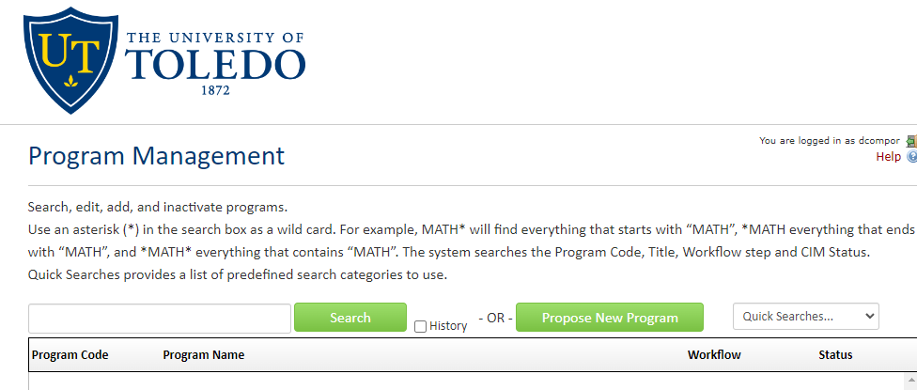

CLICK the Green Search Button, which pulls up all listed proposals in alphabetical order.

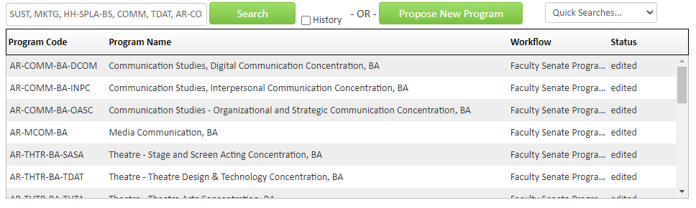
Only items that have Faculty Senate Programs under the Workflow tab have been endorsed by the committee.

SELECT A proposal to view. The list of proposals will remain at the top of the browser page.

