Faculty Senate

Academic Programs Committee

Review for November 21, 2023 Senate Meeting

The following four proposals need to be reviewed by the Academic Programs Committee.

CLICK (or ENTER) this URL.

https://nextcatalog.utoledo.edu/programadmin/

COPY & PASTE this comma-delimited list into CIM programs search box.

PH-PCOS-BSS, ANTH, Data* *Ethics*, Environmental Ethics*

The full instruction sheet, with images, is still included at the end of this document.

Proposals Sorted by College

Arts & Letters: FS Representative: Dan Compora

- ANTH: Anthropology Minor: Program Modification

  - including ANTH 4440 (People, Population and Society: Demographic Analysis) as an "or" option to Anthropology core requirement

  - expanding elective options to include additional 2000-level courses; stipulating 50% of elective hours must come from 3000-4000 level courses in Anthropology

No new or modified courses are part of the proposal.

- PHIL: Data and Technology Ethics Certificate. New Proposal.

The development of this certificate provides a focused way for students to pursue additional courses in their area of interest, and received acknowledgement of their expertise, without being committed to a more demanding minor or major program.

- PHIL: Environmental Ethics Certificate. New Proposal.

The development of this certificate provides a focused way for students to pursue additional courses in their area of interest, and received acknowledgement of their expertise, without being committed to a more demanding minor or major program.

Instructions to View Original Proposal Files on CIM

# NPP New Program Proposal
# PCR Program Change Request

CIM changes summarized: Green is NEW, Red (strikeout) is OLD

ENTER this URL to see the actual proposal documents of programs

https://nextcatalog.utoledo.edu/programadmin/

COPY & PASTE this comma-delimited list into CIM programs search box.

PH-PCOS-BSS, ANTH, Data* *Ethics*, Environmental Ethics*

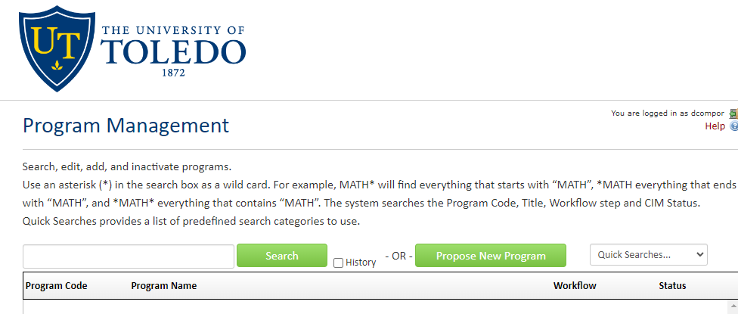

CLICK the Green Search Button, which pulls up all listed proposals in alphabetical order.

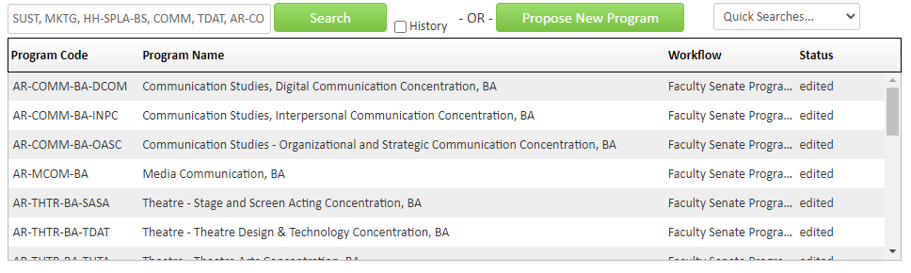
Only items that have Faculty Senate Programs under the Workflow tab have been endorsed by the committee.

SELECT A proposal to view. The list of proposals will remain at the top of the browser page.

