How to Use Cisco WebEx

Contents
How to Install Webex Meetings software 2
Windows Instructions: 2
Mac Instructions: 3
How to schedule a meeting using Outlook 4
How to schedule a meeting via utoledo.webex.com 6
How to Join a Webex meeting via Outlook on a PC 7
How to Join a Webex meeting via Video Endpoint 8
How to Join a Webex meeting via utoledo.webex.com 9
How to Join a meeting via Phone 10
Selecting PC Audio Preferences When Joing a Meeting 11
How to Start your Video in a Webex meeting 12
How to Share Content in a Webex meeting 13
Share Screen: 13
Share Files: 13

How to Install Webex Meetings software

Windows Instructions:
- Press the Windows key on your keyboard or click on it in your taskbar (far left side)
- Type out “webex” and then click on the Software Center desktop app.

- Once Software Center opens, it will display all of the available applications. Search for Webex.
- Click on the “Webex Meeting Center Desktop”. Yellow circle
  - If you cannot see the Meeting Center software, you will need to submit a Help Desk ticket requesting to have Cisco Meeting Center pushed to your Software Center
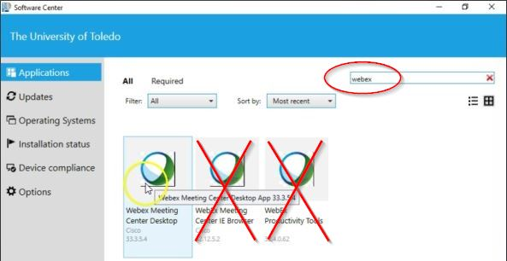
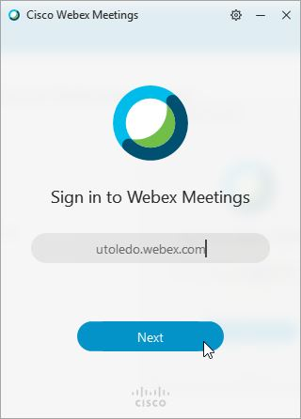
- Next, Click the blue “Install” button and wait for the software to be installed.
- Once the software is installed and open, enter the URL: utoledo.webex.com and click next.
- When prompted, log in with your UTAD credentials.
- Quit and reopen Outlook to confirm the upgrades. (this software also adds features to Outlook)

The Webex Meetings desktop app allows you to start and join meetings quickly from your meetings list within the app without going to your calendar or Webex site. It also allows you to add a Webex meeting directly in Microsoft Outlook. The Webex Meetings desktop app can also automatically detect nearby video devices, so you can share the desktop on a video device or automatically call it when joining a meeting.

Cisco WebEx install option 2
- Go to “utoledo.webex.com” and click “Support” on the left side menu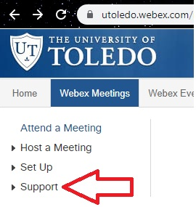

- From the drop-down menu select “Downloads”
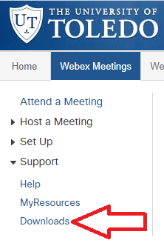
- Click on “Cisco Webex Meetings Desktop App”
- Select Windows from the dropdown menu
- Click “Download”
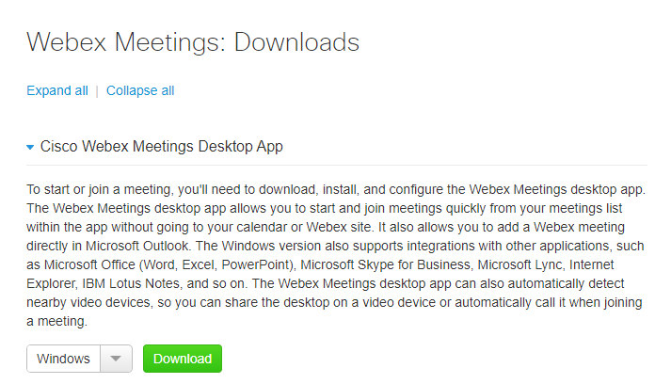

Mac Instructions:
To install Webex Meeting Center on your Mac, go to utoledo.webex.com and sign in with your UTAD credentials.
- Click on the Webex Meetings tab.
- Click to expand the support option.
- Click on Downloads.
- Expand the Cisco Webex Meetings Desktop App option.
- Choose Mac from the dropdown menu and download.
- Install the software on your Mac like you normally would any other software.
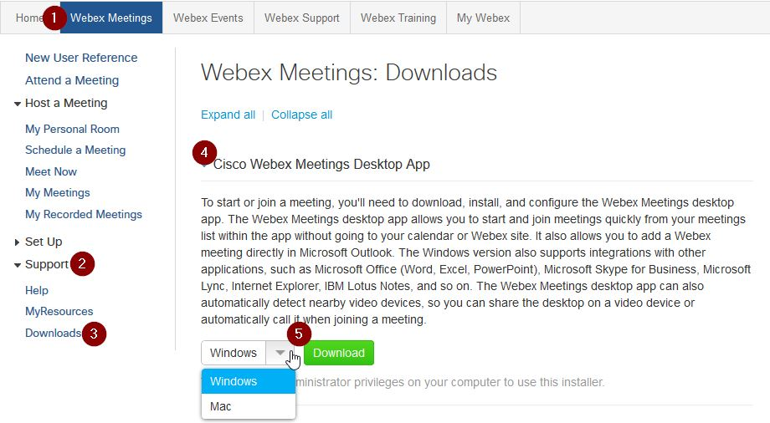

How to schedule a meeting using Outlook
Please note: This method will only work if you have the Webex Meeting Center application installed.
- From the Home ribbon in Microsoft Outlook, select Schedule Meeting. In the drop-down list, choose from the following:
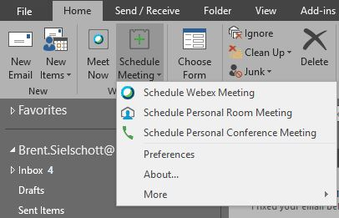
- Schedule Webex Meeting (recommended for meetings)–Webex meetings are the standard meeting choice.
- Schedule Personal Room Meeting–Personal Rooms are your own virtual conference room. It’s always available and you don’t have to book it.
- Schedule Personal Conference Meeting–Personal Conference meetings are for meetings using telephone service provider (TSP) audio.

- Click To and choose who you want to invite to your meeting or type in their full email address
- Add a Subject and Location
- Choose the Start time and End time for your meeting. (This includes the date, time, and duration of the meeting.)
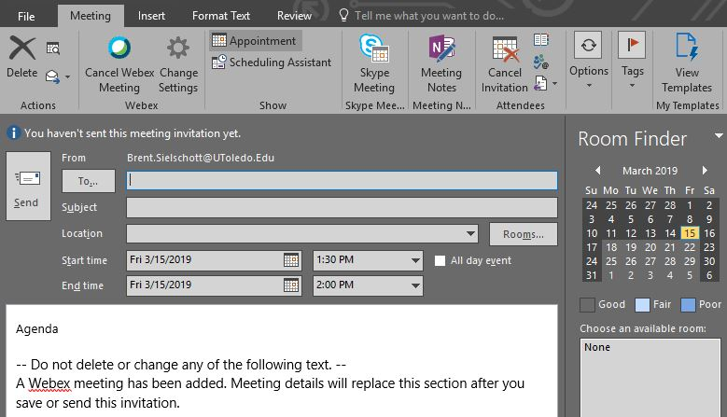
- Click Send when finished.
  - Alternatively, you can click Scheduling Assistant to view the best time for your meeting by checking other people’s calendars. This also works with Rooms. Simply add a room (or rooms) to see which room(s) are available.

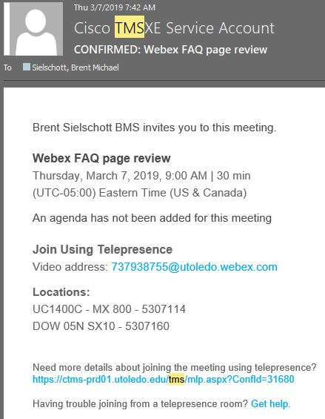
- Once you have finished entering in all of the details of your meeting click Send. You will receive a confirmation of your meeting in your inbox that will look something like this:

How to schedule a meeting via utoledo.webex.com
- Go to http://utoledo.webex.com
- Click ‘Log In’ located in the upper right corner and sign in using your UTAD credentials
- Once signed in, click the ‘Webex Meetings’ tab and then ‘Schedule a Meeting’
- Fill in the necessary information for your meeting and click Schedule.
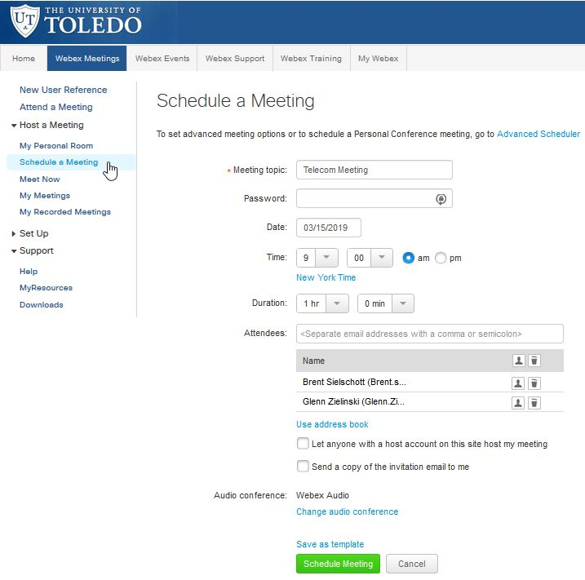
If you need more detailed meeting options, such as recurrence, click the Advanced Scheduler link at the top of the Classic View.

How to Join a Webex meeting via Outlook on a PC
Please note: This method will only work if you have been invited to the meeting.
- Double click on the calendar invite. This will open up the meeting details where you can join:
- Clicking the green Join Webex Meeting button

How to Join a Webex meeting via Video Endpoint
Using the touch pad attached to the video endpoint:
- Tap the dial button
- Enter the 9 digit meeting ID
- Press the green Call button
  - To schedule a video endpoint, make sure you invite the room the Cisco video endpoint is in to your meeting (before the meeting starts). When scheduling a Webex meeting in Outlook, simply click on the Room button to view all of the available rooms. Also, don’t forget to check out the Scheduling Assistant view to see if the room is available.

How to Join a Webex meeting via utoledo.webex.com
- Go to http://utoledo.webex.com,
- click ‘Log In’ located in the upper right corner and sign in using your UTAD credentials.
- Once signed in, click the Webex Meeting tab, then click Attend a Meeting.
- Enter the 9 digit meeting number (access code) in the box.
- Click Join.
Note - This method will work with any UT Webex room ID.
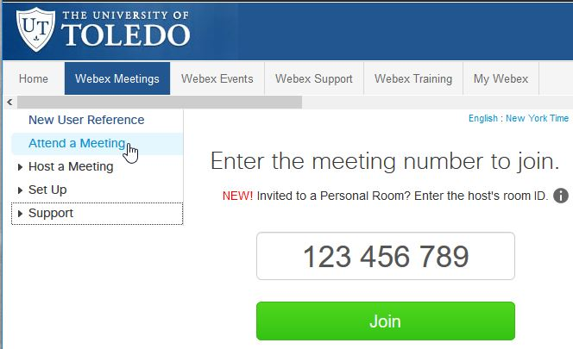

How to Join a meeting via Phone
- Using the emailed invite, dial the number provided under Join by Phone from a LAN line phone or cell phone

Selecting PC Audio Preferences When Joing a Meeting
- Once you Join a meeting, you will be asked to select your how you will hear the meeting. You may select from the following options:
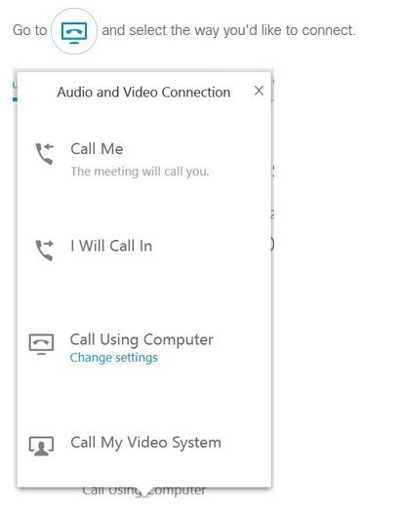
  - Call Me: you desk phone will then ring
  - I will Call In: you will be presented with a number to call using your desk phone
  - Call Using Computer: you will use our PC’s default audio and microphone options (if equipped)

How to Start your Video in a Webex meeting
- When joining a meeting, your video may be off by default. If you’d like others to see you, select
  - The button turns blue when your video is ON
- If you want to mute or unmute your mic, select

How to Share Content in a Webex meeting

Share Screen:
- To share your screen during a meeting, select
- Click Share My Screen

Share Files:
- Click
- Select More Options
- Click Share File
