Division of Technology and Advanced Solutions

Banner Navigation Updates

Introduction
Banner recently released a new enhancement to Application Navigator to allow for new navigation options, preferred starting page, and the option to tag forms under a Favorites folder. The information below provides a quick guide for these updates.
Please be aware that with these latest updates Banner no longer supports Internet Explorer. We strongly recommend using another browser (Chrome, Firefox, Edge) when utilizing Banner. Internet Explorer will not function properly and should not be used. As a substitute, Microsoft Edge is a new browser and is supported by Banner. If interested, Edge can be downloaded at Microsoft Edge Browser.
Updates
1. New Navigation Layout:
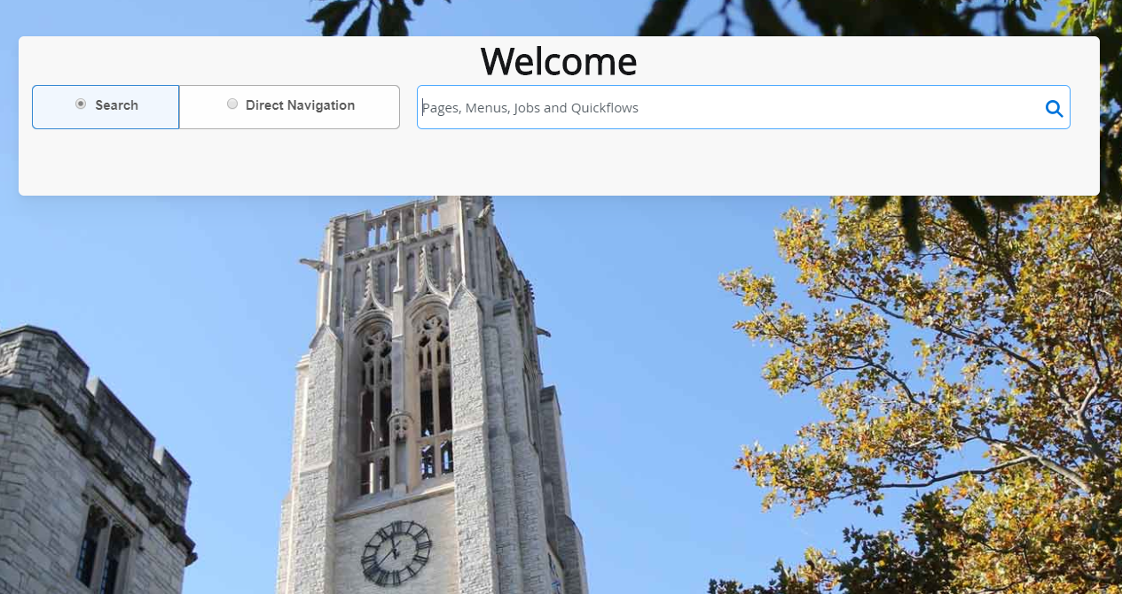

- Search: Same navigation as previously experienced. Returns matching list of objects for selection.
- Direct Navigation: New navigation function. Expects an exact match and returns list for all exact matches if more than one exists.
**Recommend using Search function unless user knows exact name of Banner Application(s)**

2. New Personal Settings Menu:
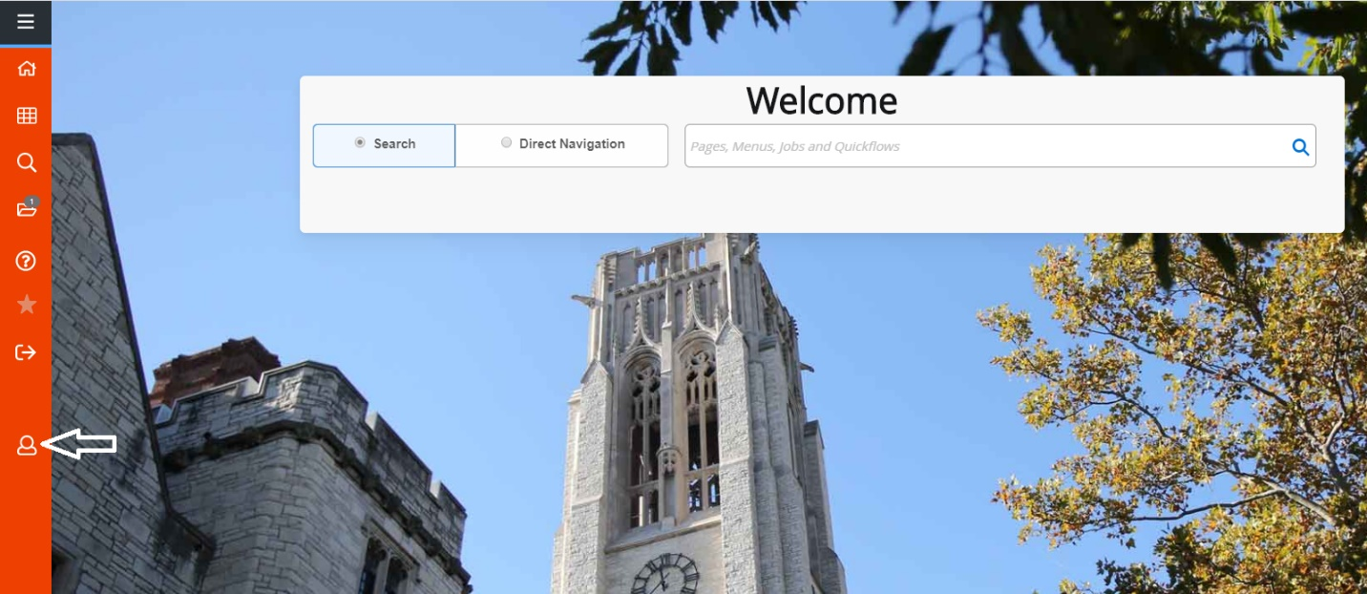

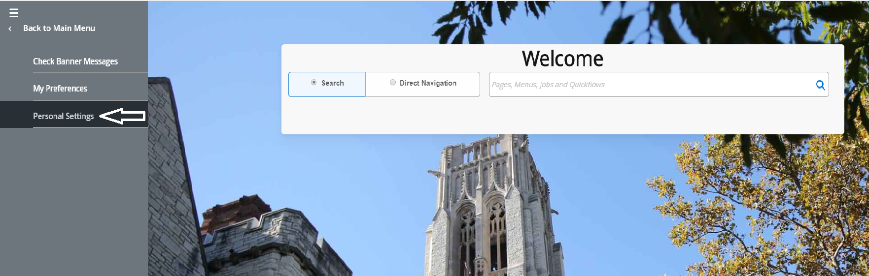

- Users manage settings:
  - Direct Access vs Search default
**Recommend using Search function unless user knows exact name of Banner Application(s)**
  - Confirm logout vs no confirmation – If user selects ‘Yes’ to needing a sign out confirmation they receive the message below when logging out:
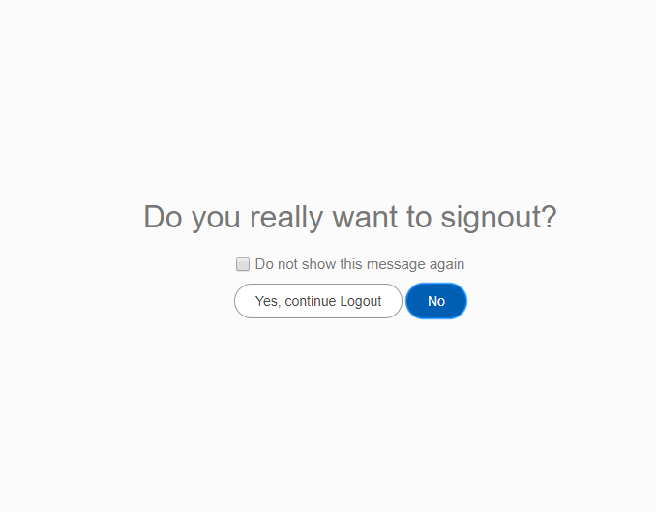

**No recommendation for confirming log out - user preference**
  - Define page to auto open at log in (e.g. TSAAREV)
    - Applied at next session log in
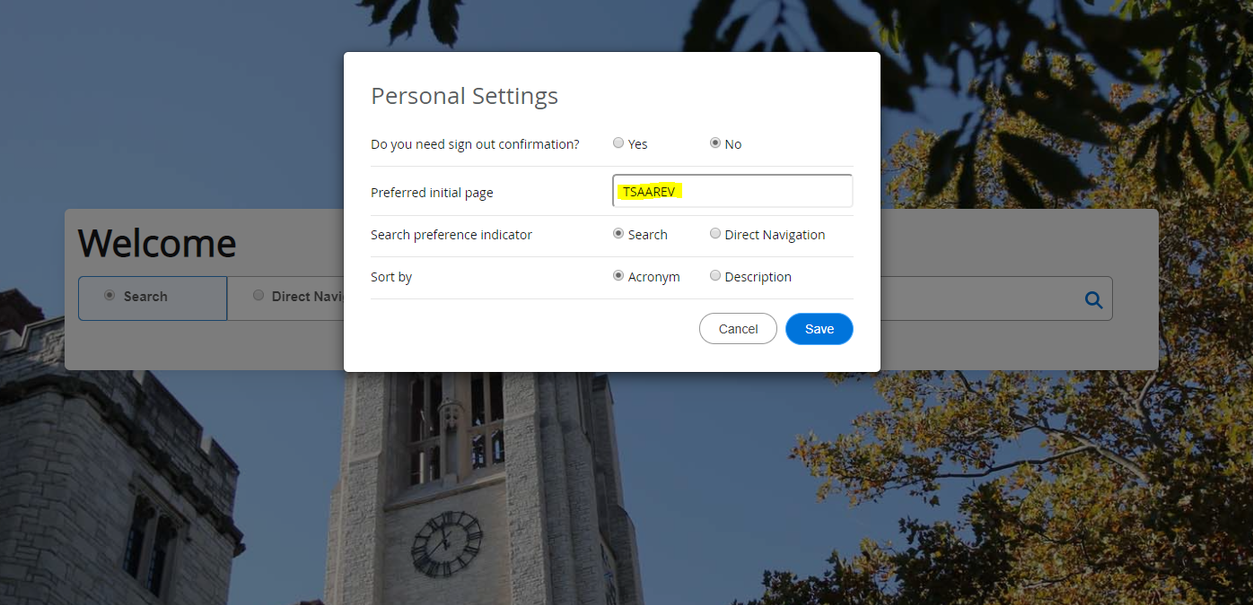

3. New option to sort by Acronym or Description:
- Update via Personal Settings:
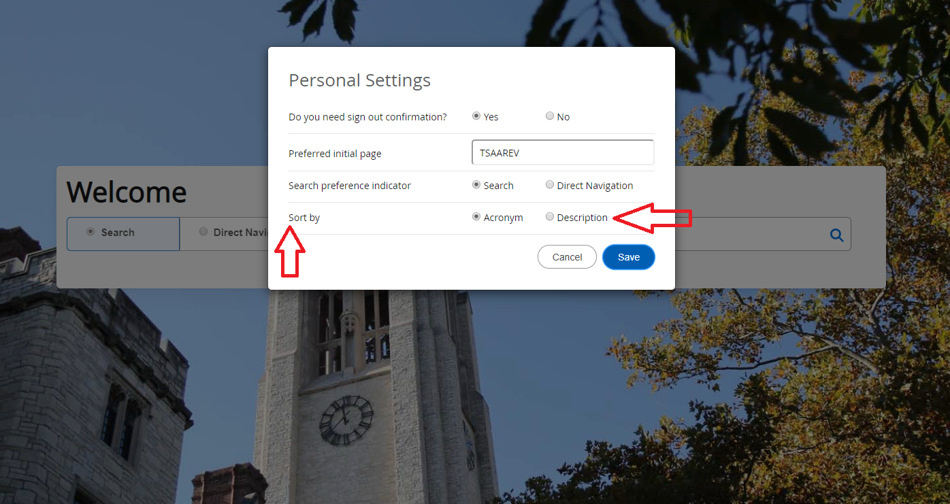

- Adjust via Search Navigation:
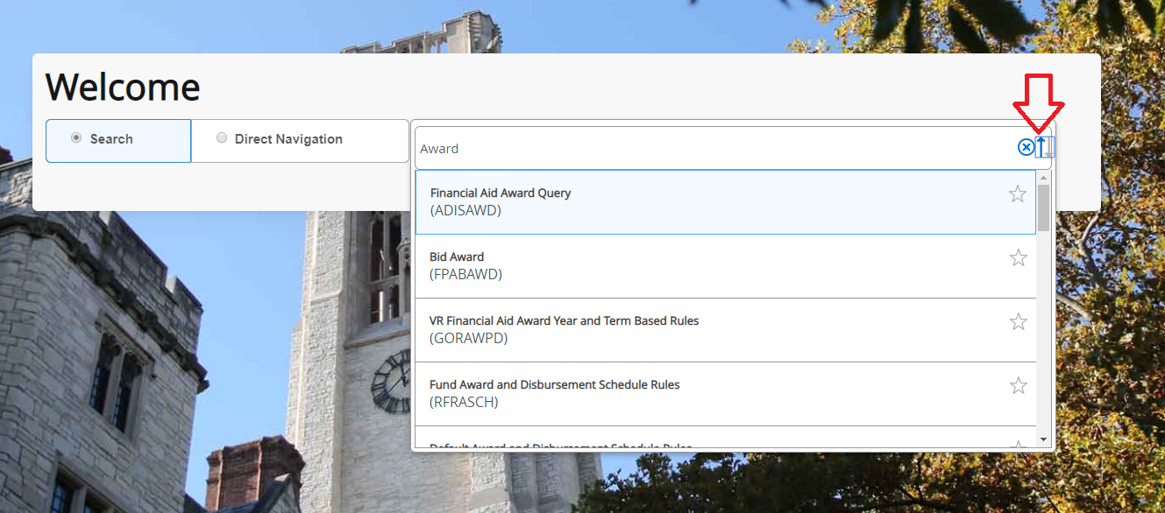

4. New ability to manage content in Favorites Folder:
- Option 1: From Banner Applications - Add or remove Banner Admin pages to Favorites folder

- From toggle menu search Applications -> Banner

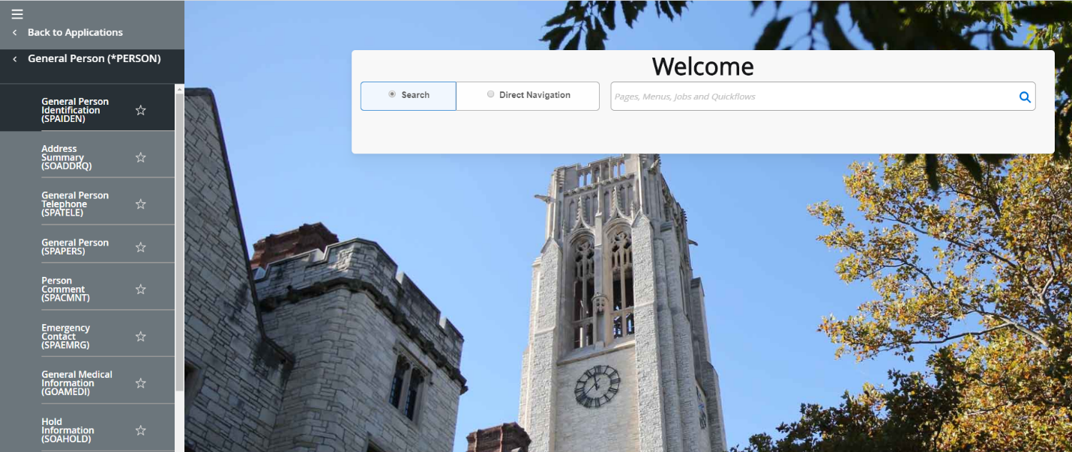

- Select the ‘Star’ to save Banner Form as Favorite. Select ‘Star’ again to unselect from Favorites list

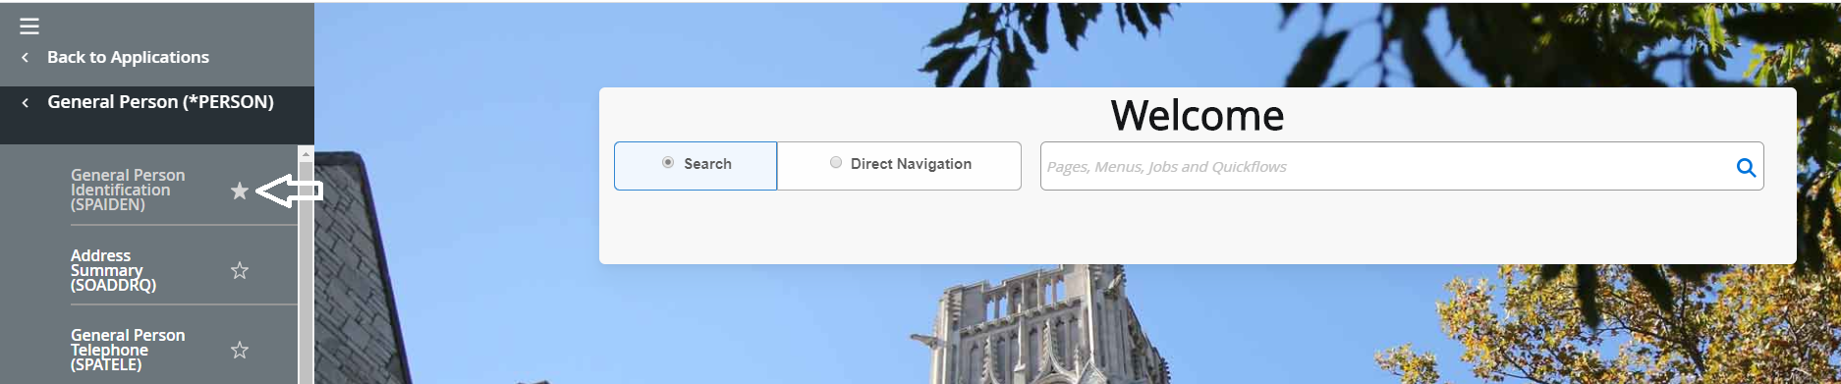

- Once selected as Favorite – Banner Form will be found in Favorites Folder.

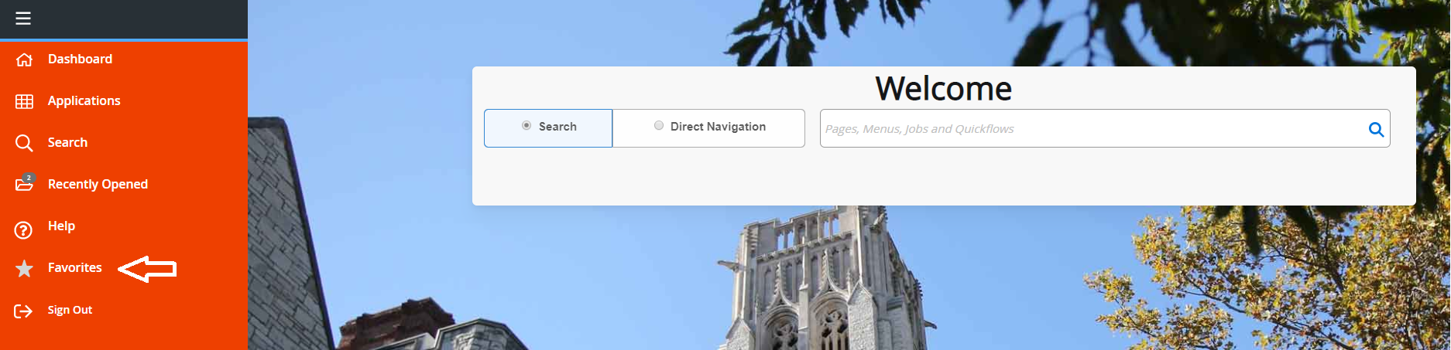

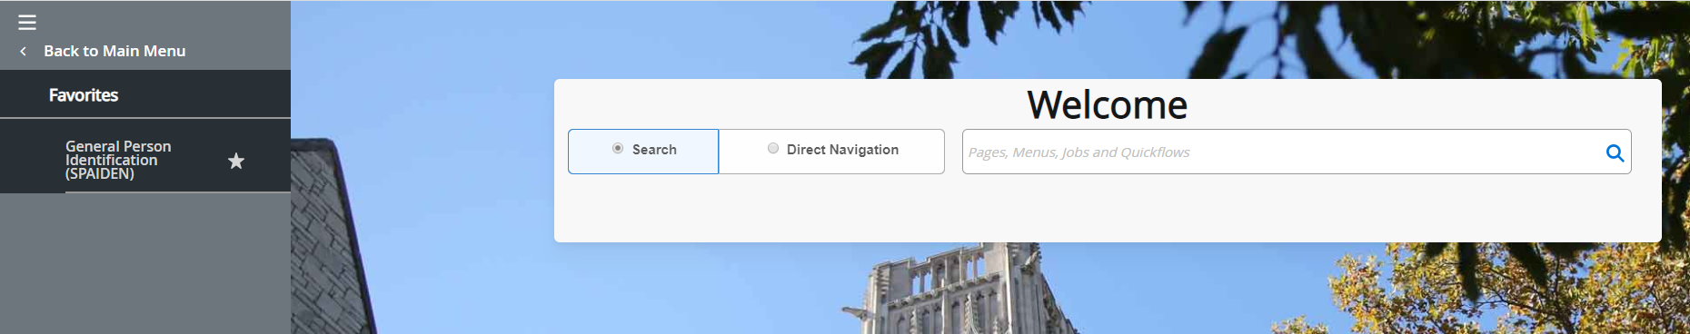

- Option 2: From Banner Search Bar - Add or remove Banner Admin pages to Favorites folder

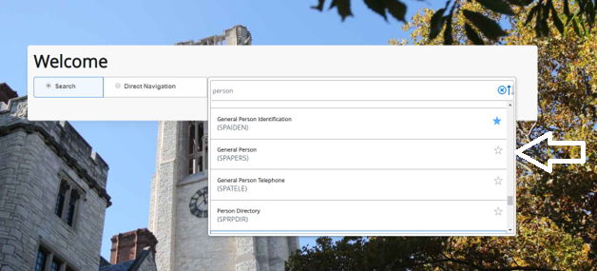

- Favorites Folder VS My Banner – My Banner still exists and there has been no announcement from Ellucian to discontinue My Banner

**However - recommend saving My Banner screens to Favorites Folder. Allows for quicker navigation to frequently used forms**
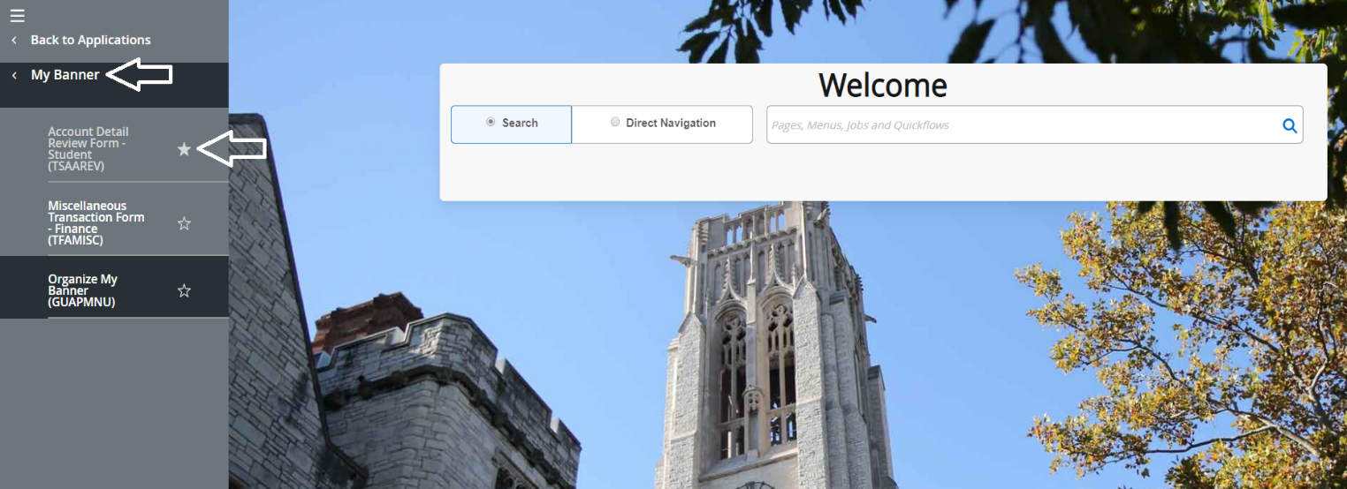

For more information visit: https://www.utoledo.edu/it/banner9/

