|  |
| --- |
| C:\Users\John\Desktop\50years.jpgC:\Users\John\Desktop\whitecoat2.jpg |
| anatomy lab.JPGgraduation.JPGC:\Users\John\Desktop\clinicalskills.jpg |
| Clinical Rounds.JPGshoulder.JPGC:\Users\John\Desktop\current2.jpg |
|  |

University of Toledo College of Medicine and Life Sciences

**Raymond & Beverly Sackler  
Academy of Educators**

Annual Report 2013-2014

The Year in Review – One Step at a Time

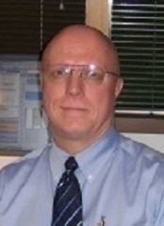In the 2013-2014 academic year, sound strategies have been put in place to advance some of the goals of our Academy: provide learning opportunities for and promote discussion among faculty on the issues facing medical education. At the 2014 UTCOM Retreat, Dr. Ali spoke of the curricular trends in medical education including changes in pedagogy, assessment and the curriculum itself. Academy members have begun to experiment with new pedagogy, been involved in implementing the new competencies and the Academy has supported education research in these and other areas in the amount of $21, 000 over the last two years. Our progress is slow, steady and significant.

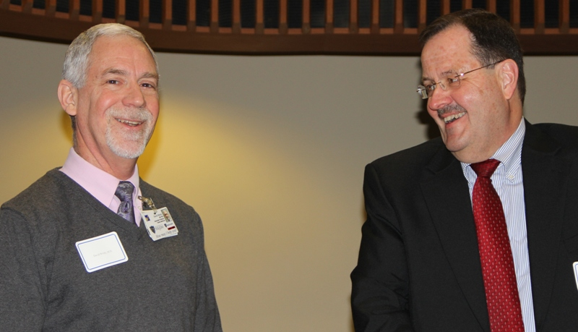The Academy’s second year had us offering a medical education journal club and grand rounds. The crowning achievement was our first Medical Education Day where presenters spoke on a number of topics, and opportunities for discussion were plentiful. We heard from both our own faculty and two from Case Western who are incorporating Interprofessional Education into the curriculum. Read on to learn more about these activities. I encourage you to think about how the Academy might benefit you, your committee, your department, and your educational challenges.

Medical education is the foundation upon which high quality healthcare is built. Training is important but education is vital. It is education that triggers student curiosity, a student’s desire to know more and to do it better. In the practice of medicine it is being stimulated by the unknown and not being intimidated by it that is likely to produce our best providers. First-class education can do this.

As you read through this report, I urge you to consider the breadth and depth of work being done in just 2 short years and what you might have to offer the educational mission of UTCOMLS, either through the Academy or in joining with the Academy. I have the good fortune to work with a wonderful group of highly dedicated medical education professionals who are committed to the educational mission of the UTCOMLS, in the service of improving the health of our patients and community. To them I say “Thank You!”



John M. Wryobeck, PhD, ABPP  
Associate Professor of Psychiatry  
Director of the COMLS Academy of Educators 2012 - 2015

**__________________________**

**“We need to make sure we are giving medical students the chance to become the doctors they always wanted to be – and the doctors our nation so desperately needs them to be.”**

**Darrell G. Kirch, MD, AAMC President and CEO**

**_______________________________**

**Finance and Philanthropy**

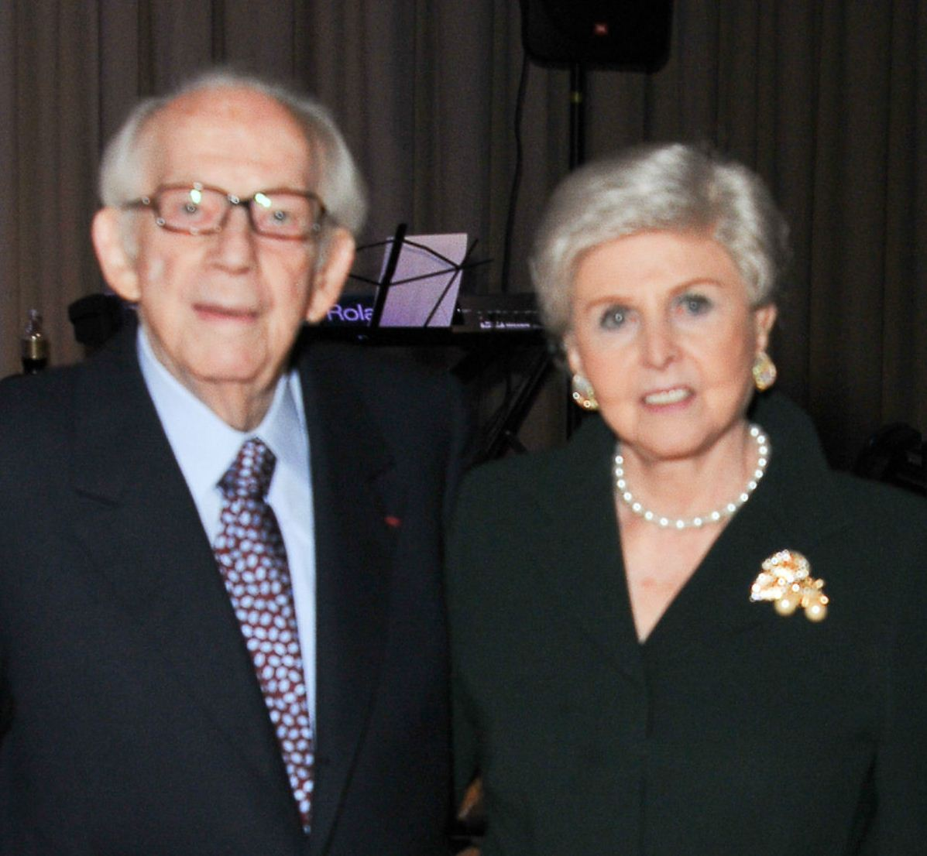 The Academy is deeply grateful for the generous support of our educational mission by Raymond and Beverly Sackler. Their generosity has been acknowledged by renaming the Academy as the **Raymond and Beverly Sackler Academy of Educators**. In an era where there is much talk about training healthcare providers for the 21st century and beyond, healthcare and medical education are experiencing many financial pressures. This gift demonstrates how concerned individuals can make a difference to future patients by supporting providers’ early career education and development. It is through this and other philanthropic investment that UT’s education community can reach higher levels of medical education/research excellence.

**Journal Club & Grand Rounds**

In this year the Academy sponsored a Medical Education Journal Club open to Academy members. We had good attendance and some interesting discussions. It was decided that we would open up these events to all faculty of the College of Medicine and Life Sciences in the next year. This past year we reviewed and discussed:

1. Factors Associated with Successful Self-Directed Learning Using Individualized Learning Plans During Pediatric Residency; John Wryobeck, PhD
2. Exploring first-year undergraduate medical students’ self-directed learning readiness to physiology; Connie Shriner, PhD
3. Teaching pediatric epilepsy to medical students: A randomized crossover trial; Thea Sawicki, PhD
4. Clarifying Assumptions to Enhance Our Understanding and Assessment of Clinical Reasoning; Keith Crist, PhD

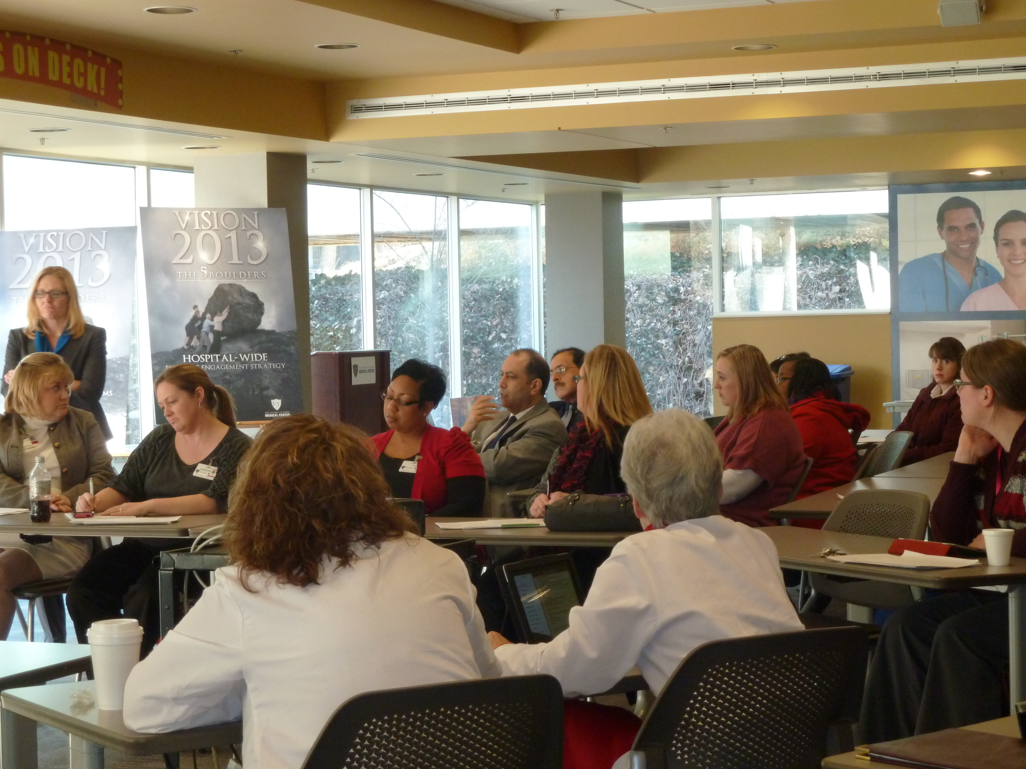We held two Medical Education Grand Rounds this past year. Unlike the journal club, these were open to the Health Science Campus. We hope to bring in more regional/national speakers to bring in more faculty attendees. Each of these Grand Rounds was presented in collaboration with the UTCOMLS Office of Faculty Development.

1. **Strategies for Engaging Learners in Lecture Settings**, Carol Bennett-Clarke, Associate Dean for Preclinical Undergraduate Medical Education (Team-based Learning), Kathy Shan, Lecturer, Department of Physics and Astronomy (Interactive Engagement).
2. **Turning your Clinical Work into Scholarship**, Linda M. Roth, PhD, Director of Professional Development, Wayne State University School of Medicine

In addition to Journal Club and Grand Rounds the Academy sponsored 3 idea incubator discussions. The idea here is to promote discussion and the development of ideas concerning teaching and curriculum.

1. Follow-up discussion group of Salman Khan’s presentation on the integration of technology and learning.
2. **Teaching Critical Thinking** by Linda Speer, MD, Chair, UT Department of Family Medicine and **Expanding the Use of Echo 360**, by Connie Shriner, UT Associate Provost for Faculty Development in Academic Affairs & Associate Dean College of Medicine.
3. **Inter-professional Immersive Simulation Center as a Resource for Idea Incubators**, Pamela Boyers, UT Executive Director Center of Clinical Simulation

**Education Day**

|  |  |
| --- | --- |
| Inaugural Education Symposium: March 28, 2014   1. **Using LectureTools™ to Become a Fearless Teacher**, Claire E. Stuve, MA, UT Educational Technologist 2. **Online Delivery, Copyright, and You**, Phoebe J. Ballard, MEd, UT Sr Instructional Designer & Coordinator for Special projects 3. **The Good, The Bad, and The Ugly of Implementing Interprofessional Education**, Carol S. Hasbrouck, MA, Director, School for the Advancement of Interprofessional Education, Susan Sochacki, PhD, MSN, RN, Assistant Professor, College of Nursing 4. Keynote: **Interprofessional Education: Building Momentum while Meeting the Challenges: The Story of Case Western Reserve University**, Patricia W. Underwood, PhD, RN, FAAN and Ellen Luebbers, MD, Co-Directors, Macy Foundation Interprofessional Education Grant. 5. Tour of the Interprofessional Immersive Simulation Center (IISC) | **C:\Users\John\Desktop\goodbadugly.jpg** |
| **C:\Users\John\Desktop\simulation center.jpgC:\Users\John\Desktop\talk.jpg** |
|  |

A core feature of Academies, both those who belong to the AAMC’s Academy Collaborative and those who do not, is the annual MEDICAL EDUCATION DAY. UT held its first medical education day this past year and as you can see a variety of topics were covered. We plan to develop this day to include workshops and a poster presentation event so that UT educators can display and talk about the new and innovative teaching they are involved in. The Academy should bring about opportunities for our educators to gather, share what they know and to learn from others.

**Medical Education Scholarship**

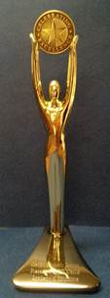With the demands placed upon healthcare providers and the increasing need for students to know more, HOW we educate and train students becomes very important. Approaching medical education from an empirical perspective is vital. We stress the use of empirically validated treatments for our patients, we should do no less in providing education to our students. This past year we awarded the **Academies first “Oscar”** of medical education research to **Brian Fink**. In the past year as a member of the Academy he was part of three posters presented on education (with an additional poster on patient education).

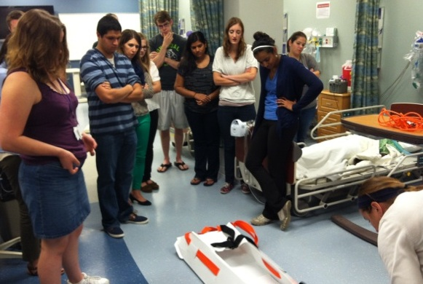In 2012-2013 the Academy with the support of the Dean’s office awarded two medical education research grants. Dr. Satzman of the Department of Public Health & Prevention gave an update on her work: Interdisciplinary Crisis Management for Medical and Public Health Professionals: A semester Course. Kandace Williams of Biochemistry, Cancer & Biology will be presenting the results of her work this Fall: Scientific Communication Skills and Career Goals.

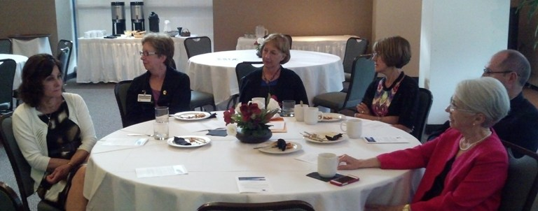One measure of success for any Academy is in disseminating the work that it supports or is accomplished through its members. During the Academy’s Annual Business Meeting we heard results from previous years grant awardees and announced four new awards. During 2013-2014 the following scholarly activities took place either by Academy members or the result of an Academy education grant.

1. Arps G, Didion JA, **Fink BN**. Perceived level of disaster preparedness of rural nurses in a midwest community. American Public Health Association Annual Meeting 2013, November 2-6 in Boston, MA.

2. **Saltzman B**, Rega P, **Fink B**. An interdisciplinary simulation course for disaster preparedness and management. All Together Better Health VII Meeting 2014, June 6-8 in Pittsburgh, PA.

3. Shoup K, Sexton M, Rega P, **Fink B**. Investigating the impact of TeamSTEPPS training on an emergent evacuation of a simulated health care facility. All Together Better Health VII Meeting 2014, June 6-8 in Pittsburgh, PA.

Stay tuned as next year’s Annual report will include additional work that is currently in progress. Dr. Williams’ work will result in Biomedical Science Program graduate students having articles published once a month in the Toledo Blade’s Medicine and Science section.

**2013-2014 Education Research Awardees**

**Virtual Cardiovascular Physical Exam: Using Green Screen Technology to Teach Cardiovascular Auscultation Skills with Immediate Imaging Feedback. Principal Investigator: Jodi Tinkel, MD, Assistant Professor Division of Cardiovascular Medicine**

In cardiology, the stethoscope has been supplanted by multiple imaging modalities including echocardiography, CT, MR and invasive angiography. The proposed technology could be used in a feedback loop to hone physical exam diagnostic skills. I propose to create a series of short educational videos that incorporate auscultation findings using a recordable stethoscope with the imaging results to share with students in cardiology. I will use audio and video technology linked with green screen technology to create the educational videos. I propose a series of 10-12 videos covering topics including valvular heart disease, carotid and peripheral arterial disease to list a few.

**Assessment of Medical Narratives, Primary Author: Patricia Hogue, PA PhD1, Co-PI: Reginald Baugh, MD2, Other co-investigators: Kim Trott RN3, James Jones MBA4, Valarie Takyi MD2, Cassius Hudson Pharm D5**

We propose to use an online methodology to teach acquisition of patient narrative analysis skills. It is with great difficulty students acquire the skill to recognize, collect and document key patient elements from the patient narrative, or history of present illness. We are proposing an educational process whereby the student will process the narrative, emphasizing some points and eliminating others, shaping it into a recognizable medical narrative.

**Building Resiliency in Family Medicine Residents: Primary Investigator: Julie Brennan, Ph.D., R.D., L.D.** Co-Investigators: Angele McGrady, Ph.D., LPCC; University of Toledo, Department of Psychiatry, Linda Myerholtz, Ph.D.; Mercy Family Medicine Residency, Rebecca McClarren, M.D.; University of Toledo, Department of Family Medicine, Daniel Rapport, M.D.; University of Toledo, Department of Psychiatry

The purpose of this study is to study the impact of a resiliency training program on resident’s resiliency, quality of life, burnout and general psychological distress. The Resiliency Training Program is an interactive series of experiential sessions that have been designed based on a review of the resiliency literature. The program will include concepts such as increasing value

as a physician and self-awareness, balancing and prioritizing professional and personal time, maintaining supportive professional and personal support and learning effective practice management style. Additionally, positive psychology principles that include increasing resources, positive connections, perceived control, and emphasizing meaning, mindfulness and flow will be integrated throughout the program.

**Tech+Touch: Developing and Implementing Curricular Innovations to Scaffold Medical Students' Learning in a Service Learning-Intensive Preclinical Elective Course, Yvette V. Perry, PhD, Office of Student Affairs**

The goal of the proposed curriculum development project is to design and implement a system of formal student feedback (formative and summative) in a new service learning intensive (SLI) format of a preclinical elective for medical students. Specifically, I will use "web 2.0" teaching-learning tools to create activities and materials to scaffold students' critical reflection skill development as well as encourage greater self-directed and peer-to-peer learning. In addition to Blackboard's collaboration tools, students will be assigned to watch and respond to brief video lessons I create in the TED-Ed platform (as an example, see my lesson: http://ed.ted.com/on/gmSnt0nx) and "micro response readings" (MRR) on my course feed on the Ponder platform (https://www.ponder.co/). I will develop these materials and activities over several months of the project, using students' work to revise subsequent lessons as well as taking advantage of current events related to the course topic throughout the year.

**_______________________________________________________**

**“Better than a thousand days of diligent study is one day with a good teacher.”**

**-Japanese Proverb**

**____________________________________________________**

**Web Site**

|  |
| --- |
| C:\Users\John\Desktop\Academy\Sackler Academy Logo.jpg |
| <http://www.utoledo.edu/med/academy/> |
| The Academy has its own website, a place to learn more about the Academy and a resource for links to many educational initiatives and resources. |

Introducing Members of the Academy

2013-2014 Academy Steering Committee

Cathi Badik, MD* Assistant Professor Pediatrics  
Carol Bennett-Clarke, PhD* Professor Neurosciences  
Brian F. Fink, PhD, MPH, CHES Associate Professor Public Hlth & Prev Medicine  
Linda French, MD* Professor Chair Family Medicine  
Daniel Hickey, JD* Associate Professor Family Medicine  
Keith Crist PhD Associate Professor Surgery  
Dorothea Sawicki, PhD* Professor Med Microbiology & Immunol  
Constance Shriner, PhD* Associate Professor Faculty Development  
John Wryobeck, PhD* Associate Professor Psychiatry

Members

Andrew Beavis, PhD Professor Physiology & Pharmacology  
George T. Cicila, PhD, FAHA Associate Professor Physiology & Pharmacology   
David Heidt, MD Assistant Professor Surgery  
Boyd Koffman, MD Associate Professor Neurology  
Catherine Marco, MD, FACEP Professor Emergency Medicine  
Richard Mooney, PhD Professor Neurosciences  
Vicki Ramsey-Williams, MD Assistant Professor Neurology  
Howard Rosenberg, MD, PhD* Professor Physiology & Pharmacology  
Steven H. Selman, MD Professor Urology  
Mary R. Smith, MD Professor Internal Medicine  
David Weldy, MD, PhD Associate Professor Family Medicine  
Marlene Welch, MD, PhD* Assistant Professor Surgery  
Mallory Williams, MD, MPH, FACS Associate Professor Surgery  
Mary Wroblewski, MD* Assistant Professor Pediatrics

* denotes founding members of the Academy

**The Mission of the Academy of Educators of the College of Medicine and Life Sciences**

Our mission is to promote student learning, advance the acquisition of knowledge and enhance patient care and health outcomes through teaching excellence. We aim to achieve this by the promotion and dissemination of best practice in medical education and fostering an environment that supports the educational efforts of COMLS teaching faculty. We mean to do this by:

•Promoting innovation in medical curriculum/evaluation methods

•Mentoring and providing learning opportunities for educators at all stages of their career

•Fostering communication among faculty educators

•Encouraging research and scholarship in education

•Identifying and rewarding teaching excellence

Membership in the academy is reserved for full and part-time college faculty with at least half-time appointments who are engaged in educational activity as defined by the AAMC group on educational affairs (teaching, evaluation, curriculum, mentoring and service/leadership).