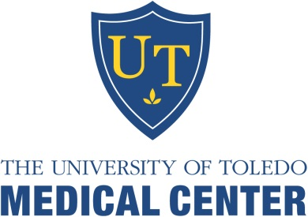
University of Toledo Medical Center
Department of Orthopaedic Surgery
The University of Toledo is accredited by the ACCME to provide continuing medical education for physicians. The University of Toledo designates this enduring activity for a maximum of 2 AMA PRA Category 1 CreditsTM. Physicians should claim only credit commensurate with the extent of their participation in the activity.
Release Date: February 1,2020 Termination Date July 30, 2022

Name: _______________________________________________ Degree: _______________________
Specialty: _____________________________________________
Address: ___________________________________________________________________________
Phone: __________________________________Email (Required):______________________________

Learning Objectives: Participants will be able to:
- Describe common orthopaedic concerns
- Review new treatment options available for common orthopaedic injuries.

February 2020 Orthopaedic Monthly Questions

Please check the appropriate answer and mail back to the CME office to receive credit.
- A triceps tendon rupture…  - Results in weakness of the triceps  - Should be diagnosed and repaired early.  - May be assessed by the “flake sign”.  - Reconstruct by graft in chronic cases.  - All the above.  - Posterior dislocation of the sternoclavicular joint…  - Is less common.  - Is more dangerous than anterior dislocation.  - May result in dyspnea.  - Closed reduction with cardiac surgeon back up.  - All the above | - A pediatric transepiphyseal dislocation...  - The elbow moves posteriorly and medially.  - The elbow moves posteriorly and laterally.  - The elbow moves anteriorly and laterally.  - The elbow moves anteriorly and medially.  - What do you look for when reading an x-ray of the elbow in a child?  - The non-rotated high definition x-ray.  - The position of normal ossification centers  - Posterior fat pad sign.  - Position of the capitellum.  - All the above.  - Anterior sternoclavicular joint injuries…  - Are usually common.  - Does not affect shoulder function.  - Are usually unstable after reduction  - Are less serious than a posterior dislocation  - All the above.
Bibliographic references:
- Functional Outcomes of Distal Triceps Tendon Repair Comparing Transosseous Bone Tunnels with Suture Anchor Constructs. Journal of Shoulder and Elbow Surgery. Dec. 2017;26(12):2213-2219.Epub2017 Oct 9. PMID: 29032989
- Sternoclavicular Joint Dislocation:A systematic review and meta-analysis. Journal or Orthopaedic Trauma. Feb.2019;26; Epub 2019 Feb.26. PMID: 30844956
- Radial Neck Fracture in Children: Results When Open Reduction is Indicated. Journal of Pediatric Orthpaedics. 2014 Dec:34(8):756-62 PMID 25171679
To receive CME Credit, you must obtain at least 80% (4/5).
_____ Check Payment: Mail ($15 payable to UT-CME) along with completed post-test to: Center for Continuing Medical Education, The
University of Toledo, 3000 Arlington Ave, MS #1092, Toledo, OH 43614.

_____ Credit Card Payment: Email completed post-test to:
ContinuingMedEd@utoledo.edu (include phone # so we can contact you to obtain payment information)

