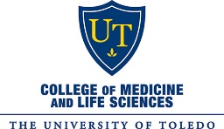

UTCOMLS’ Global Health Program

STUDENT FORM 2: ACKNOWLEDGEMENT OF INFORMED CONSENT, WAIVER, AND RELEASE AGREEMENT
[For Signature Prior to Participation in a University-Approved Global Health Elective]

This is a release of legal rights and reflects the informed consent to the many risks of, and procedures and standards of conduct for, The University of Toledo College of Medicine and Life Sciences’ (UTCOMLS) Global Health electives/rotations/medical missions. Participant must read and understand before signing.

I am a student at The University of Toledo College of ________________________________ and have asked for permission to participate in a University-approved Global Health elective/rotation/medical mission for _____ not for _____ University credit and/or with University funding.

Name: _______________________________________________________________________________

Global Health Site/UTCOMLS’ Medical Mission:

Dates of Global Health Rotation/Medical Mission:

UTCOMLS’ Faculty Supervisor: _______________________________________________________________

Global Health Program Advisor: Deborah Krohn, M.Ed.

Students must initial each paragraph below and sign and date the final page.

In consideration of being permitted to participate in an approved UTCOMLS’ Global Health elective/
rotation/medical mission at an approved affiliate site outside the United States, I agree to the following:

ACKNOWLEDGEMENT OF RISK

- Notwithstanding any agreement by the University to award academic credit for the course of study I undertake, the University has not required me to participate in this Global Health experience in any way, and my academic progress at the University will not be adversely affected if I decide not to participate. I understand that the University has not undertaken any kind of control or supervision over the institution at the Global Health site. __________

- I understand that there are unavoidable risks in travel and living abroad including, but not limited to the following: risks of transportation, risk of foreign/political/legal/social/economic conditions, risk of standards of design/safety/maintenance of buildings, public places, and conveyances, risks of local medical and weather conditions, and other unanticipated risks. I have full knowledge of the nature and extent of the risks associated with the experience, including but not limited to any manner of injury resulting from staying in a location not operated by the University, injuries that may occur due to the use of different standards of care applied to the medical practice, transportation, travel, war, weather, sickness, quarantine, government restriction or acts of any agent, entity or third party. __________

- I have read all current recommendations and advisories issued by the U.S. Department of State and the Center for Disease Control as to the risks of travel to, from, and within my Global Health site. I promise to stay current on such information and communicate with Global Health site and UTCOMLS’ contacts regarding any developing risks. __________

RELEASE, INDEMNIFICATION, AND COVENANT NOT TO SUE

- I understand that the University does not control or run every aspect of this Global Health experience. I acknowledge that I am ultimately responsible for my own safety and that the University has a very limited obligation to provide supervision and oversight for my safety on the experience. Knowing that I am voluntarily assuming these many anticipated and unanticipated risks, and in consideration of being permitted to participate in the Global Health experience, I, (print name) ____________________________, the undersigned, HEREBY RELEASE AND WAIVE THE RIGHT, on behalf of myself, my family, heirs, and personal representative(s), to any claims or potential claims whatsoever for any and all liability for harm, injury, damage, claims, demands, actions, causes of action, costs and expenses of any nature, including death or loss of any kind, that I may have or that may accrue to me, arising out of/or related to my participating in this Global Health experience. I further agree to indemnify and hold harmless the State of Ohio and The University of Toledo, its Trustees, officers, employees, faculty, students and all other of its agents, from any claim, liability or damage of any kind caused by me arising out of or related to my participation in this Global Health experience and any travel I undertake in connection with it. __________

- If the U.S. Department of State or Center for Disease Control issues a travel warning or alert for my Global Health site prior to travel, I understand my eligibility to have a Global Health experience at this site may be revoked at the consideration of The University of Toledo, and I will incur all monetary fees and penalties resulting from travel cancellation. In the event such alerts or warnings are issued while I am abroad, determination of the appropriate action will be made on a case-by-case basis, with The University of Toledo having the authority to require me to return to the United States. I understand that if it is required that I must return to the United States early, I will incur all fees and penalties for altering my original travel arrangements. __________

- I, on behalf of myself, my family, heirs and personal representative(s) hereby grant The University of Toledo and its agents full authority to take whatever actions they may consider to be warranted under the circumstances regarding my health and safety and fully release each of them for any liability for such decisions or actions as may be taken in connection therewith. I authorize The University of Toledo and its agents, at their discretion, to place me at my own (or my parents’) expense, and without further consent by me, in a hospital within or outside the United States for medical services and treatment or, if no hospital is readily available, to place me in the hands of a local medical doctor for treatment. If deemed necessary by The University of Toledo or its agents, I authorize my transportation to the United States by commercial airline at my own (or my parents’) expense for medical treatment. I understand that, should my participation be terminated, The University of Toledo may purchase a tourist class return air ticket for me and I agree to reimburse The University of Toledo for such expenditure. I hereby release The University of Toledo and its agents from all liability and responsibility in the event that I leave prior to or extend my stay beyond the dates specified in this release. I hereby agree to indemnify and promptly reimburse The University of Toledo or its employees or agents for all medical expenses incurred on my behalf or benefit, and for all transportation or other extraordinary expenses incurred for my benefit, when in the opinion of The University of Toledo or its agents such expense must be incurred for my safety or best welfare. __________

- I understand that The University of Toledo is not responsible for any monetary or property loss incurred by me at any time during the planning, preparation, or participation in the Global Health experience. __________

ASSENT TO RULES OF CONDUCT

- I understand that each foreign state has its own laws and standards of acceptable conduct. I recognize that behavior, which violates those laws or standards, could harm The University of Toledo, as well as my own health and safety. I have informed myself to the best of my ability of the local laws and standards, and I understand I am solely responsible for the consequences of any violations I incur at the Global Health site. I will assume the risk of any legal problems I may encounter with any government or controlling administration at the Global Health site. The University of Toledo is not responsible for providing any assistance under such circumstances. __________

- As a representative of The University of Toledo and of the medical profession, I promise to know and adhere to the laws of the host country and the countries through which I travel to reach and return from there, to know and adhere to The University of Toledo’s code of conduct for students, to the standards of professional behavior that govern U.S. and Ohio health-care professionals, including those articulated in the American Medical Association’s Code of Ethics, in the laws of the State of Ohio, and by the State of Ohio’s Licensing Board, and to any standards of conduct at the Global Health site. __________

- I also acknowledge that the student handbook and any other rules applicable on the home campus also apply overseas. __________

- I agree to follow the UTCOMLS’ Student Occupational Exposure to Blood Borne Pathogens/Needle Stick and Airborne Pathogens/Tuberculosis Policy (Policy Number: 3364-81-04-016-04) throughout my Global Health experience.

Universal blood and body fluid precautions lessen the risk of exposure to such fluids, and these precautions must be used routinely.

In the event of exposure to blood or bodily fluids, I will immediately:
- Excuse myself and decontaminate (wash with soap and water) the exposed site immediately;
- Report to my immediate supervisor (Attending/Fellow/Resident Physician); and
- Get to care without delay for immediate treatment.
    - If at University of Toledo Medical Center – I will go to the Emergency Department and identify myself as a medical student. University of Toledo Occupational Health (419.383.5598) is located in the Emergency Department.
    - If at an outside facility (for away rotations/Global Health electives/Medical Missions) – follow the host institutional policy if known or go to the Emergency Department.
In the event of exposure to blood of bodily fluids, I will follow up after immediate treatment.
- Regardless of where the initial care is received, it is my responsibility to bring in medical records for follow-up care at Student Wellness Center (419.383.3745) to avoid delays in treatment.
- I will schedule a follow-up visit to review the results of baseline testing, provide additional counseling and support and assess medication side effects, compliance, and provide additional medication, if applicable.
- I will notify the Office of Student Affairs and fill out the Student Accident and Injury report, if not done already. The Office of Student Affairs will contact the Office of Disability as deemed necessary.
Payment
- At The University of Toledo Medical Center Occupational Health, all charges will be waived.
- Outside facilities: If the hospital does not cover the cost, then The University of Toledo College of Medicine will cover the student’s out-of-pocket costs up to a maximum of $1000.
- Student Wellness Center for follow-up care: Any additional testing costs will be borne by me, the student. __________

- I understand that (1) many U.S. students and travelers have been jailed for years and have suffered greatly in other ways as a result of drug-related incidents while traveling outside the United States; (2) the U.S. Embassy or Consulate can only aid U.S. citizens in obtaining legal assistance to manage their legal difficulties, and cannot guarantee that such aid will result in release from foreign jails or other remedies; (3) illegal activities involving the possession or use of illicit drugs place not only me but also other students who may want to travel to this Global Health site, and The University of Toledo, more generally, in jeopardy; and (4) I am a representative of The University of Toledo, the medical profession, and the United States of America, and that my use of illegal drugs may bring lasting disgrace to all of them. __________

- In light of these possible harms to me, others, and the institutions I represent, I, (print name) _______________________________________________________________, promise that during this Global Health experience I will refrain from the use or possession of any quantity of marijuana, cocaine, heroin, or any other drug or intoxicant deemed illegal according to the laws of the United States of America, the country of my Global Health site, and any other countries in which I am traveling to reach or return from my site. I further promise to use alcohol responsibly during my entire Global Health experience. __________

- Further, I, (print name) _____________________________________________, understand that, should I break this promise and use or possess any illegal drugs, or use alcohol excessively, or cause any other behavioral or professionalism issue, I may be faced with any to all of the following consequences:
- Immediate termination of this Global Health experience;
- Total forfeiture of all fees and monies paid for this experience;
- Loss of all academic credit for this experience;
- Prohibition from participating in all future Global Health experiences; and
- All other consequences deemed appropriate under The University of Toledo policies. __________

COMPLIANCE WITH RISK-REDUCTION PROCEDURES

- I have secured health insurance from either:
- CISI (Cultural Insurance Services International) – https://www.culturalinsurance.com/SelfEnrollment/UTOL as mandated by UT Risk Management for month-long rotations/medical missions which will provide me with the following foreign coverage limits: __________

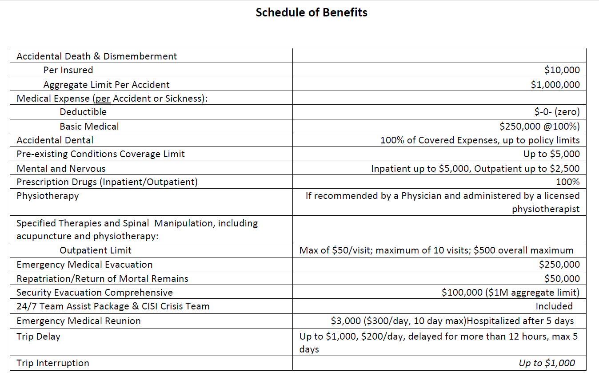
or
- United Healthcare Global Safe Trip 2 - https://www.uhcsafetrip.com/ ($500,000 Medical/Accidental Coverage amount with zero deductible) for medical missions less than one month in length which will provide me with the following foreign coverage limits: __________
    - $500,000 Medical/Accident coverage amount per person.
    - Zero deductible.
    - $1,000,000 Medical Evacuation.
    - Medical Repatriation.
    - Return of Children.
    - Emergency Reunion.
    - Return of Mortal Remains.
    - $25,000 Accidental Death Dismemberment.
    - Baggage Loss - $250 per Article / $1,000 max limit / $50 deductible.
    - Baggage Delay - $250 / 24-hour delay.
    - Medical Assistance, Travel Assistance, and Destination Intelligence included.

- I have provided documentation of CISI or United Healthcare Global Safe Trip 2 (($500,000 Medical/Accidental Coverage amount with zero deductible) insurance coverage to the Global Health Program. In addition to providing documentation as required by the Student Global Health Experiences Policy, with my signature below, I certify that I have confirmed my health care coverage meets the above stated requirements, and hereby release the State of Ohio and The University of Toledo, its officers, employees, faculty, and agents from any responsibility or liability for expenses or damages incurred by me for injuries or illnesses (including death) that I may incur. __________

- I have read and understand all Student Global Health forms required and understand my requirements for participating in this experience. __________

- I will complete all Global Health Forms and their required attachments, and any other forms or requirements considered necessary by the Global Health Program/Committee for my particular site location, and return them to the Global Health Program Advisor prior to my leaving for the experience. __________

- After completion of the Global Health experience, I will complete my MedEd evaluation within 5 days or my rotation/medical mission end date. __________

- I understand, as a UTCOMLS’ 4th year medical student, that I am fully responsible for completing all clinical elective requirements listed below:
  - completing my UTCOMLS’ MedEd evaluation within 5 days of the rotation end date;
  - presenting my rotation/medical mission with my travel group at the annual Global Health Forum hosted on the Wednesday of UTCOMLS’ graduation week;
  - forwarding the Global Health Program Advisor my reflective piece and photos to share on the Global Health website as well as my personal email address to share with future UTCOMLS’ medical students completing the same rotation. __________

- I agree to release the following information to the UTCOMLS’ Global Health Program to assist in connecting students, faculty, and staff interested in participating in a future clinical elective or medical mission and for promotional advertising/recruitment of future student participants via UT-sponsored Global Health Program website.
- name;
- Global Health Program location and dates of participation;
- reflective piece;
- photos;
- shared personal email address with rising 4th year medical student participants. . __________

- I understand that the only activities that are sponsored by the host university/institution during a Global Health experience are limited to those necessary to accomplish the goal(s) of the Global Health experience and that inherently dangerous activities (such as bungee jumping, cliff climbing, etc.) are not part of the sponsored experience. __________

- I understand I am generally safer when I travel with a trusted companion or companions, to, from, and within the Global Health site and have done and will do what I can to do so. __________

- I also understand that it is significantly safer for me to use public transportation or approved transportation companies, even if I legally hold a valid international driver’s license. __________

- I agree to attend a pre-departure orientation with the Global Health Program and/or UTCOMLS’ Faculty Leader before departing for my Global Health experience. I agree to attend all orientation meetings upon arrival; to be supervised at the Global Health site by my Global Health site supervisor/coordinator; to contact my UTCOMLS’ faculty supervisor and/or Global Health Program Advisor weekly while on site if my trip is longer than two weeks; and to contact my Global Health site emergency contacts, my UTCOMLS’ faculty supervisors or Global Health Program staff, the U.S. Embassy, and my insurance plan’s emergency contact, if necessary, should any emergency or other trouble arise. __________

- I understand that competency or training in the local language is strongly encouraged, and that when this is not possible, that, for my health, safety, and effectiveness, I should become familiar at a minimum with common phrases and health care terms. __________

CONCLUDING STATEMENTS

- I certify that I am in good health and that I have no physical/psychological limitations that would preclude my safe participation in the Global Health experience. __________

- I agree that should any provision or aspect of this agreement be found to be unenforceable, all remaining provisions of the agreement will remain in full force and effect. __________

- I represent that my agreement to the provision herein is wholly, voluntary, and further understand that, prior to signing this release, I have the right to consult with the advisor or attorney of my choice. __________

- I agree that, should there be any dispute concerning my participation in the Global Health experience that would require the adjudication of a court of law, venue will lie in an appropriate jurisdiction in Ohio and that the laws of the State of Ohio will govern. __________

- This agreement represents my complete understanding with The University of Toledo concerning The University of Toledo’s responsibility and liability for my participation in the Global Health experience, supercedes any previous or contemporaneous understandings I may have had with The University of Toledo on this subject, whether written or oral, and cannot be changed or amended in any way without written concurrence from both myself and The University of Toledo. __________

I HAVE CAREFULLY READ THIS FORM AND INITIALED AFTER EACH PARAGRAPH BEFORE SIGNING IT.

_________________________________ ____________________________ ______
Student Signature Student Name Printed Date

________________________________________ Deborah Krohn, M.Ed. ______
Global Health Program Witness Witness Name Printed Date

In addition, if student is under age 18:
As parent and/or guardian of the above-signed student, I also hereby release and discharge The University of Toledo, its Trustees, officers, employees, students, and all other of its agents under the terms of the above agreement from any claims which I might have against The University of Toledo or its agents both in my own behalf and as legal representative of the above–signed student. I also agree to reimburse The University of Toledo for any expense it incurs on behalf of my child, including any medical or transportation expense, which are not included as part of the regular program.

______________________________ ______________________________ ______
(Witness of Signature) (Signature of Parent or Guardian of Student Date under the age of 18)

For traditional, month-long, clinical rotations, your supervisor is Kris Brickman, M.D. – Director, Global Health Program. For approved UTCOMLS’ faculty-led, team-based medical missions, your supervisor is the UT faculty member leading the medical mission.
The UTCOMLS’ Global Health Program Advisor will privately share former participants’ personal email addresses with medical students interested in participated in said rotation/mission. Personal email addresses will not be listed on UTCOMLS Global Health Program website.
Deborah Krohn, UTCOMLS Global Health Program Advisor, will serve as your required witness. She will witness your form at your required pre-departure orientation. Revised 06/2019_DMK

