This document is will guide you through the necessary steps to email receipts to another user’s profile. Delegate access is required in order to send receipts for another user. For more information about delegates, please review Adding a Delegate and Acting as a Delegate.

Verify Email Addresses
In order to successfully send receipts to Concur, each user’s email address must be verified. This includes the Delegate and Delegator. To verify an email address:
- Navigate to the user’s Profile within Concur.
- Click Email Addresses under the Your Information heading.
- Click Verify for any known email accounts you would like to use.

Emailing Receipts to your Delegator’s Profile
When preparing the email to your delegator’s Receipt Store:
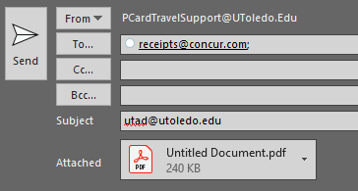
- Use your verified email address to send the email.
- Receipt images can either be attached to the email or embedded in the email content. Supported image formats are .html, .jpg, .jpeg, .pdf, .png, .tif, or .tiff.
- Send the email to receipts@concur.com.
- Enter your delegator’s verified email address in the Subject line of the email.
Note: The receipt image will appear in your Receipt Store if your delegator’s email address has not been verified, or if you are not identified as a delegate for the individual. If you are sending the email from an address other than the one you verified, the image will be discarded and not appear in any user’s Receipt Store.

