**Pnet4 Issues/Resolution**

**How do I Review/Approve in the new Pnet4 system?**

After you open a transaction there is a Review/Approve section above the Accounting Code box. Only the actual cardholder can select the Review box, then they should select from the drop down box an Approver to forward this transaction to.

If you are reviewing a transaction for another cardholder you will not have access to the Review box, only the Approve box (if you are listed). You can always use the Historical Review option for reviewing/approving. This will show as checked when you print your monthly Report, but will not change the Status of the report on the main screen.

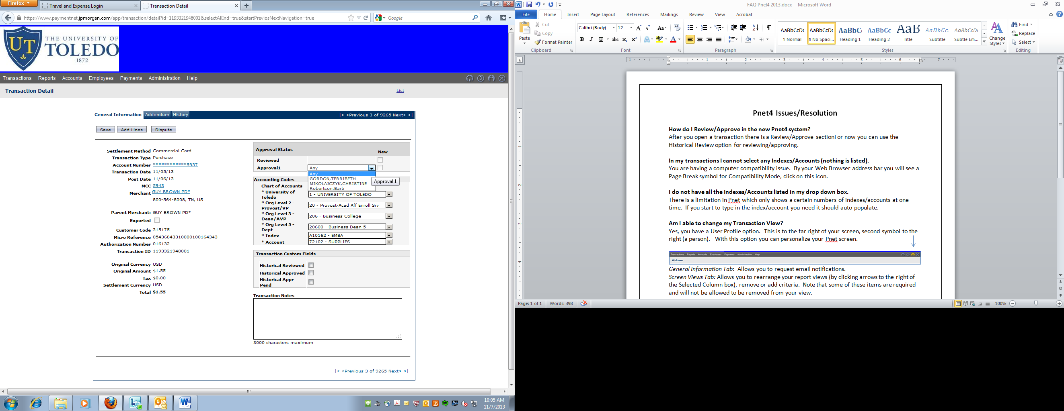

**In my transactions I cannot select any Indexes/Accounts (nothing is listed).**

You are having a computer compatibility issue. By your Web Browser address bar you will see a Page Break symbol for Compatibility Mode, click on this icon.

**I do not have all the Indexes/Accounts listed in my drop down box.**

There is a limitation in Pnet which only shows a certain numbers of indexes/accounts at one time.  If you start to type in the index/account you need it should auto populate.

**Am I able to change my Transaction View?**

Yes, you have a User Profile option. This is to the far right of your screen, second symbol to the right (a person). With this option you can personalize your Pnet screen.

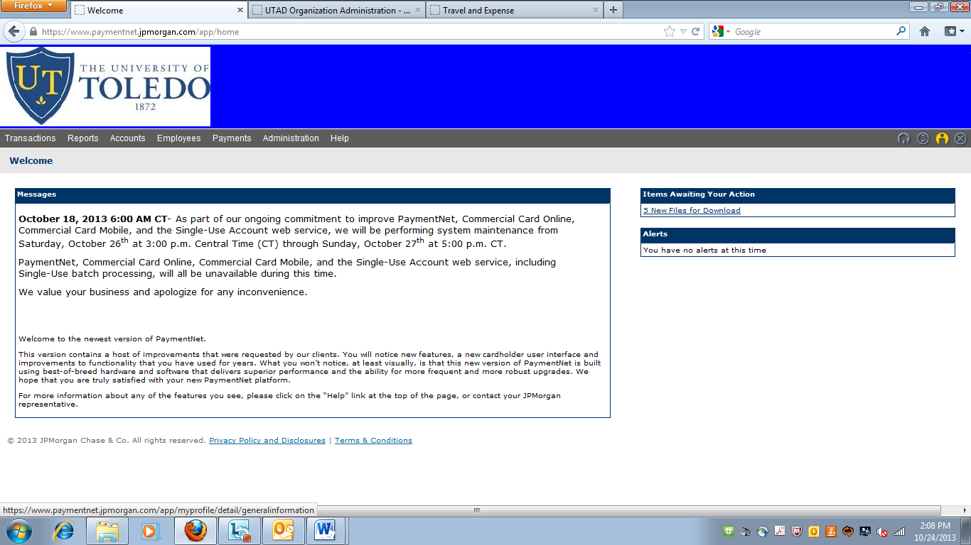

*General Information Tab*: Allows you to request email notifications.

*Screen Views Tab:* Allows you to rearrange your report views (by clicking arrows to the right of the Selected Column box), remove or add criteria. Note that some of these items are required and will not be allowed to be removed from your view.

**Can I see current transactions, even those that are declined?**

Yes, under Transaction- Authorizations/Declines you can see instant transactions. This will allow you to see if your transactions have gone through or the reason why the transaction was cancelled. Please note that it will take a day or so for these transactions to appear on your main Transaction screen for editing (it all depends on how quickly the vendor approves the transaction on their end).

**How can I see transactions that have been downloaded into Banner?**

In your Transaction View there is now a field called Exported. This will have a check mark by it if the transaction has been downloaded into Banner and therefore locked for your edits. Unfortunately, with this new system you are also locked from making any electronic notes as well. If you do have a note to add, please make sure to add it to your Monthly Pcard Packet.

**Has Monthly Reporting changed?**

No, all policy/procedures are the same as they always have been. Under the Reports section you will still run the Transaction Detail with Accounts Codes and Notes for your Monthly Pcard Packet each month.

**How do I split a transaction?**

When you go into a transaction, click on the button “Add Lines” it will ask you how many line you need, enter the number and click the “Add” button.

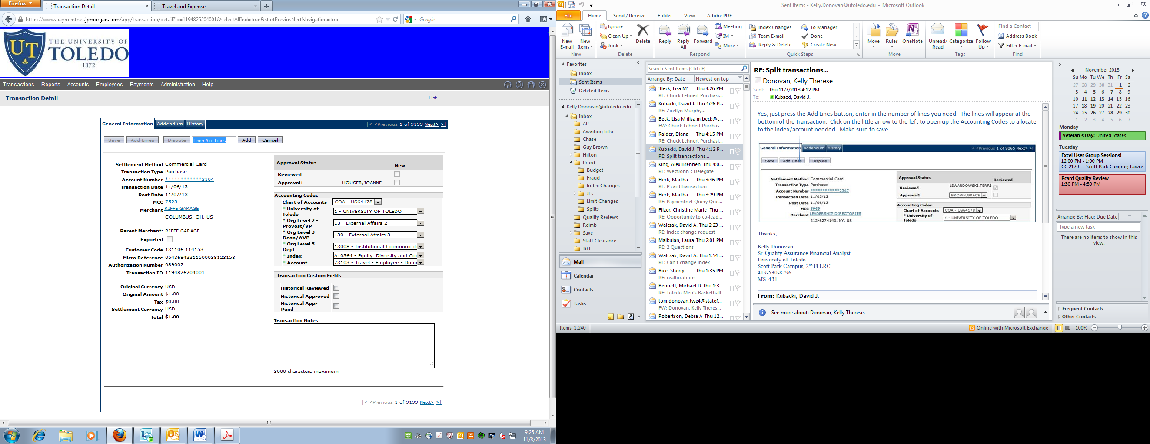

The lines will appear at the bottom of the transaction, click on the arrow to the left of the line item to allocate to an index/account.

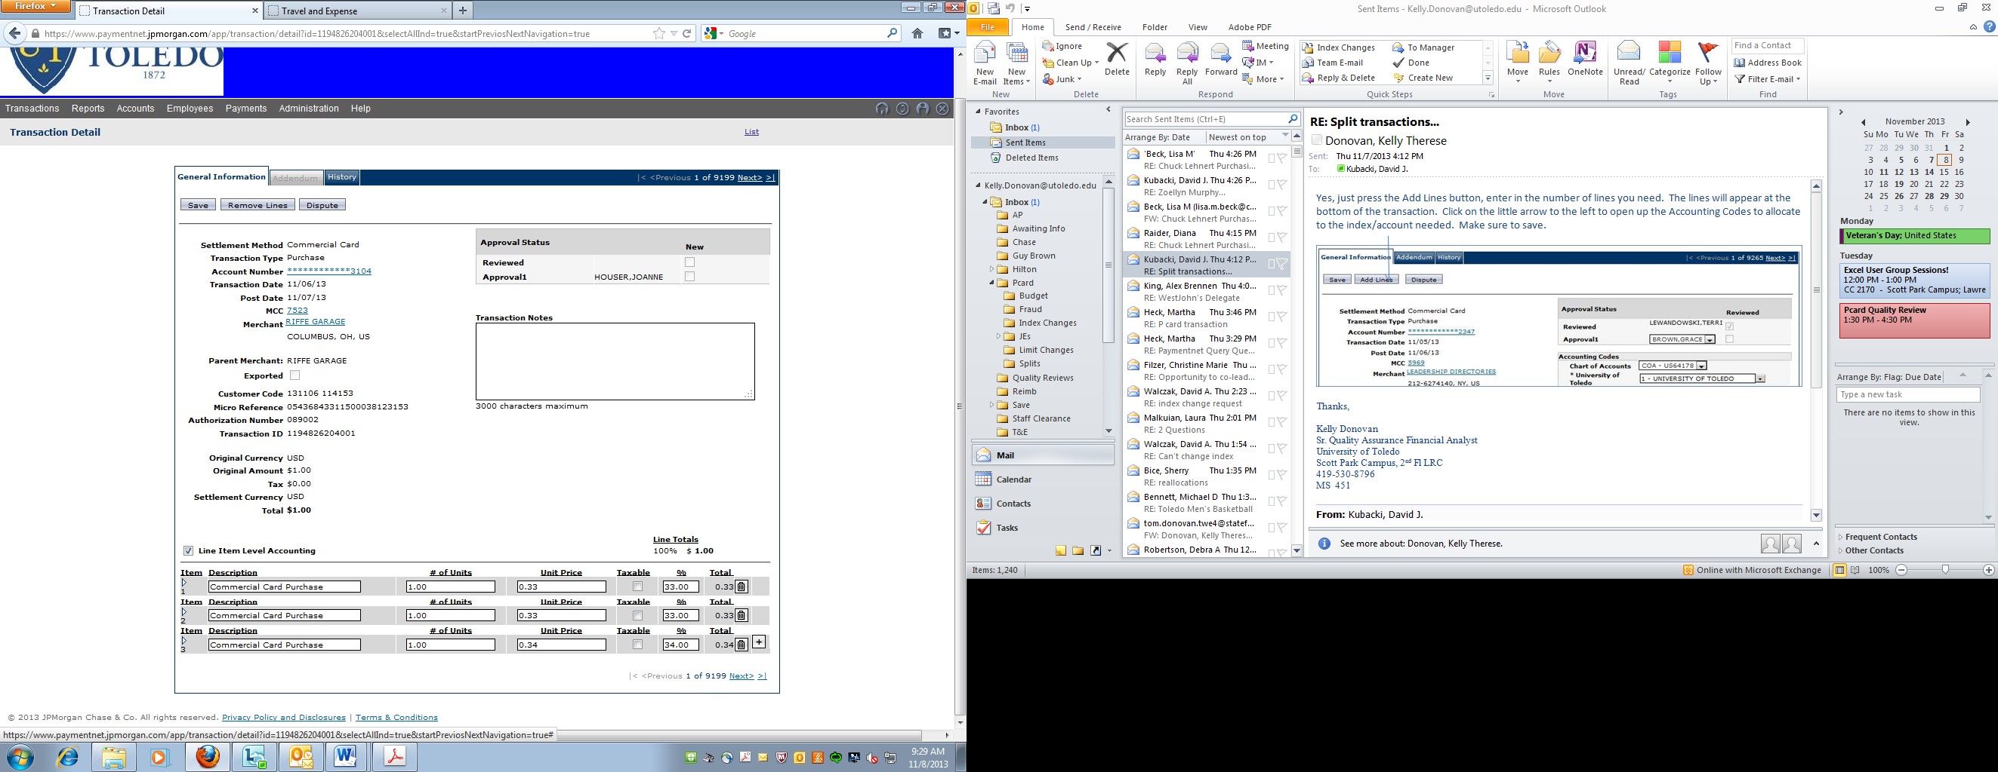

**When running a Transaction Query, how do I find the Index?**

Under Transaction, query: all hierarchy levels are located in the Field, “Accounting Code Values”. In Chart Name select, COA – US64178. Under the Segment Name you have the option of selecting Org Level 2, Org Level 3, Org Level 5, Index, or Account. Once you select and option, type in the value in the Segment Value line. Click the Process button to run the query.

*\*\*Please note in the date range, it will automatically default to the last 30 days unless you specify otherwise.*

