BANNER TRAVEL & REIMBURSEMENT OVERVIEW (THE APPROVER)

From an Approver standpoint, you will receive an email stating that you have a Travel & Reimbursement form submitted to you for your approval.
It will be addressed from APTravelExpense@UToledo.edu and it will have a general overview of the travel expense including: the document code, the traveler, the business purpose, the description, the comments, the reimbursement amount, the payment form and the total payment amount of the trip.
Within the email, there will be a hyperlink which will take you to the Workflow sign-in page.

There are multiple places to access Workflow:
- MyUT/Self-Service Home Page within the ‘Workplace Tools’ section, subsection ‘Travel & Reimbursement Information’
- Accounts Payable Travel page
- Notification email received will have a hyperlink to Workflow
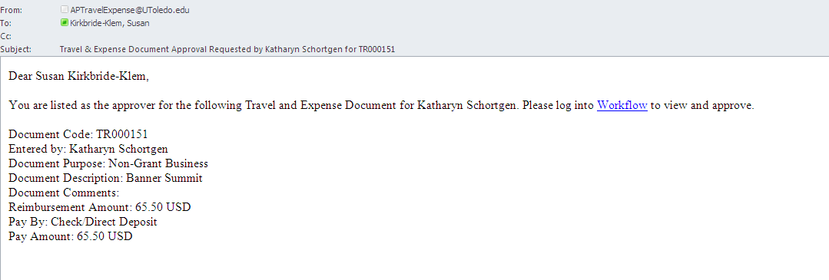
To review and approve the Travel & Reimbursement document submitted to you for approval, follow the steps below:

- The Banner Workflow log-in screen will appear using one of the links mentioned above. Log-in to the system by using your UTAD as the Username and your UTAD Password as the Password. Click on the “Submit” icon.

- If you use the link in the email, the exactly Travel & Reimbursement document will appear. If the general link is used, you will be shown a list of your current workflow documents to choose from under ‘Worklist’. Press on the name of the document you would like to view.
*Note: ‘Worklist’ is the default screen when you log into Workflow.

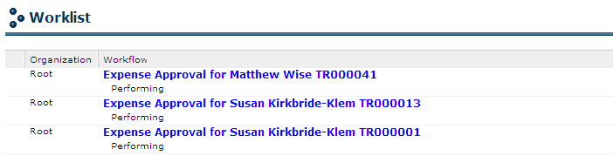

Once within the specific travel document you will see a general summary of the traveler’s trip.

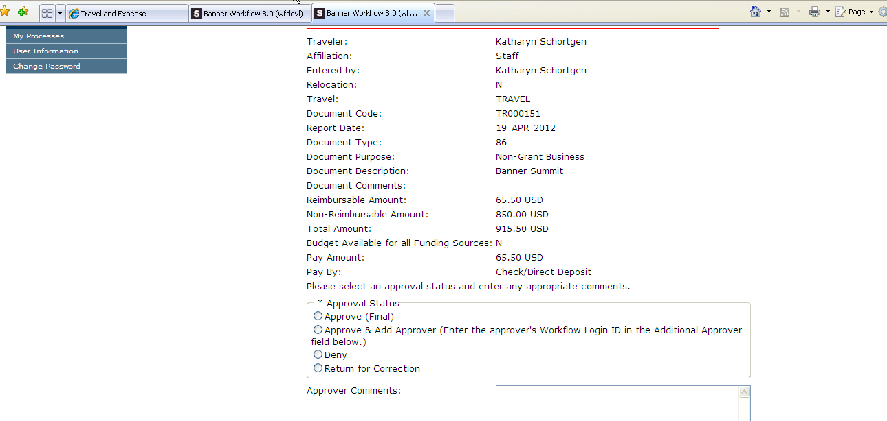

To review the traveler’s corresponding documents related to the Travel & Reimbursement form, you will need to press the ‘Travel & Expense Page’ hyperlink at the bottom of the page.

After clicking on the Travel & Expense Page link, you will be see the Travel & Reimbursement module login and your will log-in using your UTAD and UTAD password. It will bring up the same four tabs as described in the Travel & Reimbursement module directions as well as the Status History of the TR document.

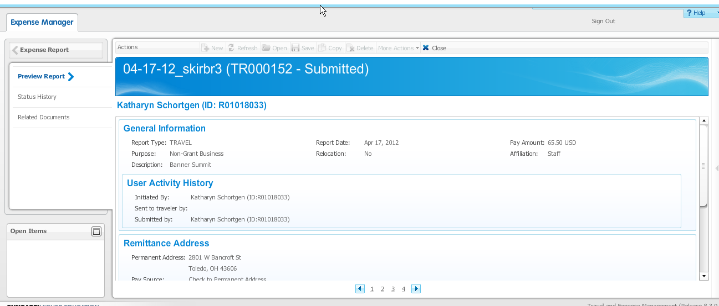

- After reviewing the information in the Travel & Reimbursement module, you can sign out and return to Workflow.

*Note: how to complete a Travel and Reimbursement form (documentation, attachments, comments etc) are in the Travel and Reimbursement directions.

- Once the approver has reviewed the supporting documentation, there are four radio dials to choose from.

Approve (Final) – means you approve of the TR document and the report will automatically route to Grants (if necessary) and onto Accounts Payable/Banner Finance for final approval.
Approve & Add Approver – means you approve of the TR document but you would like to have an additional individual approve the document as well. (See further directions below)
Deny – means you do not approve of the TR document and do not want to allow further changes. If you select this option, the traveler cannot make any revisions or resubmit for approval. If you do reject the TR document form, please leave comments in the ‘Approver Comments’ box as to why it was denied so the traveler will know.
Return for Correction – means you do not approve of the TR document form as it was submitted and you would need something about it changed. If you select this option, please leave information in the ‘Approver Comments’ box for the traveler as to what corrections you need made so the document can be approved.

If you wish to have an additional approver review the TR document, you will need to provide the approver’s UTAD in the ‘Additional Approver’ box.

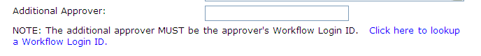

If you do not know the additional approvers UTAD, click on the hyperlink ‘Click here to lookup a Workflow Login ID’ near the ‘Additional Approver’ box.

The “Workflow Userid Lookup” screen will appear. Type in the person’s first and last name. Click on the “Find…” icon.

The available names will appear below, be sure to pick the correct person by checking their related email and department. Choose the person by clicking on the hyperlink “Select”.

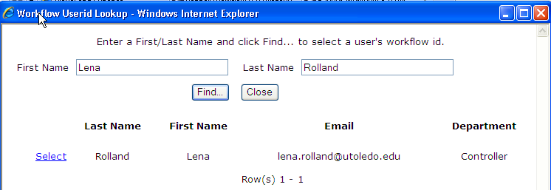

Then click on one of the three options available to finish the process.

Complete – means the approval is done and the line item will be removed from Workflow.
Save and Close – means nothing have been approved and the document will still be there later for you to bring up and review again.
Cancel – means you will not save any work that you entered.

All actions taken in Workflow during the review process of the TR document will result in an email from the approver’s email address stating the action taken by the approver: approved, denied etc. An example would be like the screenshot below:

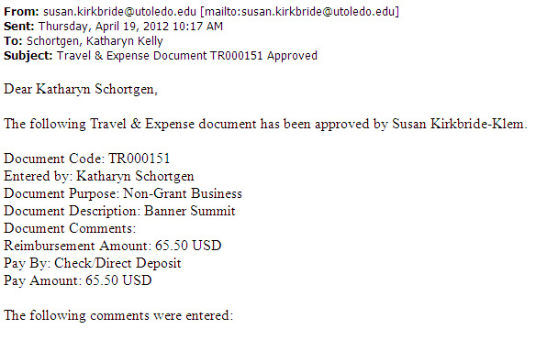

Set-up a Proxy in Workflow:

A Proxy can work on behalf of an approver in Workflow.

- Press the ‘User Information’ section on the left hand side of the screen.
- Press the ‘Add Proxy’ hyperlink next to the Role Name of Approve. (You could possibly have more Role Names other than Approver)

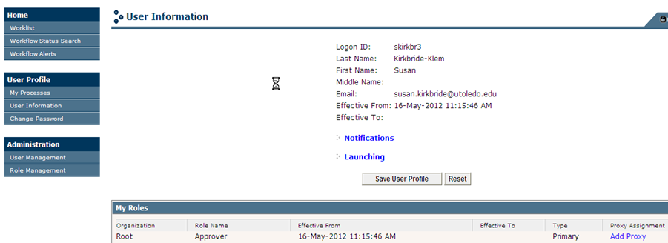

- Select the UTAD of the individual that you are setting-up as your proxy.

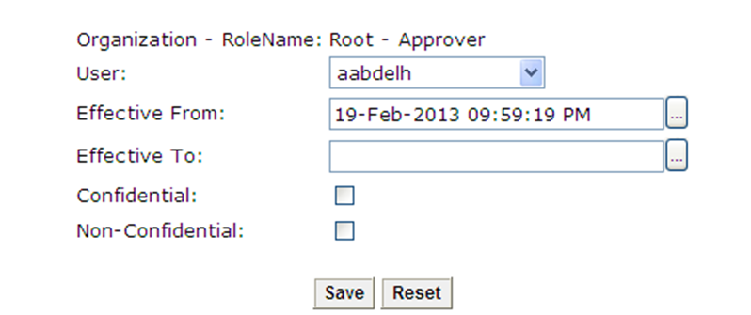

- The ‘Effective From’ will populate with the current date and time.
- Provide the ‘Effective To’ date
- Select both Confidential and Non-Confidential
- Press Save when all the information has been provided.
- Back on the main page the person you selected as your proxy will be listed under the ‘My Proxies’ Section.

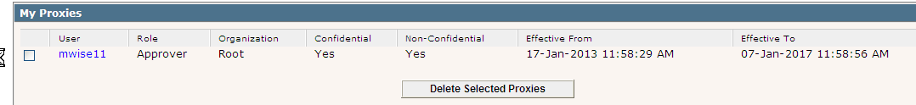
*Note: you can have multiple proxies. Also, only the Approver can set someone-up their own proxy, no one can set-up a proxy for someone else.

- Also on the ‘User Information’ area you can see who you are a proxy for.

Proxy Information:
A proxy could have two types of TR documents in their ‘Worklist’: TR documents sent direction to them as an approver or TR documents sent to an individual the approver is a Proxy for. If the document was original sent to an approver a person is a proxy for, the area to the left will have the below symbol. If the TR Document was sent directly to the approver, the area to the left of the expense name will be blank.
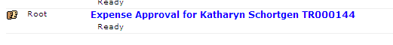
A proxy cannot access the detail of the TR document utilizing the ‘Travel & Expense Page’ hyperlink. Only the approver and not their proxy can use the link. Therefore, a proxy has two choses in order to see a TR document’s detail: become the Traveler’s delegate or utilize the ‘Approve & Add Approver’ button. The proxy would ‘Approve & Add Approver’ on behalf of the approver and would then send it to themselves as an additional approval. The proxy can still deny or return for correction when the TR document is in their personal ‘Worklist’.

