THE UNIVERSITY OF TOLEDO

PURCHASING CARD MANUAL

Table of Contents

1. Purpose 5
2. Benefits 5
3. Issuance of P-Card 6
4. How it Works 6
4.3 Responsibilities 6
4.3.1 Cardholders and Approvers are responsible for completeness and compliance by: 6
4.3.2 Department Budget Authority is responsible for 7
4.3.3 Cardholders are responsible for 7
4.3.4 Approver (Business Manager, Manager, or Designee) are responsible for 8
4.3.5 P-Card Administrator and Senior Quality Assurance Analyst are responsible for 9
5. Purchasing with the P-Card 9
6. Returns and Exchanges 11
7. Credits and Rebates 11
8. Disputes 11
9. Fraud 11
10. Lost, Stolen, Misplaced or Damaged Cards 12
11. Card Expiration 12
12. Cancellation of Cards 13
13. Transferring a P-Card 12
14. Declined Transactions 13
15. Prohibited P-Card Use 14
16. Authorized P-Card Use 15
16.2 Transactions Requiring Special Documentation or Processes 15
16.2.1 Personal/Restricted Charges-Procedure for reimbursing UT 15
16.2.2 Gift Cards 16
16.2.3 Gift or award type items 19
16.2.4 Food/Beverages for Human Consumption 20
16.2.5 Food for Non-Human Consumption 20
16.2.6 Entertainment expenses 20
16.2.7 Third Party Payment Providers 20
16.2.8 Services 20
16.2.9 Changing indexes/accounts 20
16.2.10 P-Card Sharing 21
16.2.11 Contractual Agreements 22
16.2.12 Emergency or Unusual Purchasing Situations 22
17. Travel – Employee 22
17.2 Before Travel 22
17.3 International Travel 23
17.4 During Travel 24
17.4.1 Lodging refer to Travel Policy – Section 2(c)(i)(ii)(iii)(iv) 24
17.4.2 Privately-owned Vehicles refer to Travel Policy – Section 2(a)(ii) 24
17.4.3 Rental Cars refer to Travel Policy – Section 2(a)(iii) 24
17.4.4 Meals refer to Travel Policy – Section 2(b)(i) 25
17.4.5 Business Meals refer to Travel Policy - Section 2(b)(ii) 25
17.4.6 Miscellaneous expenses refer to Travel Policy - Section 2(e)(i)(ii)(iii) 25
17.5 Travel for non-university personnel refer to Travel Policy – Section (7) 26
17.6 Athletic department team travel refer to Travel Policy – Section (8) 26
18. Sponsored and Grant Funded Programs 26
19. Records Retention 27
20. Quality Assurance Service & Compliance Reviews 27
21. Misuse of P-Card 28
22. Disciplinary Actions Steps 29
PaymentNet User Guide 30
Reviewing a Transaction 34
Editing a Transaction 35
Split Transactions 36
Edit a Row 36
Disputes 39
Creating a Query 41
Creating Reports 43
Generate the Report 43
Print Report 43
Paymentnet -Quick Reference Guide 46
Scanning or Saving P-Card transaction documents/monthly statement report 47
Travel form and related receipts 47
P-Card monthly statement report (replaces the Electronic Statement) 48
Auto Schedule Monthly P-Card Report 56
Samples 62
How to complete travel forms 63
Scenario 1 – All transactions on pcard 64
Scenario 1 – Travel form -example 65
Scenario 2 - P-Card and Cash Transactions 66
Scenario 2 – Travel form -example 67
Scenario -3 - All P-card transactions with personal expenses 68
Scenario 3 – Travel form -example 69
Maintenance Form - Instructions 70
Position Change Form – Instructions 71
Gift card Log and Confidential Gift Log 72
Changing indexes/accounts –Sample Email 74

1. Purpose

  - The Purchasing Card (P-Card) is designed to improve efficiency in purchasing low dollar goods and services by directly giving Departments buying power, thus eliminating many Purchase Orders, Requests for Payment, and costs associated with issuing checks. University employees, with the exception of student employees, are eligible for the
P-Card.Special consideration may be given for Graduate Assistants.

  - Possession and use of a P-Card is a privilege. It is the cardholder’s responsibility to protect the purchasing card with at least the same level of care and security as their own personal credit cards. Cardholders are expected to make sound business decisions in the best interest of the University, and P-Card purchases must be in compliance with all procurement, allowable expenditure and funding policies.

  - JPMorgan Chase is the provider of The University of Toledo’s MasterCard P-Card. MasterCard is readily accepted by most suppliers and is a convenient purchase and payment tool for low dollar purchases. Application or use of the P-Card does not reflect on an individual’s personal credit history

  - The P-Card is to be used for University of Toledo business only, not for personal use. All transactions made using the P-Card must benefit and support the University's mission of education, research and public service.

  - Any employee who fails to use the P-Card properly or abuses the use of the purchasing card shall be subject to cardholder penalties listed herein and may be subject to disciplinary action, up to and including termination of employment. The University will seek restitution for any inappropriate purchases made with the card.

2. Benefits

The use of the P-Card will:

2.1. Improve the University’s purchasing process by allowing employees to obtain certain goods and services faster and easier;

2.2. Enable employees to be more efficient and to focus on the value-added aspects of their jobs;

2.3. Reduce paperwork and processing time in obtaining goods and services;

2.4. Provide cost savings through consolidated payment (one monthly payment to JPMorgan Chase versus multiple supplier payments);

2.5. Allow prompt payment to the supplier. Supplier should receive payment within 72 hours of transmitting purchase to JP Morgan Chase.

3. Issuance of P-Card

3.1. The following requirements must be met before a P-Card will be issued:

3.1.1 The Purchasing Card Application form must be fully completed, including all
information, and the original forwarded to the P-Card Administrator by the Supervisor. The Approver must be at a higher level within the department than the Cardholder/Reviewer.
http://www.utoledo.edu/offices/controller/accounts_payable/pdfs/pcard_application.doc

3.1.2 The Cardholder and the Approver must attend an online training session. The P-Card Administrator or Senior Quality Assurance Analyst will email dates and times of scheduled trainings. All P-Cards that are received after attending a training session must be picked up in the Accounts Payable department, at the receptionist desk, on the second floor of the Learning Resource Building, located at the Scott Park Campus.

3.1.3 The Purchasing Card Affirmation must be signed by both the Approver/Business Manager and card holder and the completed form will be submitted when picking up your p-card. If you don’t have the signed form you will not be given your p-card.

http://www.utoledo.edu/offices/controller/accounts_payable/pdfs/PURCHASING%20CARDHOLDER%20AFFIRMATION.doc

3.2. The P-Card will display the University of Toledo, Cardholder’s name, and the University’s Tax Exempt number (34-6401483).

4. How it Works

4.1. Cardholder’s limits must be set in accordance with the purchasing card program guidelines with a single transaction limit not to exceed $4999.99, including shipping and handling. Exceptions can be given for authorized University business travel. Travel exceptions will require an email request for a temporary increase from the cardholder’s approver to the P-Card Administrator or Senior Quality Assurance Analyst.
4.2 Cardholder makes an authorized business-related purchase by charging it on their University P-Card, ensuring all appropriate University, Grant, and Outside Sponsored Agency guidelines and procedures are followed. Cardholder will keep all receipts and
supporting documentation in a secure location.

4.3 Responsibilities

4.3.1 Cardholders and Approvers are responsible for completeness and compliance by:

    - Performing transaction review and approval processes
    - Reallocating accounts if needed
    - Reconciling supporting documentation to the printed transaction report with account codes and notes, and obtaining signatures and dates of the Cardholder and the Approver on the report.

4.3.2 Department Budget Authority is responsible for:

      - Ensuring employees who participate in the P-Card program understand the responsibilities and consequences for violations of the P-Card policy and procedures,
      - Approving employees to use the P-Card to execute purchase transactions on behalf of the department,
      - Approving applications and setting appropriate transaction limits and card usage for each requested P-Card, and
      - Establishing internal controls sufficient to regulate the department's P- Card activities.
- Ensuring the return of the employee’s P-Card upon separation from the University and any P-Card transaction supporting documents owed to the University.
- Utilizing a P-Card for purchases less than $4,999 (or pre-determined threshold for a few exceptions). These purchases should be used only for UT business. P-Card transactions should also be reconciled monthly with P-Card statements, and all receipts should be available in the department for review. The department’s P-Card reports should be submitted within two weeks of the P-Card statement closing date to the corresponding departments Business Manager or Supervisor.

4.3.3 Cardholders are responsible for:

    - Participating in P-Card training and signing the cardholder affirmation to acknowledge the responsibilities of the use of the P-Card.
    - Securing the P-Card issued in their name safely.
    - Ensuring that funds are available in the index(es) that will be charged before making purchases and work with Business Manager, Budget Authority, responsible Grants Analyst to process budget transfer if needed.
    - Obtaining itemized receipts for all P-Card transactions (credit card slip is not acceptable documentation).
    - Using a P-Card or the individual reimbursement request form for all local travel, entertainment or other reimbursable items, and including original receipts and a description of the expense.
    - Using a P-Card or the individual reimbursement request form for all out-of-town travel, entertainment or other reimbursable items, and including original receipts and a description of the expense.
    - Resolving discrepancies and ensuring credits are received.
    - Adhering to all grant funding requirements of the grant being charged and ensuring the expenditures are allowable under the specific granting agency and University policies, whichever is more restrictive.
    - Reporting lost or stolen P-Card to JP Morgan Chase and the P-Card Administrator immediately.
    - Returning the P-Card upon separation from the University and any transaction supporting documents owed to the University.
    - Submitting a completed P-Card Maintenance form to the Senior Quality Assurance Analyst or P-Card Administrator when transferring to a new department where the job duties will require you to utilize a P-Card.

    - Reviewing and verifying charges posted in PaymentNet (Web based P-Card software application) are correct, posted accurately, allowable, and are not fraudulent.

    - Reconciling supporting documents to the P-Card monthly report

http://www.utoledo.edu/offices/controller/accounts_payable/pdfs/p_cardplacemat.pdf

    - Reallocating charges if necessary (See PaymentNet user guide -Editing a transaction. Charges reallocated by the cardholder can be changed by the approver before the approval is applied. All charges must be reallocated before the download to assure the correct General Ledger posting.(See download schedule located on AP website)

      - Obtaining the Ohio State sales tax exemption. The cardholder must tell in-state
suppliers the University is exempt from Ohio sales tax. If the supplier requests a copy of the University’s tax exemption certificate the cardholder may copy the certificate that was received with the P-Card. Goods delivered to Ohio are exempt from sales tax.

Cardholders May Not:
- Use the P-Card for personal charges. The card is for business expenses only. If during the course of business, a personal/non-allowable expense is charged on the P-Card the cardholder must reimburse the University. To process a reimbursement refer to See Personal/Restricted Charges.
- Allow others to use their P-Card. An exception, based on special needs of a department, must be approved by the P-Card Administrator. An agreement to follow specific compliance procedures must be signed and followed and a tracking log of the use, maintained and available for auditing. See section 16.2.10 P-Card Sharing,
      - Split transactions, i.e. Pyramiding or dividing one purchase into two or more, in order to stay within your transaction limit.
      - Receive cash advances of any form using the p-card.
      - Receive cash back or in-store credits for any refunds or exchanges. Such amounts must be credited back to the p-card account. If a supplier mistakenly issues a refund check, it must be submitted to the cashiers’ drop box and deposited into the P-Card system posting account. See Personal/Restricted Charges
      - Make purchases that violate University policy on restricting business transactions that may be perceived as a conflict of interest (purchases from a business in which you or a relative have a financial interest). See Conflict of Interest policy
      - Make purchases from an index that does not have budget available.

4.3.4 Approver (Business Manager, Manager, or Designee) are responsible for:

      - Participating in P-Card training and signing the cardholder affirmation to acknowledge the responsibilities of the use of the P-Card.
      - Ensuring that departmental funds are available in the index(es) for P-Card purchases, including the default index and, if needed, process a budget transfer.
      - Reallocating charges if necessary. Any changes made by the Approver cannot be undone or changed by the cardholder. See “Editing a Transaction” in the PaymentNet section See PaymentNet user guide -Editing a Transaction. All charges must be reallocated before the p-card download.
      - Verifying that all charges against the Cardholder's account for that department are supported by the appropriate transaction documentation.
      - Ensuring all P-Card records (itemized receipts/documents, statements, etc.) are retained in the department files in accordance with the University's document filing and record retention policies, and kept current and complete for compliance review and audit.
      - Initiating corrective action if a charge is inappropriate or inconsistent with University policies and procedures.

4.3.5 P-Card Administrator and Senior Quality Assurance Analyst are responsible for:

- The day to day operations of the P-Card and serving as a bank liaison with JP Morgan Chase.
      - Processing and Maintaining P-Card applications and records.
      - Training cardholders, approvers, and staff on the P-Card policies and procedures and use of PaymentNet.
- Performing Quality and Compliance Assurance Service Reviews See section 20 Quality Assurance Service & Compliance Reviews
- Performing appropriate follow-up procedures with cardholder, cardholder’s approver and supervisor if cardholder had been suspended and then reinstated (after being retrained) for not following the reconciliation process.
- Documenting the approver(s) for each cardholder in the system and updating them on a consistent basis to ensure cardholders/approvers who leave employment or transfer internally are tracked and documented appropriately.
      - Providing customer service and education of best practices.

5. Purchasing with the P-Card

5.1 All cardholders are obligated to order required goods or services from those suppliers who are authorized contract and/or preferred suppliers to the University at:

http://www.utoledo.edu/depts/purchasing/

5.2 The purchasing card can be used directly at a storefront, via the telephone, fax, or online.

5.2.1 Ensure the P-Card is used for University of Toledo business only, not for personal
use. All transactions made using the Purchasing Card must benefit and support the University's mission of education, research, and public service.

5.2.2 Be sure that the total amount, including all shipping and handling will not exceed
your P-Card’s single transaction limit, up to the max single allowable limit equal to $4,999.99.

5.2.3 Obtain a receipt/valid source document from the supplier.

All receipts/documents must be:

      - Original itemized receipts (credit card slip is not acceptable
documentation.

All receipts/documents must include:

      - Supplier information (names, location, etc.);
      - Description and quantity of items purchased
      - Amount (itemized); and
      - Date of transaction.

The Business Purpose and a List of attendees/recipients must be noted
on any receipt listing these types of items:

- Food/Beverages
- Entertainment or party-like items
- Award or gift type items
- Non-employee (i.e. - airline, hotel for visitor)

The business purpose must include more detail such as the name/topic/reason on any business purpose listed as a meeting,
seminar or program. Provide a concise but clear business purpose for
each receipt. Answer the questions: WHO, WHAT, WHERE, WHEN
and WHY. This will ensure that the dates and business purpose are clear for audit purposes.

Internet transactions will require you to print copies of web screens that show the required information. (i.e., completed order forms, confirmation of an order)

5.2.4 Inform the supplier of the sales tax exemption. The tax exempt number is
embossed on the front of the P-Card. A blanket certificate of exemption is available for cardholders to use and given to the cardholder with the P-Card. The cardholder is responsible to contact the supplier to request a credit to the P-Card for any sales tax that is charged. If sales tax has been charged the vendor can either credit the P-card or the vendor can issue a refund in the form of a check.

5.2.5 Request and record name of person handling any phone orders. For goods being
delivered to the University and to help create an efficient receiving process you
will need to request the supplier to include on the shipping label, the words
“P-Card”, your Name, and your Building Location (MC – 1615 North Westwood, 43606 or HSC – 3000 Arlington, 43614).

5.2.6 If placing an order on a website, check to see if the site is running a secure web
server and your credit card number will be encrypted (transform data into unreadable form). You can tell this by looking for https://... in the web address or a key or lock icon in the lower corner of the web browser. If the web address only starts with http://... or the icon is broken, the web server is not secure and your information could be intercepted and readable.

5.2.7 Cardholder is responsible for inspecting the goods when they are received. After
making a purchase, retain all boxes, containers, special packing slips, etc., until
you are certain you are going to keep the goods.

6. Returns and Exchanges

6.1 It is the responsibility of the Cardholder to contact the supplier when merchandise purchased
with the P-Card is not acceptable (incorrect, damaged, defective, etc.) and arrange a return
for credit exchange.

6.2 Request a credit receipt for returned items. Some suppliers may not provide this receipt unless
requested. Follow the supplier return instructions to avoid delays in receiving the credit. A
restocking fee may be charged.

6.3 Keep sufficient documentation of the transaction, including names, dates, and conversation
results, as this information may be needed for the cardholder to file a Dispute. See Section Disputes

7. Credits and Rebates

7.1 Suppliers will issue all credits to the individual P-Card account for any item they have
agreed to accept for return. This credit may appear on a subsequent statement. Under no
circumstances should a Cardholder accept cash in lieu of a credit to the P-Card account.

- Rebates for University purchased supplies are the property of the University and must be
deposited back to the appropriate University account.

8. Disputes

8.1 The cardholder must first try to resolve any discrepancies by working directly with the supplier
and only if a credit is unobtainable file a formal dispute online in PaymentNet. Disputes can be
initiated online up to 60 days from the transaction post date. See Paymentnet user guide - disputes

What is the difference between a disputable transaction and a fraudulent one?
  - Disputable transactions are merchant errors or errors in billing between the merchant and cardholder. Some examples include: multiple billing, billing wrong account, billing without receiving merchandise and billing on a cancelled order.
  - Fraudulent is defined as unauthorized transaction(s) made with a lost, stolen, compromised or counterfeit card/ card number.

9. Fraud

9.1 Unrecognized charges - If fraud is suspected, immediately call JP Morgan Chase to report the
charge (JPMorgan Chase 1-800-270-7760), and also contact the Senior Quality Assurance Analyst (419-530-1389) or the P-Card Administrator (419-530-1341).
9.2 The cardholder must call JP Morgan Chase to verify which charges are legitimate and which are fraudulent. If the fraudulent charges are greater than $25 dollars JP Morgan will email an affidavit that must be completed by the cardholder in a timely manner.

10. Lost, Stolen, Misplaced or Damaged Cards

10.1 Cardholders are responsible for always keeping the P-Card secure.

Immediately upon realizing the P-Card is lost, stolen, or misplaced, the Cardholder must notify all of the following:

JP Morgan Chase 1-800-270-7760

Senior Quality Assurance Analyst 419-530-1389
or
P-Card Administrator 419-530-1341 (Fisical Manager)

Police (local (off-campus) or if on- campus @ 419-530-2600) to report stolen P-Card

It is imperative that the Cardholder contacts JP Morgan Chase immediately for suspension of the Purchasing Card, as the Cardholder is responsible for all charges made on the card until it has been cancelled at JP Morgan Chase. The Cardholder's card will be cancelled, and J.P. Morgan Chase will issue a new P-Card. The new card will be sent to the P-Card Administrator and an email will be sent to the cardholder for pickup of the new card. A Purchasing Card that is found after it has been reported lost or stolen must be destroyed by cutting it up several times and then discarded.

Damaged P-Card - If the P-Card is damaged contact the Senior Quality Assurance Analyst or P-Card Administrator to issue a replacement card.

11. Card Expiration

11.1 All P-Cards will have an expiration date of 3 years from the original issued date. JP Morgan Chase will automatically reissue new P-Cards each month for all active cardholders, whose card will be expiring that month. The account number will remain the same, but the expiration date and security code on the back of the card will change. The replacement P-Cards will be sent to the P-Card Administrator and the cardholder will be notified via e-mail. The replacement card will need to be picked up Accounts Payable department, at the receptionist desk, on the second floor of the Learning Resource Building, located at the Scott Park Campus. A signature is required documenting receipt, it is not sent through campus mail. The P-Card will need to be activated.
The P-CARD is good through the end of the expiration month.

12. Transferring a P-Card

12.1 A P-Card does not have to be cancelled if a cardholder transfers to another department and
the duties include utilizing a P-Card. A cardholder would complete the Purchasing Card
Maintenance Form with the information and the approving signature for the new area and forward the form to the P-Card Administrator to make the changes in the P-Card system.

http://www.utoledo.edu/offices/controller/accounts_payable/pdfs/PurchasingCardMaintenanceForm.pdf

13. Cancellation of Cards

13.1 P-Cards should be cancelled and the P-Card Administrator notified immediately if:

- Cardholder terminates employment;
- Cardholder is laid off;
- Cardholder transfers to another department and assumes different duties that do
not require the use of a P-Card;
- Cardholder is requested to surrender card due to misuse or violations of policies

13.1.1 Cardholders on extended leave should have the limits on the P-Card set to $0 to
protect and secure the use of the P-Card. Setting the limits to $0 will decline
any transaction activity and eliminate the risk of fraud.

J.P Morgan Chase will automatically cancel P-Cards that show no activity for 18 months.

If your P-Card was cancelled under this circumstance and it needs to be replaced the cardholder will need to complete and resubmit a P-Card application.

http://www.utoledo.edu/offices/controller/accounts_payable/pdfs/pcard_application.doc

14. Declined Transactions

14.1 If an attempt to purchase was made with the P-Card and the transaction was declined,
contact the Senior Quality Assurance Analyst or P-Card Administrator during normal University business hours, 8am – 5pm, for information and to resolve. If declined during non-business hours you may leave a message or email and the issue will be handled as soon as possible.

The most common reasons for a declined transaction are:

    - Cardholder did not activate the card;

    - Cardholder has reached one of his or her transaction limits;

    - Supplier is classified under a merchant category code (MCC) is blocked from use;

    - Supplier has incorrectly noted the card number and/or expiration date
(Cardholder should verify information);

    - Supplier asked for the billing address ( 2801 W. Bancroft ) and the information provided by the cardholder does not exactly match what is on file with JP Morgan Chase;
    - The transmission between the supplier and JP Morgan Chase is down (supplier should try again later);

    - Cardholder’s limits have been set to $1 due to the budget edit report showing no funds available in the index

15. Prohibited P-Card Use

Under Federal, State and/or University Policies certain expenses are not generally allowed from University funds. Grants and departments may impose stricter requirements than those stated in this P-Card manual.

15.1 Prohibited uses of P-Card include but are not limited to:

    - Alcohol and Alcoholic Beverages;
    - Airline Travel Insurance;
    - Gasoline (expect for refueling a rental car or UT owned vehicle);
    - Cash advances (ATM’s) and traveler’s checks;
    - Charitable or political contributions;
    - Construction and Renovation (carpeting, draperies, etc);
    - Donations;
    - Stolen or lost personal articles;
    - Traffic or parking violations, fines and/or court fees;
    - Late fees or fees for personal credit card;
    - Unauthorized trips or entertainment;
    - Items purchased from individuals where a conflict of interest would be perceived;
    - Expenses of a personal nature (charity or pledge, toiletries, golf fees,
country club dues, hotel in-room movies, mini bar service, newspaper,
baby-sitting, theater tickets, health and fitness fees etc.);
    - Products and Services specifically excluded by the funding agencies,
where applicable;
    - Staff Gifts (examples include retirement, farewell, Christmas, Birthday, and
baby) This includes gifts for student workers;
    - Entertainment Software;
    - Hospital inventory items;
    - Medical devices;
    - Purchases of goods or services whereby onsite work effort requires insurance
or workmen’s comp validation;
    - Purchases of goods or services requiring a signed contract;
    - Cell Phones, Smart Phones, GPS’s
    - Capital equipment or goods

Exceptions may apply to specific purchases that are specific to a department’s purchasing needs (i.e. weapons, ammunition – Police)

    - Live animals, Animal research items subject to protocol;
    - Radioactive and hazardous materials;
    - Weapons, ammunition, explosives

The following list is expenses generally not allowed from University funds. Any exceptions will require prior written approval from the divisional Vice President, Provost, or Presidents office to be allowed. (i.e. staff meals – retreat)

    - Club Memberships; Membership dues and subscription policy
    - Departmental Staff Meals, Parties, or office entertainment supplies for staff
(coffee, sugar, cream, pop, cups, etc.);
    - Staff Awards other than University wide sponsored awards;
    - Flowers for employee illness or bereavement (including Family);
    - Holiday or special event decorations for office;
    - Food/Beverages for staff meetings (all employees, no outside guest)
Do not use the University P-Card to pay the University of Toledo (i.e.; UT events; any inter- departmental charges). These charges would be done as an inter-departmental journal and would require the completion of the inter-departmental journal form: (click on link below)
General Accounting Inter-Departmental Journal Entry Request Form
(Please email completed form generalaccounting@utoledo.edu)

16. Authorized P-Card Use

16.1 The P-Card may be used for non-capital equipment, supplies, and services costing less than
$4,999 (including any applicable tax and shipping) when not prohibited. The P-Card is the
preferred method of payment for purchases or payments where the purchasing card is
accepted by the supplier.

All purchases must be made in accordance with established University, Federal, State, and
applicable Grant policies. All purchases made with the P-Card must be for expenses
associated with official university business. Use of the P-Card for unauthorized,
inappropriate or personal items may result in disciplinary actions as indicated in
section 21. Section 22 Disciplinary Actions Steps

Common uses of the P-Card may include, but are not limited to:

    - Books;
    - Membership dues; See Membership dues and subscriptions Policy #3364-40-04
    - Conference registrations;
    - Periodicals;
    - Subscriptions.
    - Travel expenses as outlined by the Travel Policy
    - See Travel and business expense reimbursement Policy #3364-40-03
    - Meals See Section 17.4.4 -Meals & (Refer to Travel Policy – Section 2(b)(i)

16.2 Transactions Requiring Special Documentation or Processes

16.2.1 Personal/Restricted Charges-Procedure for reimbursing UT

Personal charges are not permitted on the P-Card. Such charges (.i.e., movies,
personal phone calls) must be paid out-of-pocket at checkout.

If in the course of business, personal expenses are inadvertently charged to the
P-Card they must be reimbursed to the University.

If charged during travel and the travel does not include any out-of-pocket
expenses, where a reimbursement would be due to the cardholder, then a
personal check must be written to the University and deposited into the
account charged on the P-Card.

To deposit checks:

      - The description for your deposit should read:

PC refund, last name, first name initial (i.e.; PC refund, Doe J)

      - Checks should be deposited with supporting detail for posting in one of
the depositories in the following locations:

Main Campus- Cashier’s Office – 1790 Rocket Hall
HSC – Mulford Library 1st floor

Checks can be sent through inter-office mail to MS 331 Cashier’s Office

To verify repayment of money owed for personal or departmental restricted
expenses where no deposit receipt available you will need to:

      - Run a financial report of your account showing the deposit (i.e.; web report library, Banner) and do a screen printout to attach to the P-Card statement.

16.2.2 Gift Cards

Purpose:
To define and properly document the purchase and distribution of gift cards and gift certificates purchased using university or grant funds.

Definition:
Individual gift cards/gift certificates may not exceed one hundred dollars ($100), unless approved by the appropriate Vice President or Provost. Those approved to exceed the $100 will be subject to the 1099 or W-2 addition regulations, if applicable.
When gift certificates are being purchased with grant funds, the following criteria must be met: (1) the gift certificate is for research participant incentive payments and (2) costs for research participant incentive payments are included in the researcher's grant budget and allowable by the terms and conditions of the specific grant.
Procedure:
A signed "Authorization/Request for the Purchase of Gift Cards/Gift Certificates” is required PRIOR to purchasing gift cards or certificates, including Grants Accounting signature approval, if applicable. A copy must be sent to Accounts Payable for tracking Gift Card/Certificate purchases. This authorization is for a single intended purpose only - i.e. a specific study, a specific event, etc. and must be specified in the "detailed description of intended purpose for items purchased" section on the form. It is recommended to limit the number of gift cards purchased at one time so that the disbursement documentation is more manageable. If the original intended purpose or intended recipient changes, a new authorization form must be completed.
The following information will be required:
- Purchaser's Name
- Purchaser's Department
- Purchaser's Signature
- Vendor Name (where gift cards/gift certificates are to be purchased)
- Date and Amount
- Description of what's going to be purchased (i.e., specific store cards or shopping center gift certificates)
- Description of the intent for use (i.e., a grant's study, a survey participant)
- Month/Year cards to be disbursed
- Appropriate authorized signature and date
- Original itemized purchase receipt must be attached upon purchase
- This form must be attached to the appropriate documentation for payment (P- Card receipt kept in monthly packet)
Departmental Documentation:
Purchasing Gift Cards/Certificates with the P-Card will require the cardholder to contact JP Morgan Chase (1-800-270-7760) to inform them of the purchase of the gift cards/certificates prior to making the purchase so this information can be placed on your P-Card profile. This will eliminate a temporary hold that is placed on P-Cards based on the Bank’s security and protection program, which checks for transactions that may indicate a compromised P-Card. Purchases of gift cards/certificates are considered high risk for fraud and, therefore, preventive measures of placing the P-Card on temporary hold are done by the bank until verified to be actual charges by the cardholder. Temporary holds would not be placed on those cards that show purchasing information of the profile, and this will eliminate transactions being declined and the cardholder having to resolve payment issues.
A Gift Card/Gift Certificate Disbursement Log is required to record the dispensing of all gift cards purchased - even if only one card is purchased for one individual. In the event the gift cards are purchased for a study or research project where the participants are to remain anonymous, the Gift Card/Gift Certificate Disbursement Log 1 AND the Confidential Gift Card Disbursement Log 2 must be maintained.

1. Proof of original purchase and authorization form must be kept on file with the appropriate method of payment (i.e., P-Card packet). The receipt must show the individual gift card numbers purchased.
2. Gift card/certificate numbers must be identified and entered in the "Gift Card or Certificate Number" column of the Gift Card/Gift Certificate Disbursement Log 1. The amount of each card must be entered in the "Amount" column.
3. If cards were purchased using a P-Card, enter the P-Cardholder’s name, last four digits of the P-Card number, and the transaction date posted in Paymentnet, on the top of the form where indicated.
4. The Gift Card/Gift Certificate Disbursement Log 1 (with the card numbers and amounts) must be kept on file in a secure location available for the person disbursing the gift cards.
a) The person disbursing the gift cards must update the disbursement log each time a card is disbursed:
- Locate the card number on the disbursement log
- Enter the name of the person receiving the card in the same line as the card number given
- Ask the person receiving the card to sign their name in the signature field
- Enter the date disbursed
b) The person disbursing the gift cards must sign the disbursement log in the issued by field.
5. Once all cards have been given out, a copy of the disbursement log must be sent to Accounts Payable. The log will be attached to the initial Authorization/Request for the Purchase of Gift Cards/Gift Certificates to confirm completion of the disbursement of the gift cards/certificates. The original completed disbursement log should be attached to the original receipt (in the P-Card packet).
6. At all times the total of the undistributed gift cards/gift certificates and the disbursement log must equal the total of all gift cards/gift certificates purchased. If the purchase was made using the P-Card, and the packet is requested for audit, it is the responsibility of the department to provide the most up-to-date disbursement log, along with proof of remaining gift cards/certificates.
7. Confidential studies/research requires the use of a second log - the Confidential Gift Card Disbursement Log 2. This confidential log is kept in a secure location in the department or with the PI. Gift cards/certificates purchased with grant funds must retain the confidential gift card disbursement log 2 according to the Grant retention regulations in section 18.2. Section 18.2
- Prior to disbursing the cards, enter the card numbers in the Gift card or certificate number field on the log (as done on the Gift Card/Certificate Disbursement Log 1)
- Assign each participant a unique participant ID/identifying number (you can use the last four digits of their Social Security number or University ID number, the study/research abbreviation and sequential number - such as PSYDEV01, or any other series of numbers of your choice)
As disbursed: on the Confidential Gift Card Disbursement Log 2
- Enter the participant's name and assigned ID number in the row containing the card number being disbursed to them
- Enter the date disbursed
- The participant must sign as an acknowledgement for receiving the gift card.
The Gift Card/Gift Certificate Disbursement Log 1 must be updated with the information from the Confidential Gift Card Disbursement Log 2 at regular intervals and at the end of the project (and remains with the payment receipt). On the Gift Card/Gift Certificate Disbursement Log 1 in the row corresponding to the gift card number, enter the following for all disbursed cards:
- The participant ID/identifying number is entered in the Person receiving card or ID/Identifying # field
- The Amount and the Gift Card or Certificate Numbers should already be entered
- "On file with PI" or "On file" is entered in the signature field
- The person who disbursed the card signs in the Issued By field
The business purpose of the gift card(s) should be documented in the notes section in the PaymentNet system.

16.2.3 Gift or award type items

Awards, gifts, and prizes are allowed to the extent the expense is reasonable and necessary to carry out the mission of the University. They may not be lavish or extravagant, and must comply with any funding source restrictions. Proper classification of payments is necessary to differentiate between those considered scholarships, which may be tax free and those that are awards, gifts, or prizes, which may be taxable.

Non-employee: If a gift or award is purchased, the name of the recipient(s) must be provided and listed on the receipt and noted in the PaymentNet system. The purpose of the gift or award must also be provided. See Section 5.2.3 Gifts less than or equal to $100 are usually not reportable to the IRS. See Section 16.2.2 - Gift Cards

Employee: Awards to employees will be reported as taxable compensation
and added to the employee’s W-2 at year end. Gifts, including those for
birthdays, weddings, bereavement, and other personal events, are usually
not allowable expenditures of University funds. At their discretion,
co-workers may contribute personal funds for this purpose.

16.2.4 Food/Beverages for Human Consumption

With outside guests invited: If food is purchased for a University sponsored event/meeting the names of those people attending or a group name, if recognizable and obtaining names would be difficult, (i.e.; local high school students, UT community) must be provided and listed on the receipt and noted in PaymentNet system. The purpose of the event/meeting must also be provided.

16.2.5 Food for Non-Human Consumption

If food is purchased for non human consumption the purpose must be provided, must be consistent with appropriate protocol, and listed on the receipt and noted in the PaymentNet system. (i.e.; animals, lab experiments)

16.2.6 Entertainment expenses

Business meals: See Section 17.4.5

Payments to individuals or companies providing entertainment services at
University held functions should follow the procedures for services
See Section 16.2.8 -Services and should use the Account 71107 Entertainment Contractors (i.e., musicians, clowns, etc)

16.2.7 Third Party Payment Providers

If a third party payment provider is being used, for example PayPal, provide documentation as to who the actual item was purchased from (supplier’s name) in the notes section of the PaymentNet system.

16.2.8 Services- Accounts Payable Processing

Services purchased using a P-Card must be reported to the IRS at year end
on a 1099, if applicable. These purchases including supplies that may be
used in the process of the service should all be recorded using a service
account number and should be reallocated, if needed, to assist in the 1099 process. See Expense Account Code Definitions

A Substitute W-9 form is needed for all individuals and companies providing a service. See Substitute W-9

16.2.9 Changing indexes/accounts

All changes to indexes and accounts need to be completed prior to the scheduled download period. Please refer to the P-card download schedule on the Accounts Payable web site. If a correction is needed after the download a P-Card Journal Entry Form, found on the Accounts Payable web site, will need to be completed and emailed to # PcardAdm.
The entries will be processes twice a year, December 15 and the last day of the JE for the fiscal year end. A yearly memo is sent out that will contain the specific dates.

Transactions post in Paymentnet to the default index that was setup for your P-Card, based on your application or an approver’s request for change. The expense account posts based on MCC (merchant category code).

Only Indexes assigned to a cardholder/approver’s department are
available in a drop down box in Paymentnet for reallocating or splitting charges. Only approvers that are setup in a Division level (i.e.
Business Managers) would be able to reallocate charges between
departments within their division.

Charges needing reallocated or split with a department outside the
cardholder’s division will require:

An email to the Senior Quality Assurance Analyst or P-Card Administrator stating the following information regarding the transaction:

- Id number (located on the left side of the Paymentnet transaction list)
- Vendor name (transaction merchant name)
- Dollar amount of transaction
- Correct index and account number

You must also copy the other department whose account will be charged for
the transaction so they are aware of the expense when it posts to the budget.
See sample email.

A drop down box is available for changing the Account (expense), if
needed. If any transaction posts without an account you will need to
select an account from the drop down box in Paymentnet.
See Reviewing a Transaction & Account Code List

16.2.10 P-Card Sharing

Allowing a P-Card to be shared may be granted based on special conditions and needs of a department for the purpose of picking up items locally, placing orders verbally, or over the internet. This exception must be approved by the P-Card Administrator.

A request for consideration explaining the reason for the need should be
emailed by an approving authority to the P-Card Administrator.

Upon approval the cardholder will:

- Sign an agreement that acknowledges that they are directly responsible for the proper use of the card in accordance with established procedures.
- Ensure that users know the proper use and responsibilities when using the P-Card and read and sign the P-Card Sharing Request form.

- Follow specific compliance procedures that include maintaining a
tracking log of use of the P-Card and receiving of receipts that is
available for auditing

16.2.11 Contractual Agreements

Cardholders cannot make purchases that involve specialized contractual terms
and conditions, binding the University or the vendor without prior approval of
the Purchasing Services department.

While the P-Card is a purchasing tool, it does not change the policy regarding compliance with ordering goods or services with University Preferred contract suppliers. These vendors are listed on the Purchasing Department's home page under University Contracts. See Purchasing - current university contracts

16.2.12 Emergency or Unusual Purchasing Situations

The purchasing card is designed to be a tool for making both purchases and payments. At times there may be a benefit to the University to expand the use of the P-Card to make purchases or payments which may require an exception to the purchasing card policies and procedures. Requests for such exceptions must be pre-approved in writing (email acceptable) by the Director of Procurement Services.

17. Travel – Employee Travel and business expense reimbursement Policy #3364-40-03

The travel and business expense policy is applicable to all university related travel including all
operating budgets, construction funds, federal, state and private grants. The Grants Accounting
department must approve all travel reimbursements from grant accounts.

17.1 Travelers are required to use the P-Card for airline tickets, lodging, and rental car
purchases unless reimbursement is authorized and approved by the appropriate President,
Vice President, Dean, or Provost. Any travel expenses authorized and not placed on the
P-Card will be reimbursed after the travel through submission of an Employee Travel and
Reimbursement form. Expenses that are submitted 180 days after the date the expense
was incurred are not reimbursable.

17.2 Before Travel

17.2.1 Obtain pre-approval by the appropriate Approvers via email or written documents such as department pre-approval forms or Grant proposal submission.

17.2.2 Ensure your single and monthly transaction limits are adequate to meet the needs
of the travel expenses. Limits may be viewed through Paymentnet See Creating a Report. If limits need to be adjusted send an email request to your Reporting Authority to obtain the needed approval and copy or forward to both the Senior Quality Assurance Analyst and P-Card Administrator.

17.2.3 Make necessary pre-travel arrangements which may include:

Registering for an event

The registration form and meeting/conference agendas, including on-line forms, should be printed and submitted as the supporting purchase document. Information about activities and what is included in the fee must be submitted with the Employee Travel and Reimbursement form, and attached to the P-Card statement. Additional charges for extraneous activities (golf-outings, museum tours, fun runs, etc.) not included in the registration fee are considered a personal charge and should not be paid by the P-Card and are not reimbursable by the University. If the employee includes extraneous activities on their P-Card, the employee is required to reimburse the University. See Section 16.2.1

Airline Tickets refer to Travel policy – Section 2 (a)(i) Travel and business expense reimbursement Policy #3364-40-03

- Ticket class allowable
- Ohio Ethics Advisory Opinion 91-010, Division (A) (4) of Section
2921.42 and Division (A) of Section 2921.43 of the Revised Code
- “Fly America Act” (49 U.S.C. 40118)

Hotel Reservations

A traveler or a department’s designee’s (i.e. secretary, business manager, supervisor, etc) P-Card may be used to hold a reservation. If hotel policy requires pre-payment of the first night’s room charge the traveler’s or department’s designee’s P-Card may be charged. An itemized receipt must be attached to the Employee Travel and Reimbursement form.

Hotels may request you to complete a credit card payment form and fax back to them to reserve or to charge the P-Card. They may require a copy of the front and back of the P-Card. The hotel may request a copy of your personal driver’s license; you do not need to provide them with any personal information. You will need to inform them that it is a University Purchasing Card and no personal information will be given.

17.3 International Travel

- All international travel must obtain prior approval as follows:

Deans - requires the prior approval of the Provost
Vice Presidents - requires the prior approval of the President
All other international travel requires the prior approval of the appropriate Dean or Vice President.

Please note some Grants and Outside Sponsored Projects often have restrictions on
International travel and may require Funding Agency approval.

For International Travel the cardholder should contact JP Morgan Chase, JP Morgan Chase
at 1-800-270-7760 to inform them of the dates the cardholder will be on International
Travel, so they can place this information on your P-Card profile. This will eliminate
temporary holds that are placed on P-Cards based on the JP Morgan Chase’s security and
protection program which checks for transactions that may indicate a compromised P-Card. Out of the country transactions are considered a high risk for fraud and, therefore, preventive measures of placing the P-Card on temporary hold are done by the JP Morgan Chase until verified to be actual charges by the cardholder. Temporary holds would not be placed on
those cards that show the dates of travel on the profile, and this will eliminate transactions
being declined and the cardholder having to resolve payment issues.

17.4 During Travel

17.4.1 Lodging refer to Travel Policy – Section 2(c)(i)(ii)(iii)(iv)

- 50 mile rule (exception needs)
- State of Ohio sales tax exemption
- Required itemized hotel receipt (any meal charges shown on hotel bill must include itemized receipt and the amount is to be included in the meal section of the travel form)
- Extended stay allowable with cost savings to University documented

17.4.2 Privately-owned Vehicles refer to Travel Policy – Section 2(a)(ii)

- Internal Revenue Service (IRS) standard mileage rate (Grant may be more restrictive)
- Mileage reimbursement not allowable between all University campuses

17.4.3 Rental Cars refer to Travel Policy – Section 2(a)(iii)

- Advanced written approval
- Appropriate Vehicle size allowable
- The University contracts with various rental car companies which offer a significant discount for rental cars for the University, which also includes insurance. Information and ordering instructions can be located on the Purchasing website:

http://www.utoledo.edu/depts/purchasing/Supplier%20Sheets/vehiclerental.html

17.4.4 Meals refer to Travel Policy – Section 2(b)(i)

Personal meals are individual, everyday meals consumed during business travel.
A maximum of three personal meals per day is allowable. All food/drink,
including snacks are considered part of the per diem cost allowable.

- Personal meals are allowable up to the per diem rate and itemized receipts are required for all meals purchased on the P-Card. Grants and departments may be more restrictive.

The daily per diem rates for various cities within the U.S. and outside of the
U.S. can be found on the following accounts payable website:

http://www.utoledo.edu/offices/controller/accounts_payable/travel.html

- Same day travel: Meals approved without an overnight stay are considered a taxable fringe benefit and will be added to the employee’s W-2 at year end.
- Reimbursement for cost of alcoholic beverages will not be authorized from university and/or grant funds.
- Allowable tips and gratuity not to exceed twenty percent
- Departure/Arrival times to determine allowable meals:

On travel status prior to 7am – breakfast, prior to 12:00 noon – lunch,
prior to 5:00 pm and must return after 7pm – dinner

- Meals provided at a conference or where you are a guest at a meal (a business or social event at the expense of another) are considered the meal and per diem rates should not be calculated for that meal.

17.4.5 Business Meals refer to Travel Policy - Section 2(b)(ii)

- Must have business purpose and must include at least one non-university employee.
- Must document the date, place, business reason, person(s) in attendance, and business relationship of person(s) entertained.
- Itemized receipt required
- Reimbursement for cost of alcoholic beverages will not be authorized from university and/or grant funds.

17.4.6 Miscellaneous expenses refer to Travel Policy - Section 2(e)(i)(ii)(iii)

- Other allowable living /business expenses that are necessary, reasonable, and supported by original itemized receipts.

17.5 Travel for non-university personnel refer to Travel Policy – Section (7)

- The University encourages employees coordinating travel for non-university personnel to use the P-Card and comply with the travel and business expense reimbursement policy when those expenses will be paid by the university. These individuals include guests, lecturers, consultants, prospective faculty and staff, and students.

- Non-employees do not complete the employee travel form but all original itemized travel transaction documents must note the name of the person and business purpose. (i.e. John Doe, speaker for the xyz program).

17.6 Athletic department team travel refer to Travel Policy – Section (8)

- The University of Toledo athletic department will adhere to the above University travel policy for all travel not associated with pre / post season competition. Travel of essential athletic department personnel, athletes, and non-essential personnel for the purpose of attending athletic competitions in pre and post season.

18. Sponsored and Grant Funded Programs

Procurement and travel transactions under Grants or Outside Sponsored Project often have additional restrictions based on Agency guidelines, rules and regulations. In order to be in compliance, purchases made from outside grants and sponsored projects follow the most restrictive of The University of Toledo procurement and P-Card policies or the specific funding agency’s guidelines and regulations, and shall be in compliance with all policies, guidelines and procedures included in the Office of Research and Sponsored Projects Policies and Procedures Manual located at: http://www.utoledo.edu/policies/academic/research/index.html

All questions regarding allowable expenses on grants or sponsored projects are to be
directed to the Office of Grants Accounting for guidance prior to travel, purchasing, or charging expenses to a P-Card.

Any expenditures determined to be not allowed by the Grants Accounting Office, Sponsor, or Audit will be the responsibility of the department.

18.1 Use of the Purchasing Card does not change the existing cost, charging, and supporting documentation requirements that must be met for grants and outside sponsored projects. The Cardholder is required to demonstrate that the item purchased is allowable and necessary for the project. The Cardholder is responsible for assuring that the purchase is not prohibited by sponsor regulations or by other federal guidance.

18.2 Some sponsored and grant funded programs sometimes have unique audit requirements. The Cardholder and Department must retain copies of all P-Card receipts charged against a sponsored account for the life of the sponsored account and three years beyond the time the grant’s final financial report is filed. Individual items must be clearly documented and if detailed receipts are not available, the department must maintain a detailed record of the purchases.

18.3 Copies of receipts and purchase detail may be requested by Grants Accounting office, as required by the sponsoring agency. Failure to submit documentation may result in loss of P-Card privileges.

18.4 Purchases made on a Grant or Outside Agreement that are determined not to be allowable by the Grants Accounting office, Audit, or Sponsor, based on Sponsor Agency guidelines will be re-allocated to the appropriate Department account.

18.5 The Grant Recipient’s Primary Investigator (PI) is responsible for knowing the limitations and restrictions outlined in the grant.

19. Records Retention

The University of Toledo recognizes the need for orderly management and
retrieval of all official records and a documented records retention and destruction schedule congruent with all state and federal laws and related regulations. All official records as defined by Section 149.011 of the Ohio Revised Code, (paper, microform, electronic, or any other media) will be retained for the minimum periods stated in the Records Retention for Public Colleges & Universities in Ohio at:
http://www.utoledo.edu/policies/records_retention_manual/index.html

After a specified period of time, official records must be disposed of in a manner
that is consistent with, and systematically carried out in accordance with, prescribed records and information management guidelines and procedures.

20. Quality Assurance Service & Compliance Reviews

This program is closely partnered with the Internal Audit Office to avoid duplicate efforts and to
provide a consistent message to University Departments.

20.1 The purpose of this quality assurance service & compliance reviews policy is to establish
procedures for the campus community to ensure compliance with Federal & State
laws and regulations, Ohio Ethics Code, Ohio Revised Code, University Procurement
and P-Card policies, procedures, and guidelines. Quality Assurance and Customer Service
Reviews will be performed by on-site assistance visits and off-site reviews of transactions.
In addition, the focus is to provide customer education and to assist department personnel
and provide ongoing feedback.

20.2 The Quality Assurance reviewer (Senior Quality Assurance Analyst) is responsible for conducting the assessment of delegated procurements.

20.3 The results of the review will be compiled in summary format and will:

    - Determine compliance or non-compliance;

    - Notify department representative of review conclusions;

    - Commend in writing if in compliance, take necessary actions if not in compliance;

    - Continually educate users in the appropriate use of their delegated purchasing authority

20.4 Every month electronic reports (Paymentnet) are reviewed for questionable purchasing card
usage that may be in violation of a State law or regulation or University policy and
procedures. Back up documentation for all purchases are required. Identifying the questionable purchase is performed by the P-Card Administrator/Senior Quality Assurance Analyst. Cardholders who allow others to make purchases with their cards will be identified and compensating controls in place to reduce risk of misuse will be verified.

20.5 An on-site audit program that allows for announced or unannounced “customer service
visits,” on a rotating basis, to the various units within the University, is to allow the
University community to become familiar with P-Card Office audit practices and
expectations. The program allows for the review of departmental practices, identify
problem areas, communicate best practices, and provide regular reporting to department
administrators to better assure year-round compliance and optimize the chance of catching
offenders.

20.6 Declined Reports will be reviewed to identify cardholders who split transactions to ensure at system controls are not bypassed.

20.7 Disciplinary Actions will be initiated for those cardholders who are noncompliant.

21. Misuse of P-Card

21.1 Progressive disciplinary steps for P-Card infractions are outlined in the Procurement and
P-Card Manuals. These steps may include verbal notification, written notification,
temporary suspension and/or permanent loss of privileges.

21.2 Fraudulent use of the P-Card will result in immediate revocation of the card and will result
in corrective action up to and including termination and/or criminal action. In addition, the
University will seek restitution for any inappropriate charge.

21.3 Purchases made on a Grant or Outside Agreement that are determined not to be allowable
by the Grants Accounting Office based on Sponsor Agency guidelines will be re-allocated
to the appropriate Department Account.

22. Disciplinary Actions Steps

22.1 Email sent to cardholder informing of non-compliance and action needed (within a week
following deadline)

22.2 Email sent to approver when compliance not met within timeframe stated in email to
cardholder, informing of date cardholder would be set at $0 until compliance met.

22.3 Email sent to cardholder and approver informing P-Card set to $0. This will require the
cardholder to utilize the system for all business purchases as no personal reimbursements
will be allowed since this requires the same compliance with submitting the appropriate
documentation.

22.4 Email sent to notify of need to reimburse the University. Non-compliance would result in
the setup of a cardholder receivable and the collection process initiated.

PaymentNet User Guide

Using your browser, go to http://www.paymentnet.com
Login information is case sensitive.
Enter the login information required:

- Organization ID (provided at time of card issuance)
- User ID (provided at time of card issuance)
- Pass Phase (temporary password assigned at time of card issuance)

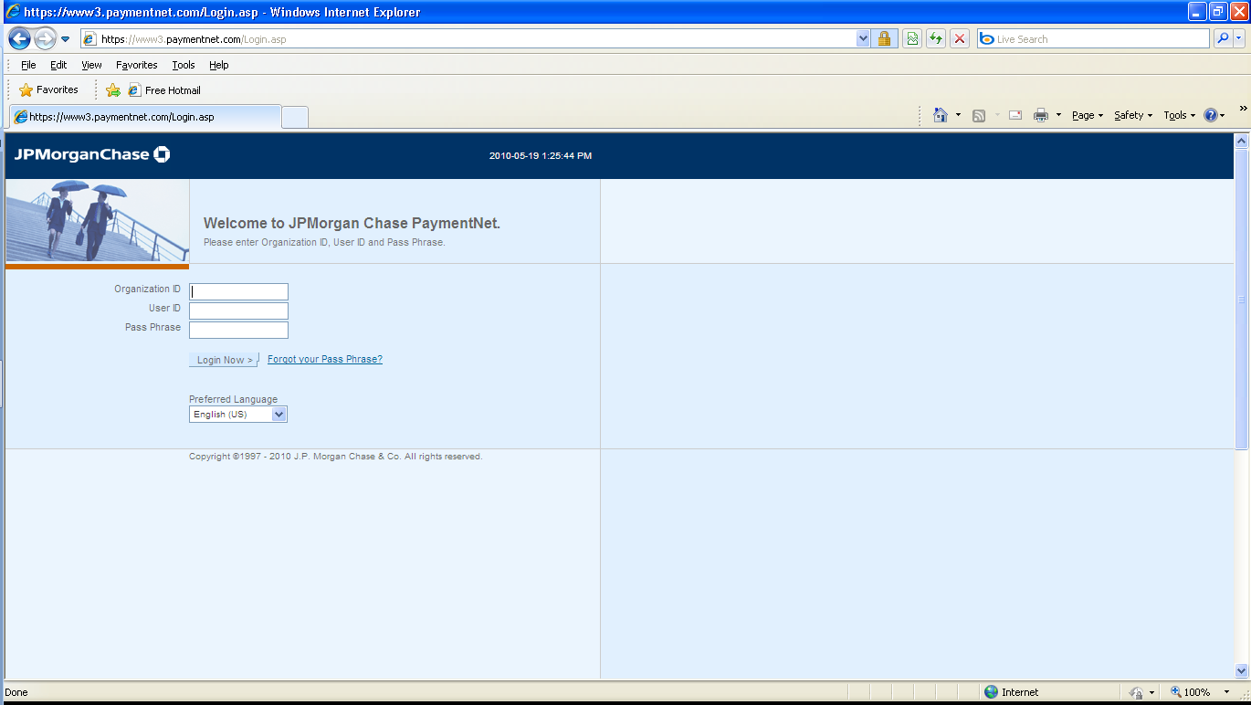
Press or Click Login Now

You will be directed to the Welcome Screen – Here you will see:

- Informational messages from your Program Administrator

- Drop down menu titled “Links” provides a drop-down list of useful and related websites and documents – A/P website, Contracted/Preferred Vendors, PaymentNet Placemat

- Navigation Bar on left lists the modules your login can access

  - Change Pass Phrase – Select this option the first time you log into PaymentNet – Your temporary password must be changed to maintain the confidentiality of the pass phase. Once you change your Pass Phrase click on the word home in the upper right hand corner. You will be directed to JP Morgan, PaymentNet home page.
  - Logoff – Logs user out of PaymentNet – For security purposes, users should log off each time they have finished their session.
  - PaymentNet – Allows for validation of transactions to original receipts, proper account allocation, splitting of transactions, review and approve transactions and used to process disputed transactions.
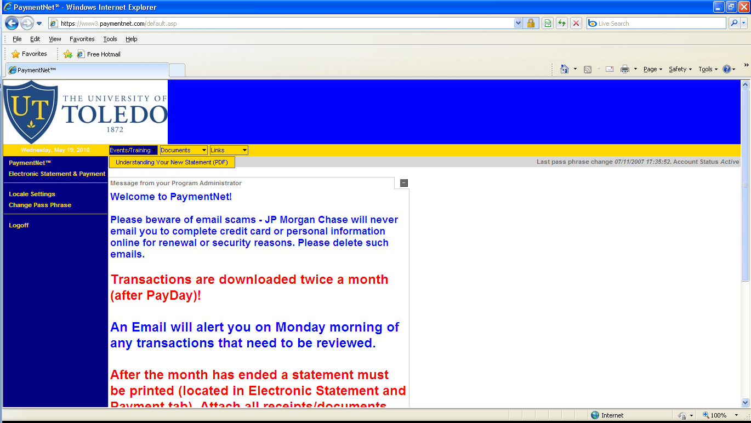

Navigating within PaymentNet

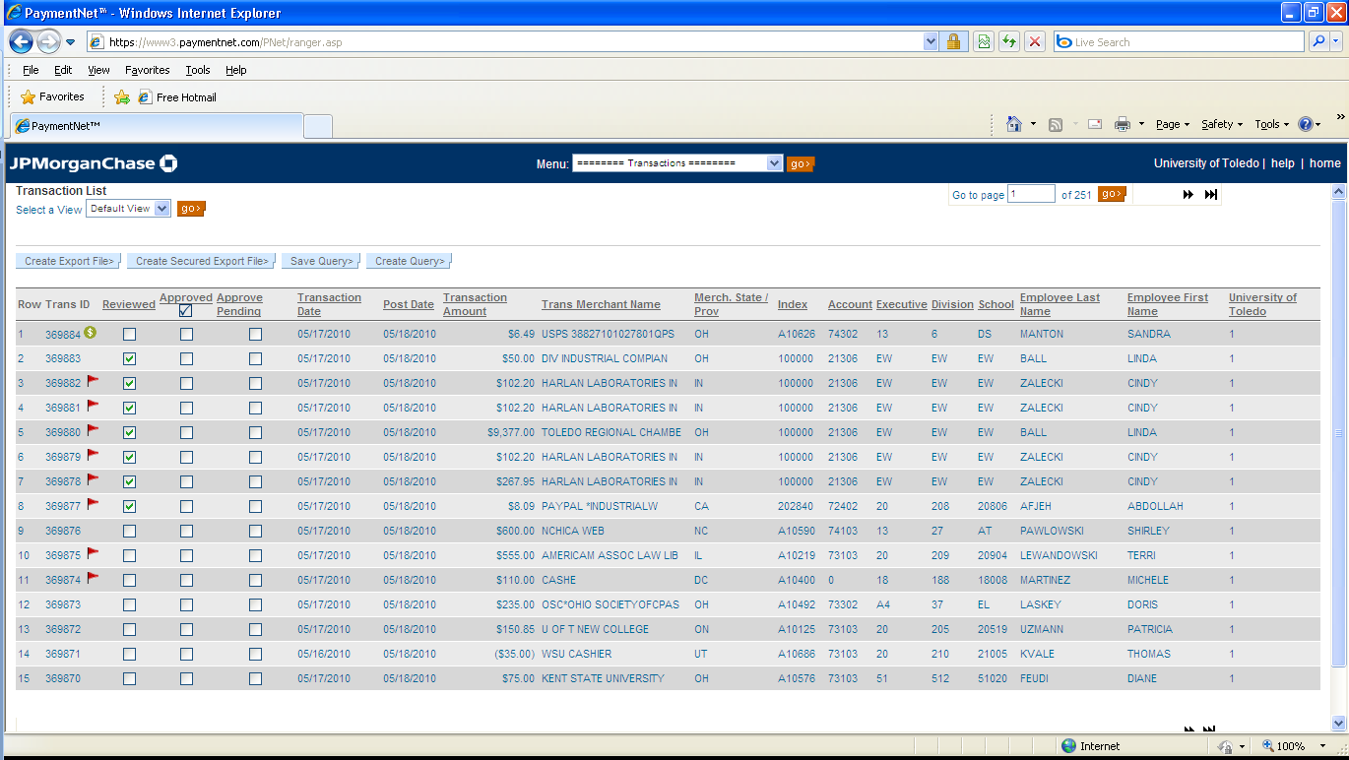
As the next screen loads, you will see a blue bar at the top that represents PaymentNet’s Main Navigation Bar. This drop-down menu navigates through all the PaymentNet screens. When you initially open PaymentNet this drop-down “Menu” defaults to Transaction. Click on the menu to see all of the options available.

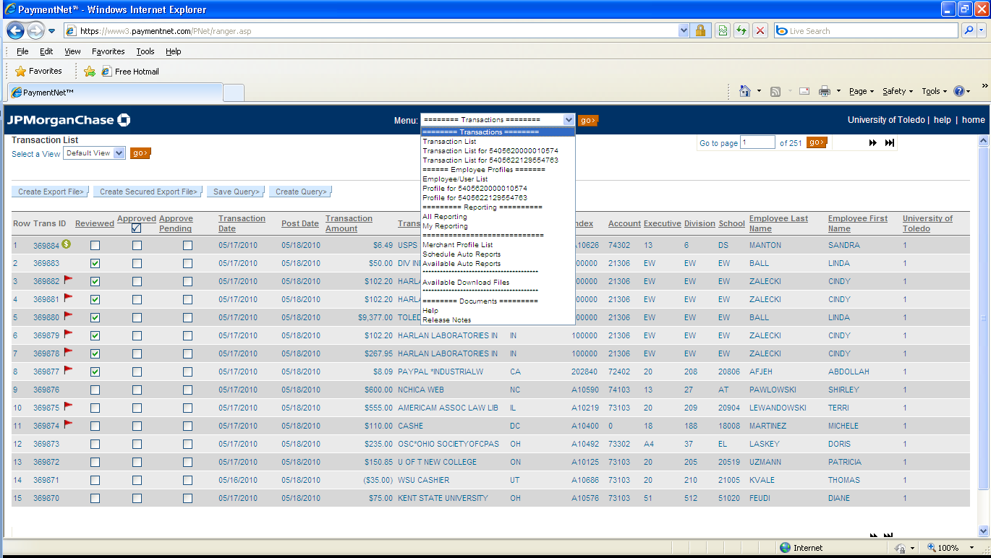
This screen also shows:

Select a View Drop-Down Menu – Displays queries that have created and saved. If none it will show the default view.

Page Navigator – Go to page displays number of pages of transactions that are available for viewing. You can click on arrows to go to first, previous, next, or last page. Or you can use the drop-down box to go to a specific page.

Sort columns – To sort data by category, click on one of the underlined column headings. This will sort the information in ascending order. To sort in descending order, click on the underlined category again. An upward or downward triangle indicator will appear next to the column that is being sorted.

Icons – A variety of icons are visible in the Trans ID column. The Trans id is a unique number assigned to each transaction in Paymentnet. Icons found here could be purchase addendum icon, note icon, dispute initiated icon, dispute in process icon. Clicking on the icon will allow the user to view additional detail pertaining to that transaction.
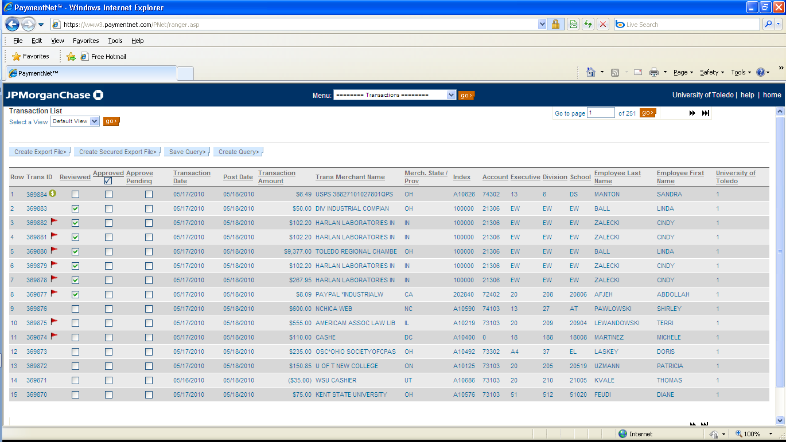
Page Navigator
Sort columns by clicking on column title
Icons
Extra details on transactions may be available; if icons are displayed in the Trans ID column, such as , click them to view line-item detail.

Reviewing a Transaction

The Transaction List screen enables users to view transactions that have been posted. You may do this daily. Reconciling, reviewing and approving are mandatory processes for P-card holders and Approvers. This needs to be done on a daily or weekly basis.

The cardholder must compare each PaymentNet transaction to your original itemized receipts. Research and resolve any differences.

To view the detail of a transaction, click the blue text of the transaction. This will bring you to the Transaction Detail Record Screen where you can allocate to different accounts that you have access to, split the transaction, dispute a transaction, check the reviewed box, if a cardholder, or the approved box, if an approver.

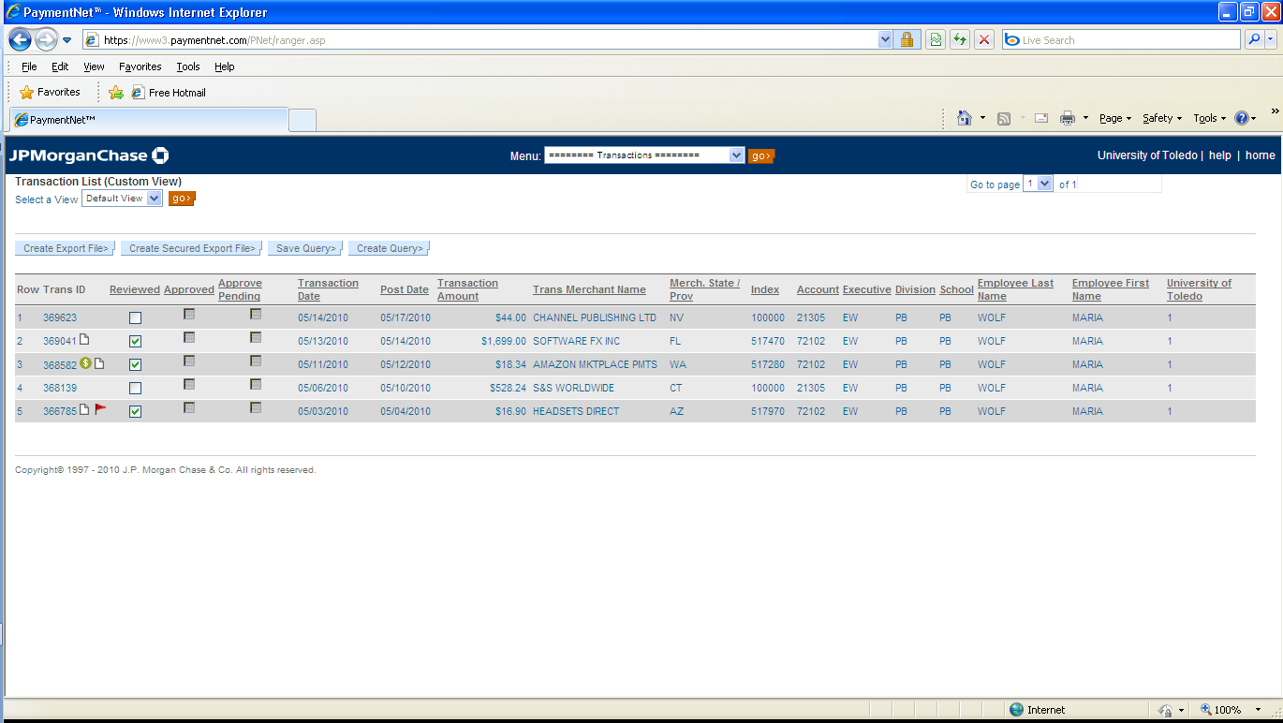
Each cardholder’s transactions have a default Index number assigned and the Account codes will default according to the Merchant Category Codes (MCC’s) and the University account code assigned to that code or a specific one in some departments where the same account code is used for most transactions, eliminating reallocating most of the transactions. The Index number and Account codes may be changed using a drop-down selection box which has been customized for each user at the time of the account set-up. The Index numbers available will be specific to your department’s access and most account codes will be available for all.
Click on any of “blue font” areas or where ever you see a “hand icon” to reallocate to another index.
Click on reviewed box if assigned to the correct index and account code
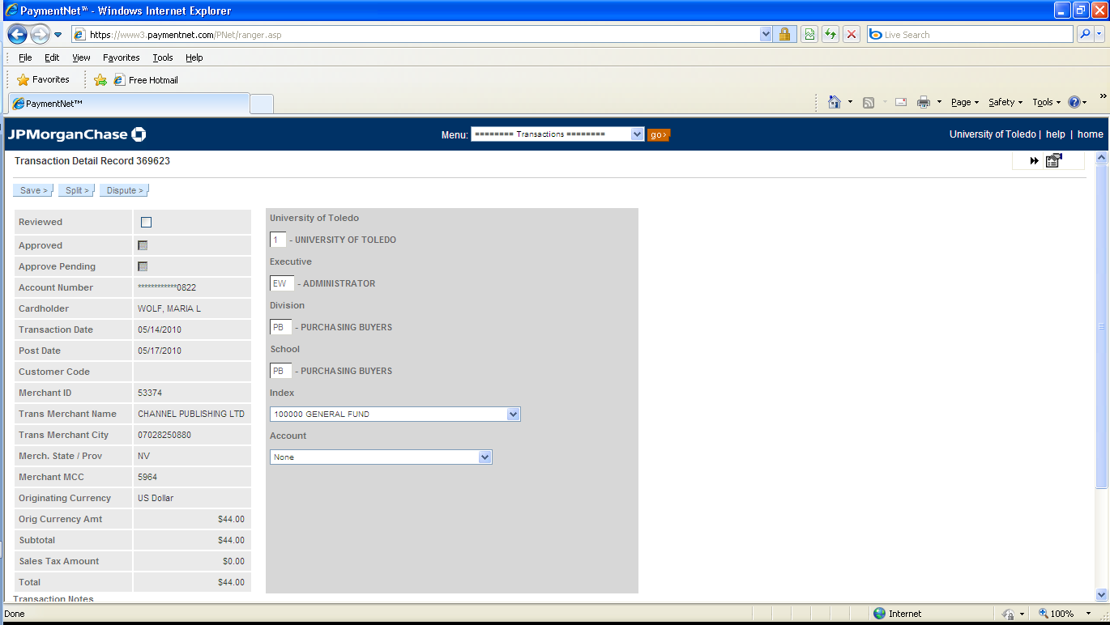
Clicking on the down arrow will pull up a list of index and account numbers available in your dept.
Always save once reallocation is complete

Editing a Transaction

To change to a different Index number or Account code- go to the drop-down box and click on the appropriate Index number so it displays in the box.

In some cases, it may be necessary to allocate a transaction among multiple Index numbers and/or Account codes. Transactions can only be split among the Index numbers and Account codes defined for each user at the time of account set-up.
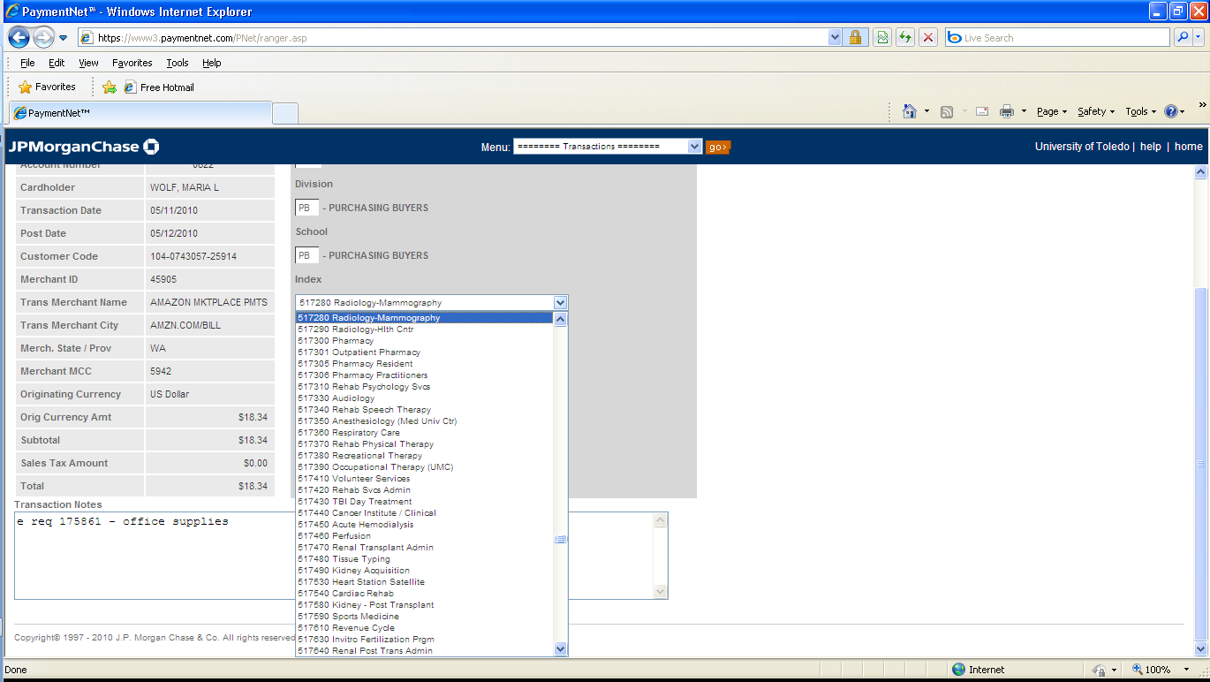
Transactions notes are recommended to assist supervisors when approving transactions and auditors when auditing statements.

Split Transactions

Select the transaction from the Transaction List screen that you want to split. Click on the text of the transaction. This will go to the Transaction Detail screen. Click Split on the upper left-hand screen. Select the number of splits desired from the drop-down box. The amount will be divided evenly among all rows.

Edit a Row
Click on the first Edit Row. Select any changes to the accounting code allocations. Determine allocation of amount by percentage or dollar amount, click on choice and type in percentage or amount that will be allocated to that line. Click Save Row. This will refresh the screen and enable you to edit any additional rows. Any changes to the first row, whether adding or subtracting from the amount, will be added to or subtracted from the last row’s amount. The last split row is not editable; it will adjust to the other edited rows.

When you have finished the entire split, click Save Split button located at the top of the screen.

If you would like to cancel the changes you have made click Undo/Cancel Split button located at the top of the screen.

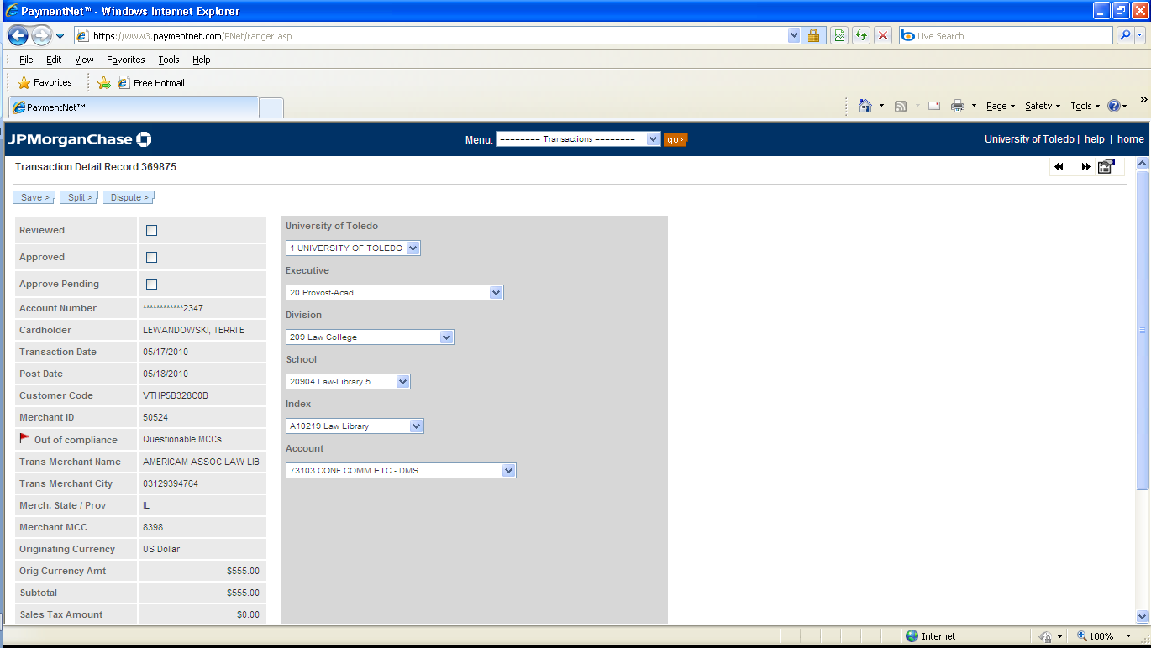
Click on split

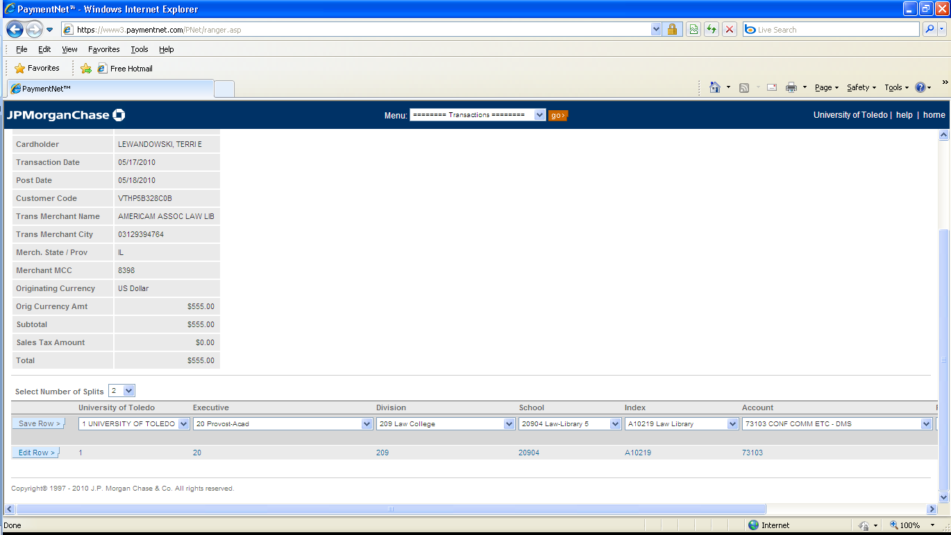
Select the number of splits desired from the drop-down box. The amount will be divided evenly among all rows

Adding the notes in PaymentNet

Notes are required for verification for your Approver as well as for auditing purposes. The cardholder can go back into PaymentNet, run a query for the month submitting, place transactions notes in the transactions that need additional information. This needs to be completed prior to the schedules P-card download. The download schedule is available on the Accounts Payable website.

Cardholders marking the Reviewed checkbox indicates the review is complete. This action certifies that you have completed the following:
- Reconciled original, itemized receipts to PaymentNet transactions
- Reviewed each transaction for allow ability and appropriateness
- Allocated each transaction to the appropriate Index number and Account code (Some departments may not require cardholder to reallocate)

Approvers marking the Approved checkbox indicates the approval is complete. This action certifies that you have completed the following:
- Verified that the Cardholder has acquired the goods or services within the guidelines, policies, and procedures and that the expenses are allowable.
- Verified that the Cardholder has allocated the transactions to the appropriate Index number and Account code and if necessary, that you have made appropriate adjustments.

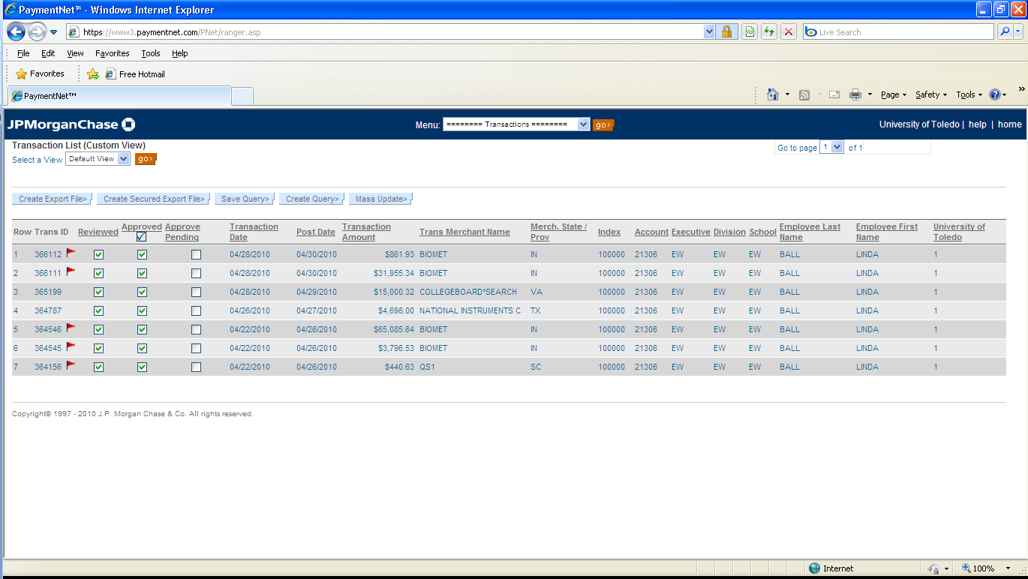
Supervisor/approver or designee approves transactions
Cardholders or designee reviews transactions

Disputes

The cardholder must try to resolve any disputed transactions with the vendor and only if you are unable to resolve the dispute will you dispute incorrect transactions on-line. Disputes can be initiated online up to 60 days from the transaction postdate.

From the transaction List, select the transaction you want to dispute and click it. This will take you to the Transaction Detail Screen where you will click the Disputes button, located in the upper left-hand corner of the screen. You will need to enter your e-mail address and the state where the purchase was made. You must select the reason for dispute from a drop-down menu. Add any additional information. (contacted vendor, not resolving or something pertaining to the transaction. Click Save.

Text will appear providing a link to the pre-populated form that must be signed and faxed to the disputes department.

A yellow square immediately appears next to the transaction on the Transaction List Screen, indicating that the dispute has been initiated. After the disputes department receives the faxed form and begins their investigation, the yellow square will be replaced with a red square.

To undo a dispute while the square is yellow, click directly on the yellow square and select Undo.

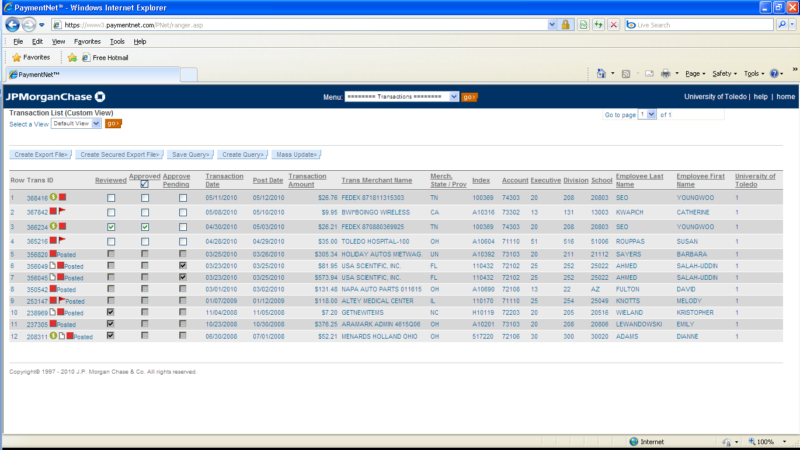
To undo a dispute while the square is red, click on the red square and select Mark As Resolved. The disputes department will be notified and cease researching the transaction.
Yellow square means a dispute has been issued by the cardholder Track the status of your dispute on the All Transactions Screen—
= Awaiting Documentation
= Disputes In Process
Click the colored dots and follow steps to Undo or Resolve your dispute.
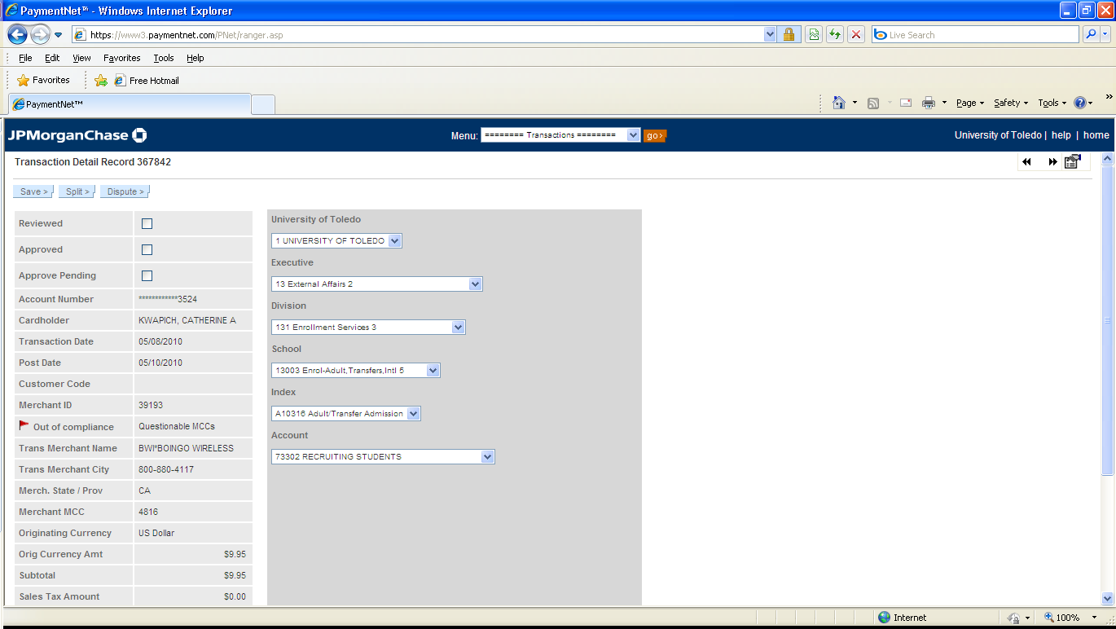
To dispute a charge

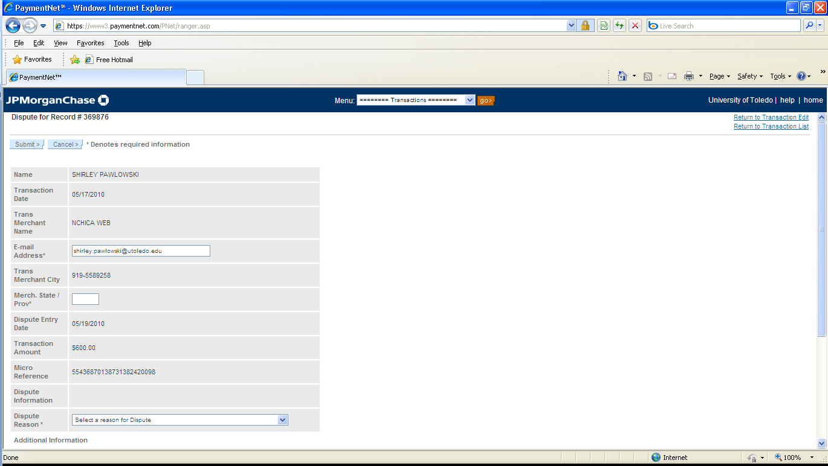

Creating a Query

On the Transaction List Screen, click on the Create Query button. This will bring you to the Query Wizard for Transaction List Screen. A list of criteria will appear which will allow you to refine the data to specific information. Here you will:

Select your choice of All or Any from the drop-down box
All – meets all criteria specified within the query
Any – meets any of the criteria specified within the query (only has to meet
one of the criteria to appear in the query)

Select the field to query in the first drop-down box

Select the variable of the query in the second drop-down box

Fill in the last box with the appropriate value

To add additional rows of criteria, click the plus sign (+), then click Process Query

To delete rows of criteria, click the x button

Query results will display on the Transaction Screen List Screen.

Beneath the criteria screen is Order by the following fields, an option that allows you to sort the data in the order you want

Reset Query allows you to revert to your previous query, and then continue the previous steps to create another query.

Save Query – If you need to run a query on a regular basis that you have created then you would click save query and type in a name for that query. The saved query will then appear in the Select A View drop-down box and since queries are specific to your user ID it would only be available for you.

Delete Query –To delete a query, first select it from the Select A View drop-down box and click go. Once the information has populated on the Transaction List Screen, click the Delete Query button.

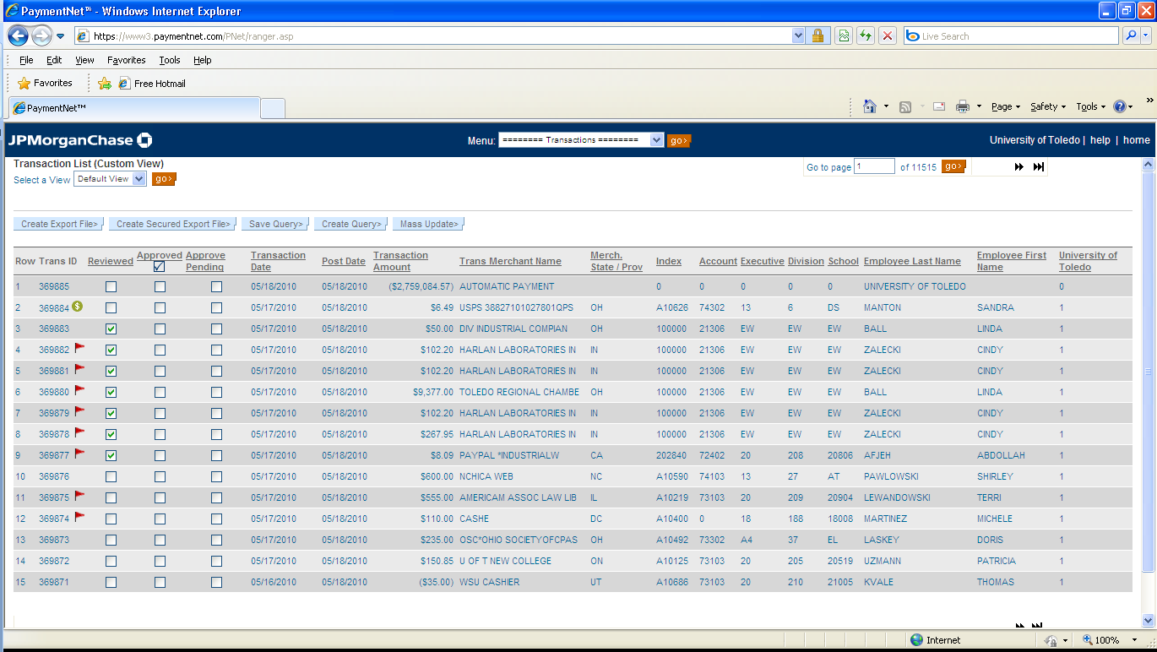
Create a query

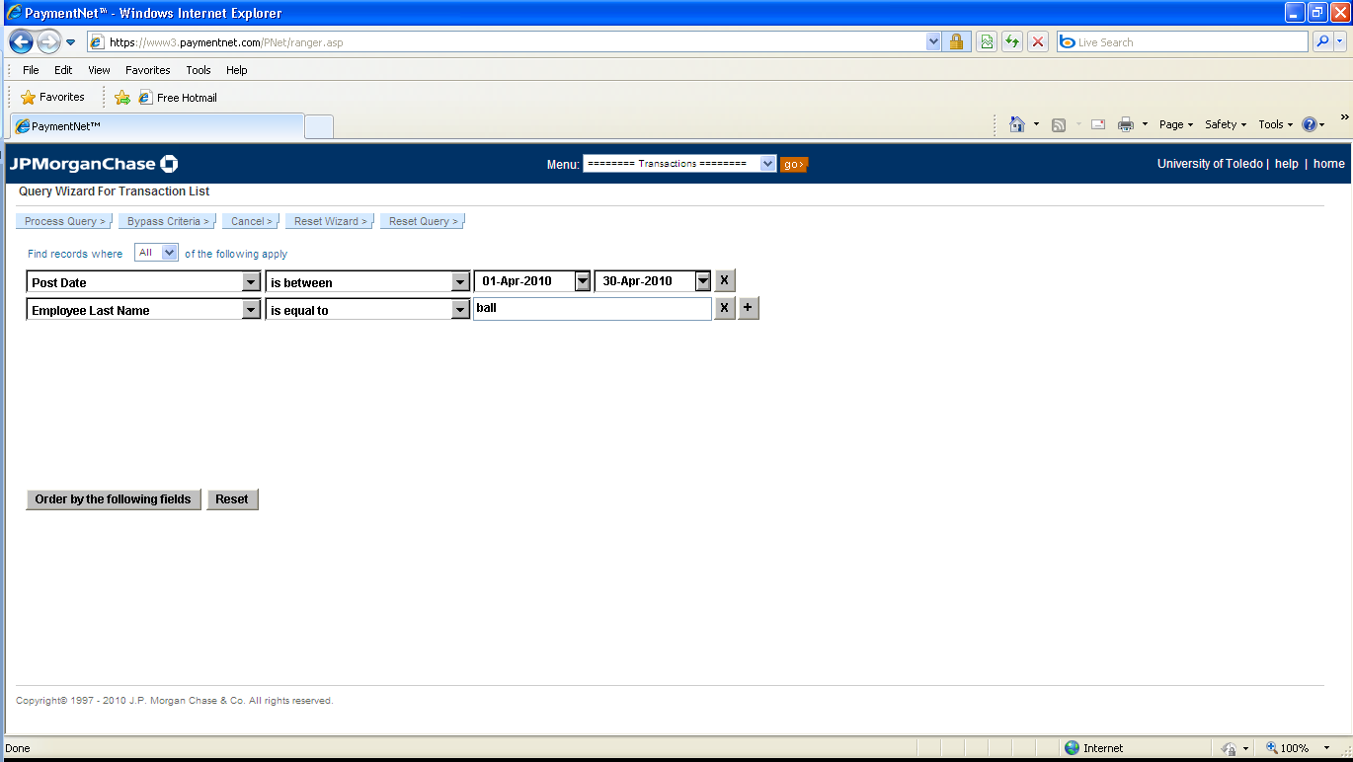
Select your criteria of your search.
Once the criteria is selected, click on process query.
All – meets all criteria specified within the query
Any – meets any of the criteria specified within the query (only has to meet one of the criteria to appear in the query)

+ = adding criteria
X = deleting criteria

Creating Reports

From PaymentNet’s main navigation bar, scroll down to the All Reporting option and press Go. This will bring you to the Reports Screen.

Select Report Type – Here you will select a category of a report you would like to create. Click inside the circle next to the desired category to display the available reports and their detailed descriptions. Click on the report title. Below is a sample report that will be helpful in knowing your limits.

- Card Status report - The Cardholder Status report can be used to identify account limits and status (i.e. Close, Not Activated, Active, etc.). The report which is sorted and sub-totaled by Account Status lists the following: Cardholder Name, Account Number, Open date, Credit Limit, Single Transaction Limit, Available Limit, and Status

After you select a report type, the system will take you to the next screen where you can input criteria in the same manner as in creating queries that will help limit the results of the report. However, you can click on Bypass Criteria and run a report without any restrictions.

Generate the Report

Select the format you want the report generated in: Adobe PDF, Microsoft Excel, or Microsoft Word by clicking on the arrow next to the format type. If you want to regularly run this report, you can click Save Report Criteria at this point and enter a file name for this query.

PaymentNet will automatically load the Available Download Files Screen. As soon as your report is ready, it will appear on this page. Most reports are available immediately so you may click Refresh until your report appears or you may continue using PaymentNet and check back later. You may select the Notify me by email when the file becomes available box.

When the file name appears, you can right click on the report to save it to your desktop, or double click on the report to view it in the format you selected.

Reports you may use often and especially if they are a large report you may want to add it directly on the Schedule Auto Reports Screen. These reports are scheduled for generation during off hours and can be accessed at a later time.

Print Report

To print the report from the screen view, click on the print icon. To print a file saved to your computer, follow the print instructions applicable to the format you selected.

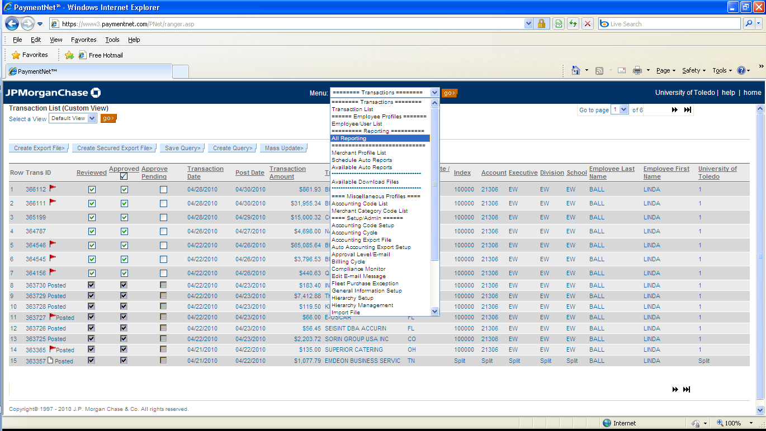
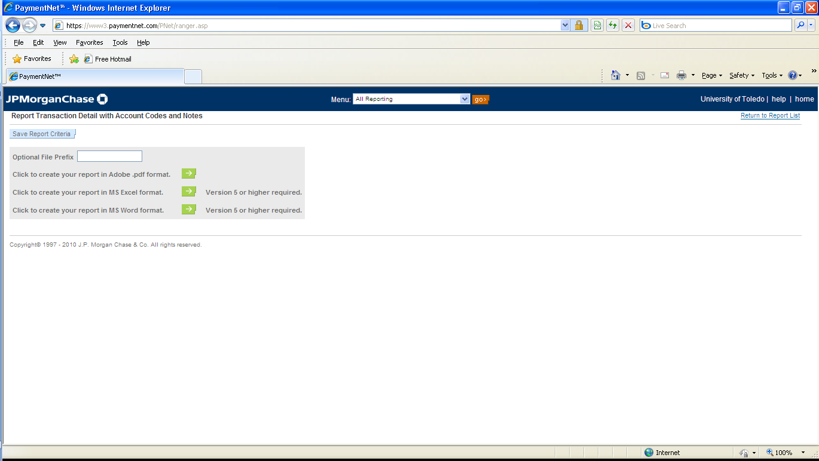

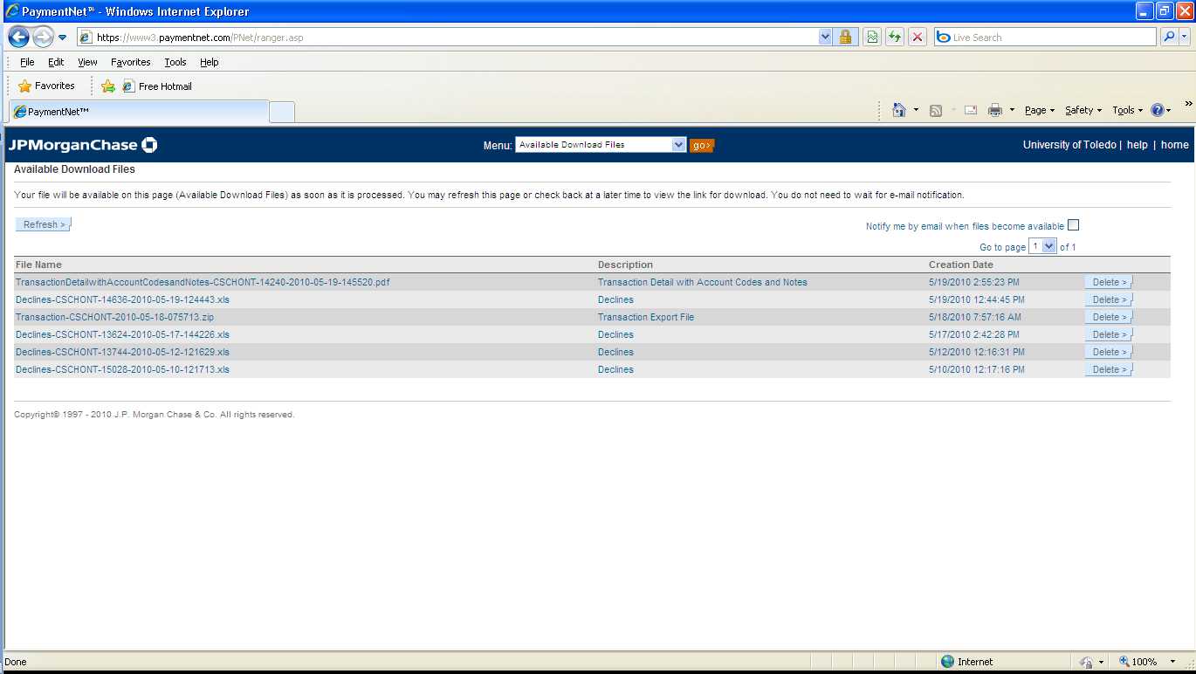
Click on refresh until report appears in below listing.
Choose report and print if desired.

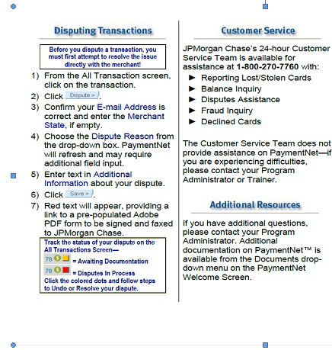

Paymentnet -Quick Reference Guide

Scanning or Saving P-Card transaction documents/monthly statement report

When scanning your information, please follow the instructions based on the scanner in your area.

- Only scan the related itemized documents/invoices/receipts according to charges shown on your P-Card monthly statement report. This will keep your scanning to a minimum. Any additional information, keep with your original P-Card receipts which will remain within your department according to the University’s and Grants retention policy.

http://www.utoledo.edu/policies/records_retention_manual/index.html

The Business Managers/Supervisors will determine were documentation is saved within the department. Some documents, such as online receipts, vendor emailed invoices, and the monthly report will not have to be printed and scanned, but can be saved in the same manner as the scanned documents.

Travel form and related receipts

- Scan the completed travel form (IRR) with related P-Card receipts and out of pocket/reimbursable expenses (if applicable).
- Email Accounts Payable only the Employee Travel Form (IRR) form if a reimbursement is due.

P-Card monthly statement report (replaces the Electronic Statement)

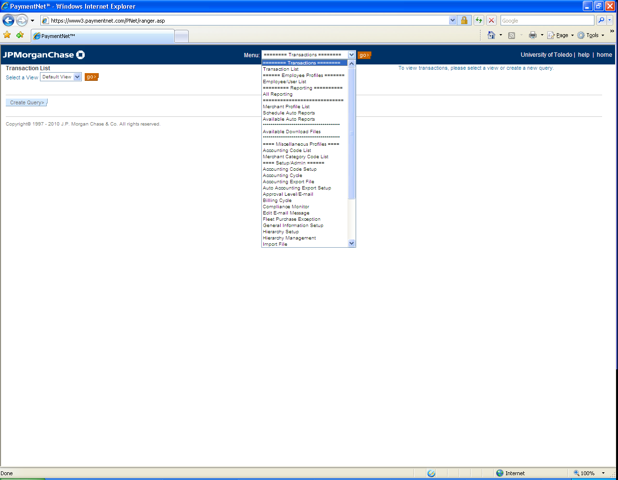
The P-Card statement is the report named, “Transaction Detail with Account Codes and Notes”, which is located in the Menu area drop-down box in PaymentNet, under “All Reporting”.
- Click on “all” to bring in all the reports available to run

- Locate “Transaction Detail with Account Codes and Notes” (reports are listed
in alpha order)

- Double click on the report title “Transaction Detail with Account Codes and
Notes” to bring in criteria boxes to perform a query for the listing of the transactions that were posted in a specific month (Monthly Statement Report)
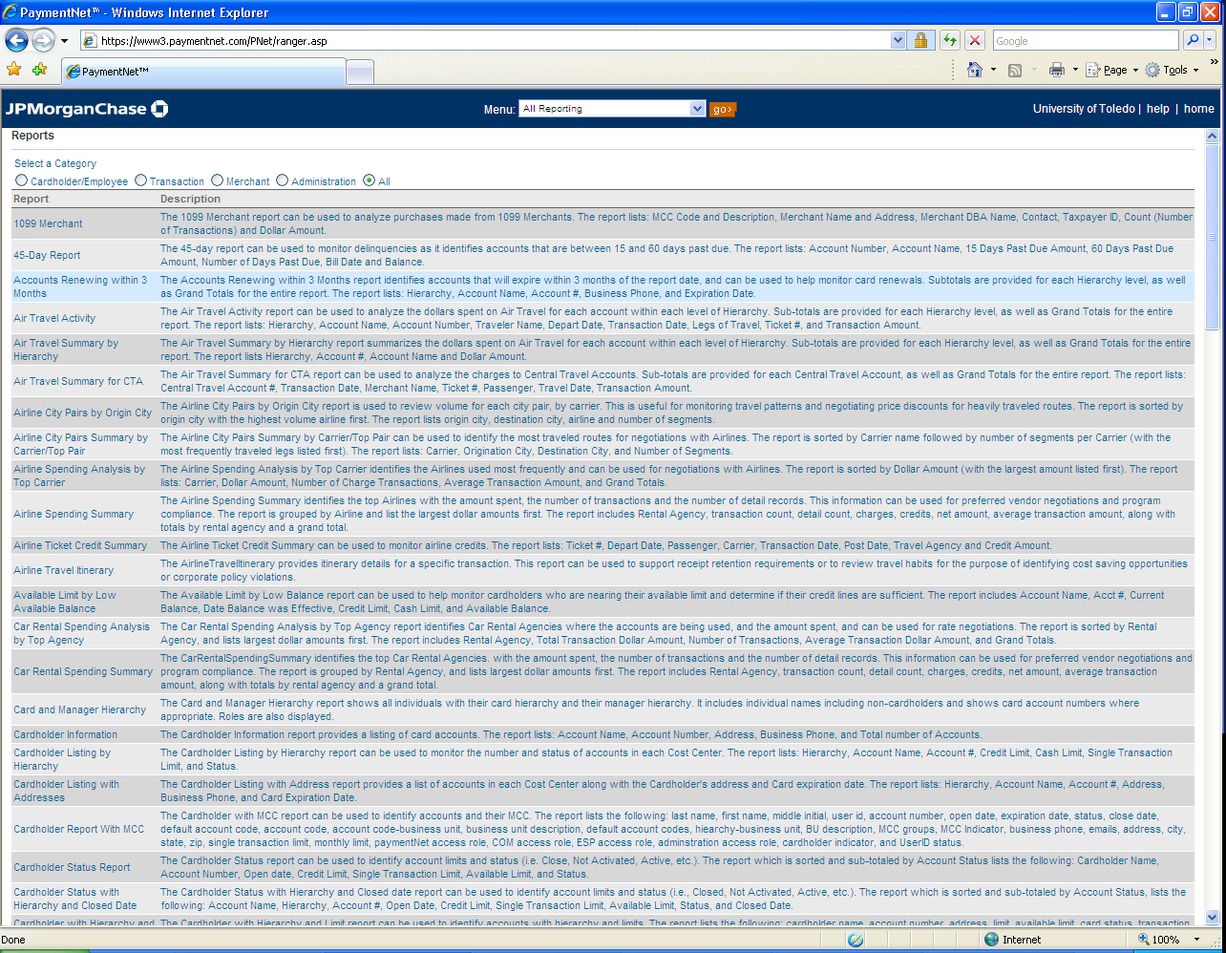
- Select All to get the correct report list.

- Select from the boxes drop-down menu the criteria needed to get your Monthly Statement Report - Your criteria should be: postdate – is between – your selected month, such as Sept 1 – Sept 30
- Use the + sign to add another line and add employee last name to make sure you are only pulling your information.
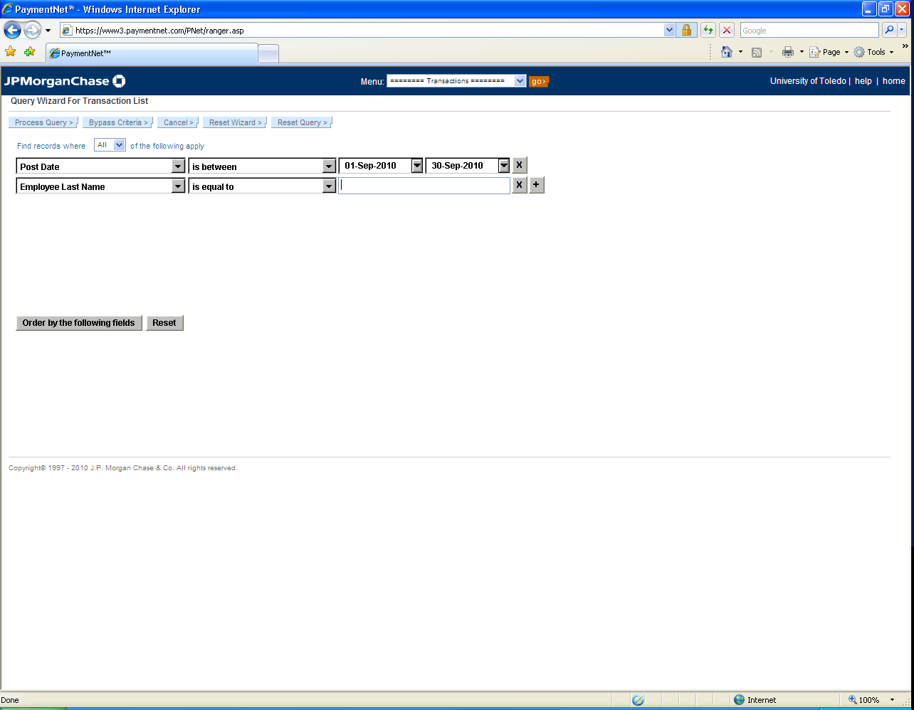
- After criteria is selected click on the Process Criteria tab

- Click the “Proceed With Report” tab (this screen does not show for all)

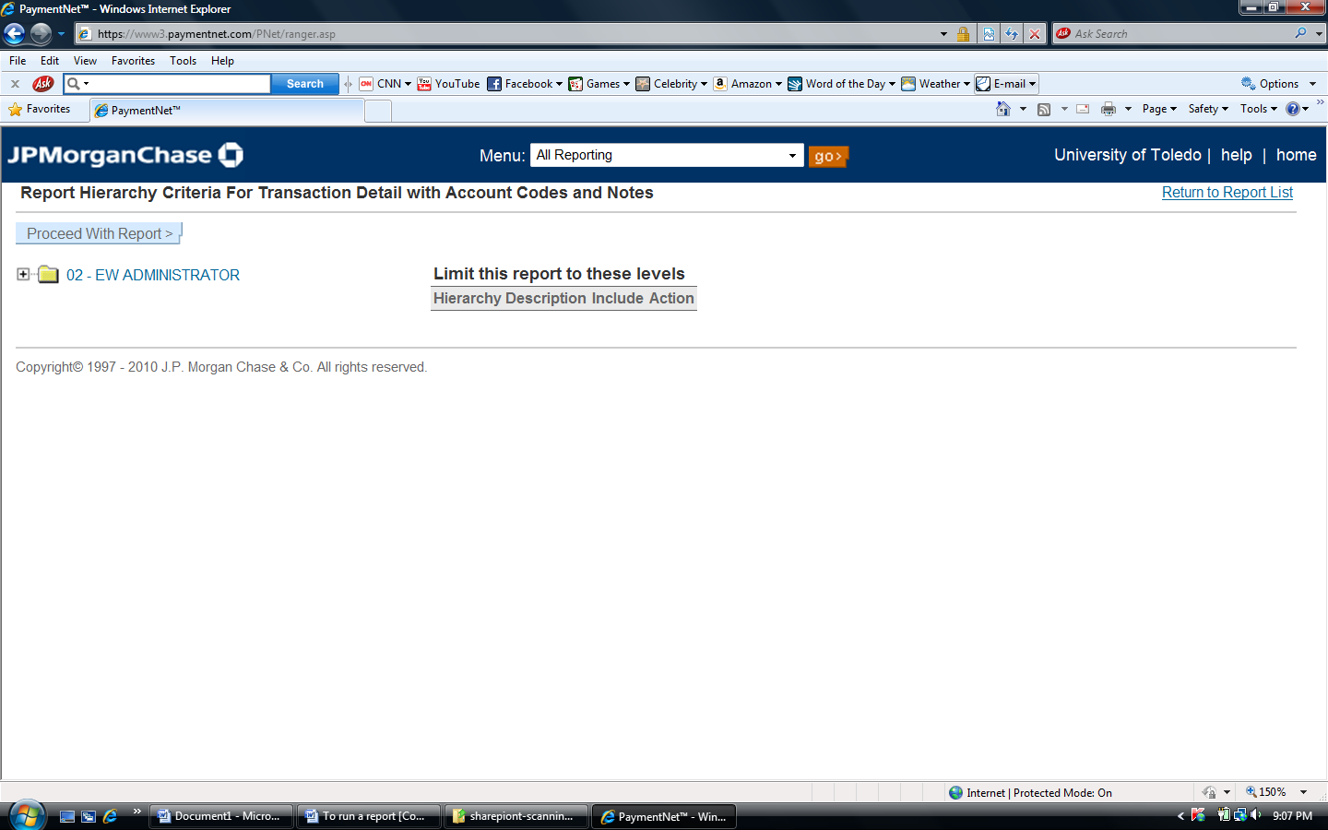

This screen allows you to create your report in a pdf, excel, or word format. The report will be saved in pdf format and the following procedures will help setup naming your report to auto schedule.

- Click on the “Save Report Criteria”,
- The following message will appear and you will need to click on the message and select the temporarily allow scripted window option in the box that appears after clicking.

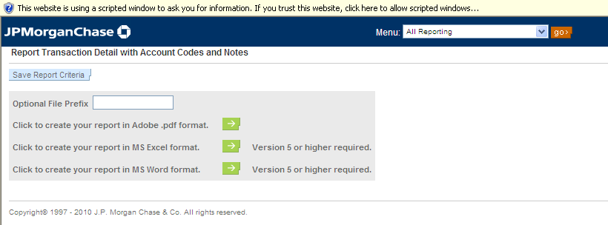

- Click on “Save Report Criteria” again and the following box will appear
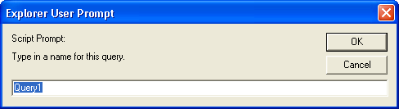

- Type in the name of the query “Monthly Report” and click the OK tab
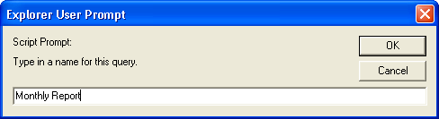

- Select and click on the PDF format
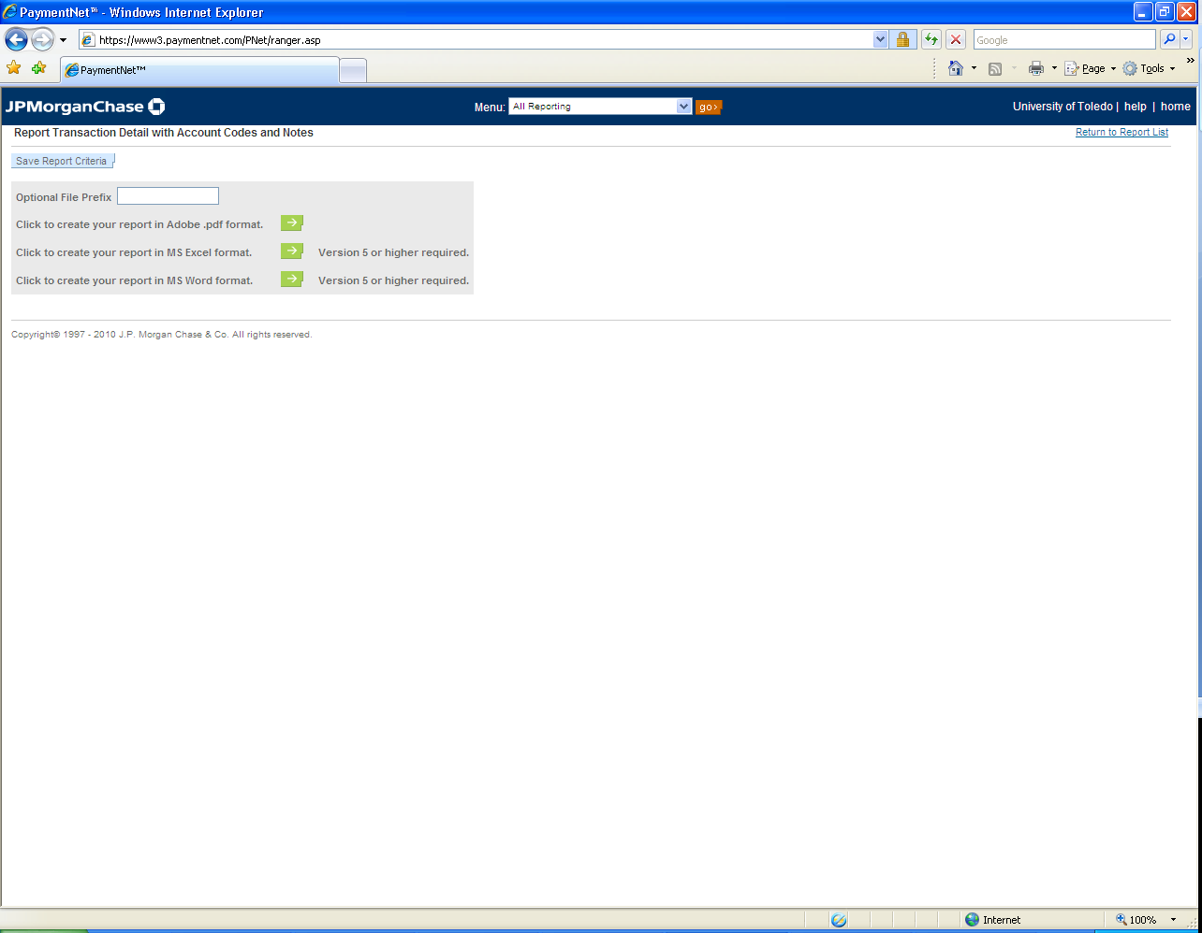

- Reports will show in the “Available Download Files” section on the Menu bar as Submitted.
- Click on refresh until the report is located under the file name.
- Click on report name
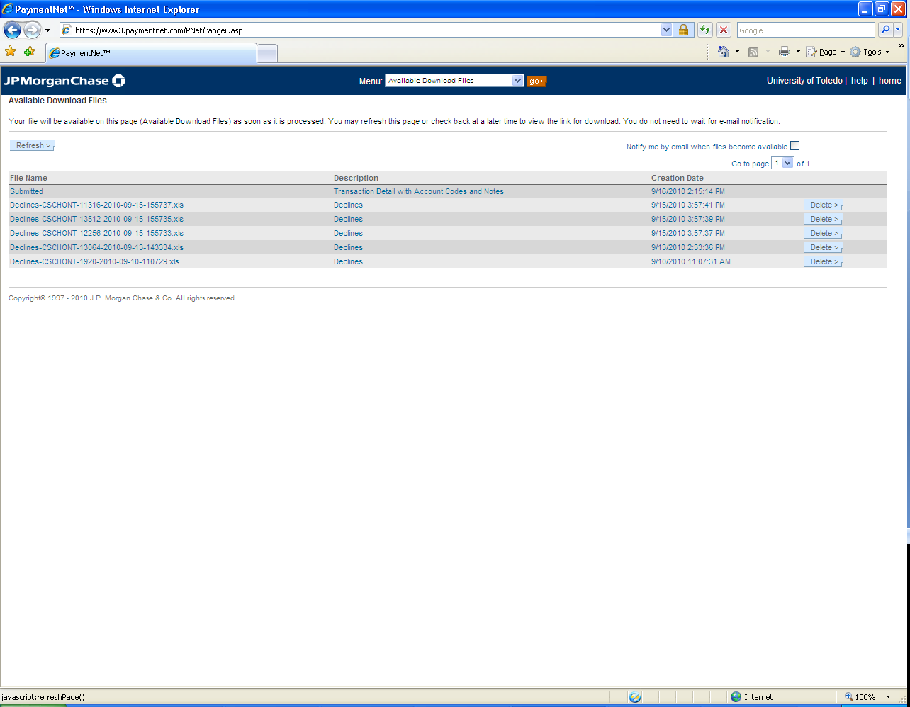

- Click on the disk icon to save the report in your H: drive or applicable drive, save as yyyy.mm.st (2010.09.st)

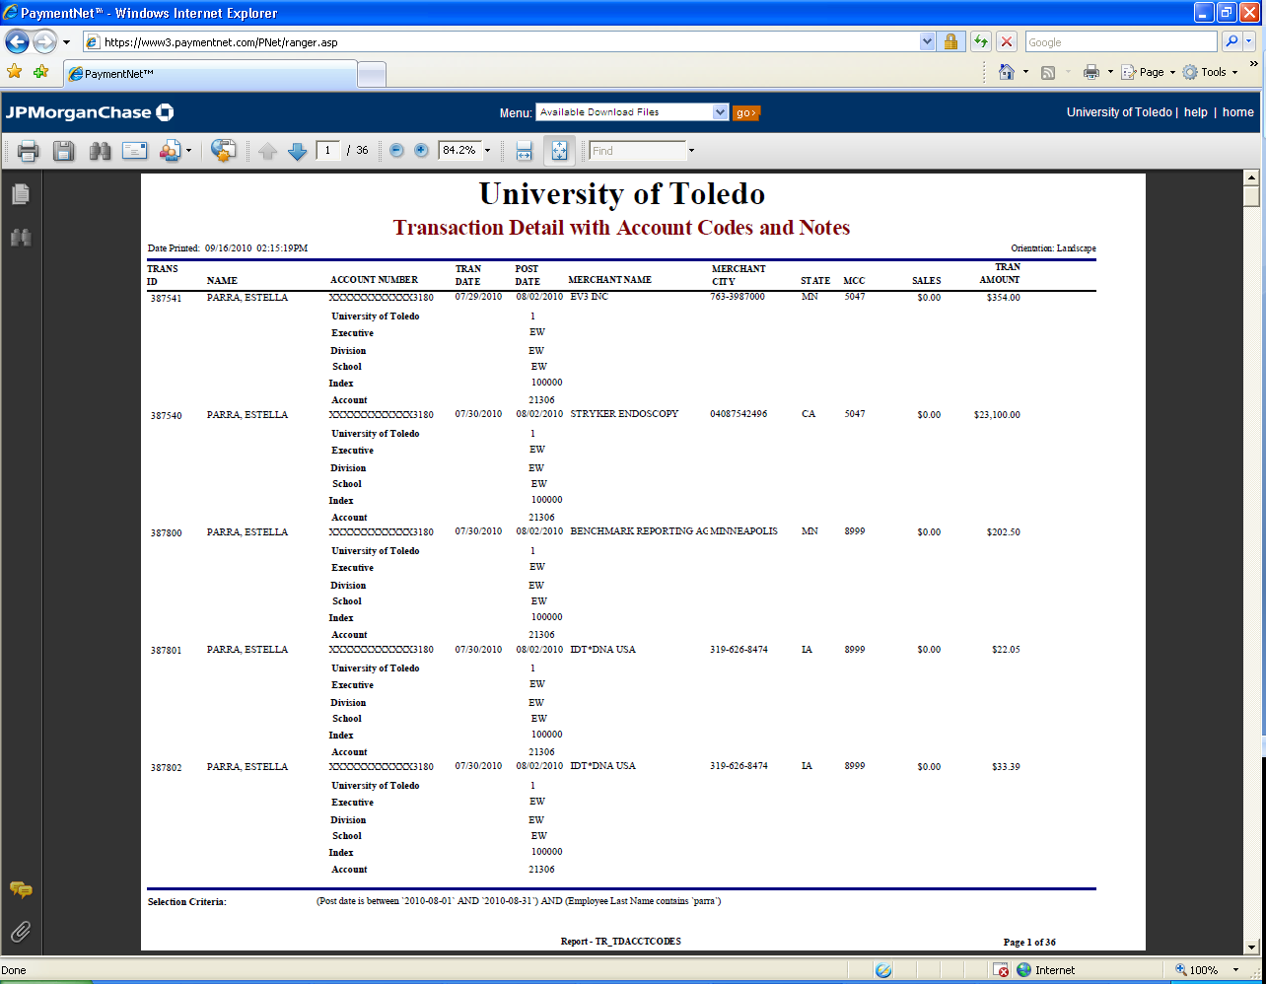

**Please note the completed package must be submitted to Business Managers by the 15th of the following month for approval.

Auto Schedule Monthly P-Card Report

After running the first “Transaction Detail with Account Codes and Notes” report, you can Auto Schedule this report, which will automatically run the report monthly and email you when it is available to save to your H: drive..

Auto Schedule Monthly P-Card Report

The monthly report that replaces the Electronic Statement & Payment Report is the “Transaction Detail with Account Code and Notes” report. This report is run after the month has ended. This report will show the index and account and notes on each transaction for the month. This report will help the approver to review if the index and account are correct or need to be reallocated or journaled depending on whether the transaction has been downloaded or not. Notes should be done for any transaction that may need explanation or detail of what was purchased, business purpose, attendees, recipients, etc. (all food/beverages, entertainment or party-like items, award or gift type items,
non-employee (i.e. airline, hotel for visitor), are examples of transactions that need a note entered.

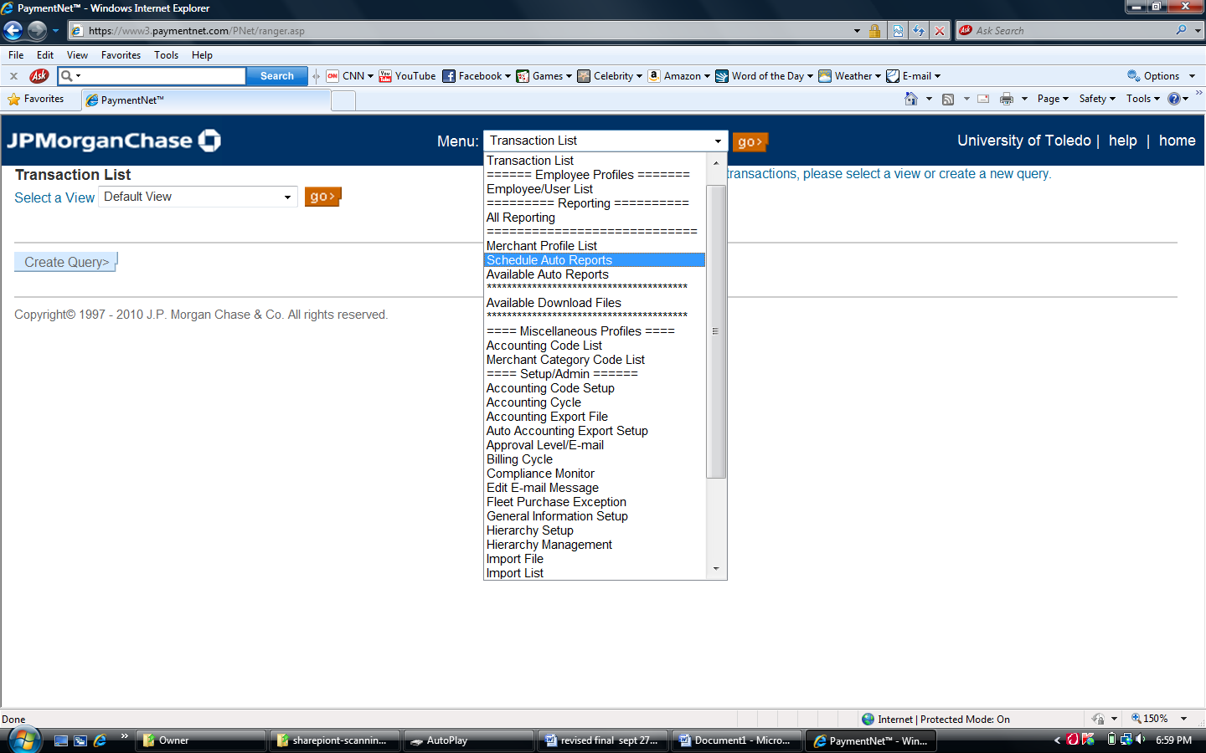
This report can be setup one time to automatically run, to schedule the report to run monthly, go to the
Menu bar in the Transaction List screen and from the drop-down box select “Schedule Auto Reports”

Once you select Schedule Auto Reports the below screen displays. In the Select a Category section click on Transaction.
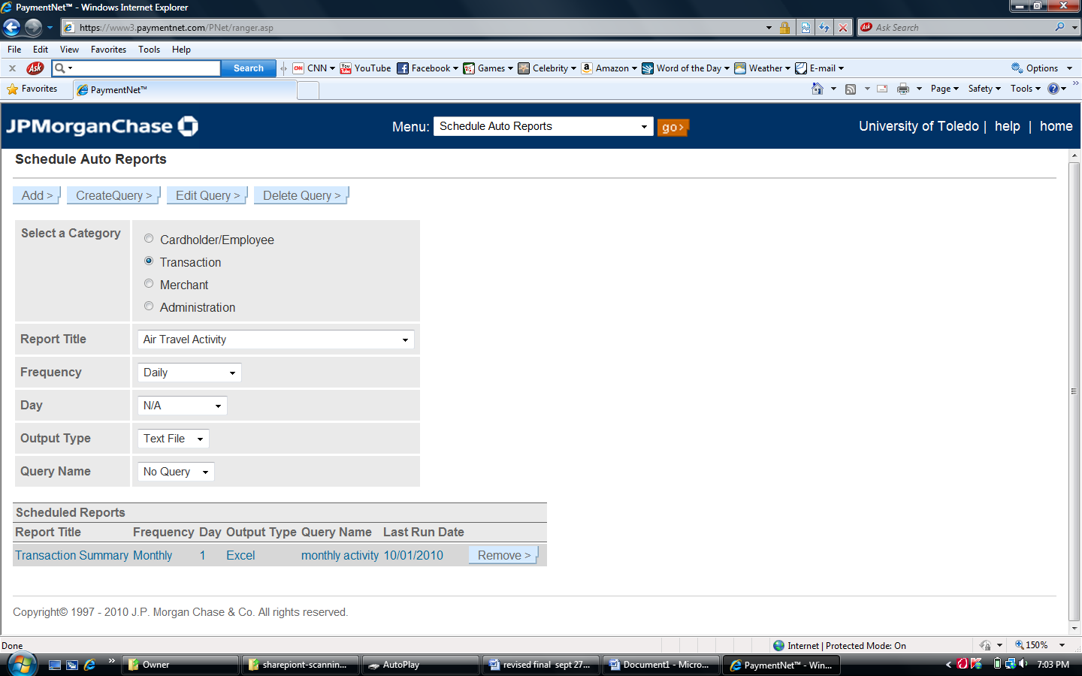

Selecting the Transaction category brings in the reports available to schedule. You will click on the sections to select the criteria to run the monthly report.

Report Title = “Transaction Detail with Account Codes and Notes”
Frequency = “Monthly”
Day = “1” (first day of following month)
Output Type = “pdf”
Query Name = “Monthly Report”

Once selection of criteria is complete:

Click Add to schedule the report
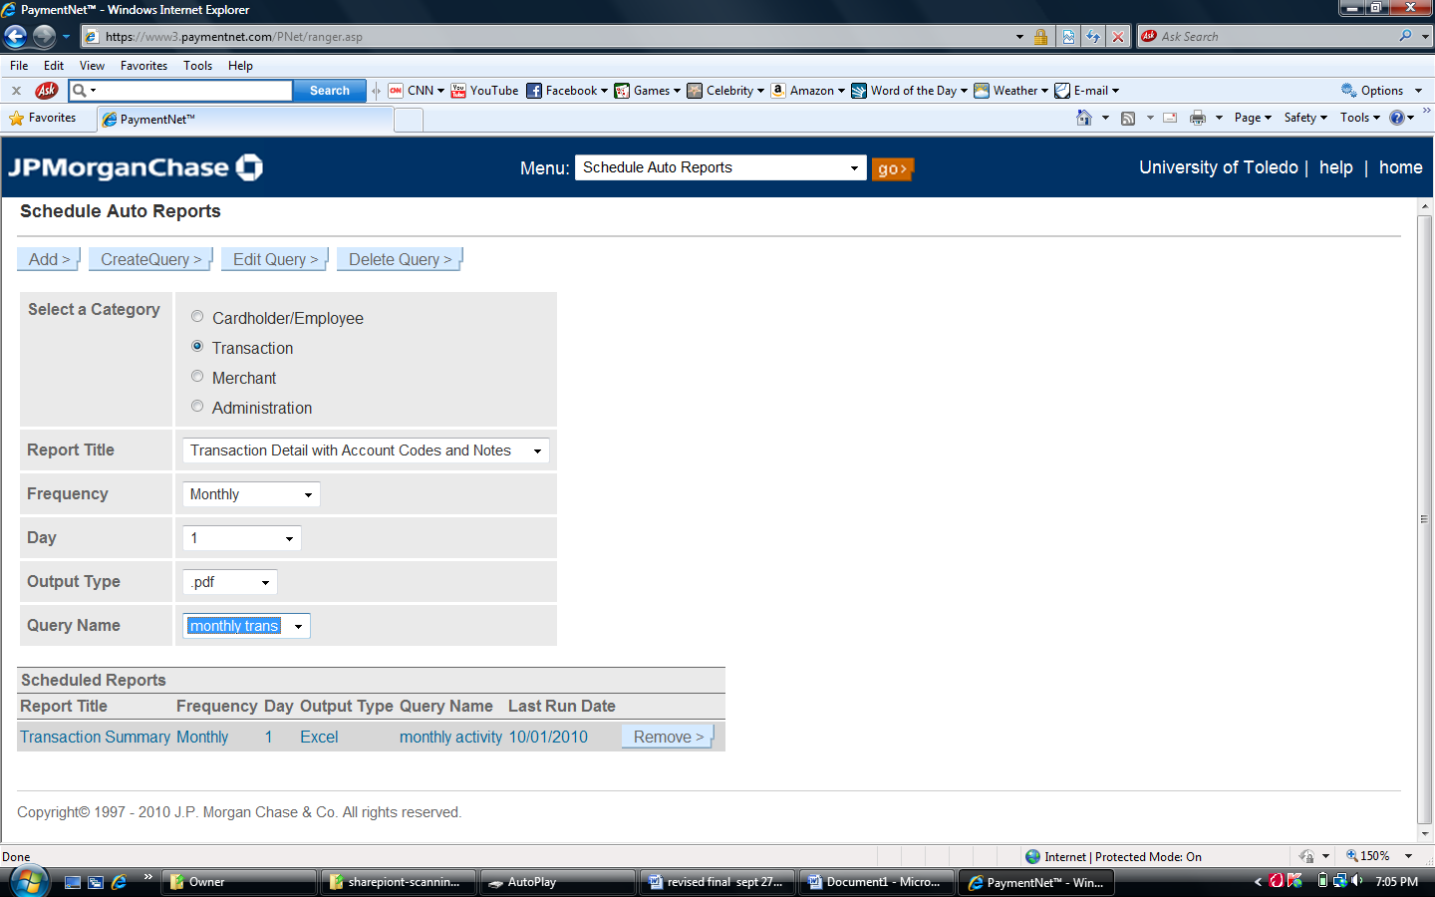

This screen will display all reports that
have been auto scheduled.

The first time you add the report this screen will show that
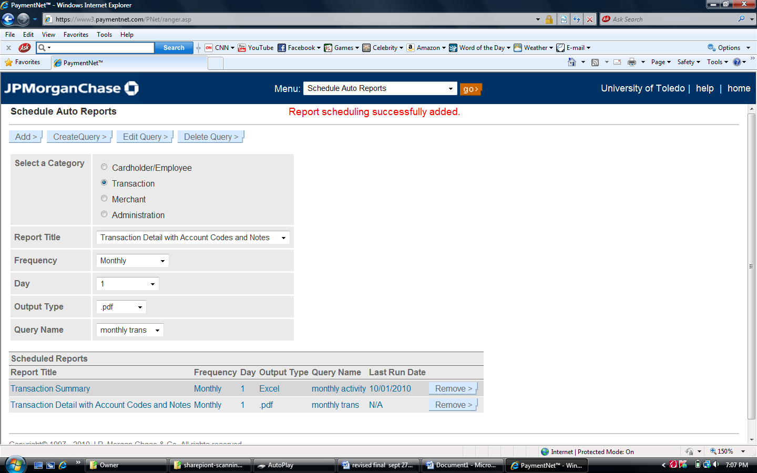
it was successfully added.

You will receive an email each month when your report is available. You will need to save to your
H: drive (or applicable drive).

Click on the link to login to Paymentnet to find the available report.

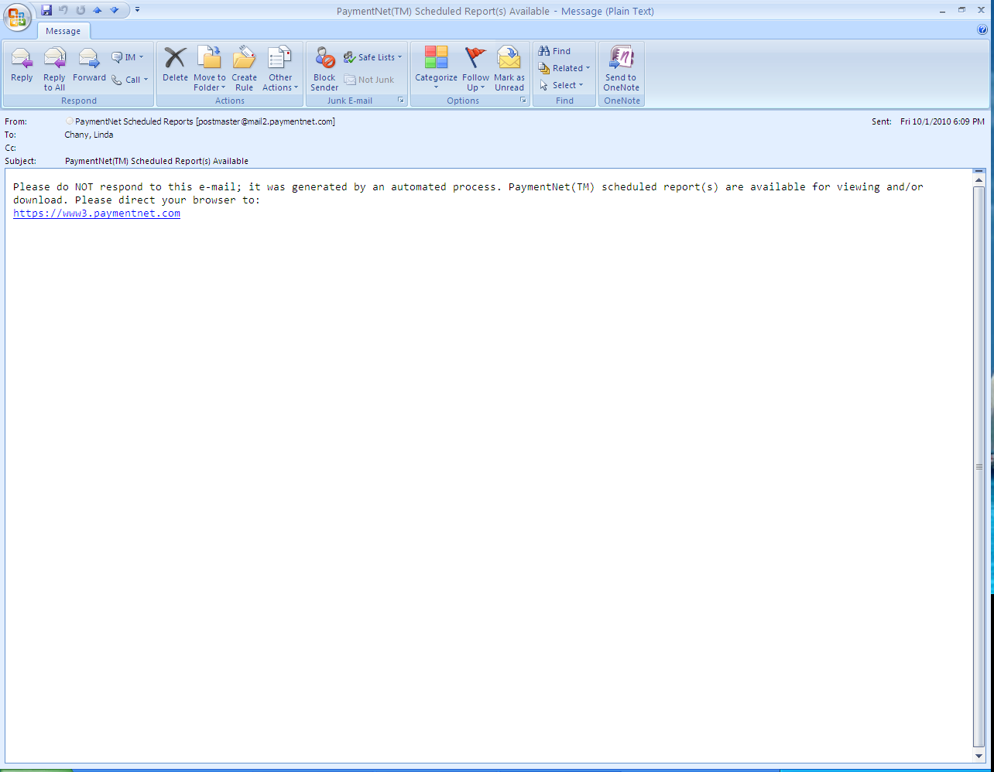

The report can be found from the Menu bar in the Transaction List under “Available Auto Reports” or “Available Download Files”

Click on “Available Auto Reports” or “Available Download Files”

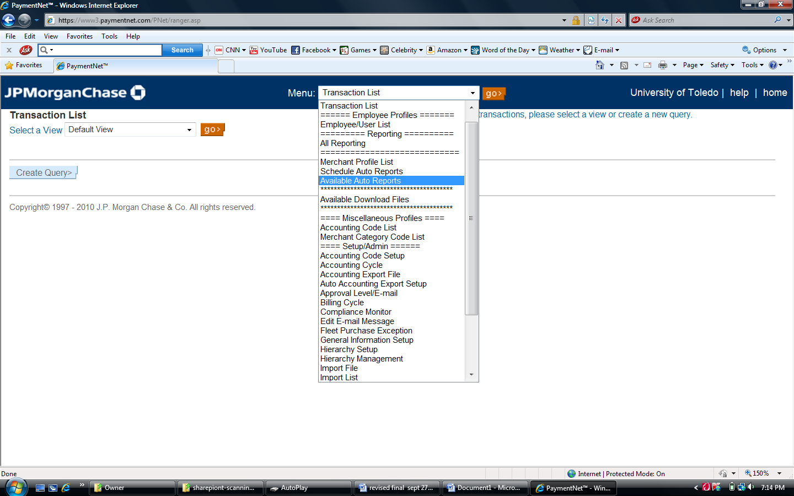

Samples

How to complete travel forms

The form is divided into two sections, Purchase Card and Reimbursable/Out of Pocket.

The form contains cells notes in many of the sections. Placing the cursor in the title sections will open a box with helpful information relating to the University policies and procedures.

Complete the Purchase Card section for all charges placed on the University P-card. Any personal/non-allowable charges will require you to type in the dollar amount. Any amount listed in this section will automatically show and subtract the amount under the Reimbursable/Out of Pocket section.

If there are any out of pocket expenses listed, the non-allowable will be subtracted from any
amount owed to the employee.

If no out-of-pocket expenses, the reimbursement amount will show a credit, which will require
the employee to write a check to the University and deposit at the depository at the cashiers in the account that was charged. A screen print of the Banner screen or the web report library report
that indicates the reimbursement will be the proof of the reimbursement.

The Reimbursable/Out-of-Pocket section will be completed for any out-of-pocket University business expenses.

Dates/Location/Time MUST be completed for all travel. This information is needed to determine per diem allowable.

Distribution of Accounts MUST be listed under each section that is completed with the Index, Account, and dollar amount to charge the account. Correction distribution will show that it “Reconciles” and those incorrect will show “Does not equal reimbursement or Purchasing Card amount!” Incorrect amounts will need to be fixed before printing and submitting to Accounts Payable.

**If you have reimbursements you must obtain the appropriate signatures on the Employee Travel form (IRR). You will then email only the IRR form to Accounts Payable to receive reimbursement.

Scenario 1 – All transactions on P-card

Employee Jane Smith is planning to attend a conference in Chicago on 12/01/10. An airline ticket ($150.00) is purchased and conference registration paid on line ($200.00) on 11/15/10 using the University purchasing card.

The TRAVEL AND REIMBURSEMENT FORM is filled out with the Airline total of $150.00 entered in Transportation section of TRAVEL AND REIMBURSEMENT FORM. Registration total of $200.00 entered in Miscellaneous section showing $ amt. & explanation.

The dollar amt. of the travel related expenses placed on the purchasing card is entered in the Total P-Card Travel Expense section. This will deduct from the total listed on the TRAVEL AND REIMBURSEMENT FORM showing, a -0- balance. (No reimbursement due to the employee, no money owed to the University by the employee)

**The TRAVEL AND REIMBURSEMENT FORM is submitted to Accounts Payable only if reimbursement is due

Scenario 1 – Travel form -example

Scenario 2 - P-Card and Cash Transactions

Employee Bob Jones is traveling to Columbus on 10/01/10 for recruiting purposes. He is driving and leaving at 7:00 am. He will be staying overnight returning to Toledo at 10:00 am. on 10/02/10. He takes a recruit and his parents to dinner on 10/01/10 for a cost of $65.00.

Allowable expenses
- Mileage from University = 146 mi
- Hotel - Room charge @ $100.00 a night, including taxes
- Meals – Breakfast/Lunch @ per diem rates for those meal, breakfast @ $8.00 and
lunch @ $10.00. Dinner with a cost of $65.00 with recruit and parents
(requires an itemized receipt with name of attendees and business
purpose listed – put in remarks section or on receipt)
Breakfast only for 10/2/03 @ $8.00 (must use the dollar amount listed
on the per diem rate chart for the meals allowable)

The dollar amt. of the travel related expenses placed on the purchasing card is entered in the Total P-Card Travel Expense section. This will deduct from the total listed on the TRAVEL AND REIMBURSEMENT FORM showing a $200.50 reimbursement due the employee. (Does not equal 0 and no money owed to the University by the employee)

**The TRAVEL AND REIMBURSEMENT FORM is submitted to Accounts Payable only if reimbursement is due.

(This example would have no receipts for mileage or per diem meal reimbursement.)

Scenario 2 – Travel form -example

Scenario -3 - All P-card transactions with personal expenses

Employee, John Doe, has traveled to Orlando, Florida on 11/3/10. His departure time to Detroit airport is 8:00 am. another employee is driving and claiming the mileage. Arrival time in Florida is 12:30 p.m.

Expenses allowable
- Meals – Breakfast/ Lunch/ Dinner - $ = up to per diem rate (Orlando = $46)
- Airline ticket - $225.00
- John’s hotel stay is for 2 nights 11/3/10 & 11/4/10. His room charge is $100.00 per night including taxes. John watches a movie one night for a charge of $10.00. His hotel bill totals $210.00. Hotel bill must be split out with the expenses in the proper section of the TRAVEL AND REIMBURSEMENT FORM.

11/04/10 – Conference schedule includes dinner

Expense allowable
- Room charges = $100.00 shown on each day for total of $200.00 lodging

- Personal charges = movie -$10.00 charge shown in misc. line ($10.00 charge is included in total p-card expense line and personal charge line) this will deduct the
personal charge from any reimbursement owed or will show an amount owed to the University. Any
amount owed to the University must be deposited into
the account charged on the p-card and a copy of the financial report screen print out (i.e. Banner or web report library report)showing the credit must be attached to the TRAVEL AND REIMBURSEMENT FORM.

- Meals – Breakfast/Lunch only – Dinner included in conference
(Per Diem rates for breakfast and lunch only are entered in the meals section at
$9.00 for breakfast and $11.00 for lunch.

11/05/03 – Return to Toledo at 8:30pm

Expenses allowable = Meals – Breakfast/Lunch/Dinner – Up to the per diem rate of $46.00

- The dollar amt. of the travel related expenses placed on the purchasing card is entered in the Total P-Card Travel Expense section. This will deduct from the total listed on the TRAVEL AND REIMBURSEMENT FORM showing a credit amount <$10.00> due to the University. (Does not equal 0 and no reimbursement due to the employee). The employee must deposit the money into the account charged on the p-card and attach a copy of the financial report screen print out (i.e. Banner or web report library report) reflecting the credit to the account to the TRAVEL AND REIMBURSEMENT FORM.

**The TRAVEL AND REIMBURSEMENT FORM is submitted to Accounts Payable only if reimbursement is due.

Scenario 3 – Travel form -example

Maintenance Form - Instructions

Only complete the sections that pertain to the changes needed.

Position Change Form – Instructions
Complete all areas in their entirety including signatures prior to sending to A/P.

Gift card Log and Confidential Gift Log

Log 1 –used for all gifts card purchased. All sections must be completed. If confidential, Log 2 must be used in conjunction with Log 1.

Log 2 – used in conjunction with Log 1 when confidential information is given. The log is retained within the department for auditing purposes. All sections must be completed.

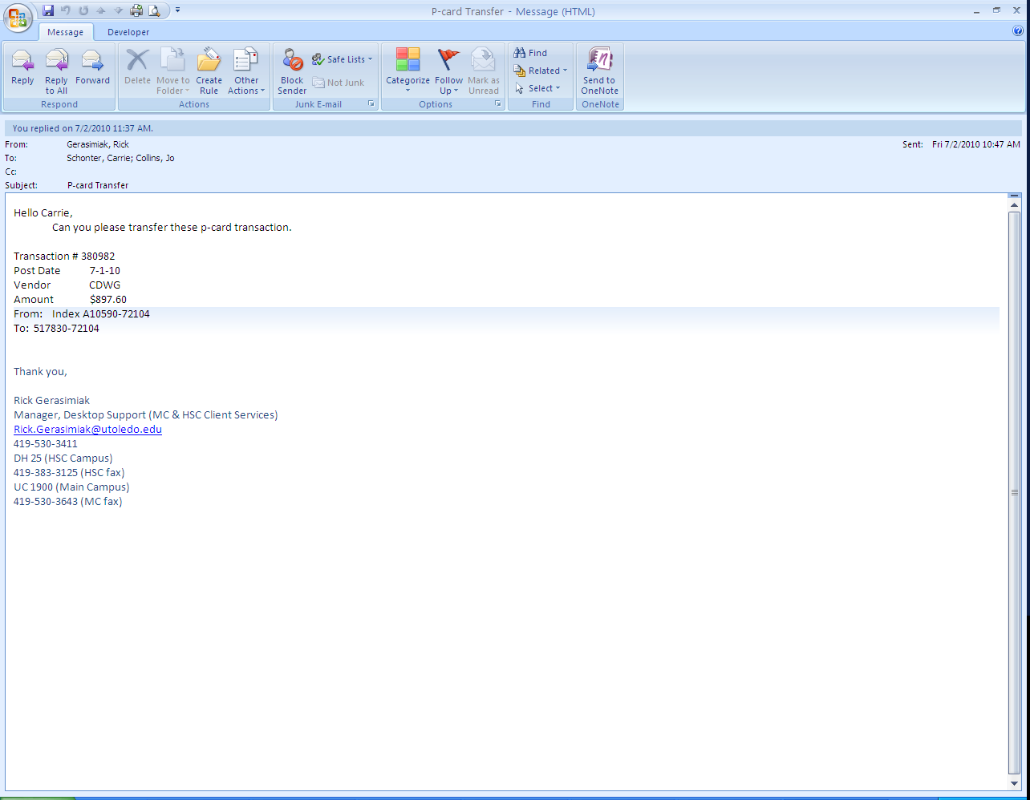
Changing indexes/accounts –Sample Email

