View the SQL Query behind Reports
- Open the Crystal Reports.
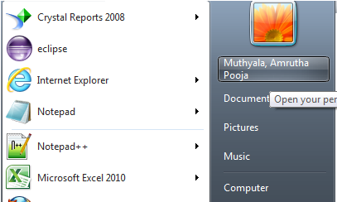

The below page appears after opening the Crystal Reports.

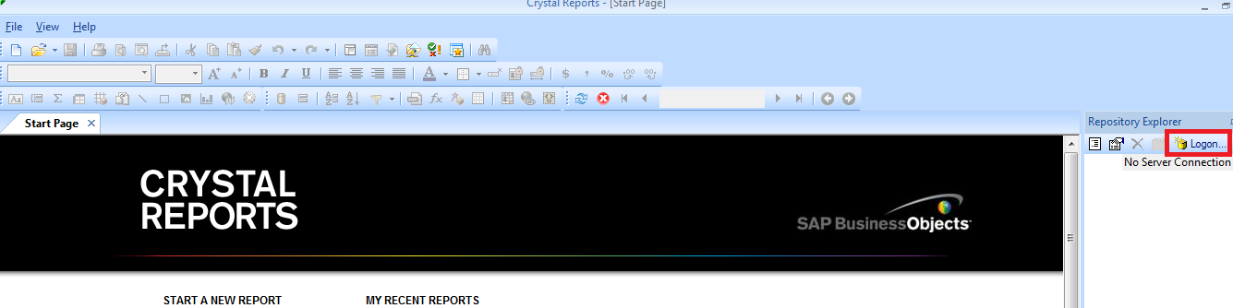

This is the beginning page of Crystal Reports.

- Login to the crystal Reports with your User ID and Password (Highlighted the “Logon”).
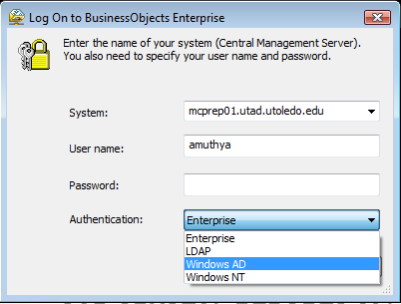
Give your “User name”, “Password”, and “Authentication” is”Windows AD”.
- After Login, the screen appears as below:
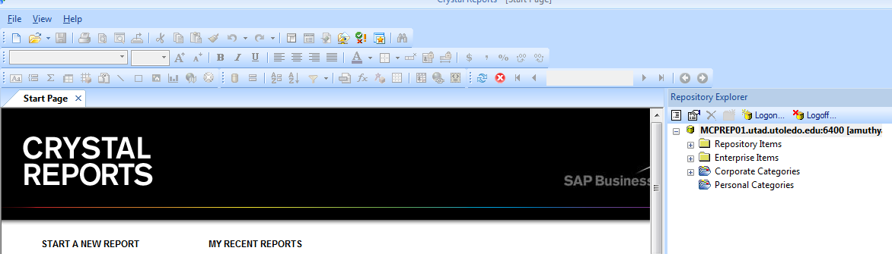

- Select a Report for Viewing its SQL.
- In this Example, “Accounts Payable Invoice Distribution History” is considered.

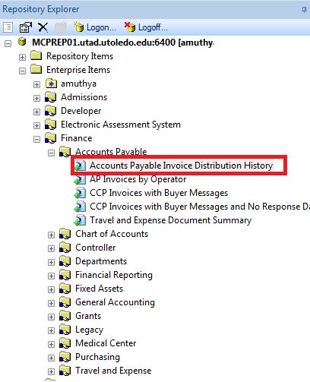

- Double click on this Report, the below screen appears.
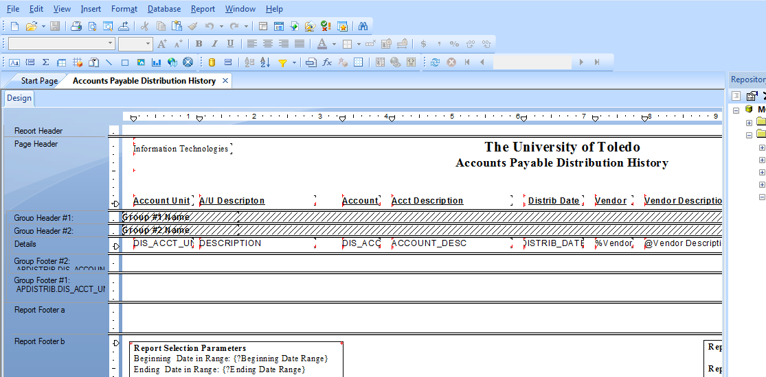

- Hit on ‘Database’ and navigate to “Show SQL Query”.
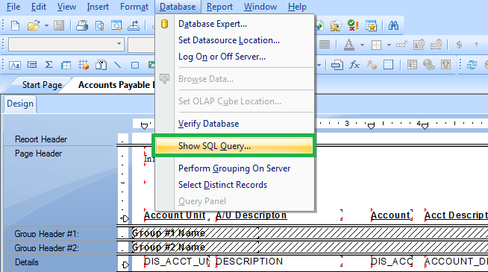

- After clicking on ‘Show SQL query’, the below screen appears.
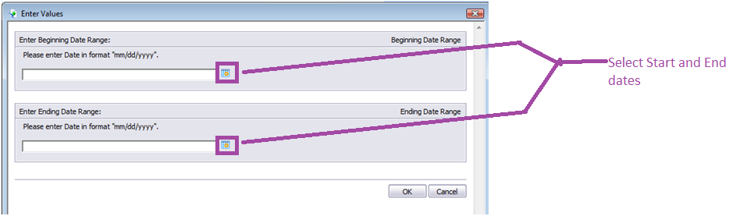

- Enter the parameters accordingly.
Selecting ‘Start Date’.
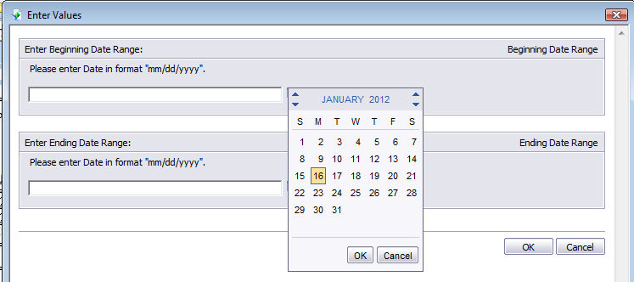

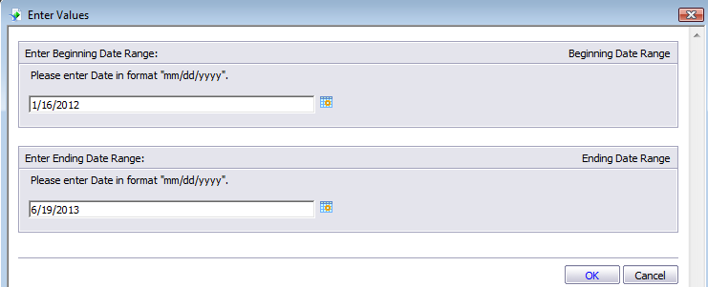
After entering the values, click on ‘OK’.

- It navigates to a Database login screen.
Login to the Database.
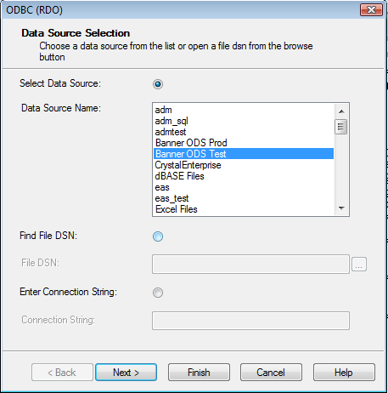

- Select ‘Banner ODS Test’.
The below screen appears requesting for User ID and Password.
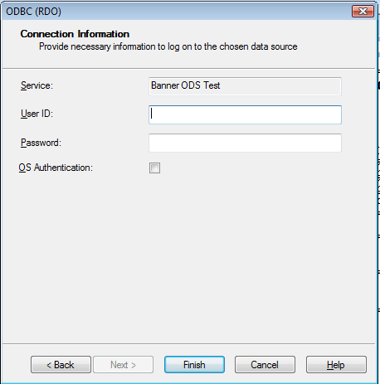

- Enter the User ID and Password.
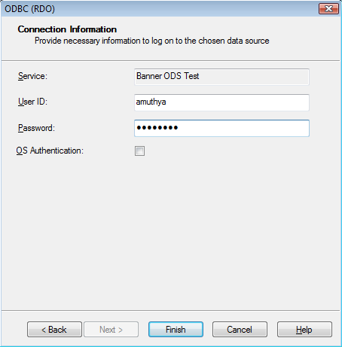
Click on ‘Finish’.

NOTE: This User ID and Password are different from that of User ID and Password entered in Step 2.

- It navigates to a Screen where SQL Query is shown.
