Shelly Horvat AuD. CCC-A
Tinnitus (prounounced TIN-ih-tus or ti-ni-tis) is the perception of ringing, buzzing, chirping, hissing, whistling or other sounds coming from within the ears or head. For some people, it is present constantly, for others intermittently. Tinnitus can also vary in loudness depending on how much background noise is present in the room or the level of attention one gives to it. Tinnitus is a common problem, affecting 1 in 5 adults. Tinnitus isn't a condition itself — it's a symptom of an underlying condition, such as age-related hearing loss, ear injury, noise exposure, or a circulatory system disorder. Although tinnitus is often associated with hearing loss, it does not cause the loss, nor does a hearing loss cause tinnitus. Although bothersome, tinnitus usually isn't a sign of something serious. When tinnitus affects someone’s ability to concentrate, sleep or relax, we recommend treatment. Treating an identified underlying cause sometimes helps. Other treatments reduce or mask the noise, making tinnitus less noticeable.
Tinnitus Treatment
The audiologists at Northwest Ohio Hearing clinic use many tools to help people manage their tinnitus condition. These treatments reduce the perceived intensity of tinnitus. They are not “cures” since they do not repair the underlying causes of tinnitus nor do they eliminate the tinnitus signal in the brain. Instead, they help lessen the burden of tinnitus by relieving the attentional, emotional and cognitive impact of tinnitus. These treatment tools address the tinnitus condition by relieving the anxiety, stress, social isolation, and hearing difficulties that accompany the tinnitus.

- Rule out and/or treat any medical causes of tinnitus such as high blood pressure, TMJ (temporomandibular joint) dysfunction, impacted earwax, sinus or allergy issues, head and neck injuries, medications toxic to the ears. Treatment of chronic pain, chronic stress, migraine headaches, depression, PTSD, and sleep disorders such as sleep apnea are also encouraged because these conditions can worsen tinnitus symptoms. This may involve referral to other specialties such as an ear, nose and throat physician, allergist, family physician, dentist or neurologist.
- Rule out any ongoing causes or exacerbations of tinnitus such as use of noisy equipment (lawn mowers, power tools, loud music etc.). We also provide guidance on the best type of ear protection to use in noise. When disposable foam earplugs are not enough, we offer custom earplugs for long term ear protection.

- Hearing aids to treat hearing loss and tinnitus. Tinnitus is a side effect or symptom of hearing loss. Treating the hearing loss with daily use of hearing aids alleviates the tinnitus symptoms for most patients. Amplification stimulates the ears and brain, giving back sound to the ears and brain, allowing the brain to relax and to stop having to compensate or work so hard to hear or fill in the blanks of the missing speech sounds. Hearing aids have proven to be an extremely successful tool for tinnitus treatment in our practice. Many good quality hearing aids are also equipped with special programs which play a masking noise to cover up tinnitus when the person is in a quiet area.

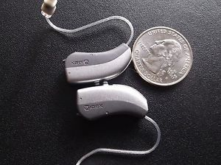

- Sound therapies. External noise played at soft levels can cover the sound of the tinnitus and reduce the perception and negative reactions to the tinnitus. At Northwest Ohio Hearing Clinic, we offer several types of sound therapies. One example is the Sound Pillow.
The patented Sound Pillow was developed by a Veteran whose tinnitus prevented him from sleeping. The Sound Pillow Sleep System is a plush, hypoallergenic pillow with two virtually undetectable speakers were engineered for total comfort and great stereo sound. The system comes complete with an easy-to-use MP3 player pre-loaded with nature sounds, hypnotic-binaural music, White Noise, Blue Noise and Pink Noise files. The MP-3 player can also be loaded with personal music or recordings.

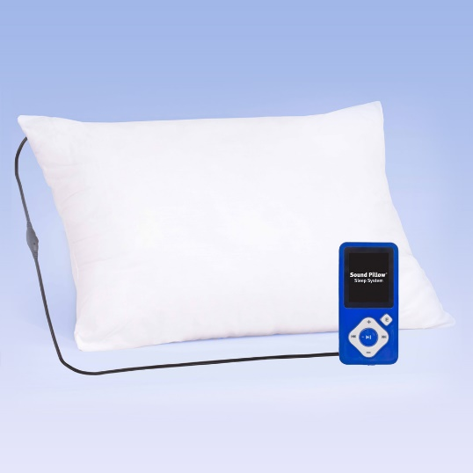

No two patients with tinnitus are alike, so the best treatment option is often contingent on multiple factors which are unique to each patient. Successful management of tinnitus is often a combination of treatments and providers. The first step to tinnitus treatment is a comprehensive hearing and tinnitus evaluation. Call Northwest Ohio Hearing Clinic to schedule your evaluation or to speak with an Audiologist if you have questions about your tinnitus. We can be reached at our Toledo location at 419-383-4012 or our Perrysburg location at 419-873-4327.

