# Instructions for PIs and Department Chairs Requested to Sign an IRB Application

November 2018

1. Open your favorite browser (Chrome, IE or Firefox are most common on PC, Safari on Mac) and go to the URL: irb.utoledo.edu

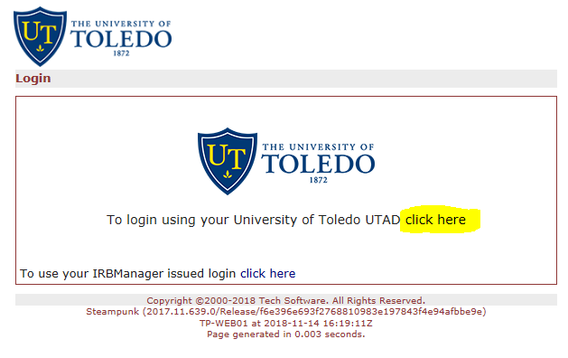

1. Click on the link that says “To login using your University of Toledo UTAD click here”
2. This will take you to the bell tower login page.  Enter your username and password just like you do to log into a UT machine.
3. You will be returned to your IRB Manager Dashboard. Click the link that says “# xForm awaiting your attention” (# may be any number, but will be at least 1)

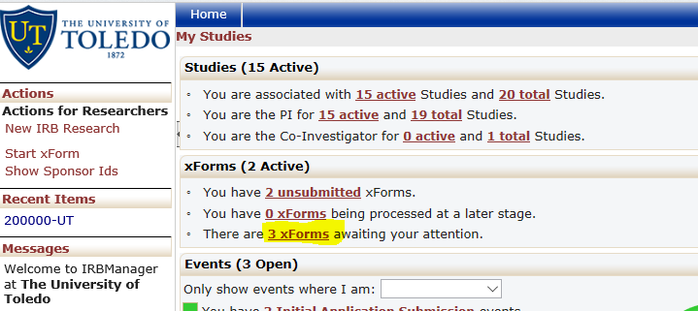

1. In the list that results, click the words “New IRB Research” on the xForm that you wish to sign. xForms can be sorted by any column by clicking on that column.

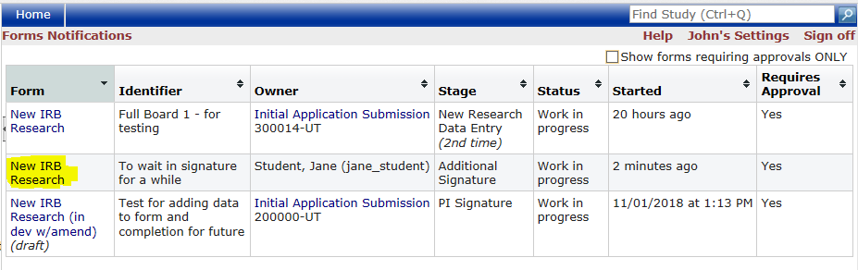

1. You are now on the xForm Application.

6A. If you wish to do a final review the content of the application, simply scroll down. All questions, answers and notes are available to you. At the bottom of the xForm is a “Next” button to move onto the signature page.

6B. If you are familiar with the content of the application and wish to move directly to the signature page, click the “Next” button that is located in the upper right corner of the header.

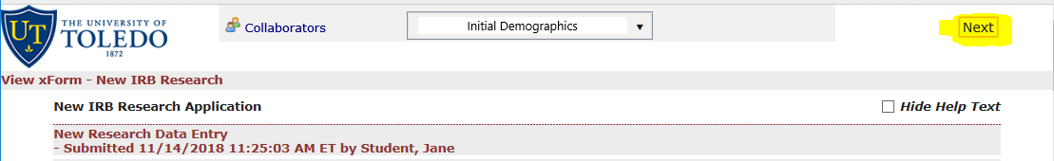

1. You are now on the signature page which looks like this:

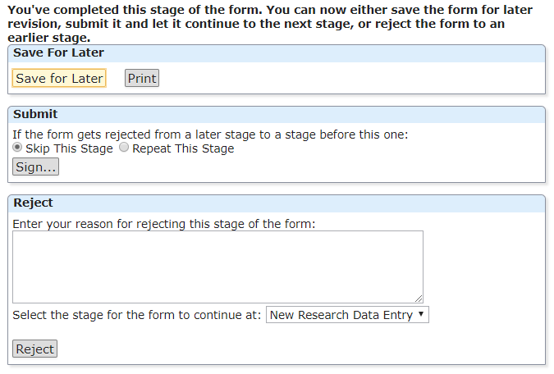

**IF YOU WISH TO COME BACK LATER:**

“Save for Later” means you want to leave without doing anything right now.

“Print” creates a PDF that you can save or print for your own use.

**IF YOU WISH TO SIGN THIS XFORM APPLICATION:**

1. You **FIRST** need to decide if you wish to allow this signature to stand regardless of changes to the application.  By default, you only have to sign once and you will never be asked to approve this submission again, even if substantial changes are made.  If you wish to review this xform again when changes are made, you can chose “Repeat this Stage.”  Make this decision **BEFORE** clicking the “Sign” button.
2. Click the “Sign” Button.
3. A smaller window will appear to ask for your user name and password again. Enter your UTAD username and password. Hit enter or “Sign In” and congratulations, you’re done.

**IF YOU SEE SOMETHING AMISS AND DON’T WANT TO SIGN YET:**

1. You can use the back button on your browser to go back to the main body of the application. Each question on the application has an “Add Note” link in the upper right corner. Click that to make a note of the problem.
2. When you have completed making notes, click the “Next” button again to go back to the signature page.
3. Enter a summary of the issues in the text box under the Reject heading. This text will be sent to the PI and the Submitter in an email.
4. Leave the Stage as “* Data Entry.”
5. Click the “Reject” button.