ESSPS Hosts Inaugural Sales Symposium

The Edward H. Schmidt School of Professional Sales (ESSPS) in the College of Business Administration at the University of Toledo welcomed over 115 sales professionals from 40 organizations on May 9th, 2008 for its Inaugural Sales Symposium.

The one day workshop for sales professionals was held in the Student Union Auditorium and featured three world renowned sales experts: Howard Stevens, Chairman and CEO The HR Chally Group, Dave Kahle, President The DaCo Corporation, and Greg Knudson, Vice President of Technology Regional Growth Partnership and Director of Rocket Ventures.

Greg Knudson opened the day with a Conceptual Selling Refresher that set the symposium’s foundation. Howard Stevens’ presentation, The New Sales Professional: The First and Only Customer-Defined Portrait of Sales Excellence, was rich with relevant research and included an interactive game show. Dave Kahle completed the day with his practical (“try this on Monday”) and engaging presentation, Mastering the Challenges of Selling Effectively in the 21st Century Economy.

Attendees came from a variety of industries and sales positions, and all came away with ideas, actionable information, enthusiasm, and 2 new sales books. Feedback was very positive – “Exceeded expectations. Assumed all lectures and same old ideas but very refreshing ideas on the industry.” “The level of quality of the speakers made it greatly valuable.”

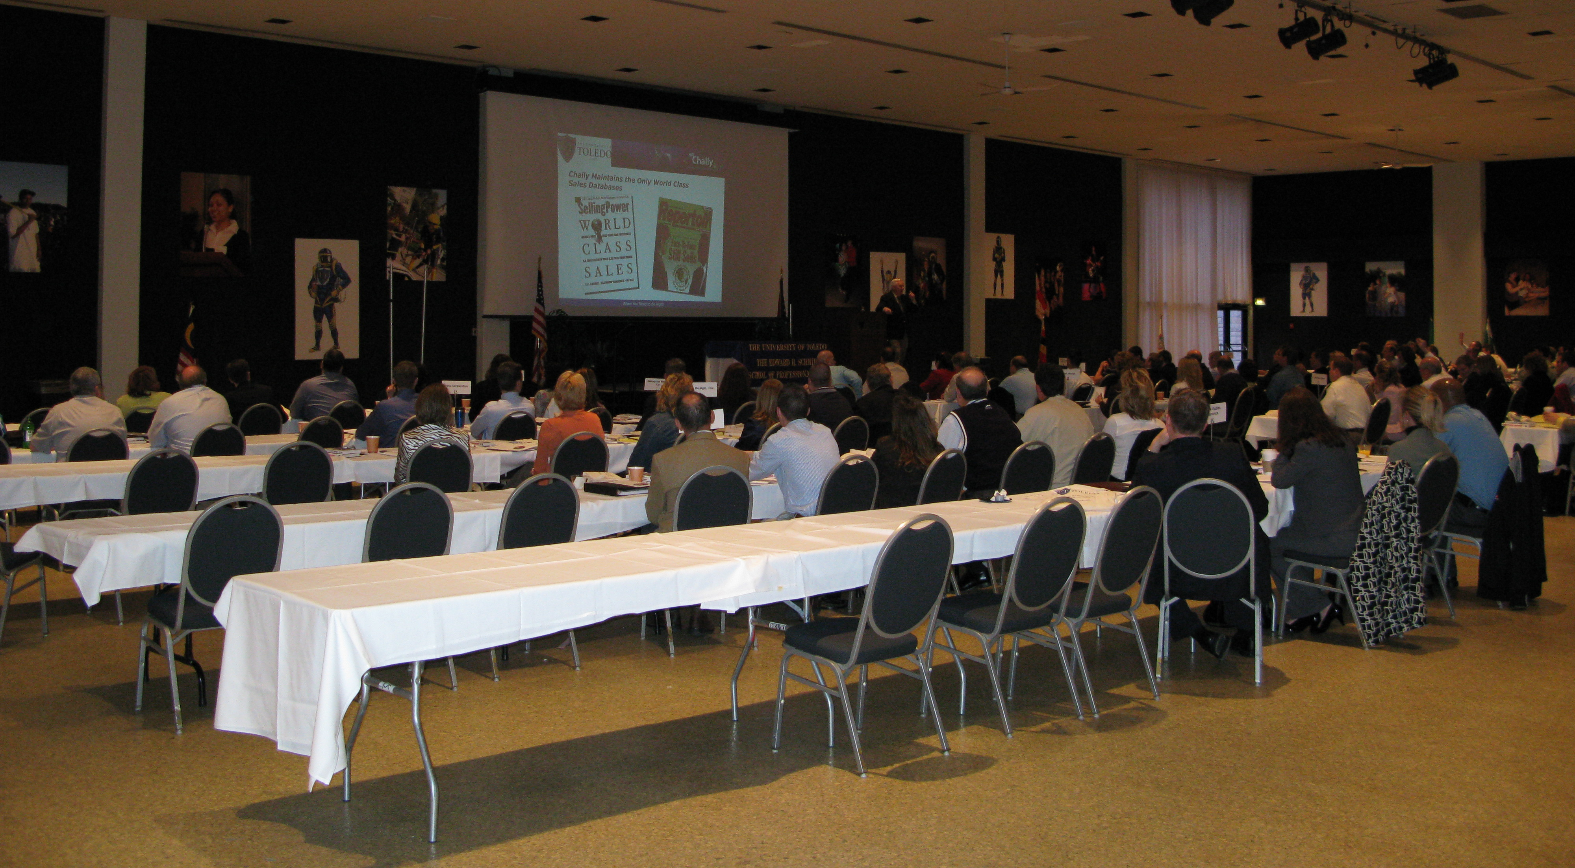
Over 115 sales professionals gathered to polish their sales skills and learn new ones at the ESSPS' Inaugural Sales Symposium

The ESSPS plans to host the Sales Symposium every other year and will host the next symposium in 2010. If you are interested in learning more about the ESSPS (recruiting, research, training/consulting), please visit www.sales.utoledo.edu, call 419-530-4604, or email edwardschmidtschool@utoledo.edu.

