UT Team Wins Second Straight National Sales Challenge

Three students from the University of Toledo’s Edward H. Schmidt School of Professional Sales (ESSPS) within the College of Business Administration claimed top team honors at the annual Russ Berrie Institute National Sales Challenge at William Patterson University in Wayne, New Jersey Nov. 6 – 8, 2008.
“There were 47 of the country’s top professional sales students competing in this three day event, and this is the second consecutive year UT’s Edward H. Schmidt School of Professional Sales team claimed the first place team prize,” noted Dr. Richard Buehrer, Director, ESSPS. “This clearly demonstrates that UT has the best sales program in the country.”
The UT team consisted of Jack Tiernay, who placed second in the individual all-around, fourth in the information gathering role play event, and fourth in the speed selling event; Brittany Phillips, who placed third in the speed selling event; and Dave Liebrecht, who placed eighth in the individual all-around. Dr. Ellen Pullins, ESSPS Research Professor of Sales & Sales Management, accompanied the team. Also involved in preparing the team were Dr. Michael Mallin, Professor Deirdre Jones, Professor Jen Cordell, Dr. Rick Buehrer, Professor Don Isenhath and Graduate Assistant Cara Paxson. Other team members include professional sales majors and members of the Sales Competition Team: Charlie Kaseman, Seth Phillips, Matt Richmond, Ryan Papp, Annie Sullivan and Laura Mecklenborg. The preparation also included working with last year team champions: Steve McKinney of Reynolds and Reynolds, Steve Harvey of News America, and Laura Jesse of Hylant Group.
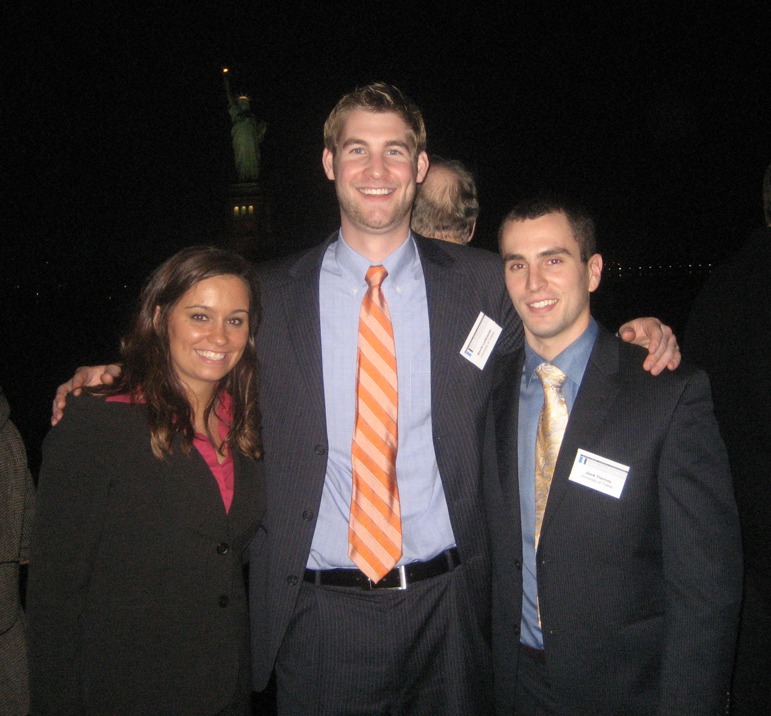
With the Statue of Liberty in the backdrop on a posh cruise in NY, ESSPS Champions, Brittany Phillips, David Liebrecht, and Jack Tiernay enjoy their win

Students role played selling pharmaceuticals to a hospital, demonstrated how they would manage time and territories for a clothing manufacturer, and sold themselves to six of the many corporate sponsors in a two minute speed selling drill.
“Business leaders applauded UT’s positive reputation and the impressive way that UT students represented their university,” Dr. Buehrer said. “Of 30 universities recognized by the University Sales Education Foundation, the ESSPS has the largest program that can boast both a major in this field as well as a full set of accreditations and certifications. Now with a two-year winning streak at the prestigious RBI National Sales Challenge, the Edward H. Schmidt School of Professional Sales can legitimately claim to be the top program in the country.”

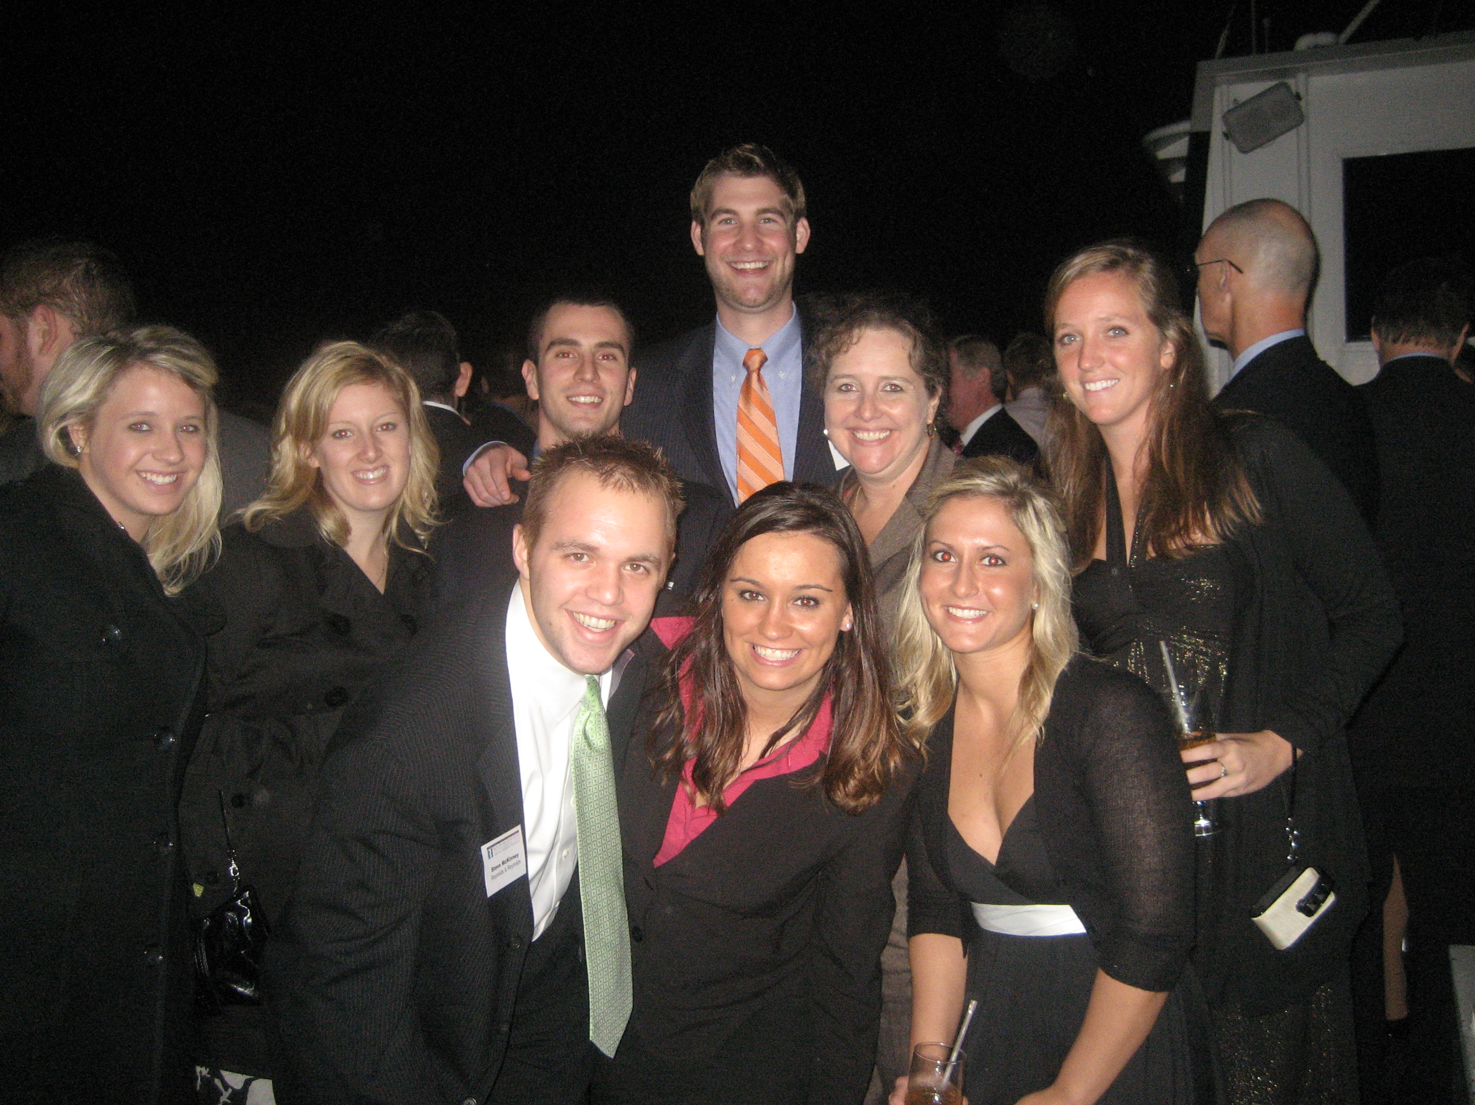
The ESSPS Sales Competition Team celebrates with ESSPS Alum based in the NY area. Front: Steve McKinney (RBI team 07, 2nd overall individual, 1st speed selling), Brittany Phillips, April Ruse. Back: Gabe Rasure, Jessica Hood (NCSC alternate team 2007), Jack Tiernay, David Liebrecht, Dr. Ellen Pullins, and Julia Lyons

