ESSPS 4th Annual Executive Sales Summit
Leading Sales in a Multigenerational Market
November 9, 2007

The Edward H. Schmidt School of Professional Sales (ESSPS) in the College of Business Administration at the University of Toledo held its fourth annual Executive Sales Summit on November 9th in the Student Union. Attendance grew again this year with close to 90 sales and human resource executives gathering to share and learn about “Leading Sales in a Multigenerational Market.” Sara Nye, Area Rental Manager at Enterprise Rent-a-Car thought “Everything was great. I learned some new things that I can bring back to my business.” The morning keynote received rave reviews, “Jason hit a home run!” “Jason was very real to our hiring/training/motivation process – kudos!” Natasha West, a Field Sales Representative and ESSPS Alum from Rexam, “enjoyed Jason Dorsey’s presentation. As a GenYer, I really related to what his message was.” Bob Kleppner and Kristen McKeag, both District Sales Managers at Paychex Business Solutions, liked the insight from the panelists because they “represented each generation and different industries.”

The summit was kicked off with an energetic, thought provoking keynote presentation on “Loyalty @ Any Age” by Jason Ryan Dorsey that was sponsored by Automatic Data Processing, Inc. Jason, who was on 60 Minutes the weekend following his appearance at UT, has also been featured on 20/20, NBC's Today Show, ABC's The View, Fortune Magazine, USA Today, and The Wall Street Journal. To see Jason on 60 Minutes and learn more on how to better retain, motivate, and develop Gen Y employees, view “The Millennials are Coming!,” at http://www.cbsnews.com/sections/i_video/main500251.shtml?id=3486473n&channel=/sections/60minutes/videoplayer3415.shtml.
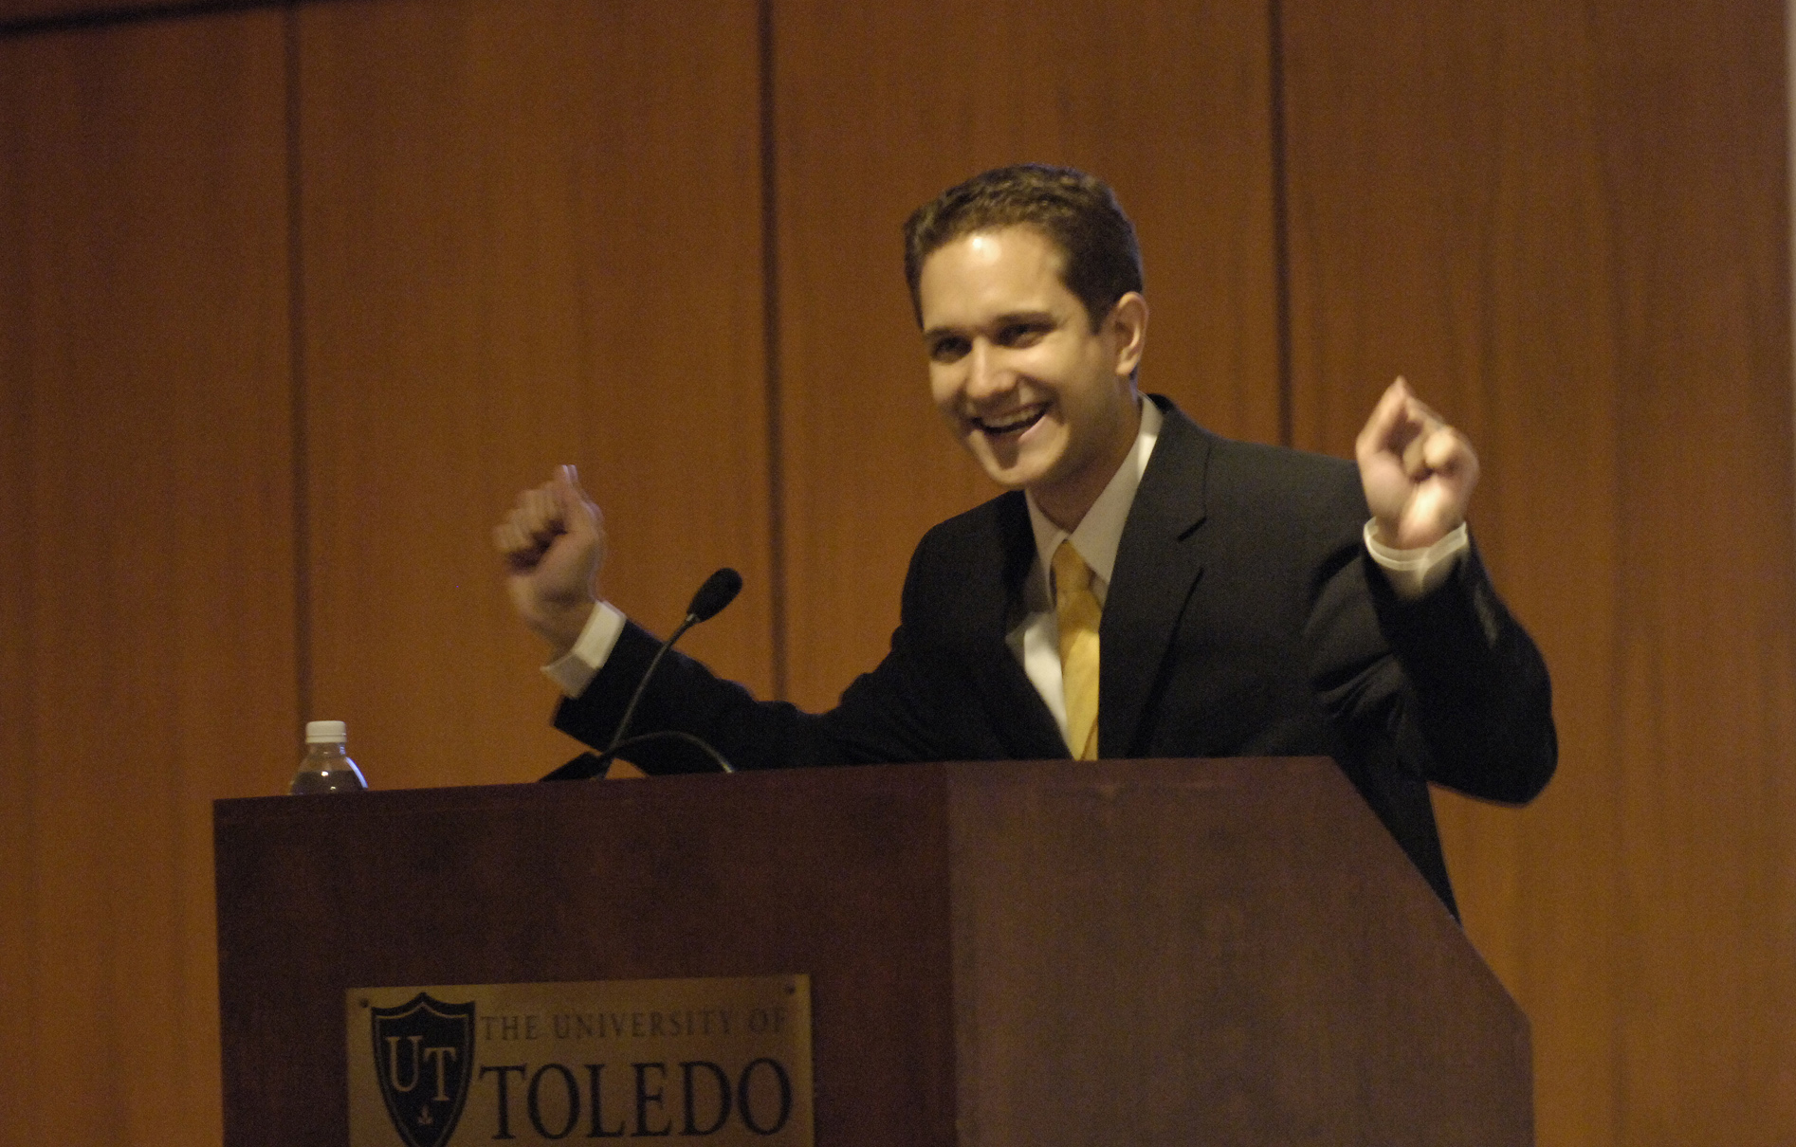
Keynote Speaker, Jason Ryan Dorsey, brought energy and insight into motivating and retaining a multigenerational workforce

Loyalty @ Any Age – Jason Ryan Dorsey – Morning Keynote – Sponsored by Automatic Data Processing, Inc.
Despite all the differences between the four generations, each generation thinks the later generations have it easier, need to pay their dues, and have bad taste in music and clothes. They are all influenced by their parents’ parenting style, technology, and lifespan. All four generations are motivated by:
- Leaders who are adaptable to their individual needs (not just the needs of that leader’s generation; individuals are key not the company or team)
- Firms that get involved in their employee’s goals (need to do this if you want them to get involved with the company’s goals)
- Understanding their higher purpose/mission (not spiritual) for the work – not simply just work

To bridge the gap and bring a multigenerational workplace together, you can try 11 things next week (© 2007 Jason Ryan Dorsey):
- Make the first day of work unforgettable (key for GenY/Millennials)
  - Gift wrapping their business cards so they feel important and professional
  - Have the office wear name badges so they can feel safe approaching new teammates
  - 5 minute welcome ceremony
  - Give their mom a tour of the office
- Recognize/Celebrate their birthday (key/most important day for GenY/Millennials)
  - Give them the day off, $75, a disposable camera, and an order to go out and spend the money on something they have never done before. Use the camera to document the new experience and bring the pictures to work
- Offer rewards of choice (gift cards, concert tickets, leaving 30 minutes early on a Friday, etc)
  - Each generation has different preferences. GenY/Millennials and GenX would prefer time off and early departures, and Boomers would prefer extra money
- Involve them in the hiring/interviewing process
  - They ask different questions
  - Build buy in
- Catch them working
  - Take pictures of them working and send it to their family (parent, spouse, children) as part of a thank you note for raising a valuable team member
- Involve them in executive meetings, industry conferences, and community events
- Coach them to ask for opportunities to prove their talent and ability
  - Research competitors, interview customers, solve a company problem
- Have a company-wide volunteer day
  - Select a project in your community, such as repainting the local animal shelter, and let each employee complete the aspect of the project that interests them. Take lots of pictures of the volunteer work and hang them in your company’s hallways.
  - Offer a day off to volunteer – give one personal volunteer day per year
- Showcase employee projects and breakthroughs via a company blog, regular staff meetings, or via email
  - Nominate them for awards as individuals and as a team (industry, company, community)
- Have a “family” event and encourage them to bring their kids or parents
- Pay them to read the right stuff
  - Create a list of 20 books that will help your Gen Y employees develop skills valuable to your company. Offer to pay them $50 for every book they read on the list and write a report explaining how they will apply the book’s principles at work.

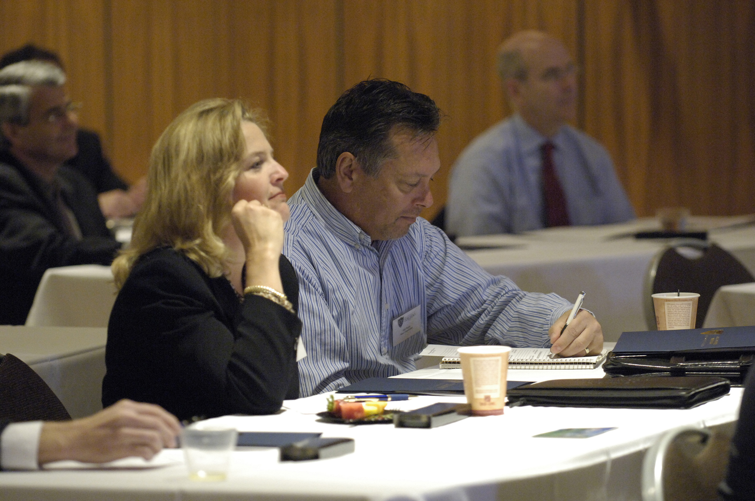
Susan Herring, General Sales Manager, and Skip Pogan, Product Manager, from Dana Corporation gather retention and leadership ideas from expert speakers and panelists.

Generation | Workplace Characteristics | Retention Tactics
GenY/Millennials  Born 1977-1995  Approx. 75 million in US  10% of current workforce | - No expectation of lifetime employment  - No social security  - Net spenders  - 90+ years life expectancy  - Entitlement  - Adultlescence – delayed adulthood, wants the perks of being an adult without the responsibility and accountability  - Instant gratification  - Individual within a group | - Reward with time (time is currency, they like shortcuts)  - Help them reach professional and personal goals  - Help them itemize and prioritize (they are good at multitasking but not necessarily on the high payoff activities)
GenX  Born 1965-1977+/-  Approx. 45 million in US  40% of current workforce | - Prove it to me (skeptical)  - Loyal to people not companies  - Time is currency (if I come in early, I want to leave early)  - Knowledge | - Explain the “why” upfront  - Talk about backup plans  - Demonstrate currency and relevance to address the “what have you done lately” skepticism  - Give facts
Baby Boomers  Born 1945-1964+/-  Approx. 80 million in US  45% of current workforce | - Workaholics – in early out late, 55 hours/week average  - Focuses on hours per week  - Competitive  - Wants acknowledgement  - 1st “Me” generation to have things customized | - Acknowledge how hard they work  - Identify their contribution to the team
Matures  Born pre 1945  Approx. 30 million in US  5% of current workforce | - Military influence  - Loyalty and duty  - Honor  - Humble  - “We” first – average Joe, just like us | - Ask questions about their life  - Respect history  - Respect = Age  - Delayed gratification

Leading a Multigenerational Sales Team - Panel Discussion
Panelists from each generation included: Greg Knudson, President, GHK Sales Consulting LLC, Miller Heiman Consulting Partner, and Vice President, Technology Development, Regional Growth Partnership; Steve Lewis, Senior Sales Executive, Paychex Business Solutions; Joshua Wolfenbarger, Account Representative, Caraustar; Ellen Fruchtman, President, Fruchtman Marketing

Tactics for Improved Productivity and Retention with GenY’s/Millennials
- Management/Leadership is a daily function
  - High maintenance
  - Be more of a teacher than a boss
  - Committed to people not organizations
  - Goals drive – individual within a group
  - Communicate opportunities – don’t assume they can connect the dots
  - Tell them explicitly WIFM (what is in it for me)
  - Monthly (or quarterly) evals on goals (professional and personal)
    - Once a year just on professional goals does not cut it
  - They want to run the business, you need them to do that eventually, so coach them and involve them on bigger, more strategic projects
  - Teach them how to deal with adversity
    - Parents came in to save them, so they never learned how to do it themselves (helicopter parents)
  - Identify and work with someone’s hot buttons. Try to see things from their point of view. (for similarities typical in each generation, see notes above or go to www.cammarston.com, Meet the Four Generations)
- Time is currency
  - 4:30pm Fridays
  - Early off for Halloween if they have children
  - 1-2 weeks paid off at Christmas time that is not part of their vacation time (industry helps retail and works heavily leading up to Christmas)
- Relationship building is critical and acts as a key differentiator in a competitive market
  - Committed to people not organizations
  - People who successfully build social capital know how to influence people, have better access to people, learn more, and are higher paid
    - Some/Most have never been taught how to network, tie a tie, etc
  - Need to work more on face to face communication because they tend to rely too heavily on email and texting
    - Technology has made things simpler and cost less
  - More firms outsource as things become more of a commodity – service is the differentiator
  - Intra company blog to post what they did at work that week, ideas for improvement
  - Pay attention to things like kick ball teams, charitable work, and other personal interests
  - Seniority does not matter
  - Good at working in teams
- Having a sales process that is repeatable, predictable, and rooted in best practices gives everyone regardless of generation a sense of team and clear purpose because everyone knows what the goal is, why they want to reach the goal, and how they are going to get there
- Knowledge based
  - Immediate experts because of technology
  - Good at acquiring data
- Can be motivated by name brands (large firms, big cities)
- Ambitious but distracted
- Have GenY’s interview GenY’s, then bring in the GenX, then the Boomer
- GenY’s are cheerleaders and can sometimes find their own replacement
- Salespeople are a resource
- Companies have forgotten to wow their employees – too concerned with customers

A half day team development forum for 25 people at Maumee Bay State Park valued at $6,000 was graciously donated by the Ohio State Park Resorts and Corporate Quest.

The event was drawn to a close over lunch with a keynote presentation by Brian S Epstein, Chairperson EPIC and Trust Executive at The Trust Company. Brian’s presentation, “Why Make a Concerted Effort to Engage Young Professionals,” positioned EPIC as a valuable resource for Toledo area businesses because it aims to connect professionals with their community. It’s the personal connection, Epstein points out, that encourages people to stay and invest in a community for the long term.

Why Make a Concerted Effort to Engage Young Professionals - Brian S. Epstein, Chairperson, EPIC and Trust Executive, The Trust Company
When Matures were younger, they were taught and expected to give back. Toledo had strong entrepreneurs and strong growth in the private sector. Over time, people left the city, and the area became transient with fewer people thinking long term about cultivating Toledo. The gap was filled by politicians, who in some cases, had short term, politically motivated objectives.

People are once again starting to see Toledo as a long term home and are looking for ways to get engaged and make a difference. EPIC, Engaging People, Inspiring Change and a member organization of the Toledo Regional Chamber of Commerce, is an organization designed to connect professionals with their community and has the following goals:

- Connect high-potential emerging leaders to each other and the community.
- Provide emerging leaders with a voice in the future of our region.
- Provide an atmosphere for creation and incubation.
- Attract and retain diverse young talent to our region.

EPIC is committed about being positive about the Toledo region and wants others to do the same. This means responding positively when people 'go negative' on Toledo in meetings, in the press, and in the community. It also means looking at your community through the lens of hope, not despair. It means focusing on what our community does right and taking action to make a positive impact, rather than complaining.

EPIC has eight (8) action committees to connect EPIC members (600 individual, 32 Corporate Members) to the Toledo community: advocacy, community involvement, cultural arts, economic development, leadership and professional development, marketing and public relations, membership, and networking and social.

EPIC hosts events to create awareness of Toledo’s benefits so people can make a personal connection to the area and stay: EPIC Unplugged, EPIC Launch, Speed Networking, Board 101 Training (for non-profits), and The EPIC Race. A specific benefit for area businesses is including EPIC in the hiring process so they can take an interview candidate out for the day or night to show them all the things to do in Toledo.

To get more information on EPIC, get on their email distribution list, and/or sign up as a member (individual or corporate), visit www.epictoledo.com.

Future Summits
The findings/themes from the summit will be used to plan next year’s Executive Sales Summit (November 14th, 2008) and future Sales Symposiums. The first Sales Symposium for the sales force will be held this spring (May 9th, 2008), and future Executive Sales Summits are intended to maintain strategic alignment.

Topics for future summits and/or symposiums include:
- Key topics from this summit (see major findings/themes above)
- Engaging everyone in a corporation as a “salesperson” in some role capacity & sales duties in non-traditional sales jobs
- Innovation in sales – cutting edge – new theory
- Motivating a remote team
- Talent management – what is out there, what are their strengths/weaknesses, what markets are they strong in
- How to interview a sales person if you are in a sales leadership position
- Selling exclusive of price
- Creating and maintaining a sales culture
- Selling your community to prospective residents, businesses, and institutions
- Selection of presentation media
- Global competition and partnerships
- How businesses partner with academia

Save the Date for other ESSPS Events
- March 18th, 2008 - 3rd Annual Networking Night (online registration and invitations in December)
- May 9th, 2008 - Inaugural Sales Symposium (register online today!, early bird discount ends 12/31/07, group discounts available)
  - One day workshop led by well known sales experts to help strengthen the skills of your sales force.
    - Howard Stevens, Chairman and CEO, The HR Chally Group “The New Sales Professional: The First and Only Customer-Defined Portrait of Sales Excellence”
    - Dave Kahle, President, DaCo Corporation “Mastering the Challenges of Selling Effectively in the 21st Century Economy”
    - Greg Knudson, President, GHK Sales Consulting LLC, Miller Heiman Consulting Partner, and Vice President, Technology Development, Regional Growth Partnership “Conceptual Selling Refresher”
- November 14th, 2008 - 5th Annual Executive Sales Summit

The mission of the ESSPS is to provide high quality educational programs in sales and related areas, to enhance the world of business practice related to professional sales and to become a recognized global leader in sales learning, discovery and engagement. The ESSPS provides a learning environment for students, faculty and business professionals that promotes shared learning, networking opportunities and the exchange of ideas about sales issues in an open and professional manner. For more information, please visit www.sales.utoledo.edu.

