ESSPS 5th Annual Executive Sales Summit
Motivation From the Inside Out: A Playbook for Sales Leaders
November 7, 2008

Over 80 sales and marketing executives from over 40 firms attended the 5th Annual Executive Sales Summit on November 7th, 2008 in the Student Union Ingman Room. The Executive Sales Summit is sponsored by the Edward H. Schmidt School of Professional Sales (ESSPS) in the College of Business Administration at the University of Toledo and its Corporate Partners: Ed Schmidt Automotive Group, Huntington Bank, DWD Technology Group, Automatic Data Processing Inc., Hilti Inc., Paychex Business Solutions, Tom James Company, Seymour & Associates, Therma-Tru Doors, All Phase Electric Supply/CED, Enterprise Rent-a-Car, Ethos Group, Hylant Group, Northwestern Mutual Financial Network, and Crown Equipment Corporation.

Motivation From the Inside Out: A Playbook for Sales Leaders was the theme selected by the active ESSPS Advisory Board and previous summit attendees. The goal of the Executive Sales Summit is to strengthen relationships with the business community by facilitating discussions on topics that are critical to their work.

The motivation theme resonated with the attendees, “…excellent subject matter, I could see the universal nature of leadership…Coaching in basketball is similar to coaching or managing sales,” Mike Owens, Director of Sales at Lott Industries.

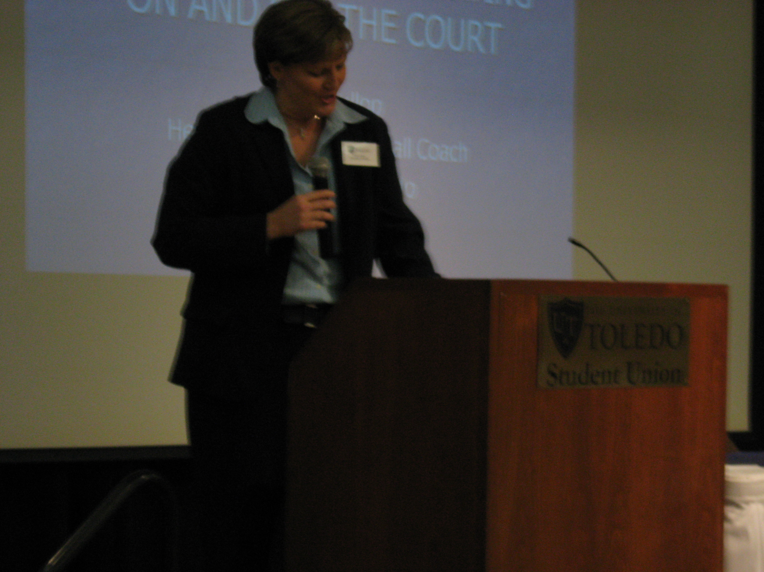
Tricia Cullop, UT’s new Head Women’s Basketball Coach inspired attendees to evaluate themselves as well as their team, put a positive spin on things, and be a continuous learner

After welcoming and updating the business leadership community, COBA Dean Dr. Thomas Gutteridge and ESSPS Director Dr. Richard Buehrer introduced the morning keynote, Tricia Cullop. Tricia Cullop is UT’s new Head Women’s Basketball Coach and comes to the Rockets as the Missouri Valley "Coach of the Year” with a 73-48 record over the past four seasons. Summit participants delighted in her motivating keynote presentation that outlined the critical steps to truly motivating a team (sales and otherwise). Her use of stories, reflection, and humor resonated with the assembled team and renewed their spirit to go out and lead their own sales teams. Below is a list of key take-a-ways that can be modified for use in your own sales leader playbook:

- Storied programs/organizations don’t guarantee success. Things might appear easy, but you have to look for the opportunity and capitalize on it.
- Focus on the positive aspect of all situations – don’t dwell on the negative
- “When you're finished changing, you're finished.” Benjamin Franklin. Leaders need to grow and change. If you get better, the team will too.
- Know yourself
  - Record yourself and listen to see how many positive and negative things you say
  - Ask your team for feedback to see if your thoughts match their’s. Be honest
  - Have a purpose so you can leave a legacy
- Know your team
  - What are each person’s strengths and weaknesses?
  - Tell people that they are doing a good job
  - Give people a sense of worth
  - Ask your team what inspires them. It is different for each.
  - Let people know that you value them – share in the success, credit, money, perks, etc
- Motivational tactics
  - Get people’s viewpoint – what do they see?
  - Praise in public; criticize in private
  - Create a fun, competitive environment
  - Be consistent – changing the message confuses and frustrates the team
- Improve the team
  - Invest in networking, mentoring, training, books, development, etc – people can’t be creative if they are forced to live in the same box all the time
  - Do for others what someone did for you – make a difference and pay it forward

The energy continued as the attendees went into breakout sessions to debrief the keynote presentation and come up with questions for the panel discussion. Dave Lukas, District Sales Manager for Paychex, and Neil Neukam, Assistant G.M./Director of Corporate Partnerships, Toledo Mud Hens led room 1 on Teams and Individuals, and Bruce Klinger, Managing Partner Northwestern Mutual Financial Network, and Brad Konvolinka, Sales Representative and ESSPS Alum, Crown Equipment guided room 2 on Going the Extra Mile.

Teams and Individuals
- It is about Us not Me
- Look for the positive spin in any situation. Some of the best successes and companies are created in downturns
- Dealing with energy vampires (eeyores)
  - Appear during transitions in management and/or philosophy
  - Try to help first
  - Let them go if they don’t improve – look to see if other team members are distancing themselves
- People need to take ownership – lead by example
  - Find a way – make a way. How to work around or within existing frameworks (“this is the way we have always done it”). Sometimes it is easier to ask forgiveness than to get permission
- Be a continuous learner – read, be humble, be coachable
- Know yourself, be honest
- Know your team members’ motivations and fears (can’t use one size fits all). Probe to get this. Ask “What else?” Give them ideas based on time, money, recognition, and other non monetary incentives. Remember that factors can change over time – check in with people. Take them out of their natural environment
- Sales people have to self motivate. A manager’s responsibility is to make it easier for people to self-motivate by creating the right environment (reward with time, money, recognition)
- Style can be more important than substance; being genuine is so important
- Passion is contagious and can feed a team
- Communication
  - Use stories to communicate
  - Consistency has a lasting impression
  - Communicate and interact with the team/troops even when you are time constrained. Make conversations about work and things outside of work.
- Self evaluations help to make sure that goals are aligned. Consider a 360º evaluation with internal and external clients to discuss joint expectations
- Re-recruit people to retain the talent
- People are more open to change during down/tough times
- Take big goals and turn them into smaller goals so people can feel a sense of accomplishment that progress is being made
- Pay attention to leaders ahead of you so you are aware of situations and can adapt your team

Going the Extra Mile
- Recruitment/Talent screening
  - Identify values and motivational factors and then recruit against that
  - Do behavioral interviews, talk to references, look at past history
  - Look to current contacts (vendors, customers, etc) for the next hire
  - Be objective, have a set number of criteria that have to be met
  - Recognition needs value, purpose, and meaning
  - Ask people where they want to be in 1, 5, and 10 years and follow-up at those intervals
- Watch your own attitude and behavior
- Focus on core products/services and better customer service to differentiate and add value
- Network and make relationships within the industry to find new opportunities, ideas, and focal areas
- Take ownership, how to figure how much to take or assign
- Build goals together
  - Tie rewards to goals – reward good habits
- Communication
  - Spend more time with the troops – stay connected
  - Mid level managers are the key to the process
  - Good, solid communication whether face to face, voicemail, or email
  - Clear communication at each level of organization (see the forest and the trees)
  - Package the message for acceptance and understanding, create a sense of urgency
  - Feedback is a gift
- Retain clients – relationships are key, network to increase mutual business, don’t casually throw around the partnership word, be creative (game or competition)

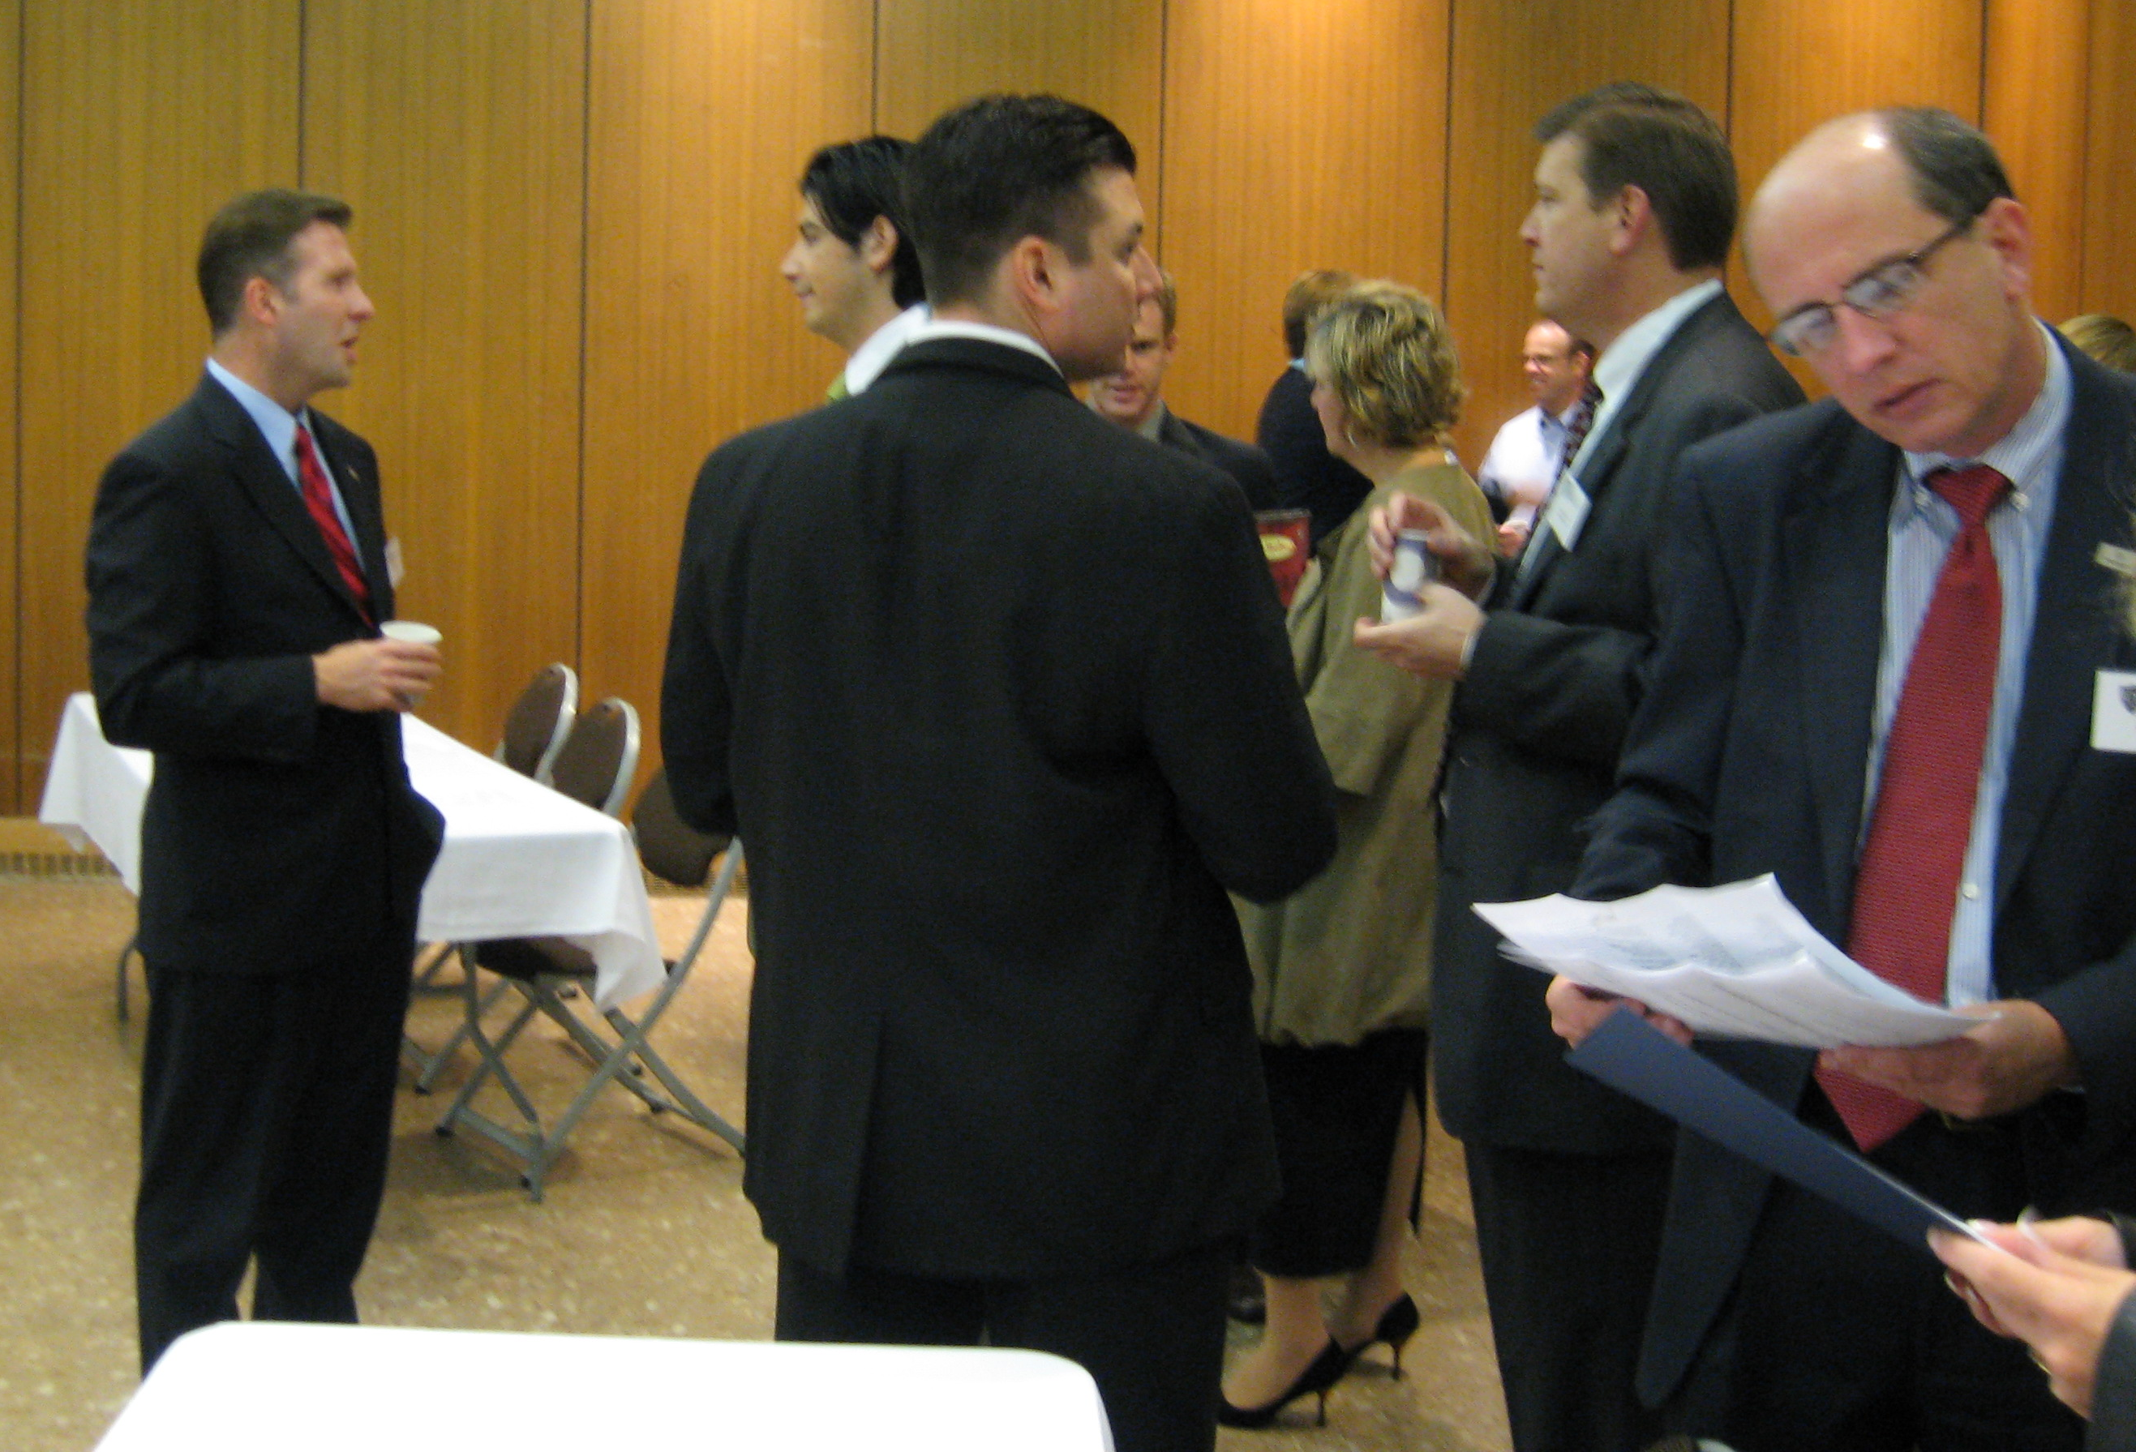
Executives and Leaders from Rexam, Owens Corning, Northwestern Mutual Financial Network, and others network and share ideas

Bringing the event full circle was inspiring luncheon keynote, Scott Bailey, Regional Strategic Sales Manager at Fastenal. Like Coach Cullop, Scott Bailey and Fastenal believe in looking for the positive opportunities even when economic times are tough. Fastenal is presently opening new stores to increase market share in the $140 billion market. Because of its strong growth and other qualities, Fastenal was named one of nine Breakthrough companies and has made Forbes’ Best 200 Small Businesses list every year they were eligible. It all starts with people, and leaders need to balance the roles of coach, player, and team. Players need to have the right attitude and believe that they can win so they can give 100% effort. The other leaders on the team need to be recognized and supported. A leader needs to help make their team better and improve their own personal performance.

There are six steps to building a winning team, and they are all ongoing (more ideas to adapt for your playbook):
- Culture and Environment
  - Fastenal has a flat, decentralized structure with leadership involvement from the very top. Employees are encouraged to be entrepreneurial and competitive, and they are trusted to make decisions on their own. Fastenal has the ability to adapt quickly as the environment changes. Frugality is instilled from the beginning to eliminate waste.
- Recruiting
  - Fastenal keeps their pipeline full, promotes from within, looks for the best who have a positive attitude and a mindset for long term opportunities, and uses a 2:1 ratio of PT to FT employees
- Set Expectations
  - For each employee based on position. Monthly sales goals, active accounts, new accounts, number of calls, signed business. Expected to perform at the highest level in all categories – goal to be in the top quartile.
- Establish Accountability and Performance Metrics
  - Each level of the organization can see how they are performing relative to their peers on a daily, weekly, monthly, and quarterly basis. This enables Fastenal to track progress and quickly adapt to change.
- Coaching and Leadership
  - Challenge rather than control
  - Treat everyone as your equal
  - Stay out of the spotlight
  - Share the rewards
  - Listen rather than speak
  - See the unique humanness in all persons
  - Develop empathy
  - Suppress your ego
  - Let people learn
  - Remember how little you know
- Training and Development
  - Fastenal School of Business and on the job
  - New hire assimilation
  - Ongoing development that people can sign up for in sales & marketing, leadership, operations, and product education

Future Summits
The findings/themes from the summit will be used to plan next year’s Executive Sales Summit (November 20th, 2009) and future Sales Symposiums. The next Sales Symposium for the sales force will be held May 2010, and future Executive Sales Summits are intended to maintain strategic alignment.

Topics for future summits and/or symposiums include:
- Key topics from this summit (see major findings/themes above)
- Sales training/leadership/development
- Developing metrics in sales management
- Game plan ideas and strategies for best recruiting questions
- Dealing with management figures who are reluctant to change and methods to hold them accountable to following the company’s process
- Reps of successful companies
- Generational differences in the seller-buyer relationship
- What does diversity really mean? How to leverage it
- Selling to the executive suite, overcoming price objections
- Technology in sales
- Compensation plans as well as commission and salary combinations that work

Save the Date for other ESSPS Events
- March 18th, 2009 – 4th Annual Networking Night (online registration and invitations in December)
- October 9th, 2009 – 3rd Annual Speed Recruiting
- November 20th, 2009 – 6th Annual Executive Sales Summit

The mission of the ESSPS is to provide high quality educational programs in sales and related areas, to enhance the world of business practice related to professional sales and to become a recognized global leader in sales learning, discovery and engagement. The ESSPS provides a learning environment for students, faculty and business professionals that promotes shared learning, networking opportunities and the exchange of ideas about sales issues in an open and professional manner. For more information, please visit www.sales.utoledo.edu.

