Edward H. Schmidt School of Professional Sales Hosts First Executive Sales Summit

Twenty four sales executives from nineteen corporations gathered at the College of Business Administration on Friday, November 12th to discuss their sales challenges and best practices in an open forum facilitated by the Edward H. Schmidt School of Professional Sales (ESSPS) faculty. Greg Knudson, a senior sales executive and consultant with Miller Heiman, said, “This was a great forum for our business community leaders to meet and share issues and ideas.” Debby Schaefer, Vice President of Human Resources at Brooks Insurance, was also “impressed with what the school has to offer.”

The Executive Sales Summit was kicked off with an energetic and provocative keynote on “What Lies Ahead, and are You Up to the Challenge?” delivered by Libbey Inc CEO and Chairman of the Board, John F. Meier. He shared his experience and philosophy on today’s competitive sales landscape and challenged the participants to think about the methodologies of tomorrow. He likened sales strategies to hockey by quoting NHL legend, Wayne Gretsky, “Skate to where the hockey puck is going.”

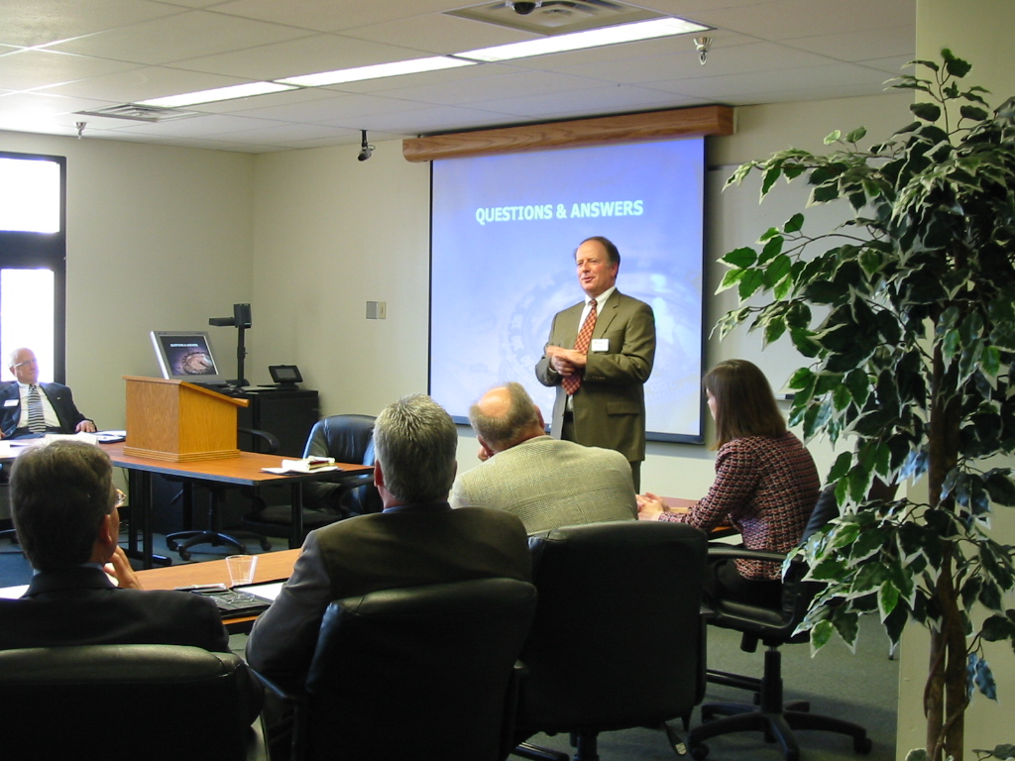
Keynote Speaker, John F. Meier, CEO and Chairman of the Board at Libbey Inc., fielding questions from his presentation

The findings/themes from the summit will be used to plan a series of sales force workshops that are a direct offshoot from the Executive Sales Summit. The first sales force workshop will be held this spring and future Executive Sales Summits are intended to maintain strategic alignment.

Key findings/themes included developing strong customer relationships, hiring and retaining the right salesperson, team selling, and adapting to change.

- Developing strong customer relationships
  - Consolidating and growing an account
  - Effective use of technology (SFA, CRM) to customize and enhance interaction
  - Commanding the attention of the growing purchasing group
- Hiring and retaining the right salesperson
  - Screening tests to find the right cultural fit
  - Ongoing training
    - Uncovering and understanding the customer’s concept, expectations, and motives
    - Time management
    - Communication skills and channels
    - Information management
    - Technology tools
- Team selling
  - Building internal alignment with your virtual account team (sales and non-sales force)
- Adapting to change
  - Part of your corporate culture
  - Tie incentives to strategic and tactical goals

Topics for future summits and/or workshops include:
- Key topics from this summit (see major findings/themes above)
- Industry specific focus – manufacturing, financial services, etc
- Best practices for selecting and retaining salesmen
- Technology as a tool to improve efficiencies
- What sales students expect from a sales career

The mission of the ESSPS is to provide high quality educational programs in sales and related areas, to enhance the world of business practice related to professional sales and to become a recognized global leader in sales learning, discovery and engagement. The ESSPS provides a learning environment for students, faculty and business professionals that promotes shared learning, networking opportunities and the exchange of ideas about sales issues in an open and professional manner. For more information, please visit www.sales.utoledo.edu.

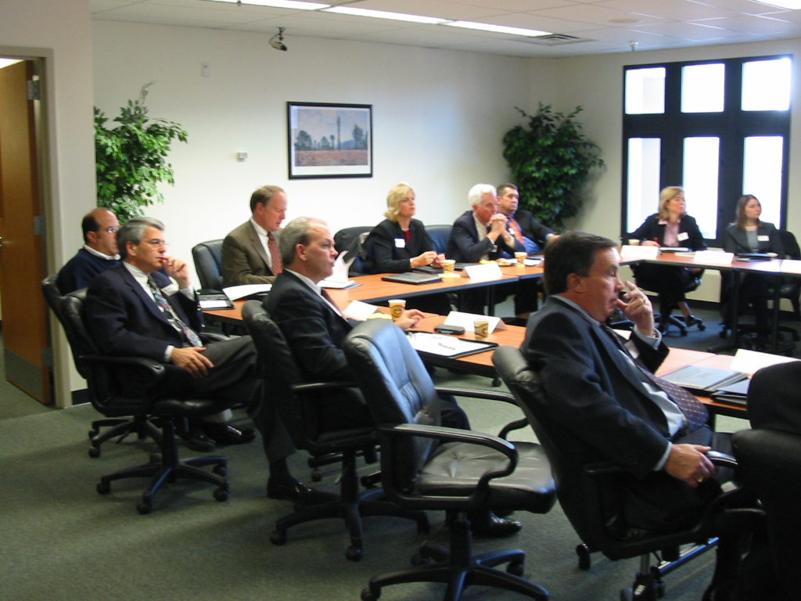
Sales executives from Therma-Tru Doors, Pfizer, Crown Equipment, Dana Corporation, ADP Inc., and others listen to and comment on current sales trends

