ESSPS Competes at the National Collegiate Sales Competition (NCSC)

Every spring the top professional selling students in North America travel to the Coles College of Business at Kennesaw State University (KSU) in Georgia to compete in the National Collegiate Sales Competition (NCSC). The competition, now in its eighth year, tests students’ selling skills in one-on-one sales presentation role-plays. The intense, two-day role-playing challenge is often called the “World Series of Sales.” Just as a baseball scouting camp brings the best players to one location, the NCSC brings the top sales students together with professionals from the business world to create exclusive networking opportunities.

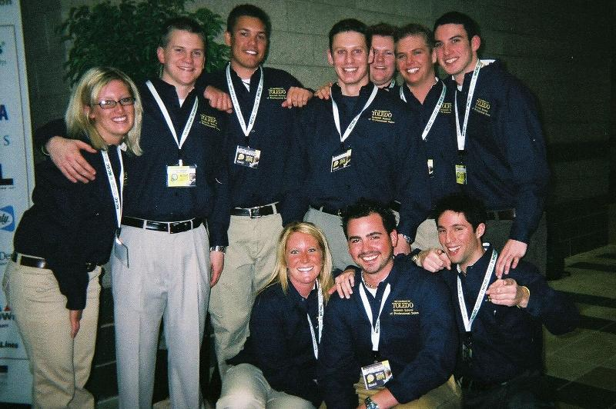
The ESSPS team of (back to front) Jessica Hood, Ryan Bjorklund, Chad Rethman, Brian Kimmel, Patrick Culhane, Josh Holbein, Dan Carhart, Stacey Fryberger, Eric Beltakis, and Kyle Schlosser proudly display their ESSPS and rocket pride at the NCSC.

The 2006 NCSC had 78 contestants from more than 39 universities, competing for the coveted overall champion award. Two COBA students, Ryan Bjorklund and Stacey Fryberger, placed 11th in the best overall university team at the 8th National Collegiate Sales Competition. Stacey Fryberger took 5th place in the product sale for ACT! software and ended up in 10th place overall. Our students did a great job in preparing for this competition and richly deserve this recognition. The ESSPS would like to especially thank our business partners who helped the sales faculty coach Ryan and Stacey: Pete Brotzki, Tammy Theaker, and Brian Koiser at UPS, Kristie Kmiec and Kathleen Hack at ADP, and Chris Ashby and Brit Eaton at Pro-Active Solutions. Additional gratitude is extended to ADP for sponsoring our nine ADP Fellows to attend the sales competition and for providing sales training to the entire NCSC team.

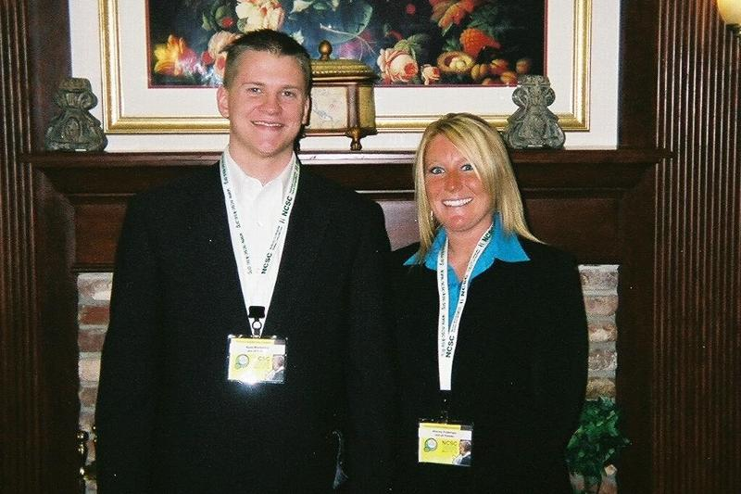
Ryan Bjorklund and Stacey Fryberger represented the ESSPS in the actual competition. Stacey finished 5th for the product sale and 10th overall in the nation.

