UT STUDENTS COMPETE IN THE 9TH ANNUAL NATIONAL COLLEGIATE SALES COMPETITION

Four students proudly represented The University of Toledo at the 9th Annual National Collegiate Sales Competition (NCSC) held March 15th – 19th, 2007 at Kennesaw State University. Lyndsey Dasen, Andrew Kapustik, Jessica Hood, and Kelley Leonhardt comprised the UT team where students from 44 schools across the nation competed in a 5-round tournament style sales competition.

The NCSC is a one-of-a-kind networking opportunity for the students as well as the professional sponsors. It is the only competition in existence in which top sales students in North America test their sales skills in one-on-one sales call challenges. Each sales call is broadcast live to a room of judges comprised of world-class corporate sponsors scouting for the next top talent in sales.

The UT team was assembled based on the results of a local sales competition playoff that was run through the Edward H. Schmidt School of Professional Sales within the College of Business Administration. The two top winners from this playoff, Lyndsey Dasen and Andrew Kapustik were designated to compete at the NCSC. The two runner-ups, Jessica Hood and Kelley Leonhardt attended the NCSC and supported the UT team.

At the competition, Lyndsey Dasen did very well advancing 4 rounds into the (“sweet sixteen”) semi-finals before finally being eliminated from the tournament. Overall, Lyndsey finished within the top 8 among the original 88 competitors.

Way to go UT team.

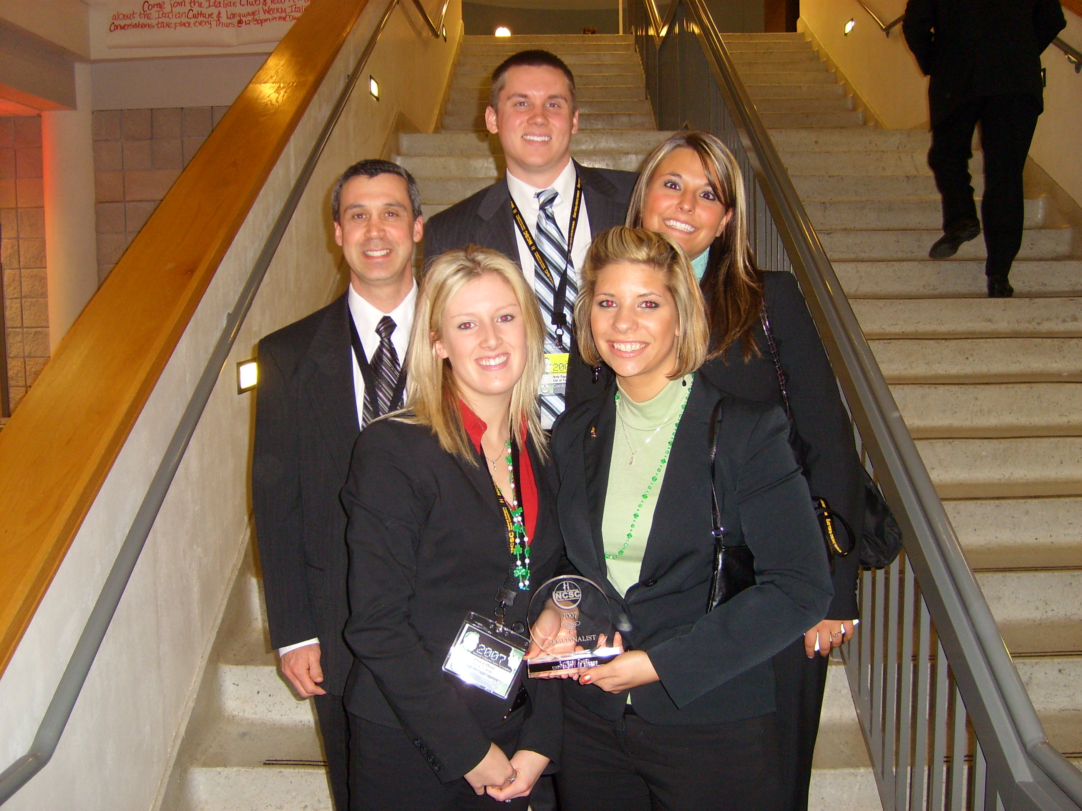
Jessica Hood, Lyndsey Dasen, Dr. Michael Mallin, Andrew Kapustik, and Kelley Leonhardt (front to back) join for a team shot after Lyndsey was recognized as a tournament semi-finalist.

