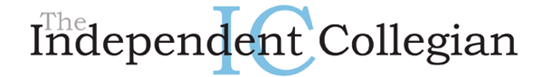

UT students win honors in national sales competition

Melinda Lauber
Issue date: 3/20/08 Section: News

Two UT students competing in a national sales competition received top-10 honors last weekend.
Ethan Oblonsky and Brandy Gillen, both seniors majoring in professional sales and marketing, competed in the National Collegiate Sales Competition for UT in Atlanta March 13 through 15.
Out of the 104 competitors from 54 schools, UT placed seventh.
Jack Tiernay and Tyler Sampson were Oblonsky and Gillen's alternates for the competition.
"Me and Ethan were both just ecstatic," Gillen said.
Oblonsky made it into the semifinals, which consisted of the top 16 competitors, and Gillen made it into the quarterfinals, which consisted of the top 32 competitors.
Gillen, Oblonsky and other competing students had to best complete the sales cycle within 20 minutes.
The sales cycle includes rapport building, needs assessment, product demonstration, overcoming objections and closing, Gillen said.
"[The faculty members] all pool together to practice with Ethan and Brandy," said Michael Mallin, UT assistant professor of marketing and sales who also attended the event.
Mallin said he, Visiting Instructor Jennifer Cordell, professional sales school Director Richard Buehrer, Assistant Director Deirdre Jones and Associate Professor Ellen Pullins all advised Gillen and Oblonsky.
"We've been practicing for three-and-a-half months for this competition," Gillen said. "It's a huge jump for the Schmidt School [of Professional Sales at UT]."
Starting in December, Mallin said the teachers and the students had to work out a selling strategy and just practice.
"I think I did at least 35 role plays," Gillen said.
"It was a long haul," Mallin said. "[Both students] could have easily gotten burned out."
In order to choose which students could compete in the national sales competition, the UT College of Business Administration held its own competition, Gillen said.
"The two with the highest scores were Ethan and I," she said.
Though the duo didn't go home with first place, the accomplishment is still noteworthy, Mallin and Gillen said.
"Anything in the top 10 is considered an accomplishment," Mallin said.
Florida State University won first place at the competition.
The opportunity in of itself is a good one, Gillen said.
"It's definitely something that sets you apart because the recruiters know that you're at the top of your class," she said.
Oblonsky won a $1,000 custom-made suit and Gillen won a $300 gift card, both from Tom James, at the competition, Gillen said.
UT paid for Gillen and Oblonsky's travel expenses, while Automatic Data Processing, Inc., paid for Tiernay and Sampson's.
Last year, UT won 11th place at the competition, Gillen said.
Gillen is also the sales manager at The Independent Collegian.
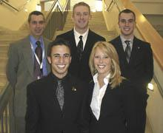
Media Credit: Brandy Gillen
Clockwise from top left, Michael Mallin, Tyler Sampson, Jack Tiernay, Brandy Gillen and Ethan Oblonsky pose for a picture at a national sales competition last week.

