UT Sales Team Finishes Strong at National Collegiate Sales Competition and
Captures the 7th Place Student Spot

Two undergraduate and two graduate students from the Edward H. Schmidt School of Professional Sales represented the University of Toledo at the 11th Annual National Collegiate Sales Competition (NCSC) at Kennesaw State University on February 26-28, 2009.

The undergraduate team of LeAnne Sullivan and Laura Mecklenborg, both graduating seniors, placed 11th as a team. Ms. Sullivan finished 7th out of 106 students in the nation. The graduate team of Carli Macek and Marta Trendell, placed 2nd as a team. Fifty three universities from across the country brought their top sales students to compete in the 5 round tournament style competition that also included an exclusive career fair, presentations, and a university expo. Thirty businesses helped to sponsor this one of a kind networking opportunity and were given the chance to watch the sales calls broadcast live so they could scout for the next top sales talent.

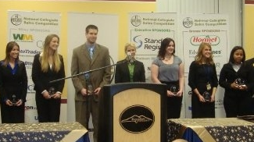

LeAnne Sullivan (second from right) joins other semi-finalists and enjoys her 7th place finish

The competitors chosen to represent UT are members of the ESSPS Sales Competition Team. The Sales Competition Team is an elite group of professional sales students that the sales faculty selected from a pool of applicants in September. Team members prepare and compete with each other for a chance to represent UT at NCSC and the RBI National Sales Challenge. The team is coached by sales faculty year round. Additional Sales Competition Team members, Matt Richmond, Ryan Papp, and Seth Phillips attended NCSC as Automatic Data Processing (ADP) Fellows to help support the competitors and attend the career fair.

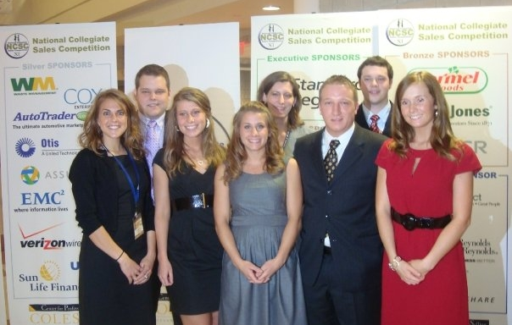

The Sales Competition Team poses for a team shot before the awards banquet at the 2009 National Collegiate Sales Competition (NCSC). From left back row – Matt Richmond, Deirdre Jones (Asst. Director and Instructor), Ryan Papp. Front row – LeAnne Sullivan, Marta Trendell, Laura Mecklenborg, Seth Phillips, and Carli Macek

