ESSPS Hosts 1st Annual Networking Night

The Edward H. Schmidt School of Professional Sales (ESSPS) hosted its 1st annual Networking Night on March 21st from 6:00-8:30pm in the University of Toledo’s Student Union Auditorium. The event was attended by 52 recruiters representing 23 firms from various industries and approximately 150 professional sales students. Networking Night is a social event designed to strengthen relationships and encourage networking between professional sales students, recruiters, and sales faculty. The formal reception with appetizers gave recruiters the opportunity to better manage their sales talent pipeline by focusing their interactions with professional sales students. Student benefited as well by meeting with talent management professionals who are focused on recruiting for sales careers.

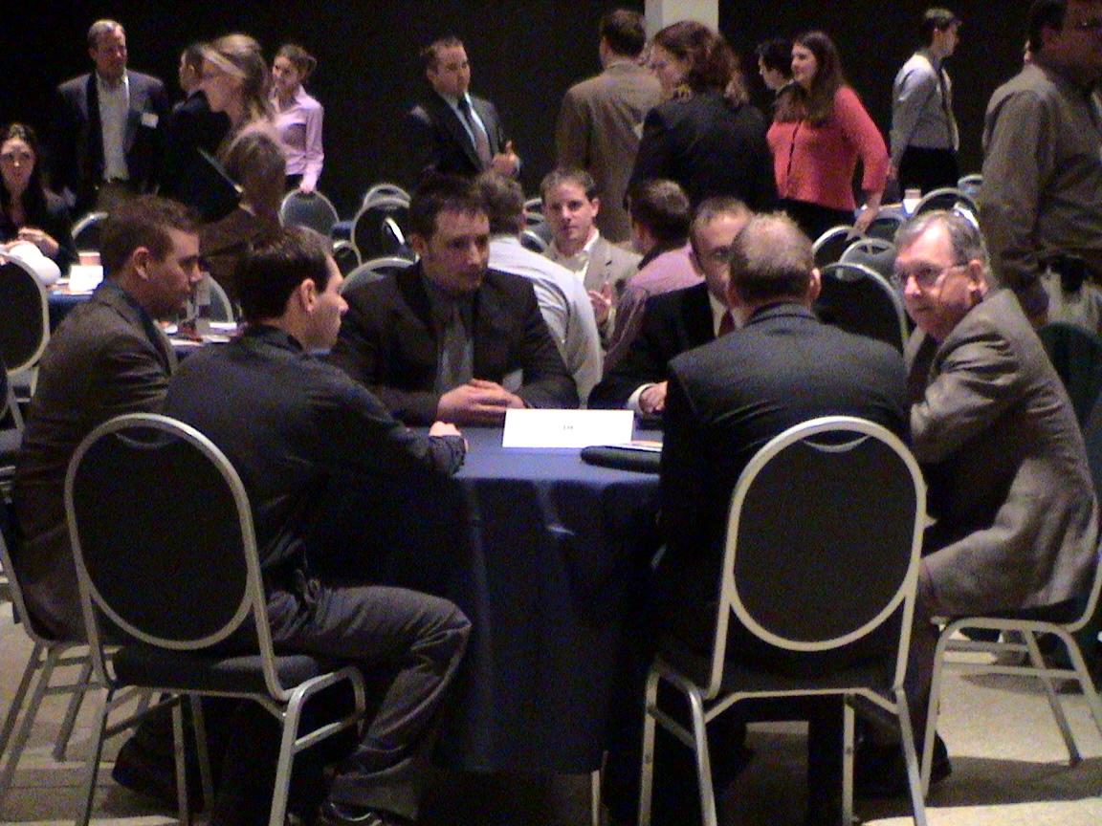
Students Josh Holbein, John Vencl, Pete Carey, and others talked with John Lanning to learn more about 3M.

Brad Stalder and Craig Breckenridge, both sales managers at Sherwin Williams, “enjoyed the open format”, and Pfizer District Manager Mark Burns was appreciative of the ESSPS “setting up a great event!” Many of the recruiters who came decided to do so because of previous experience with ESSPS professional sales students. Rebecca Gill, VP of Marketing at Technology Group International, is “very pleased with the program and overall internship program offered.”
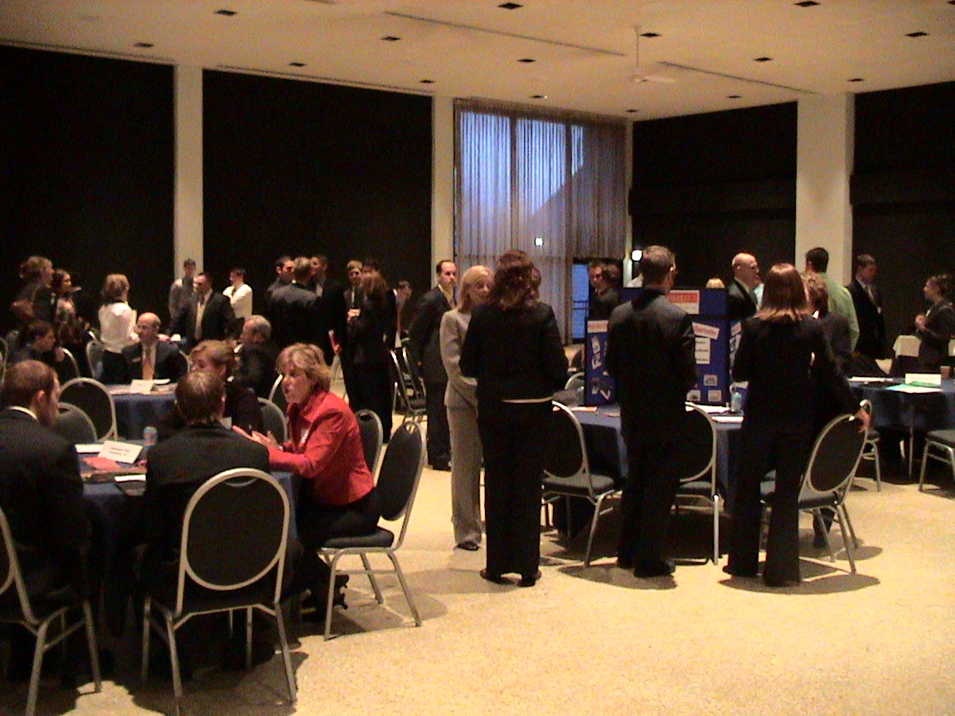
Approximately 150 professional sales students networked with 23 firms such as Automatic Data Processing, Inc., Ed Schmidt Automotive Group, and Ethicon Endo-Surgery.

“Networking Night had a successful launch because of our strong relationships in the business community,” notes ESSPS Director, Dr. Richard Buehrer. “In addition to the organizations who look to the ESSPS for frontline sales talent, we had 10 of our corporate partners attend this event. It was so nice to see advisory board members interacting with our students.”

The ESSPS plans to host the second annual Networking Night sometime next spring and would like to include even more firms.


Libbey’s Jeff Joyce and Rob Bules met with sales students to learn more about their training and experience in the ESSPS program.

To learn more about the ESSPS, please visit our website at www.sales.utoledo.edu or contact Dr. Richard Buehrer, Director, at 419-530-4604 or Richard.Buehrer@utoledo.edu.

