ESSPS Hosts 2nd Annual Networking Night

The Edward H. Schmidt School of Professional Sales (ESSPS) hosted its 2nd annual Networking Night on March 13th from 6:00-8:00pm in the University of Toledo’s Student Union Auditorium. The event was attended by 68 recruiters representing 34 firms from various industries. Networking Night is a social event designed to strengthen relationships and encourage networking between professional sales students, recruiters, and sales faculty. The formal reception with appetizers gave recruiters the opportunity to better manage their sales talent pipeline by focusing their interactions with professional sales students. Students benefited as well by meeting with talent management professionals who are focused on recruiting for sales careers.

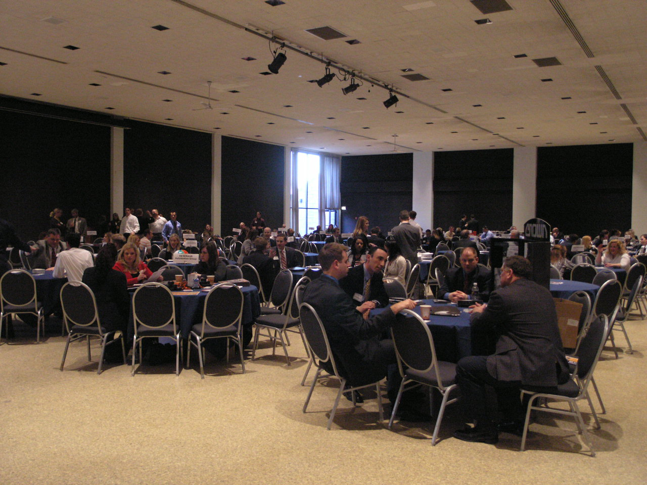
Professional Sales students interacted with 34 recruiting firms to learn more about sales careers and current opportunities. Some of the firms in attendance were Crown Equipment, Paychex Business Solutions, Hilti Inc, and Mercy Health Partners

Natalie Johnson, Recruiting Manager at Enterprise Rent-a-Car, said that “Every student we spoke to was top quality!” and Deb Bubp, Human Resources Manager at Hylant Group, found the event to be “a very effective environment.” The attractiveness of Networking Night is apparent. Fifteen of the 34 firms were attendees last year, and virtually all of this year’s attendees said they would return again next year. Some even recommended hosting the event once a semester to help both fall and spring graduates.

ESSPS Alumna and NewPage Sales Trainee, Lindsey Barbee, and Scott McKenzie, Director of Human Resources, meet with Julia Laciniak to learn more about her sales career ambitions

ESSPS Director, Dr. Richard Buehrer, sees Networking Night as an increasingly important event for students and recruiters, “The size of the skilled labor pool is shrinking due to retirement. According to the Administration on the Aging, 7,918 Baby Boomers retire everyday. The number of non-retail salespeople is expected to grow 7-19% through 2014. The Millennials we train and graduate play a vital role in that succession plan. Our future success is directly linked to engaging with our business community.”

The ESSPS plans to host the third annual Networking Night sometime next spring and would like to include even more firms.

To learn more about the ESSPS, please visit our website at www.sales.utoledo.edu or contact Dr. Richard Buehrer, Director, at 419-530-4604 or Richard.Buehrer@utoledo.edu.

