ESSPS Students Advance Their Careers at 4th Annual Networking Night

Approximately 100 recruiters and sales professionals came to The University of Toledo’s Student Union on March 18, 2009 to interact with almost 200 professional sales students at UT’s College of Business Administration Edward H. Schmidt School of Professional Sales’ 4th annual Networking Night. Thirty five companies were looking for the right individuals for internships and full-time positions. “The challenged economy has taken a small bite out of the number of firms attending our 4th Annual Networking Night,” said Dr. Richard Buehrer, Director, ESSPS. “However, our students are still in demand and are being successfully placed. In fact, the students are excited about this event because they know that the firms attending this event are more stable and are investing in their sales force.”

Networking Night is a social event designed to strengthen relationships and encourage networking between professional sales students, recruiters, and sales faculty. The formal reception with appetizers gave recruiters the opportunity to better manage their sales talent pipeline by focusing their interactions with professional sales students. Students benefited as well by meeting with talent management professionals who are focused on recruiting for sales careers. The event also gave them an awareness of the different types of sales careers that are available so they can make informed and confident career decisions.

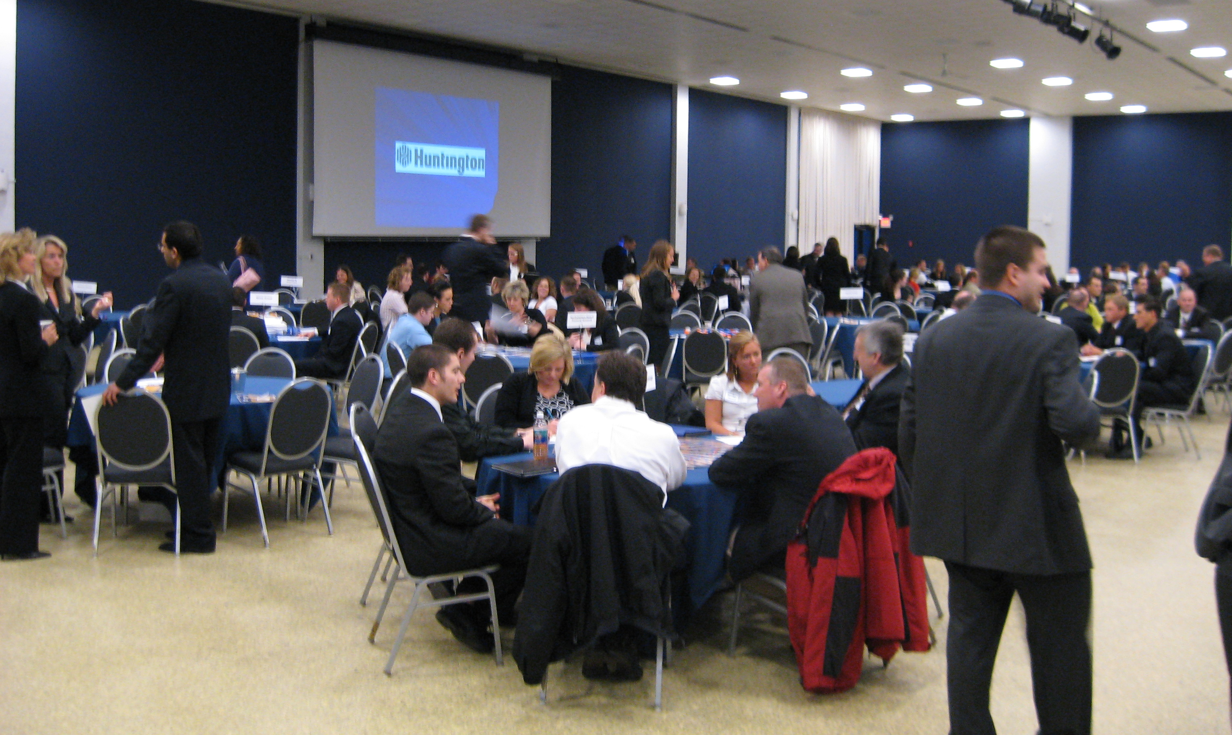
Despite the weakened economy, approximately 100 recruiters from almost 40 firms networked with ESSPS students to find their next intern or full time hire. Some of the firms in attendance were Crown Equipment, Northwestern Mutual Financial Network, Huntington Bank, and Ed Schmidt Automotive.

COBA Alums and Goodyear Tire & Rubber representatives, Maria Tsipis and Kelly Studer, “can’t wait to come back” again because of the “nice atmosphere and professional students.” Amanda Thompson, Corporate Recruiter at Equity Trust, and Jeremy Tudor, Senior Program Manager for Emerging Sales Professionals & Interns at AT&T, agreed, “great program,” “perfect.” The attractiveness of Networking Night and its intimate format is apparent. Twenty six of the 35 firms were attendees last year at Networking Night and/or this past fall at Speed Recruiting, and virtually all of this year’s attendees said they would return again next year.

ESSPS Director, Dr. Richard Buehrer, sees Networking Night as an increasingly important event for improving economic development, “Firms across the board are competing in a more complex environment, and they are realizing the importance of having a talented and properly trained sales force that can successfully build relationships and think strategically. Relationships are a critical differentiator, and our best practice-trained professional sales students come out with the knowledge and field experience to produce results quickly.” A 2007 HR Chally Corporate Sponsor Survey agrees and concluded that university-trained sales graduates ramp up 50% faster and are 35% less likely to turnover than their non-university trained counterparts because they have already demonstrated the aptitude and desire for sales and are more focused and in tune with the numbers and with navigating the sales process.

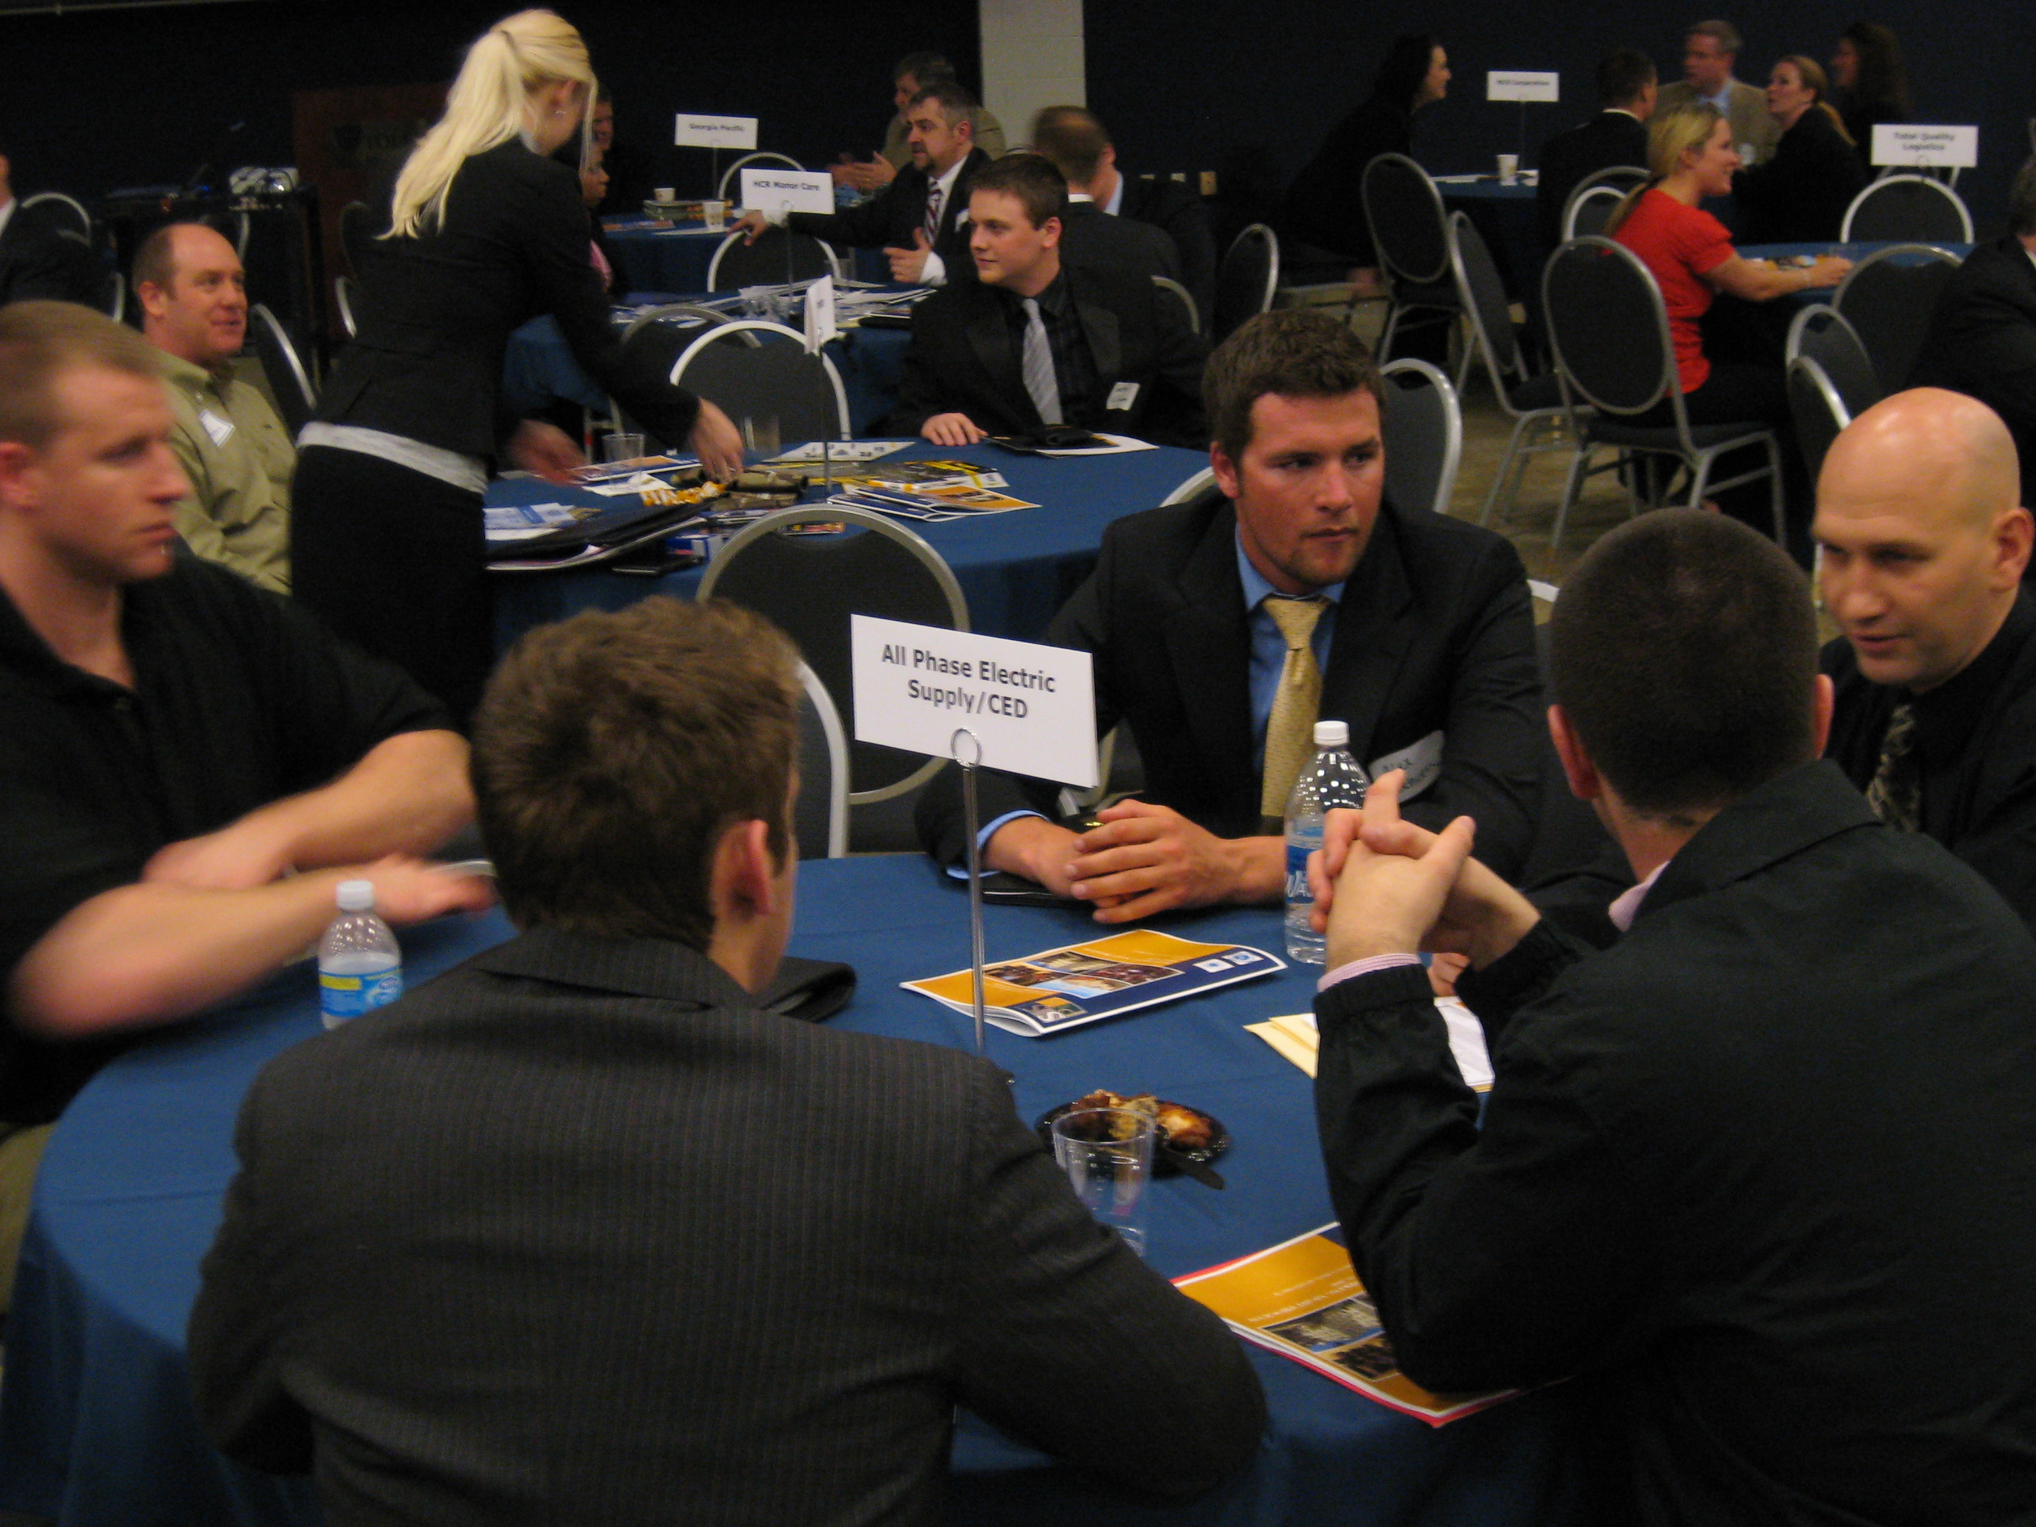
All Phase Electric Supply/CED explains the “hidden industry” of distributors to sales students Alex Schoen, Tom Dooley, and Kyle Lind.

The ESSPS plans to host the third annual Speed Recruiting in October 2009 (date TBA) and the fifth annual Networking Night on March 23rd, 2010 and would like to include even more firms.

To learn more about the ESSPS, please visit our website at www.sales.utoledo.edu or contact Dr. Richard Buehrer, Director, at 419-530-4604 or Richard.Buehrer@utoledo.edu.

