November 8th, 2006

ESSPS Students Take Top Three Spots at Regional Sales Competition

The Edward H. Schmidt School of Professional Sales (ESSPS) is proud to announce that our professional sales students took the top three spots at the Regional Pi Sigma Epsilon (PSE) ProAm Sellathon. Emily Strayer, Lyndsey Dasen, and Ross Miller took 1st, 2nd, and 3rd respectively. These students worked hard to prepare, and their dedication paid off. PSE Executive Director, Ann Devine, commented on the support and leadership of The University of Toledo’s ESSPS program as exemplified by the professionalism of our students.

Eleven University of Toledo ESSPS students traveled to Miami University at Oxford on November 4th to compete in a regional sales contest hosted by Pi Sigma Epsilon (PSE) and Vector Marketing (Cutco). Other schools represented were Miami University, The University of Akron, and Virginia Tech. Students were given a buyer profile/scenario in advance and prepared for a 10 minute role play to demonstrate mastery of the stages of a sales call: opening, information gathering, demonstrating capability, handling objections, and closing.

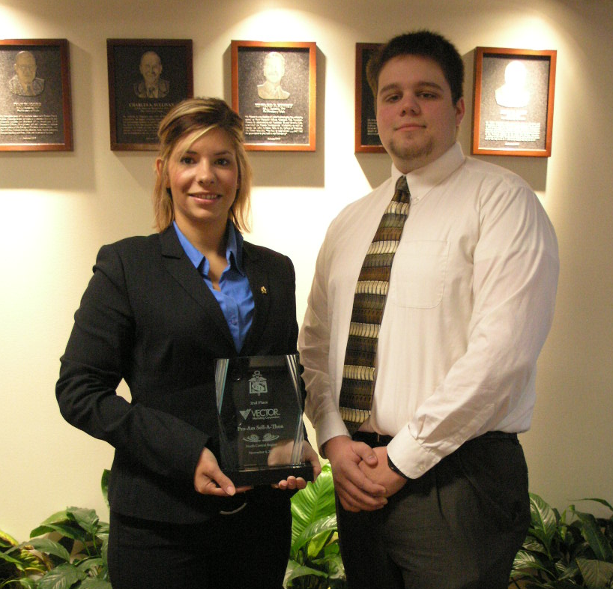

ProAM Sellathon Winners, Lyndsey Dasen and Ross Miller, proudly display one of their award plaques. First place winner, Emily Strayer, not shown.

