4th Place National Finish for PSE/ESSPS Student
Pi Sigma Epsilon (PSE) students continue to shine at national competitions. On March 25-28, 2009, ESSPS students in PSE traveled to Norfolk, VA to represent UT at the national PSE conference. Danielle Matus, a junior professional sales major, placed 4th overall in the Pro-Am sales competition among 75 national competitors. The UT chapter placed 1st in a sales/marketing simulation game beating the likes of LSU and UNC among others. Other accomplishments included achieving “Gold Chapter” status and finishing the year with a 5th best in the nation chapter efficiency index (CEI).

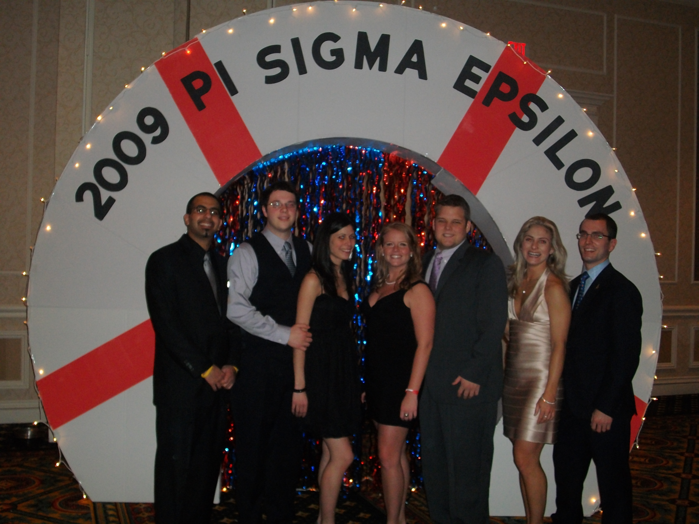

PSE students (left to right) Peter Shehata, Ryan Papp, Sara Lawrence, Danielle Matus, Matthew Richmond, Olivia Halter, and Jack Tiernay (alum) celebrate Danielle’s 4th place national finish and the chapter’s 5th place national CEI finish at the awards banquet in Norfolk, VA.

