University of Toledo Sales Students Win National Championship
November 12, 2007

The University of Toledo's Edward Schmidt School of Professional Sales (ESSPS) won First Place in the Sales Team Award at the Russ Berrie Institute's (RBI) National Sales Challenge on November 9-10th. Competing for the ESSPS team were three competitors: Steven Harvey, Laura Jesse, and Steven McKinney, all seniors in the Professional Sales Major in the College of Business.

The RBI National Sales Challenge is a premiere university sales competition, hosting schools from San Francisco State to College of New Jersey, and from University of New Orleans to Central Michigan University. The event consists of three separate competitions: a role played sales call contest, a speed selling (personal pitch) competition, and an in-basket exercise for time management. The competition was sponsored by a number of national firms dedicated to promoting the profession of personal selling as consultative, ethical and relationship-based. Sponsoring firms included McKesson Pharmaceutical, Hess Energy, Enterprise Rent a Car, Tom James, AT&T, Stryker Medical, Marriott Vacation Clubs, BD, DHL, Russ Berrie Foundation, Strike Interactive and others.

Awards in each category and for individual overall and team overall were given for first to fourth place. In addition to the first place win in the team overall contest, the students won:

Steven McKinney first place in the speed selling competition
Steven McKinney second place in the individual competition overall
Steven Harvey fourth place in the individual competition overall

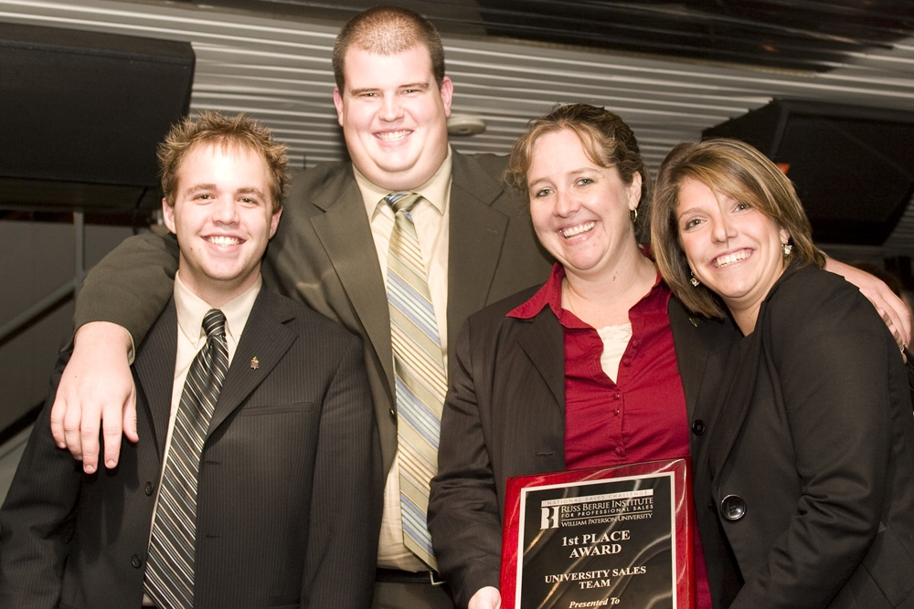
Steven McKinney, Steven Harvey, Dr. Ellen Pullins, and Laura Jesse join together for a shot of the winning team!

Top 4 overall individuals, Steven McKinney and Steven Harvey, will be profiled in an upcoming issue of Selling Power Magazine.

In addition to the actual plaques, overall individual winners won Tom James suits valued at up to $1,200, and Steven McKinney won a Marriott Vacations trip to Orlando as the top winner in the speed selling competition.

The ESSPS is one of the top three university sales programs in the world, with over 300 students, a world class curriculum, professional certifications, and multiple corporate, university and international elite partnerships. The students were selected competitively and prepared for approximately 6 weeks with all members of the ESSPS faculty.

