ESSPS Hosts Inaugural Speed Recruiting

Almost 250 professional sales students and recruiters met on Friday, October 19th, 2007 in the Student Union Auditorium for the Edward H. Schmidt School of Professional Sales’ (ESSPS) Inaugural Speed Recruiting. Sixty one (61) recruiters from 41 different firms had the opportunity to have speed recruiting appointments with as many as 20 professional sales students. Most recruiters were fully booked and enjoyed what was for many their first speed recruiting event, “I thought it was an outstanding way to meet candidates. I was very impressed with how well prepared the candidates were in regards to purpose and image.”– Matt McGeary, District Sales Manager Paychex Business Solutions. Even the more experienced speed recruiters like Beth Pai, Director of Development, Northwestern Mutual Financial Network commented that “the ESSPS’ Speed Recruiting was the best speed recruiting event we have attended. The students were well prepared, and the event was well organized and executed.” Students enjoyed the event as well and got more than sales career leads as they honed their communication skills in the speed selling format.

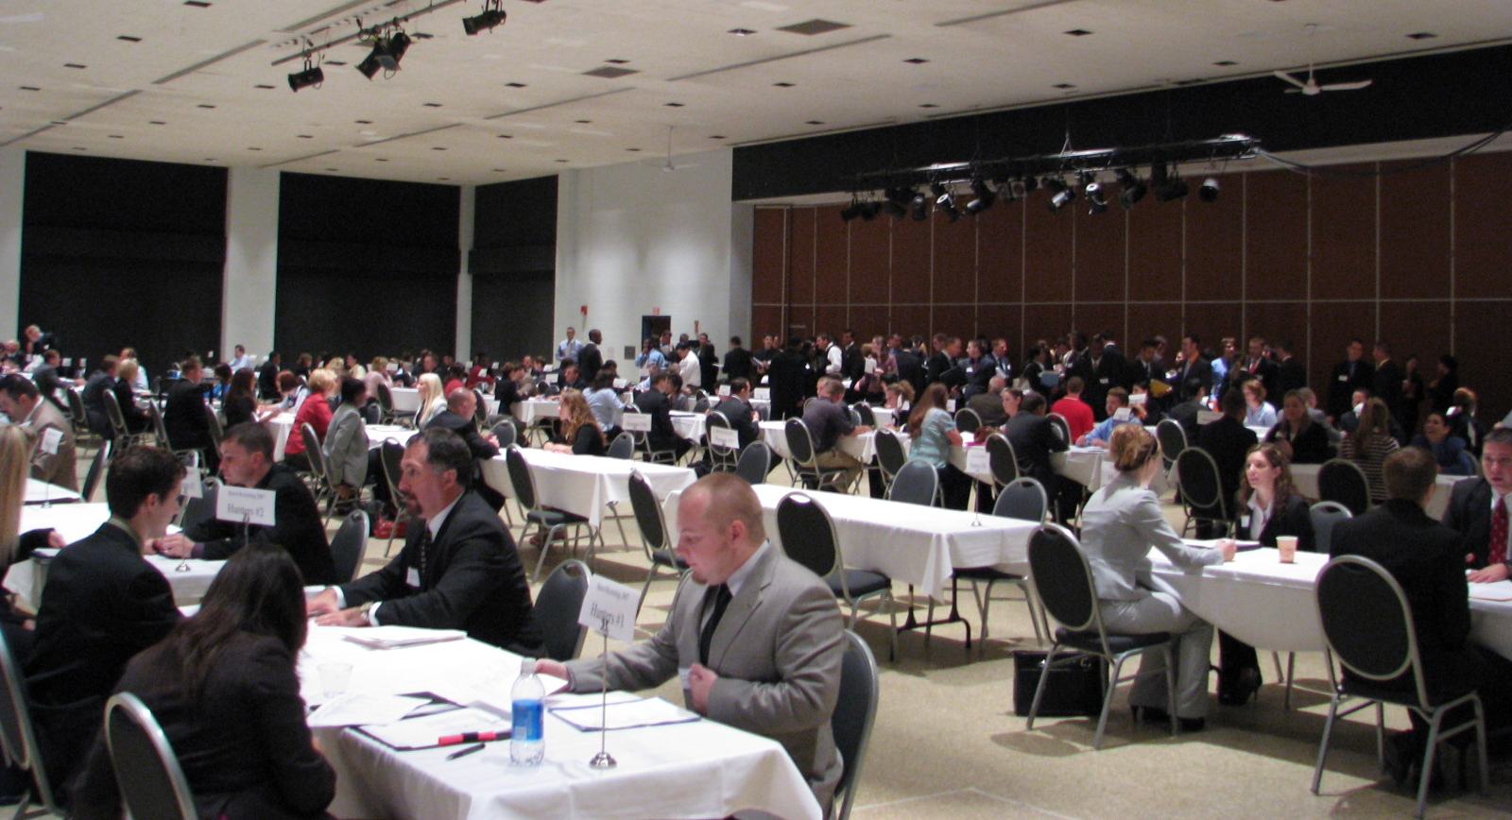
Approximately 250 professional sales students and recruiters met for 4.5 minute recruiting appointments that occurred every 6 minutes.

Like the ESSPS’s spring recruiting event, Networking Night, Speed Recruiting is focused exclusively on professional sales majors, minors, and pre-sales majors. The new and exciting twist is that Speed Recruiting lets the recruiters and students determine their schedules by having everyone fill out online profiles in advance and then having a system scan them for similarities to create a “love connection” that was used to determine everyone's schedule. Everyone was changing seats every 6 minutes to meet with new people. Speed Recruiting was a huge success with the attendees rating the event as “valuable” and stating that they “would come again” because their “expectations for the students were completely met”. The October 2008 Speed Recruiting will offer recruiters a single, stationary meeting location and longer appointments with students.

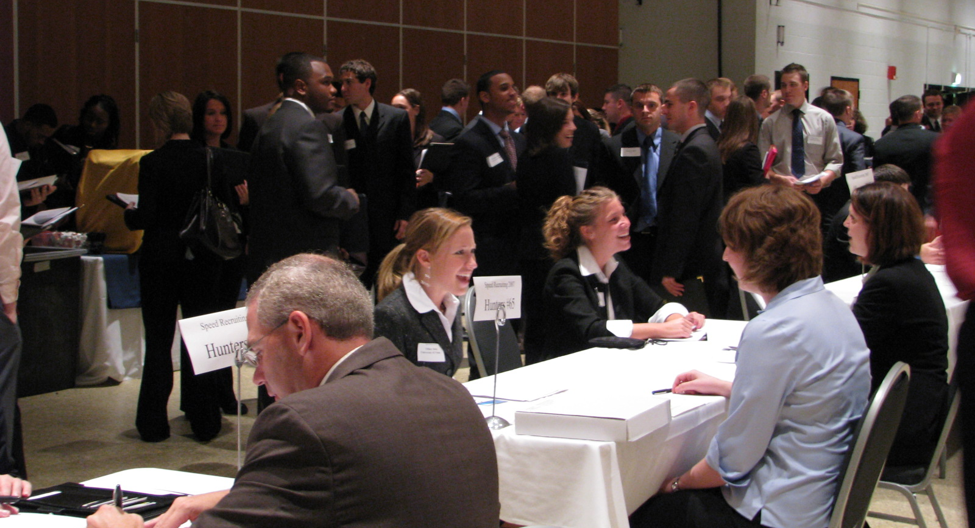
Professional Sales students, Tiffany Robey and Marta Trendell, meet with Thomson Tax & Accounting’s Julie Connell and Paychex Business Solutions’ Rebecca Hurst while other students prep in the background for their next appointment.

For more information on Speed Recruiting, Networking Night, recruiting professional sales students, and/or the ESSPS, please visit www.sales.utoledo.edu, call 419-530-4604, or email edwardschmidtschool@utoledo.edu.

