Dr. Richard Buehrer accepts American Business Award

Dr. Richard Buehrer, Director of the Edward H. Schmidt School of Professional Sales in the College of Business Administration, accepted the American Business “Stevie” Award for “Excellence in University Based Sales Education” at the American Business Awards program held in Las Vegas, Nevada on December 4, 2006. Dr. Buehrer, currently serving as the National Director of the University Sales Center Alliance (USCA), accepted the award on behalf of the eleven university members of the USCA.

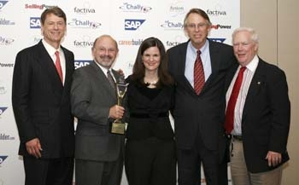

Pictured from left to right: Gerhard Gschwandtner, Publisher Selling Power magazine; Dr. Richard Buehrer, Mary Delaney, Chief Sales Office CareerBuilder.com; Ken Hartung, Director Sales Center Ohio U.; Howard Stevens, CEO,Chally Group

