ESSPS Hosts 3rd Annual Executive Sales Summit

The Edward H. Schmidt School of Professional Sales (ESSPS) in the College of Business Administration at the University of Toledo held its third annual Executive Sales Summit on December 1st in the Student Union. Attendance grew again this year with close to 70 sales and human resource executives gathering to share and learn about “A 360º View Toward Making a More Effective Sales Force.” Chris Rahe, Director of Sales, and Bill Wade, Branch Manager, both from Crown Equipment Corporation, found the summit enjoyable because the panel discussions were “relevant to what we deal with on a daily basis” and “confirmed that our process was valuable.” Greg Kaser, VP Sales & Marketing at Kellermeyer, favored the “open discussions and networking with other professionals.”

The event was kicked off with a keynote presentation by David Johns, Senior VP & Chief Supply Chain & IT Officer at Owens Corning on “A View from the Customer’s Perspective.” He addressed the strategic aspects of a successful supplier-customer relationship and then gave examples on how Owens Corning implements the strategy. He highlighted the importance of working with talented people, setting mutual expectations, defining success metrics, and eliminating things (waste) that do not add value for the customer and the customer’s customer. Using a relationship matrix to create zippered relationships between both organizations and a quarterly reviewed supplier scorecard are just two examples of how to execute a successful supplier-customer relationship where the supplier can be seen as more of a partner.

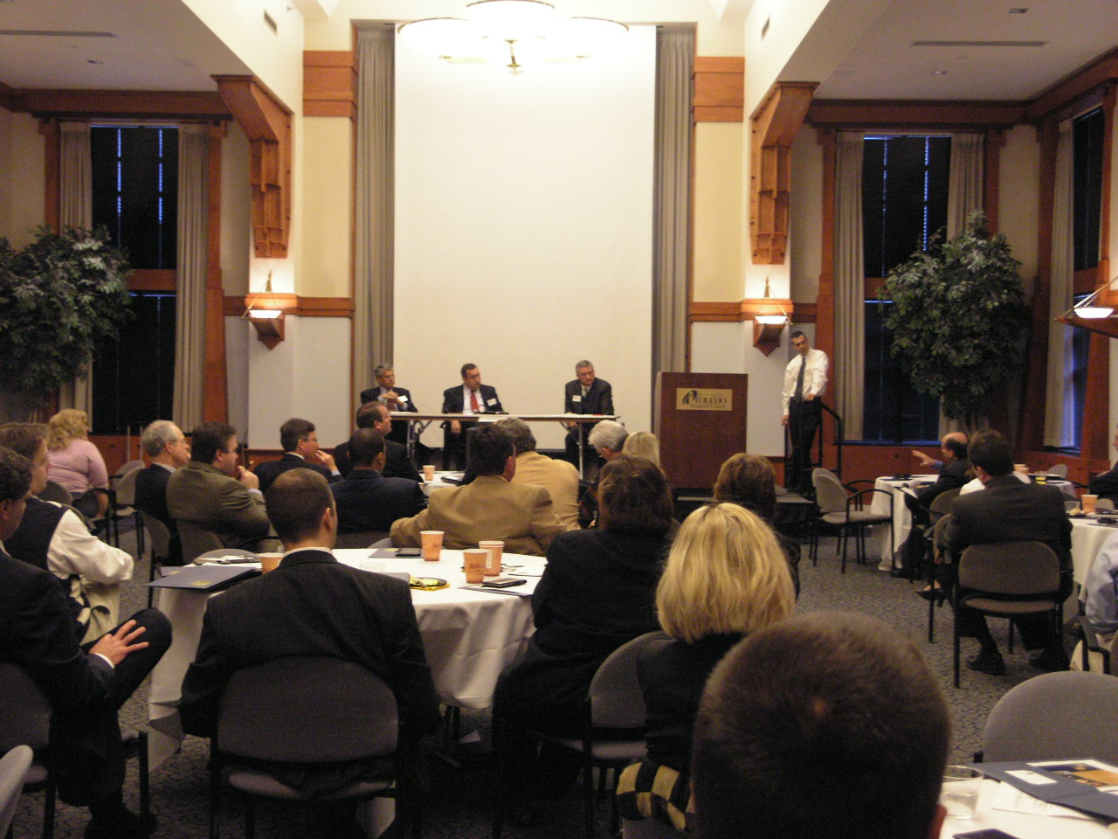
Sales and human resource executives from various industries share experiences on using cross functional teams in one of the summit’s panel discussions

Creating zippered networks and other strategic managements methods were discussed in the first panel by panelists Frank Loftus – General Manager at 3M Automotive Innovation Center, Jerry Oleshansky – VP and General Manager at Therma-Tru Doors, and Martin O’Brien – President at Century Equipment. Dr. Michael Mallin, Assistant Professor in the ESSPS at the University of Toledo, facilitated the panel and opened the floor to attendees for questions and comments. After a 30 minute networking and break session, the attendees joined again to participate in a second panel discussion on developing a more effective sales force. Dennis Sherry, Regional Vice President at Mercy Health Partners, lead the discussion of panelists Denise Lennard – Director of Human Resources at Betco Corporation, Carol Summersgill – VP Human Resources at Therma-Tru Doors, and Debby Schaefer – VP and Secretary at Brooks Insurance Agency. Key findings from each of the panel discussions are as follows:

Strategic Management of Accounts: Creating Cross Functional Teams and Zippered Networks to Understand and Meet Customer Needs
- Team members come from finance, logistics, product, engineering, customer service, and the client organization and must possess a customer-centric mentality
- Teams are lead by a product manager or the client
  - Move at the client’s speed
- Team members can become conflicted by the responsibilities from their department and the team
  - Work with department managers on expectations
- Purpose of team is typically to fix a customer pain point
  - Some teams are for new products or markets
- Momentum and focus can be better maintained with explicit goals, metrics, roles/responsibilities, and deadlines
- Global cultures draw attention to listening skills since meetings take place in different time zones and people have accents
- Zippered networks are the ideal, but the reality is more like a buttoned vest with missing buttons

Developing a More Effective Sales Force
- Behaviors that are key to look for include listening, customer focus, ethics, and continuous improvement/active learner
- Ask the candidates to prove their skills by doing role plays and/or demonstrations
- Interview in teams to get more feedback and check consistency
  - Include a senior sales professional who can convey job expectations
- Culture has different types – ethnic, corporate, regional
- Listening and flexibility are key to adapting to different cultures and generations
- Hire from within and outside of the industry
  - Inside the industry – has experience
  - Outside the industry – a fresh set of eyes to shed light on why things are done a certain way
- Younger generations such as GenY (Millennials) are individualistic, seek flexible work–life balance, are likely to change jobs for a promotion, pay less attention to hierarchies – question authority, multitask, and are technologically savvy
- Older generations such as Baby Boomers feel valued to be a mentor to coach and counsel a younger worker
- Mentors should come from the sales and the product/technical areas
- New hires should rotate through each department to better understand the business
  - Scripted rotations are comprehensive and consistent
  - Use travel time for Q&A
- Train on the social styles typical for each generation
- Refresh the sales force using webinars, conference calls, and sales builder boards
  - Sales builder boards highlight a product of the month to be discussed with customers

The event was drawn to a close over lunch with a keynote presentation by Bill Emerson, CEO at Quicken Loans. Bill’s energetic presentation emphasized the critical role that culture plays in an organization by describing the isms at Quicken Loans. Bill used isms such as “a penny saved is a penny” and “obsessed with finding a better way” to motivate the attendees to carve their business strategies differently. His presentation was peppered with illustrated examples and encouraged attendees to “do the right thing.”

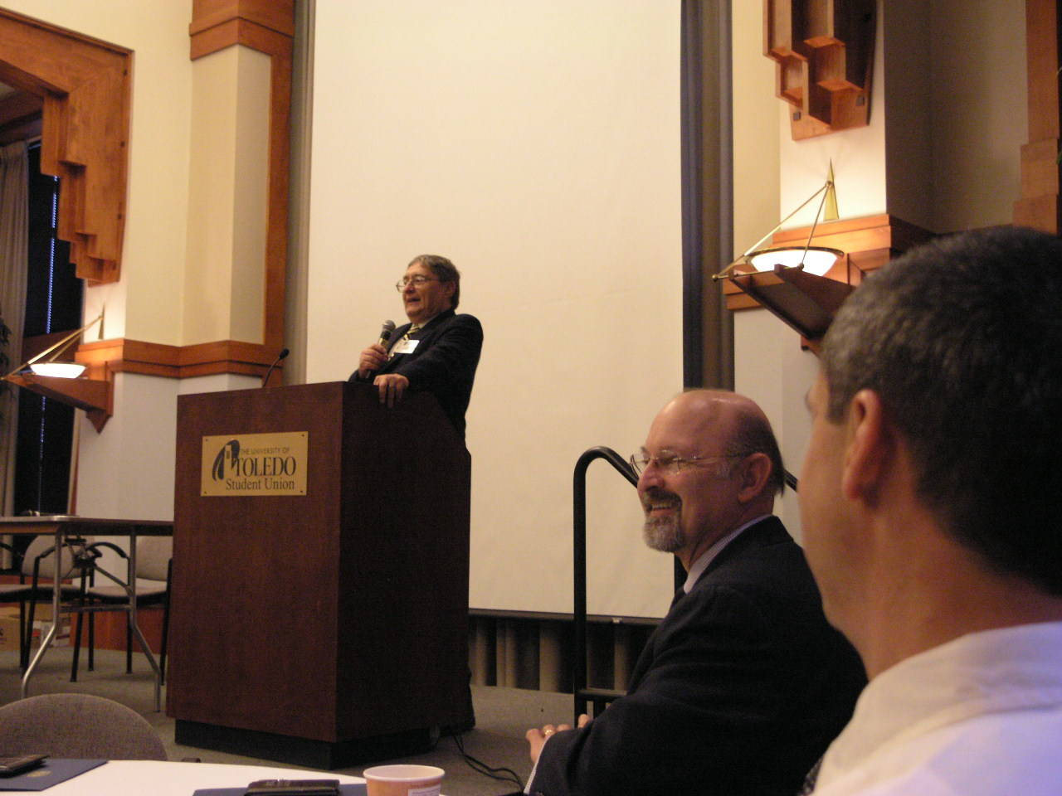
UT President, Dr. Lloyd Jacobs, expresses his enthusiasm and support for events like the summit that bring the business community and university together

The findings/themes from the summit will be used to plan next year’s Executive Sales Summit and Sales Symposium. The first Sales Symposium for the sales force will be held next spring and future Executive Sales Summits are intended to maintain strategic alignment.

Topics for future summits and/or symposiums include:
- Key topics from this summit (see major findings/themes above)
- Training on different generations
- Sales force retention
- Measuring results
- Sales force compensation
- Training a remote sales force
- Salespeople sharing their challenges in the field
- Complex sales strategies
- Getting major accounts
- Scripted sales training
- Explanations of current ESSPS curriculum - what the market sees as additional

The mission of the ESSPS is to provide high quality educational programs in sales and related areas, to enhance the world of business practice related to professional sales and to become a recognized global leader in sales learning, discovery and engagement. The ESSPS provides a learning environment for students, faculty and business professionals that promotes shared learning, networking opportunities and the exchange of ideas about sales issues in an open and professional manner. For more information, please visit www.sales.utoledo.edu.

