UT Student Team places 2nd in National Collegiate Sales Competition
The weekend began with 132 hopeful students from 62 universities across the country competing for honors at the 12th annual National Collegiate Sales Competition hosted by Kennesaw State University (March 5-8, 2010). In the end, the University of Toledo student team consisting of Matt Shipley (left), Jeff Tippy (center), and Heidi Schollmeier (right) left town with a 2nd place overall team finish and individual student awards. Ms. Schollmeier (Sales and Marketing Major) was a finalist finishing 3rd overall and Mr. Shipley (Sales and Marketing Major) was a (top 16) semi-finalist.
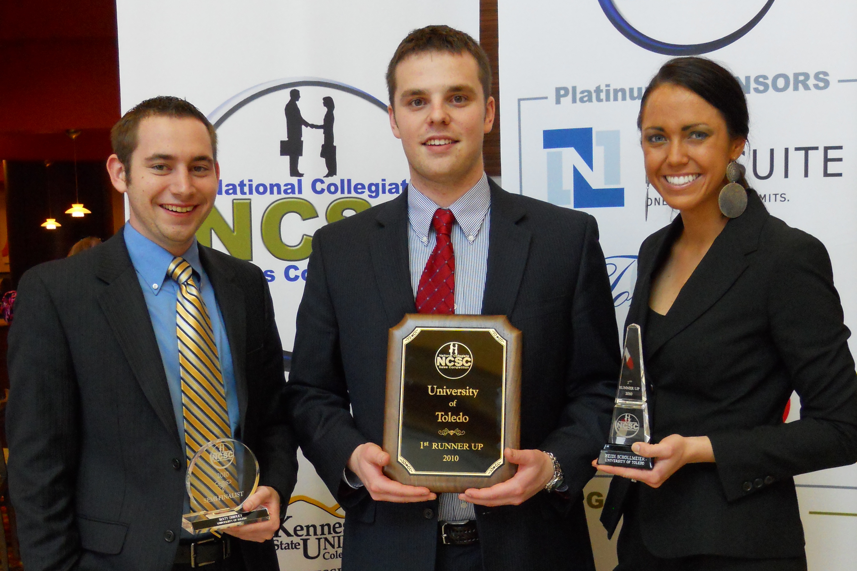
The team trained with and was coached by the UT faculty from the Edward H. Schmidt School of Professional Sales in the College of Business Administration beginning in January. The students practiced and received critiques in the new Huntington Sales Lab which is part of the college’s new $15.4 million expansion, the Savage & Associates Complex for Business Learning and Engagement. Dr. Michael Mallin coordinated the trip and coached the team at the competition. The students prepared for a series of 20 minute sales role plays where they were required to sell an online tool to fictitious companies to help them manage their salesforce and customer information. Success in each round of the competition allowed students to advance in a double elimination style tournament. To reach the finals, Heidi completed 5 rounds while Matt completed 3 as a semi-finalist. Other top 10 university teams included BGSU, Washington, Florida State, Kennesaw State, Bradley, Baylor, Houston, Michigan State, and Georgia.
Nearly 30 companies, including Liberty Mutual, ADP, Tom James, Owens Corning, AT&T, Hewlett Packard, Dow Jones, NCR and Reynolds and Reynolds sponsored this year’s competition for an opportunity to recruit top sales students. NCSC sponsors provide funding to defray the expenses of competing students and participating faculty. Many of the best and brightest sales students would be unable to attend without the help of corporate sponsors. Sponsoring the competition also provides participating companies with the opportunity to network with and preview elite up-and-coming sales talent.
About: Inaugurated in 1999, the National Collegiate Sales Competition (NCSC) is the largest and oldest sales role-play competition in existence. Its mission is to enhance the practice and professionalism of the sales profession. Each year, the NCSC hosts the top collegiate sales talent and sales faculty from the most elite university sales programs in North America. Sales students are provided a venue for sharpening their sales skills in a highly competitive environment and networking with their peers and sales faculty from across the United States. NCSC corporate sponsors have the opportunity to network with and preview the elite talent and greatly contribute to their education and careers and in turn make a great investment in the future of the sales profession. For more information, visit www.ncsc-ksu.org or contact Dr. Michael Mallin at Michael.Mallin@Utoledo.edu.

