The University of Toledo

INSTRUCTIONS FOR THE CRESTRON MEDIA IN

Stranahan

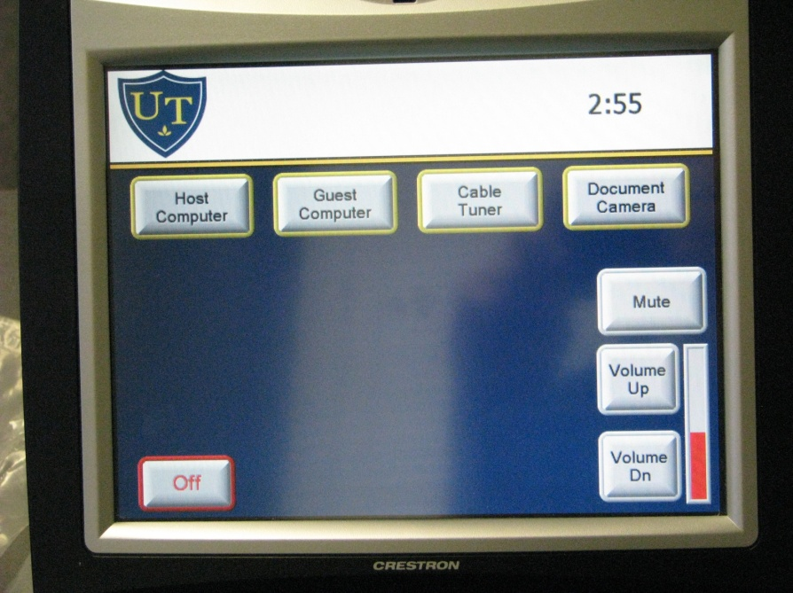

**THIS IS FOR ROOM USE ONLY!** ANY QUESTIONS, PROBLEMS, OR FOR ADDITIONAL COPIES CALL X 4607.

Starting Up

* If the Crestron screen is black then touch the Crestron screen to turn it on.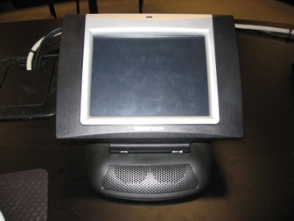
* When the UT picture is displayed, then touch the screen to begin.

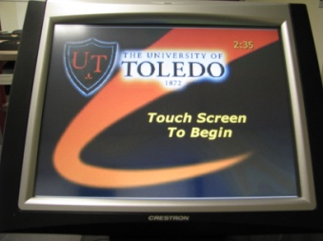

* Projector will warm up for about 60 seconds - **Please Be Patient**, a light should illuminate in the projector. (The projector will automatically shut off after 5 minutes if nothing is being displayed on the screen)

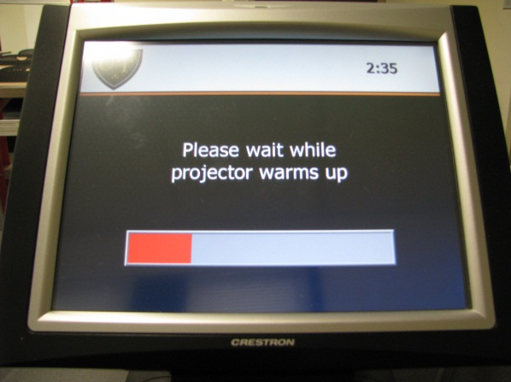 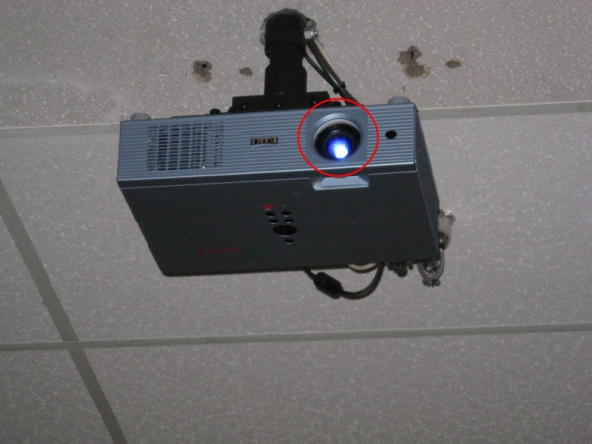

* A menu screen of devices will appear on the Crestron screen.

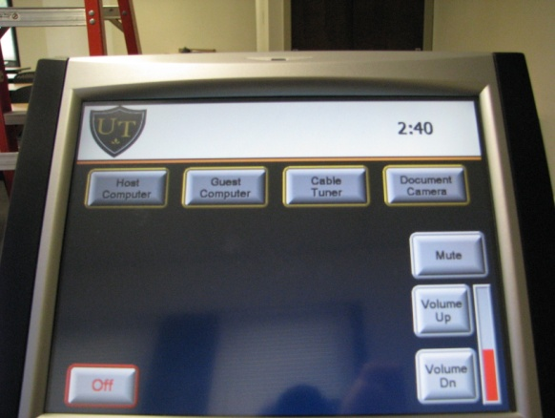

IF THE MONITOR IS OFF…

* Make sure the power button is green. This is located on the lower right hand side of the monitor.

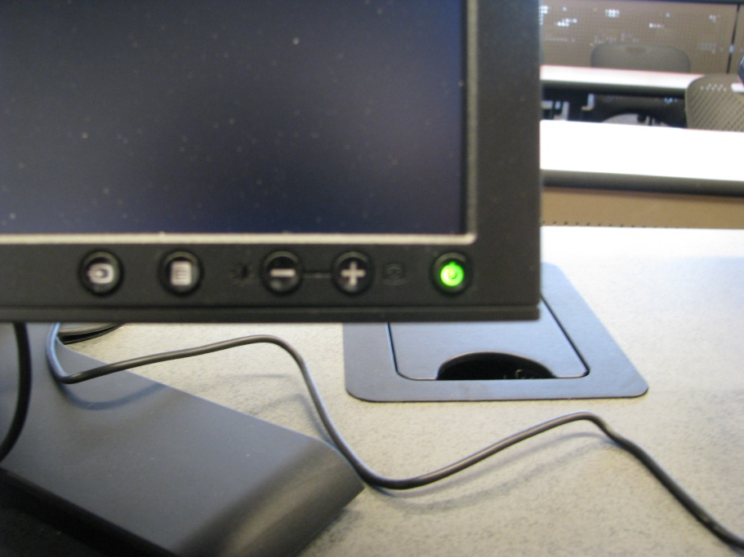

Power button

* Also check to make sure that the computer is on by checking to see if the power button is blue.

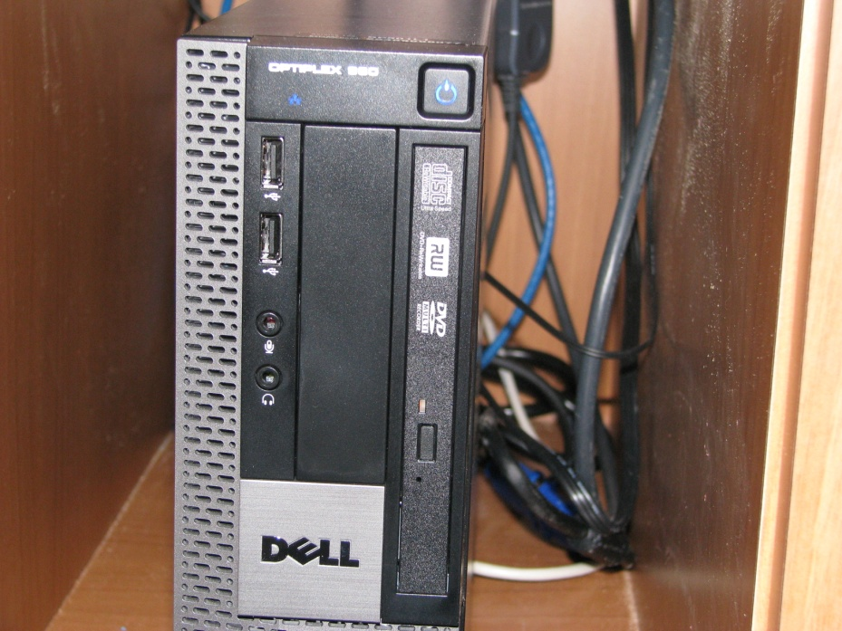

Power Button

HOST COMPUTER

* To display the host computer on the projector, touch the Host Computer button.

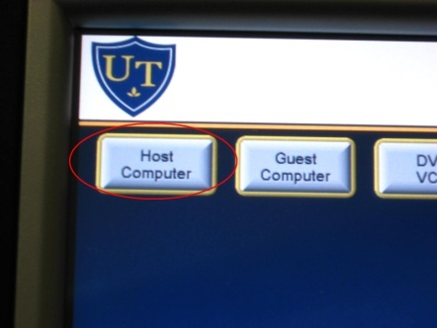

* To login to the Host Computer press “Ctrl Alt Delete” simultaneously.
* Your login screen will appear. Type in your username and password and make sure the “Log on to” is set to UTAD.

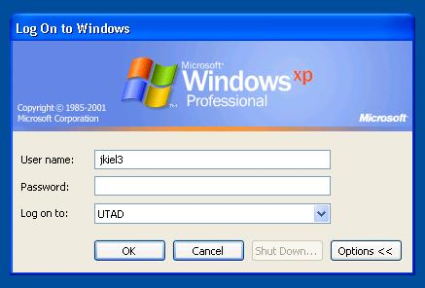

* Do not forget to logoff when you are finished.

GUEST COMPUTER

* Located on the desktop is the caddy.

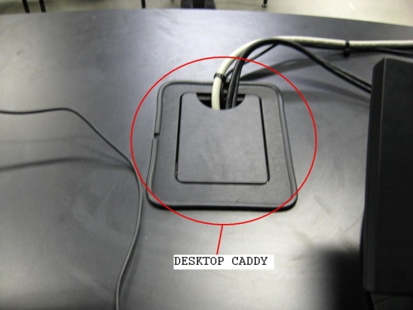

* Inside the caddy are 2 electrical outlets, an audio cable, VGA cable, and an Ethernet cable for the guest computer.

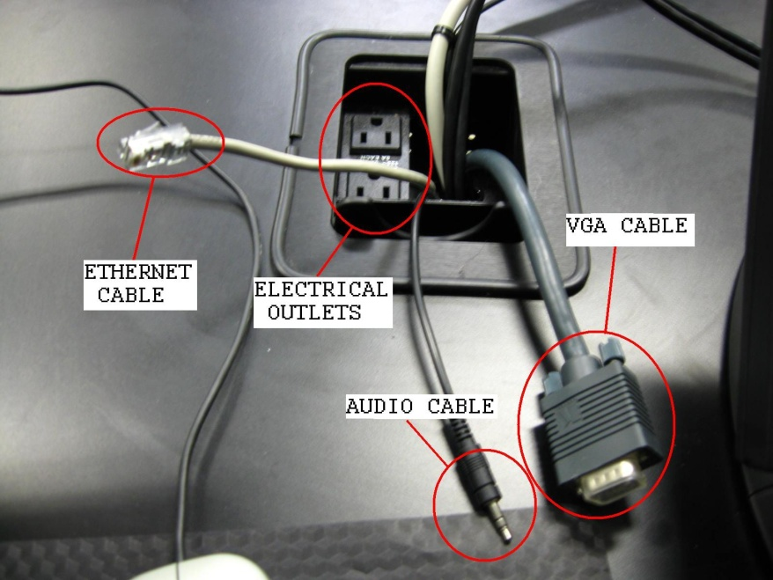

* Make sure that the VGA cable is plugged into your laptop.
* To view your laptop through the projector, push the Guest Computer button.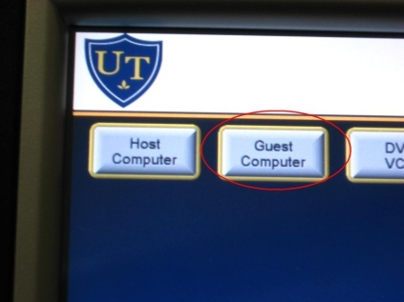

FOR CABLE TV

* When you push the Cable Tuner button, cable television will automatically start.

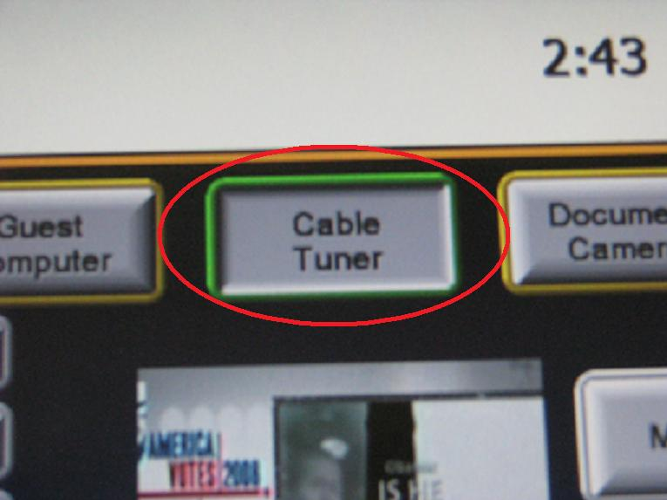

* To adjust the volume, use the Volume Up and Volume DN buttons on the Crestron touch screen.

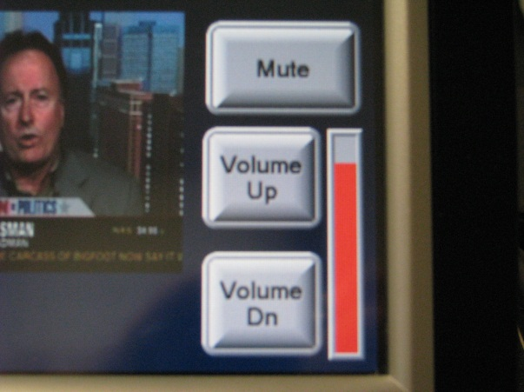

* To change the television channels, touch the CH+ and CH- buttons on the Crestron touch screen, or enter the channel number.

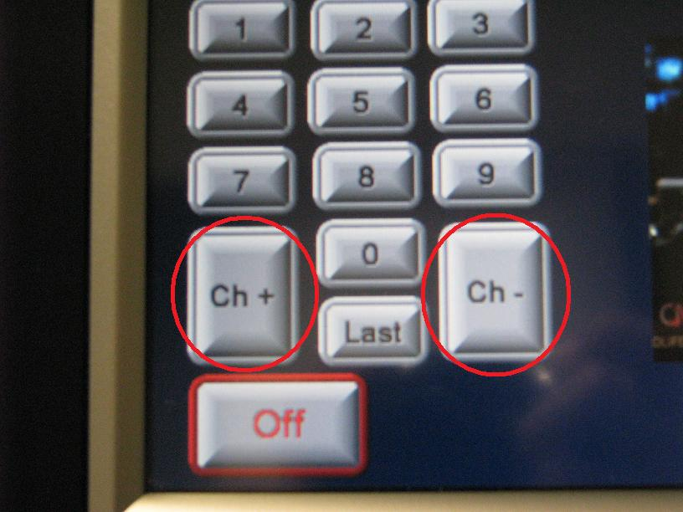

DOCUMENT CAMERA

* The Wolf Vision is now used in place of the overhead projector. It can read 8x11 sheets of paper, transparencies, and any printed material you want to project. 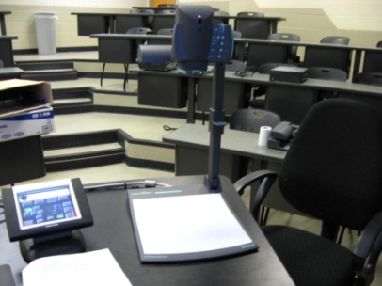
* Located near the working surface area of the Wolf Vision are the brightness and power options. Make sure the power is on as indicated by a green light.

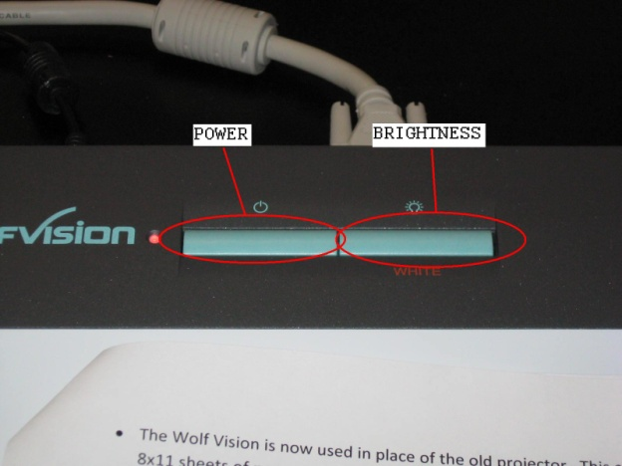

* Place your document on the Wolf Vision working surface area.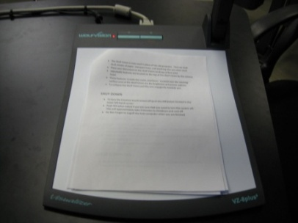
* To zoom or focus in on your documents, use the buttons located by the camera head.

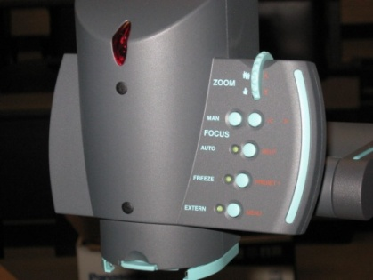

* To collapse the Wolf Vision pull the arm ring gently towards you. 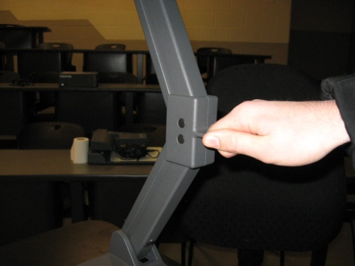

FOR DVD USE

* Press the OPEN/CLOSE button on the Optiplex 960 tower and insert the DVD.

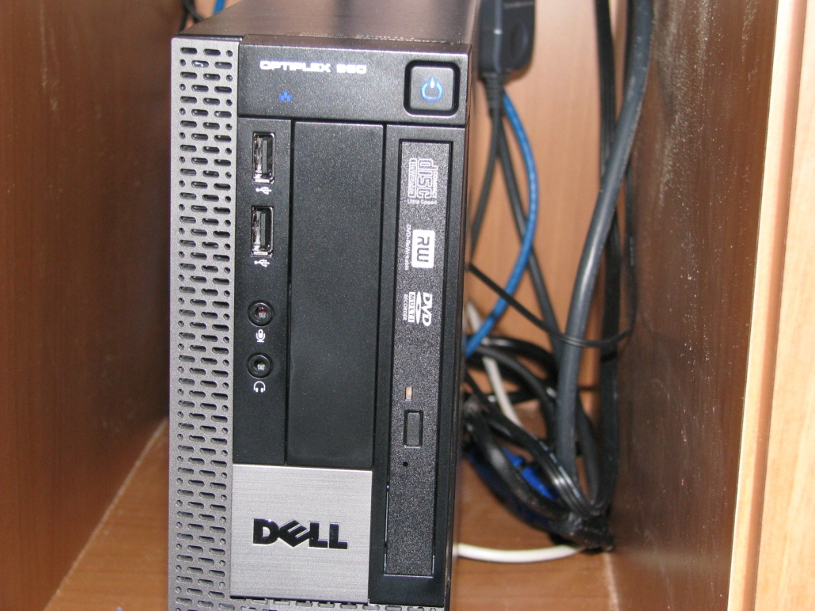

Open/Close Button

* A screen will appear that will allow you to use the appropriate program for your application.

SHUT DOWN

* At the end of your class, please turn off the projector. To do this, touch the Off button located in the bottom left side of the Crestron touch screen.

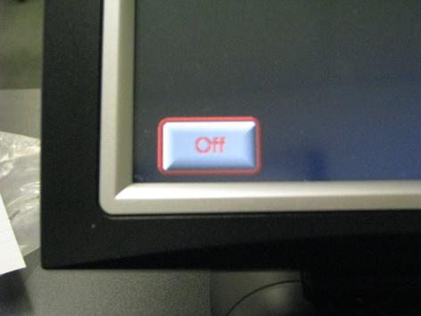

* Touch YES when asked if you are sure that you want to turn the system off. This will approximately take 2 minutes to shutdown and cool off. 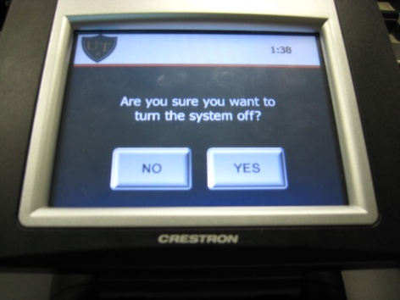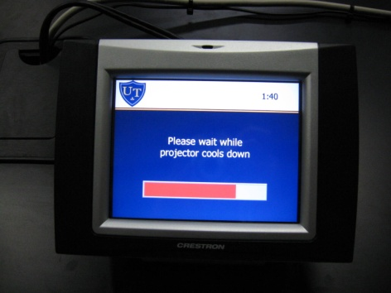

Sending a Help Desk Request

* Click on the Help Desk Icon on the Desktop



* Use your credentials to login



* Click Submit a New Help Desk Request

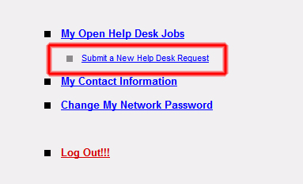

* Fill out the Form, and click Submit

