Uploading Content to My Mediasite:
- Access My Mediasite at: http://cobims.utoledo.edu/mediasite/mymediasite
- Then click Create Presentation at the top left of your screen.
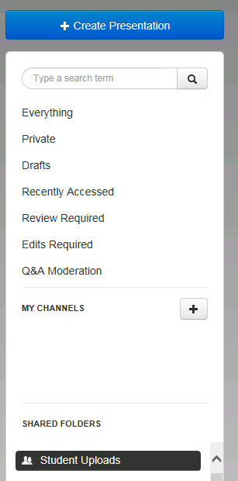

- Next you will click Upload Media.

- After clicking Upload Media, you will title your video (ex: Shannon Joyce Elevator Pitch or Abby Caye and David Irwin International Role Play). The title is important so your name and type of role play can be found in a search.
- In the Publish To section, select Student Uploads
- Then click the Select Video button and navigate to and select your MP4 video. If you do not have a MP4 file, you will need to convert it before you can upload it to Mediasite. There are free, online conversion tools such as http://video.online-convert.com/convert-to-mp4.
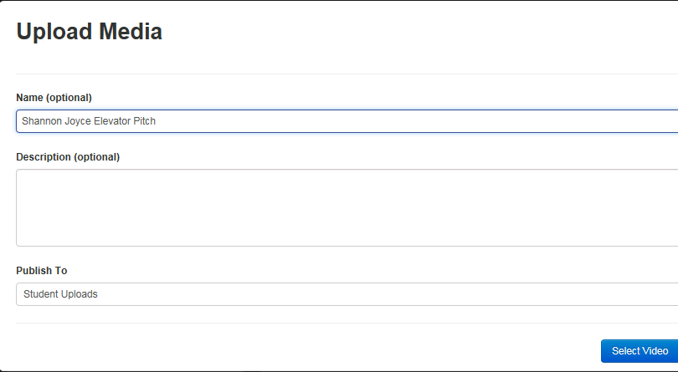

4.

5.

6. .
- Wait a few seconds (or minutes) for the video to be uploaded and processed and then change the status from Private to Viewable

