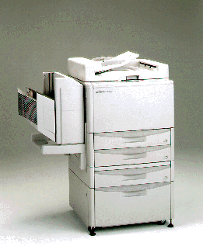
PI HV-600
For quality and dependability:
Combining legendary PIC reliability with cutting edge Digital technology, the PI HV-600 is the ideal output device for reproducing all your wide format paper-based, electronic originals, and brochures with photo quality copies.
Supplies Toner system: Automatic Toner Density Control
Additional PIC Services- 24-hour hotline, Interactive Customer Web Page, Consulting Services, Free Routine Check-Ups, Service Manual Online, Outsourcing Assistance.
Automatic Duplexing: Make two-sided copies using the automatic recirculating document feeder. Tow-sided copies save time, filing space, paper, and mailing costs.
Five-Way Paper Feed System: roll
Automatic Paper Selection: Means the proper size for paper for copying is selected automatically.
Electronic Image Editing: special computerized pad and pen lets you decide what gets copied and what doesn't. You'll be able to delete, center, trim, and/or reduce or enlarge only those portions of the original you want copied without destroying the original. All this and in color too, if you want it.

Type: Console, LED Electronic Digital copier
Process: Automatic toner for picture quality
Toner Colors: Full Color
Copy Sizes: Maximum 36" x 197"
Copying Speeds: 17.5 ft./min, 80 cpm black, or 31 cpm color
Recommended Monthly Volume: 200,000 copies
Warm-up Time: 10 minutes
First Copy Speeds: 3 sec
Copy Selector: 1-2000
Enlargement/Reduction Capabilities: Zoom from 25% to 400% in 1/10% increments.
Paper Supply: Standard Dual Media Rolls plus Sheet Bypass
Size & Wgt: Width- 616 mm, Depth-643 mm, Height-1045 mm, Wgt. - 95kg
Electrical Requirements: 220-240V
Additional Options: Network Interface Card

