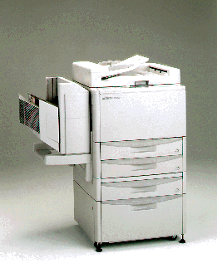

The PI HV-600 Copier Specifications
Order No. PI HV-600

