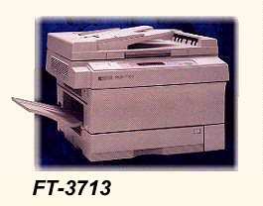

The PI LMV-300 Copier Specifications
Order No. PI LMV-300

