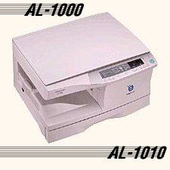
PI LV-100

Copiers that set the standard for excellence.
Every PIC Copier is designed with two things in mind - quality and dependability. To prove it, every copier we make is backed by a three-year Worry-Free Warranty that covers all services and repairs at NO CHARGE for three full years. Just think of it - a copier so reliable that all you have to think about is the time and money it's saving you.
And while the is our most economical copier, it comes with a host of features you'd typically expect to find only in larger, more expensive copiers.
Automatic Exposure: The PI LV-100 automatically scans your originals and selects the proper exposure setting to give you perfect copies regardless of the original's quality.
18 copies Per Minute: Means you'll be able to handle your jobs quickly and efficiently.
Dual Color Copying: Add the impact of color to your copies with a touch of your finger and the PI LV-100's dual color copying system with easy to use toner cartridges.

Type: Desktop.
Process: Dry Toner.
Toner Colors: Black, Red & Blue.
Copy Sizes: Maximum 11"x17", Minimum 4 1/8"x5 7/8".
Copying Speeds: 18 cpm (letter), 12 cpm (legal),
10 cpm (11"x17").
Recommended Monthly Volume: up to 15,000 copies
Warm up Time: Within 90 seconds.
First Copy Speeds: 7 seconds.
Copy Selector: 1-99.
Enlargement/Reduction Capabilities:
Zoom from 65%-150% in 1% increments. Preset Enlargement ratios of 121%,129% & 150%. Preset Reduction Ratios of 65%, 73% and 77%.
Paper Supply: Dual cassettes (250 sheets each) plus single sheet bypass
Other Features: Clamshell Design and Worry-Free
Warranty.
Size & Weight: Width 25", Depth 22", Height 13", and
Weight 103 lbs.
Options: Cabinet, 10 Bin Sorter, Color Toner, and
Automatic Document Feeder

